॥ अन्नं ब्रह्म ॥
Food is Brahman — Taittiriya Upanishad
ANNAPURNA KITCHEN · VOLUME V
The Eastern Ayurvedic Kitchen
Chinese, Japanese, Korean, Southeast Asian, Himalayan and Sri Lankan cooking through the lens of Ayurveda
87 sattvic recipes: congees, temple broths, dumplings, stir-fries, noodles, rice, tofu, banchan, sweets and teas
Ayurveda, Chinese medicine, Tibetan Sowa Rigpa and Japanese shōjin ryōri compared
Soy, miso, seaweed and salt — a guide for older hearts and kidneys
Four seasonal menus, Asian festival tables and weekly shopping lists, bridging to Indian recipes from Volumes I–II
Sattvic throughout: no onion, garlic, meat, fish, eggs, mushrooms or alcohol

Shree Shree Ma Anandamayee International Centre
Daksh Mandir Road, Kankhal, Dist. Haridwar – 249408 (U.K.), India · www.ssmaic.org
Global edition · 2026–27

Contents

If page numbers do not show, right-click the contents and choose 'Update field'.
PART I

Ayurveda and the Kitchens of Asia
Shared roots, parallel systems, a translated pantry and the art of adapting any Asian recipe

1. One Continent, Many Healing Kitchens
Long before the words "fusion cooking" were coined, the kitchens of Asia were talking to one another. Buddhist monks carried Indian ideas about food, purity and medicine across the Himalaya to Tibet, along the Silk Road to China, and onwards to Korea and Japan. Traders and teachers carried them by sea to Sri Lanka, Burma, Thailand and the Indonesian archipelago. Each culture absorbed what it met into its own medical and culinary traditions — so that today a bowl of Japanese okayu, a Korean pumpkin juk and a Kerala rice kanji are recognisably the same healing food.
This volume brings these kitchens back into conversation with Ayurveda. It is written for guests of the Annapurna Kitchen from East and Southeast Asia, for Indian readers who love Chinese, Japanese or Thai food, and for older readers anywhere who find the light, steamed, broth-based food of Asia comforting and easy to digest. Every recipe keeps the sattvic rules of Shree Shree Ma Anandamayee International Centre: no onion, garlic, meat, fish, eggs, mushrooms or alcohol. Fish sauce, oyster sauce, shrimp paste and bonito are replaced with soy, kombu and jaggery; scallion and garlic with ginger, coriander, lemongrass and galangal.

The traditions in this book
Tradition | Region | Relationship to Ayurveda | What it brings to the kitchen
Sowa Rigpa (Tibetan medicine) | Tibet, Ladakh, Bhutan, Mongolia, Himalayan India | Built on a largely Ayurvedic foundation; its Four Tantras (Gyü Zhi) overlap extensively with the Ashtanga Hridaya, translated into Tibetan by Rinchen Zangpo [8] | The three nyepa (rlung, mkhris-pa, bad-kan = Vata, Pitta, Kapha); butter, barley, warming broths
Thai traditional medicine | Thailand, Laos, Cambodia | Reveres Jivaka Komarabhacca, the physician of the Buddha, as its father; shares elemental theory with Ayurveda [9] | Herbal tonics, lemongrass, galangal, coconut, balance of flavours
Sri Lankan Deshiya Chikitsa and Ayurveda | Sri Lanka | Ayurveda practised alongside indigenous medicine for over two millennia | Kola kanda (herbal porridge), gotu kola, coconut, red rice
Chinese medicine (TCM) | China, Taiwan, Hong Kong, diaspora | An independent system with striking parallels: hot/cold natures, five flavours, food as medicine [10] | Congee, tonic soups, ginger, red dates, goji, warming and cooling foods
Kampo and shōjin ryōri | Japan | Kampo derives from Chinese medicine; shōjin ryōri is the vegetarian cuisine of Zen temples [4] | Kombu dashi, seasonal vegetables, five colours and flavours, mindful eating
Korean temple cuisine and hansik | Korea | Buddhist temple food omits the five pungent vegetables; hansik emphasises balance of yin–yang and five colours [3] | Juk (porridges), namul, fermented bean pastes
Jamu and Malay traditional medicine | Indonesia, Malaysia | Influenced by Indian Ayurveda, Arab and Chinese medicine | Turmeric, ginger, galangal, tamarind tonics

What travels — and what is different

Shared ground
- Food is the first medicine; disease begins in the digestion.
- Foods have heating and cooling natures, and tastes with specific effects.
- Eat with the season; adjust for the person's constitution and age.
- Warm, cooked, freshly made food is easier to digest than cold or raw food.
- Rice porridge is the universal food for the young, the old, the sick and the recovering.
- Moderation: stop before you are full (the Okinawan hara hachi bu, "80% full", is Ayurveda's "fill the stomach half with food, a quarter with liquid, leave a quarter empty").

Where the systems differ is mostly in their vocabulary and in a few foods. Chinese medicine speaks of yin and yang, qi, dampness and five organ networks; Ayurveda speaks of doshas, agni, ama and seven tissues. Japanese and Chinese kitchens rely heavily on soy foods and fermented seasonings, which Ayurveda treats with caution because of their salt and heaviness. Raw fish and alliums are central to many Asian cuisines and absent here. Chapter 3 maps the vocabularies side by side.

Why Eastern food suits people over fifty
East Asian home cooking is, in many ways, an ideal elder diet: a bowl of rice or congee, a warm soup, small portions of several cooked vegetables, a little tofu or beans, and tea. Japan and Korea have among the highest life expectancies in the world, and the traditional diet of Okinawa — dominated by sweet potato, vegetables and soy, eaten in moderate amounts — is often cited in research on healthy ageing [11]. The same cuisines carry one significant risk: salt, from soy sauce, miso, pickles and broths. Chapter 7 shows how to keep the benefits while halving the salt.

2. The Dosha Year in Asian Climates
Asia contains almost every climate on earth. The doshas follow the qualities of the weather, not the calendar, so readers should translate the seasons by asking: is it cold or hot? dry or damp? still or windy? [2]
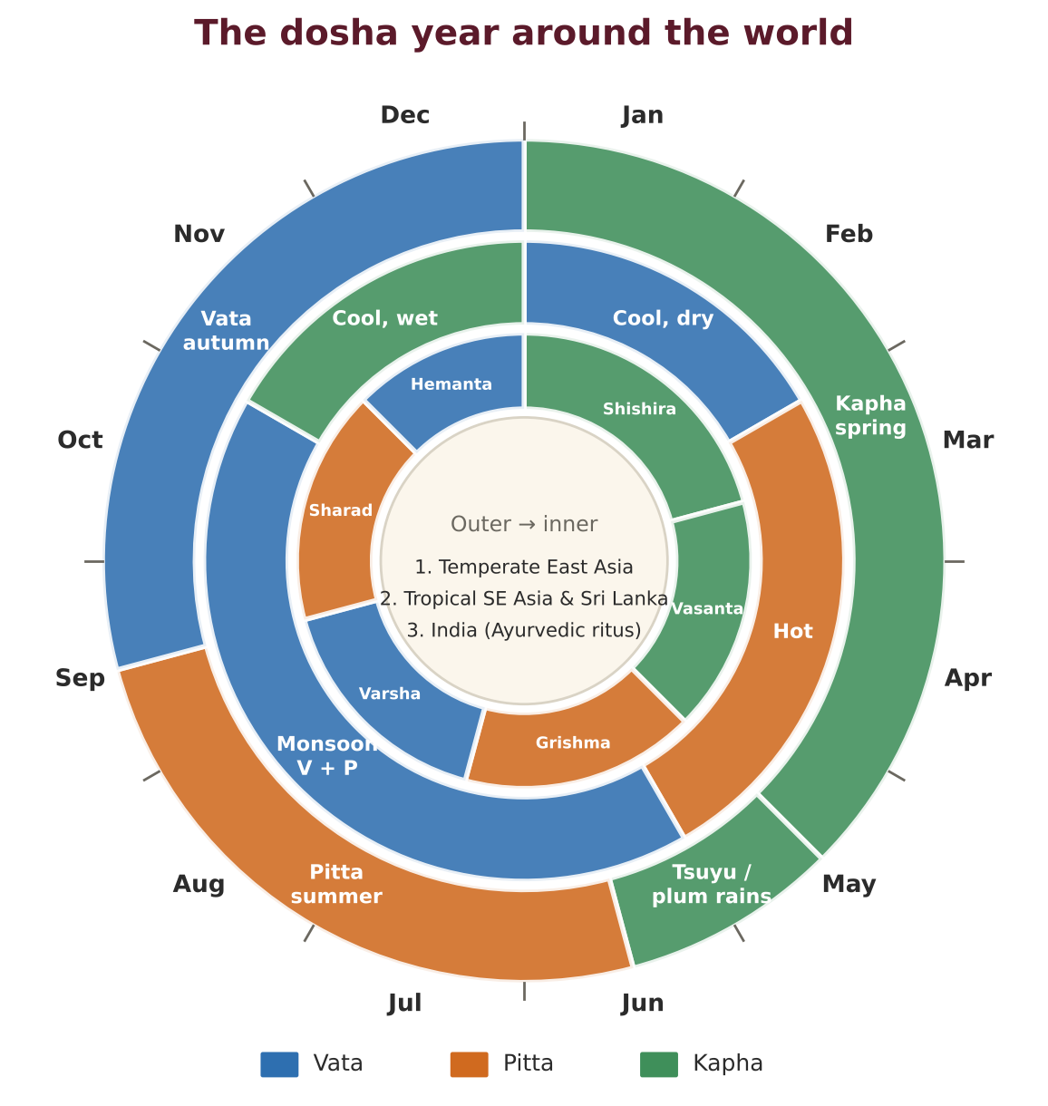
Figure. The dosha year in temperate East Asia (outer ring), tropical Southeast Asia and Sri Lanka (middle) and the Indian ritu calendar (inner).
Region | Climate pattern | Dosha calendar | Kitchen emphasis
North China, Korea, northern Japan | Very cold dry winter, hot humid summer, short springs and autumns | Vata late autumn–winter; Kapha late winter–spring; Pitta summer | Thick soups, noodle soups, dumplings in winter; mung, winter melon and barley tea in summer
South China, Taiwan, southern Japan | Mild winter, long hot humid summer, plum rains (tsuyu, meiyu) in June | Kapha in the damp rainy season; Pitta in summer | Ginger, light broths, barley, adzuki to counter dampness; cooling soups in summer
Himalaya, Tibet, Bhutan | Cold, dry, windy, high altitude | Vata most of the year | Ghee, barley, thukpa, momos, warm milk and butter
Mainland Southeast Asia | Hot dry season (Mar–May), monsoon (May–Oct), cool dry season (Nov–Feb) | Pitta in the hot season; Vata + Pitta in the monsoon; mild Kapha/Vata in the cool season | Coconut, rice, mung; ginger and lemongrass in the monsoon
Equatorial Malaysia, Indonesia, Singapore | Hot and humid all year, monsoon rains | Pitta–Kapha all year | Light, cooked, mildly spiced food; coconut used moderately; avoid heavy fried food
Sri Lanka | Two monsoons; hot coastal plains, cool hills | Pitta–Kapha in the lowlands; Vata–Kapha in the hills | Red rice, kola kanda, gotu kola, coconut, mild curries

The 24 solar terms and the doshas
East Asian farmers and cooks divide the year into 24 solar terms (jiéqì in Chinese, sekki in Japanese, jeolgi in Korean), each about 15 days long. They map neatly onto Ayurveda's six ritus, each of which spans four solar terms.
Ayurvedic ritu (approx. dates) | Solar terms (Chinese / Japanese) | Dosha | Eastern kitchen guidance
Shishira — late winter (mid-Jan – mid-Mar) | Xiǎohán / Shōkan (Minor Cold) · Dàhán / Daikan (Major Cold) · Lìchūn / Risshun (Start of Spring) · Yǔshuǐ / Usui (Rain Water) | Kapha accumulates | Warming congees, ginger and jujube tea, Lunar New Year food in moderation; nanakusa-gayu on 7 January
Vasanta — spring (mid-Mar – mid-May) | Jīngzhé / Keichitsu (Awakening of Insects) · Chūnfēn / Shunbun (Spring Equinox) · Qīngmíng / Seimei (Clear and Bright) · Gǔyǔ / Kokuu (Grain Rain) | Kapha aggravated | Spring greens, buckwheat soba, daikon, sprouts; less sticky rice and sweets
Grishma — early summer (mid-May – mid-Jul) | Lìxià / Rikka (Start of Summer) · Xiǎomǎn / Shōman (Grain Buds) · Mángzhòng / Bōshu (Grain in Ear) · Xiàzhì / Geshi (Summer Solstice) | Pitta accumulates; Vata begins to rise | Mung, winter melon, cucumber, barley tea at room temperature; plum-rain foods with ginger
Varsha — rains / high summer (mid-Jul – mid-Sep) | Xiǎoshǔ / Shōsho (Minor Heat) · Dàshǔ / Taisho (Major Heat) · Lìqiū / Risshū (Start of Autumn) · Chǔshǔ / Shosho (End of Heat) | Vata aggravated, Pitta accumulating | Cooked food only, ginger, light congees, mung-bean soup
Sharad — autumn (mid-Sep – mid-Nov) | Báilù / Hakuro (White Dew) · Qiūfēn / Shūbun (Autumn Equinox) · Hánlù / Kanro (Cold Dew) · Shuāngjiàng / Sōkō (Frost's Descent) | Pitta aggravated | Pears, persimmons, lotus root, sesame, rice; Mid-Autumn Festival
Hemanta — early winter (mid-Nov – mid-Jan) | Lìdōng / Rittō (Start of Winter) · Xiǎoxuě / Shōsetsu (Minor Snow) · Dàxuě / Taisetsu (Major Snow) · Dōngzhì / Tōji (Winter Solstice) | Agni strongest; Kapha begins | Nourishing soups, adzuki, sesame, tang yuan at Dongzhi, root vegetables

The monsoon kitchen
- Ayurveda treats the rainy season (Varsha) as the most dangerous for digestion: agni is weak, water may be contaminated, and all three doshas are disturbed.
- Across monsoon Asia, the same wisdom appears: boil all water, eat freshly cooked food, add ginger to everything, and favour thin rice porridges and clear soups.
- In this season choose the congees (Section 1), clear soups (Section 2), steamed dishes (Section 3) and ginger teas (Section 11); avoid raw salads, rice-paper rolls with raw herbs, and cold desserts.

3. Ayurveda, Chinese Medicine and the Temple Kitchen
Readers who know Chinese medicine or Japanese temple cooking will find much that is familiar in Ayurveda. The comparison below is offered as a bridge, not an equation: each system has its own logic and should be learned on its own terms. Modern science has tested few of the traditional classifications of foods as heating or cooling [10].
Concept | Ayurveda | Chinese medicine (TCM) | Notes for the cook
Basic elements | Five: ether, air, fire, water, earth | Five phases: wood, fire, earth, metal, water | Different lists; both describe qualities in nature and body
Functional principles | Three doshas: Vata, Pitta, Kapha | Yin and yang; qi, blood and fluids | Vata ≈ wind and dryness; Pitta ≈ heat; Kapha ≈ dampness and phlegm
Thermal nature of food | Virya: heating (ushna) or cooling (shita) | Five natures: hot, warm, neutral, cool, cold | Broadly agree: ginger, cinnamon, pepper warm; mung, winter melon, cucumber, chrysanthemum cool
Tastes | Six rasas: sweet, sour, salty, pungent, bitter, astringent | Five flavours: sweet, sour, salty, pungent, bitter (plus bland and astringent) | Astringent is a full taste in Ayurveda; TCM groups it with sour
Digestion | Agni (digestive fire); ama (undigested residue) | Spleen–stomach qi; dampness | Both advise warm, cooked food and avoiding iced drinks
Daily clock | Kapha 6–10, Pitta 10–2, Vata 2–6 (twice daily) | Organ clock: stomach 7–9 am, spleen 9–11 am, etc. | Both favour a substantial breakfast or lunch and a light, early dinner
Seasons | Six ritus; ritucharya | Five seasons including late summer; 24 solar terms | Both eat with the season
Excess | Kapha: heaviness, mucus, sluggishness | Dampness: heaviness, phlegm, poor appetite | Both use barley, adzuki, ginger and light grains to clear it

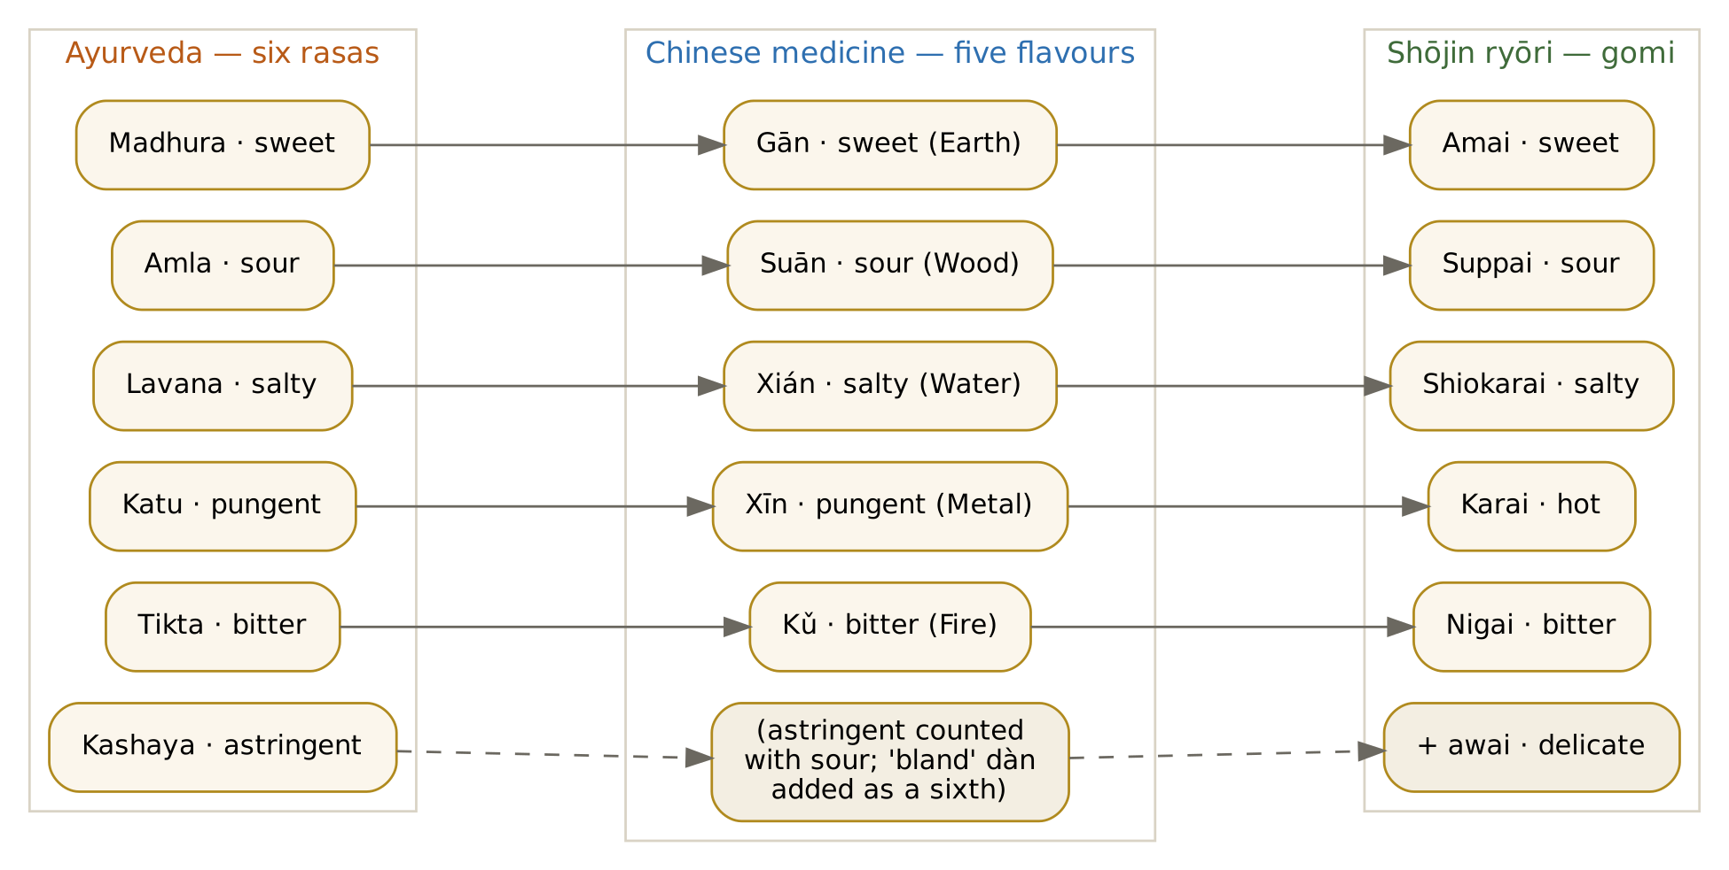
Figure. Six rasas, five Chinese flavours and the shōjin ryōri gomi.

Shōjin ryōri: the Zen kitchen
Shōjin ryōri — literally "devotion cuisine" — is the vegetarian food of Japan's Zen temples, brought from China by monks such as Dōgen in the 13th century. It is organised by a set of "fives" that echo Ayurveda's attention to variety and balance [4]:
Principle | Japanese | What it means | Ayurvedic parallel
Five colours (goshiki) | White, black, red, yellow, green | Every meal shows all five colours | Varied vegetables supply the six tastes and many qualities
Five flavours (gomi) | Sweet, sour, salty, hot, bitter (+ delicate, awai) | Every meal touches every flavour | The six rasas on one plate
Five methods (gohō) | Raw, simmered, grilled, fried, steamed | Variety of cooking techniques | Varied qualities: light and heavy, moist and dry
No gokun | The five pungent vegetables excluded | Onion, garlic, leek, chive and scallion are omitted | Sattvic diet omits onion and garlic
Seasonality | Shun | Eat each food at its peak | Ritucharya
Mindful preparation | Tenzo | The temple cook cooks as spiritual practice | Annapurna seva — cooking as worship

The five pungents and the sattvic diet
Mahayana Buddhist monastics in China, Korea, Vietnam and Japan avoid five pungent plants (wǔ hūn): garlic, onion and shallot, leek, chive or Chinese onion, and — in some lists — asafoetida [3]. Their reason is close to the yogic one: the pungents are said to excite the passions and disturb meditation. The Annapurna Kitchen follows the same rule for onion and garlic.

A note on hing (asafoetida)
- Indian sattvic cooking uses a pinch of hing to replace the savoury depth of onion and to help digest beans.
- Several Chinese Buddhist lists of the five pungents include asafoetida. For guests who follow strict temple rules, hing is marked optional throughout this book — and none of the Eastern recipes depend on it.
- Ginger, kombu, toasted sesame and a little soy sauce supply the depth instead.

4. The Eastern Pantry Through Ayurvedic Eyes
The East and Southeast Asian pantry overlaps more with the Indian one than most people expect: rice, mung beans, ginger, turmeric, sesame, coconut, tamarind and jaggery are shared, while soy foods, seaweeds, Asian greens and teas are new. The tables below give each food's effect on the doshas, drawing on the Ayurvedic Institute's food guidelines [1] and classical reasoning about taste, potency and post-digestive effect.
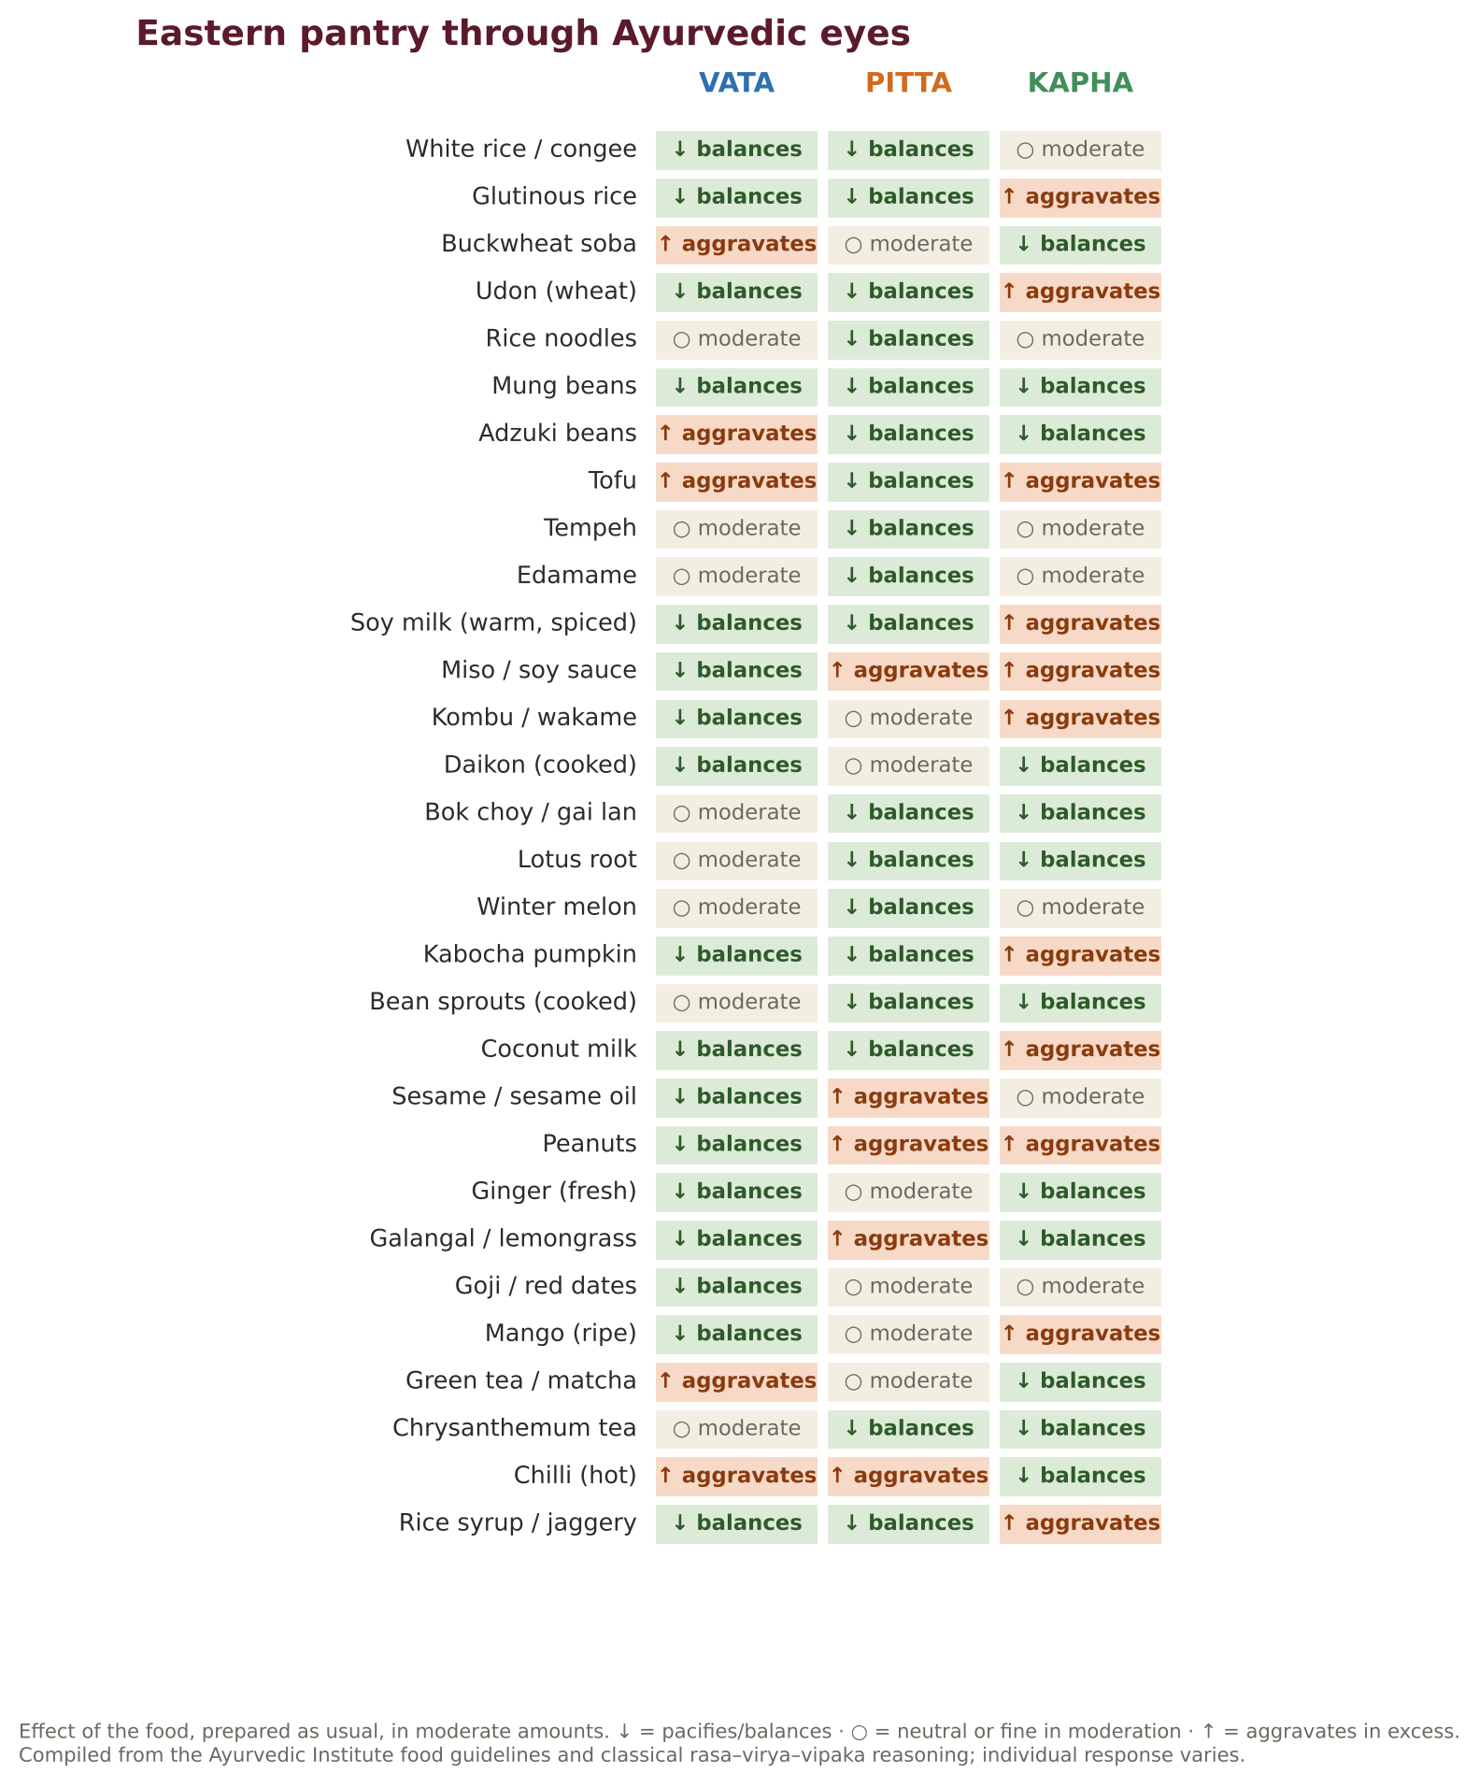
Figure. Thirty everyday Eastern foods and their effect on Vata, Pitta and Kapha.

Rice, noodles and grains
Food | Taste · potency | Vata | Pitta | Kapha | Notes for 55+
Jasmine / short-grain white rice | Sweet · cooling | Balances | Balances | Moderate | The easiest grain to digest; congee for weak agni
Brown rice, mixed-grain rice (japgok-bap) | Sweet, astringent · warming | Moderate | Moderate | Balances | Soak 1–2 hours; cook soft
Glutinous (sticky) rice | Sweet · heavy, warming | Balances | Balances | Aggravates | Festive; small portions; choking risk — supervise
Red / black rice | Sweet, astringent · warming | Balances | Moderate | Balances | Sri Lankan red rice, Chinese black rice; soak and cook long
Millet (foxtail, proso) | Sweet · warm, dry | Moderate | Moderate | Balances | Northern Chinese porridge grain
Buckwheat soba | Sweet, astringent · warming | Moderate | Moderate | Balances | Choose 80–100% buckwheat for gluten-free
Wheat noodles, udon, mantou | Sweet · cooling, heavy | Balances | Balances | Aggravates | Udon is the softest noodle
Rice noodles, rice paper | Sweet · cooling, light | Moderate | Balances | Moderate | Gluten-free; serve in warm broth for Vata
Glass noodles (mung or sweet-potato starch) | Sweet · cooling | Moderate | Balances | Moderate | Snip short; slippery
Job's tears (yi ren), barley | Sweet, bland · cooling | Moderate | Balances | Balances | Classical dampness-clearing grains in both systems

Soy foods
Soy is the protein foundation of East Asian vegetarian cooking. Ayurveda considers the soybean cool, heavy and difficult to digest, and so prefers fermented or well-cooked forms, warmed with ginger and spices. Soy sauce is salty and cooling, with a sweet post-digestive effect; it suits Pitta in moderation but increases Kapha and fluid retention in excess, and a tablespoon contains roughly 900–1,000 mg of sodium [7].
Soy food | Vata | Pitta | Kapha | Ayurvedic preparation
Tofu (firm) | Moderate (warm, spiced) | Balances | Moderate | Press, then braise or bake with ginger, pepper, star anise
Silken tofu | Moderate (warm) | Balances | Aggravates | Steam warm with ginger; never chilled for Vata
Tofu puffs, aburaage | Moderate | Moderate | Aggravates | Blanch in boiling water to remove excess oil
Tempeh | Balances | Balances | Moderate | Steam 10 minutes first; fermentation aids digestion
Edamame | Moderate | Balances | Moderate | Young, easier than mature beans
Soy milk | Moderate (warm, spiced) | Balances | Aggravates | Always boil homemade soy milk; add ginger, cardamom
Miso, doenjang | Balances | Aggravates | Aggravates | Small amounts; never boil after adding
Soy sauce, tamari | Balances | Moderate | Aggravates | Reduced-salt versions; measure, do not pour
Natto | Moderate | Moderate | Moderate | Very high in vitamin K2 — avoid if on warfarin [14]

Vegetables, sea vegetables and aromatics
Food | Vata | Pitta | Kapha | Comment
Daikon (cooked) | Balances | Moderate | Balances | Ayurveda's mooli; raw daikon is pungent and Pitta-provoking
Bok choy, gai lan, choy sum | Moderate | Balances | Balances | Cook with ginger and sesame oil
Napa cabbage | Aggravates (raw) | Balances | Balances | Steamed or in dumplings
Lotus root | Moderate | Balances | Balances | Astringent and cooling; long-simmered in soups
Winter melon (ash gourd) | Moderate | Balances | Moderate | Kushmanda — prized in both systems
Kabocha pumpkin | Balances | Balances | Aggravates | Sweet, dense, very grounding
Taro, Chinese yam | Balances | Balances | Aggravates | Mucilaginous, nourishing
Burdock (gobo) | Moderate | Balances | Balances | Bitter cleansing root; parsnip is a soft substitute
Bean sprouts | Aggravates (raw) | Balances | Balances | Blanch for Vata and elders
Bamboo shoots | Aggravates | Moderate | Balances | Always cooked; rinse canned shoots
Kombu | Balances | Moderate | Aggravates | Umami source; very high in iodine — use for stock, not to eat in large amounts
Wakame, nori | Balances | Moderate | Moderate | Small amounts; good minerals
Hijiki | — | — | — | Not used: high in inorganic arsenic [13]
Ginger | Balances | Moderate (fresh) | Balances | The universal Asian and Ayurvedic digestive
Galangal, lemongrass, lime leaf | Balances | Moderate | Balances | Thai aromatics; warming and carminative
Thai basil, coriander, mint | Moderate | Balances | Balances | Fresh herbs add Pitta-cooling brightness
Chilli | Aggravates | Aggravates | Balances | Used mildly or optionally in this book
Sesame seeds and oil | Balances | Moderate | Moderate | Toasted sesame oil is for finishing, not frying
Coconut milk | Balances | Balances | Aggravates | Cooling, rich; use light versions for Kapha

Fruits, tonics and sweeteners
Food | Vata | Pitta | Kapha | Use
Red dates (jujube) | Balances | Balances | Moderate | Sweet tonic in porridges and teas
Goji berries | Balances | Moderate | Moderate | Small amounts; may interact with warfarin — ask your doctor
Longan, lychee | Balances | Aggravates (in excess) | Aggravates | Sweet and heating in Chinese medicine
Asian pear | Moderate | Balances | Moderate | Steamed with honey for dry autumn coughs
Persimmon | Moderate | Balances | Balances | Astringent; ripe only; not on an empty stomach
Mango (ripe) | Balances | Moderate | Aggravates | Season's sweetness
Rice syrup, palm sugar, jaggery | Balances | Balances | Aggravates | Unrefined sweeteners
Green tea, matcha | Aggravates | Moderate | Balances | Caffeine — mornings only
Barley tea, chrysanthemum, jujube tea | Moderate | Balances | Balances | Caffeine-free all-day drinks

5. The Indian–Eastern Ingredient Translator
Indian ingredient or dish | Eastern equivalent | Notes
Rice kanji, peya, vilepi | Congee, jook, okayu, juk, cháo, bubur | Same food — see the ladder in Chapter 6
Moong dal / whole mung | Mung beans (lü dou) | Used sweet in Chinese desserts, savoury in congee
Rajma, lobia | Adzuki beans | Adzuki are lighter and sweeter
Paneer | Firm tofu (texture), Bhutanese datshi cheese | Tofu is cooler and lighter
Dahi | Soy yoghurt (rare); fermented foods instead | Asian cuisines use little dairy — calcium comes from tofu, sesame and greens
Ghee | Ghee, toasted sesame oil (finishing), light sesame or peanut oil | Ghee remains the Annapurna Kitchen's prime fat
Tamarind | Tamarind (Thai, Indonesian) | Identical
Jaggery | Palm sugar, rice syrup, Korean jocheong, rock sugar | Rice syrup is gentler than rock sugar
Kokum, amla | Yuzu, calamansi, lime, umeboshi (very salty) | Sour taste
Curry leaves | Kaffir lime leaves (aroma), Thai basil | Different but similarly aromatic
Dry ginger (saunth) | Dried ginger, ginger powder | Identical
Hing | (none — omitted in temple style) | Use ginger and kombu
Lauki, petha | Bottle gourd (hulu), winter melon (dong gua) | Identical families
Mooli | Daikon | Identical
Arbi | Taro (yu tou, satoimo) | Identical
Idli, dhokla | Steamed rice cakes, mantou, Vietnamese bánh bò | Steamed, soft, fermented or raised
Dosa, neer dosa | Rice-flour crêpes, bánh xèo (without egg), cheung fun | Rice-batter pancakes and rolls
Thoran, poriyal | Namul, gomaae, mallum | Lightly cooked, dressed vegetables
Rasam | Clear soups (tang), tom yum (mild) | Thin, spiced, sour broth
Avial, olan | Sayur lodeh, Thai curries | Vegetables in coconut
Payasam, kheer | Tong sui, mango sticky rice, bubur | Sweet milk- or coconut-based desserts
Kadha | Ginger–jujube tea, ginger syrup | Warming decoctions

6. Techniques of the Eastern Sattvic Kitchen

The congee ladder
Ayurveda describes a series of rice preparations of increasing thickness — manda (rice water), peya (thin gruel), vilepi (thick porridge), and finally rice — used to restore appetite and strength step by step after illness, fasting or panchakarma. The East Asian kitchen has the same ladder. Japanese hospitals and households still grade okayu by water ratio: zen-gayu (1:5), shichibu-gayu (1:7), gobu-gayu (1:10) and sanbu-gayu (1:20) [6]. Congee is served throughout Asia to the sick and the elderly [5].
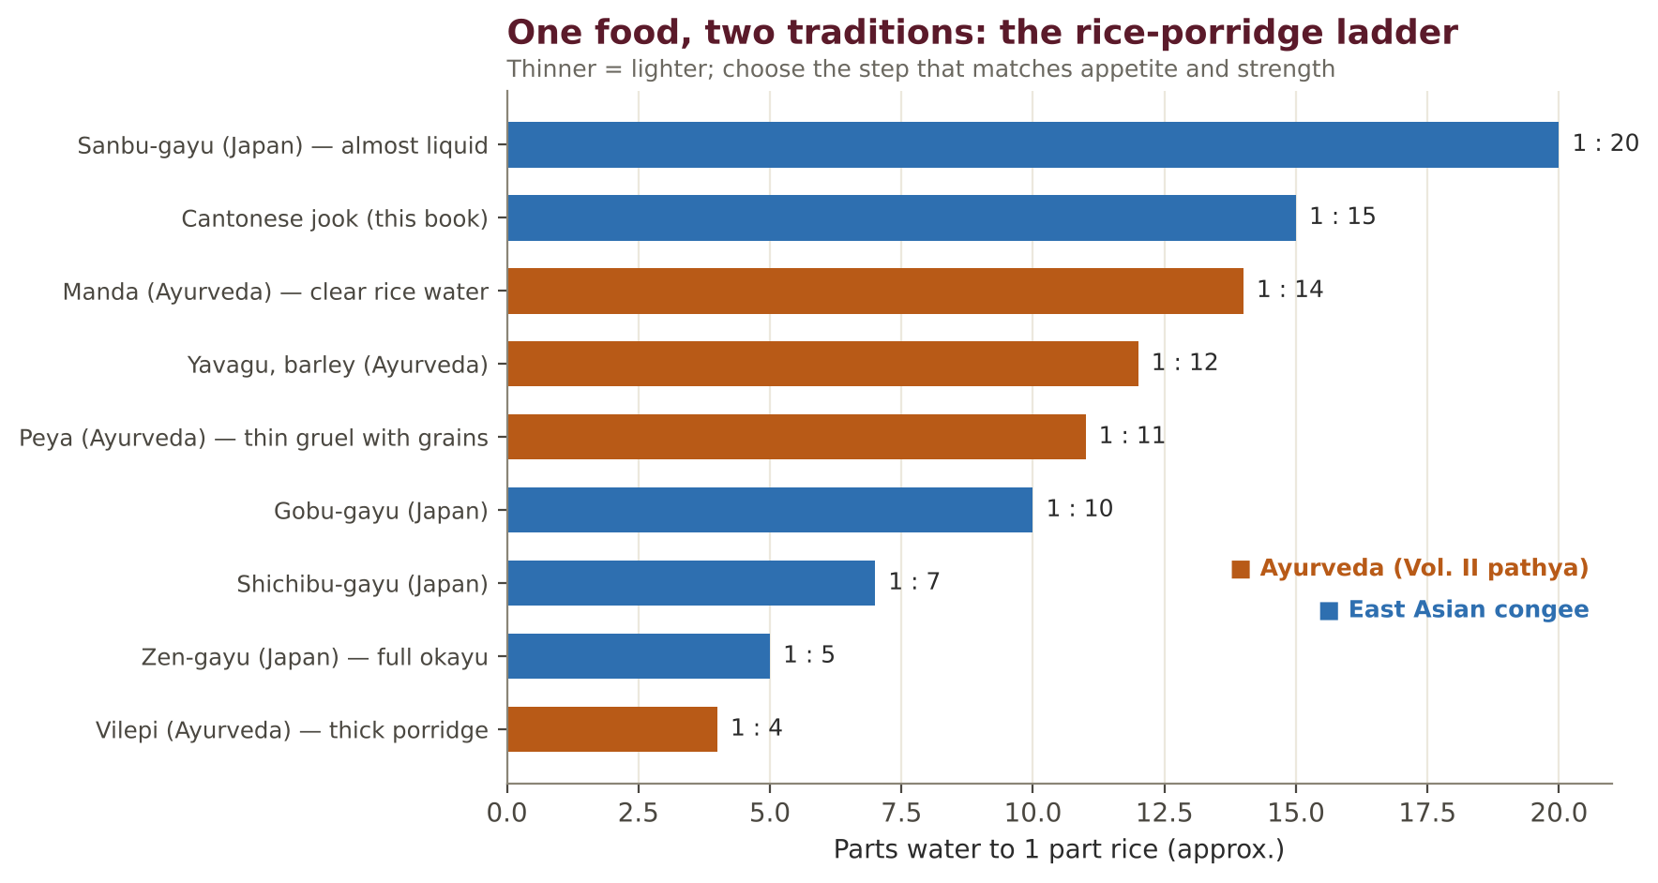
Figure. The rice-porridge ladder in Ayurveda and East Asia.

Congee master method
- Rinse rice until the water runs clear; soak 30 minutes (or freeze rinsed rice overnight for a quicker, silkier congee).
- Bring the water to a full boil before adding rice — this prevents sticking.
- Simmer with the lid ajar on the lowest heat; stir every 10 minutes, scraping the bottom.
- Season at the end, never at the start; offer toppings separately so each person adjusts.
- Pressure cooker: 1 part rice to 8–10 parts water, 20 minutes high pressure, natural release.
- Slow cooker: 1 to 10, 6–8 hours on low — ready for breakfast.

Kombu dashi: umami without fish, mushrooms or onion
Dashi is the stock behind most Japanese soups and simmered dishes. Temple cooks make it from kombu (and usually shiitake, which this kitchen omits). Kombu is rich in natural glutamate — the source of umami, the "fifth taste" discovered by the Japanese chemist Kikunae Ikeda in kombu itself. A strong kombu dashi lets you use far less salt (Recipe 2.01).
Stock | Ingredients (for 1 litre) | Time | Best for
Cold-brew kombu dashi | 10 g kombu, 1 L water | Soak 8 h, refrigerated | Miso soup, okayu, chawanmushi
Hot kombu dashi | 10 g kombu, 1 L water | Soak 30 min, heat slowly to 60 °C, hold 30 min, remove before boil | Noodle broths, nimono
Kombu–daikon–carrot | 10 g kombu, 100 g daikon, 1 carrot, 1.2 L water | Simmer 30 min | Congee, kenchin-jiru
Charred-ginger spice stock | 30 g charred ginger, star anise, cinnamon, clove, coriander, fennel, daikon, carrot | Simmer 40 min | Pho, thukpa
Corn-cob & ginger | 2 corn cobs, 3 slices ginger, 1.2 L water | Simmer 30 min | Sweet corn soup, summer broths

Steaming
Steaming keeps food moist and soft without added fat and is the gentlest cooking method for older digestion. Use a bamboo steamer over a wok or a metal insert over a saucepan; line baskets with cabbage leaves or perforated baking paper; keep water at a steady simmer and top up with boiling water.
Food | Steaming time | Test
Silken tofu (whole block) | 8 min | Heated through
Kabocha wedges | 12–15 min | Skewer slides through
Sweet potato chunks | 15–20 min | Soft
Jiaozi / momos | 10–12 min | Wrappers translucent
Mantou | 15 min + 5 min rest | Spring back when pressed
Glutinous rice (soaked) | 25 min | Translucent and tender
Rice-noodle sheets (cheung fun) | 3 min | Translucent, set
Egg-free chawanmushi | 15 min, gentle heat | Wobbly but set

The wok, adapted for elders
The classic stir-fry cooks vegetables crisp-tender in minutes. For older teeth and digestion, use the stir-fry–braise: stir-fry aromatics and vegetables 2 minutes, add a splash of stock, cover for 2–3 minutes until tender, then uncover to glaze. Cut vegetables small and thin. Use a neutral oil for high heat and add toasted sesame oil only at the end, off the heat — it burns easily and becomes bitter.

Tofu and tempeh, step by step
Step | Firm tofu | Silken tofu | Tempeh
Prepare | Press 20 min under a weight | Drain gently; do not press | Steam 10 min to soften and remove bitterness
Flavour | Marinate in soy, ginger, a little jaggery | Pour warm sauce over after steaming | Simmer in spiced liquid (bacem)
Cook | Bake, pan-sear, braise | Steam or add to soup at the end | Pan-sear after simmering
Ayurvedic touch | Ginger, pepper, star anise warm it | Warm ginger–sesame oil over the top | Coriander seed, galangal
55+ note | ≈ 12–15 g protein per 100 g | ≈ 5 g protein per 100 g; spoon-soft | ≈ 19 g protein per 100 g

Rice and noodle cooking chart
Item | Water / method | Time | Tip
Jasmine rice | 1 : 1.5 by volume | 15 min + 10 rest | Rinse three times
Japanese short-grain rice | 1 : 1.2 by volume | Soak 30 min; 15 min + 10 rest | Fluff with a wet paddle
Glutinous rice | Soak 4 h; steam, do not boil | 25 min | Line steamer with cloth
Red / brown rice | 1 : 2.2 | Soak 2 h; 40 min | Pressure cooker 15 min
Soba | Large pot of boiling water | 5–6 min | Rinse in warm water for hot dishes
Udon (frozen) | Boiling water | 1–2 min | Do not overcook — they tear
Rice noodles (dried) | Soak in hot water, then boil 1 min | 10 min soak | Snip with scissors for elders
Glass noodles | Boil | 6 min | Snip into short lengths

7. Salt, Soy, Seaweed and the Older Heart
The greatest health risk in East Asian cooking is not any single food but the cumulative salt from soy sauce, miso, pickles, broths and condiments. High salt intake raises blood pressure and the risk of stroke, heart disease and kidney disease; the World Health Organization recommends that adults eat no more than 5 g of salt a day [12]. A single tablespoon of regular soy sauce contains about half of that.
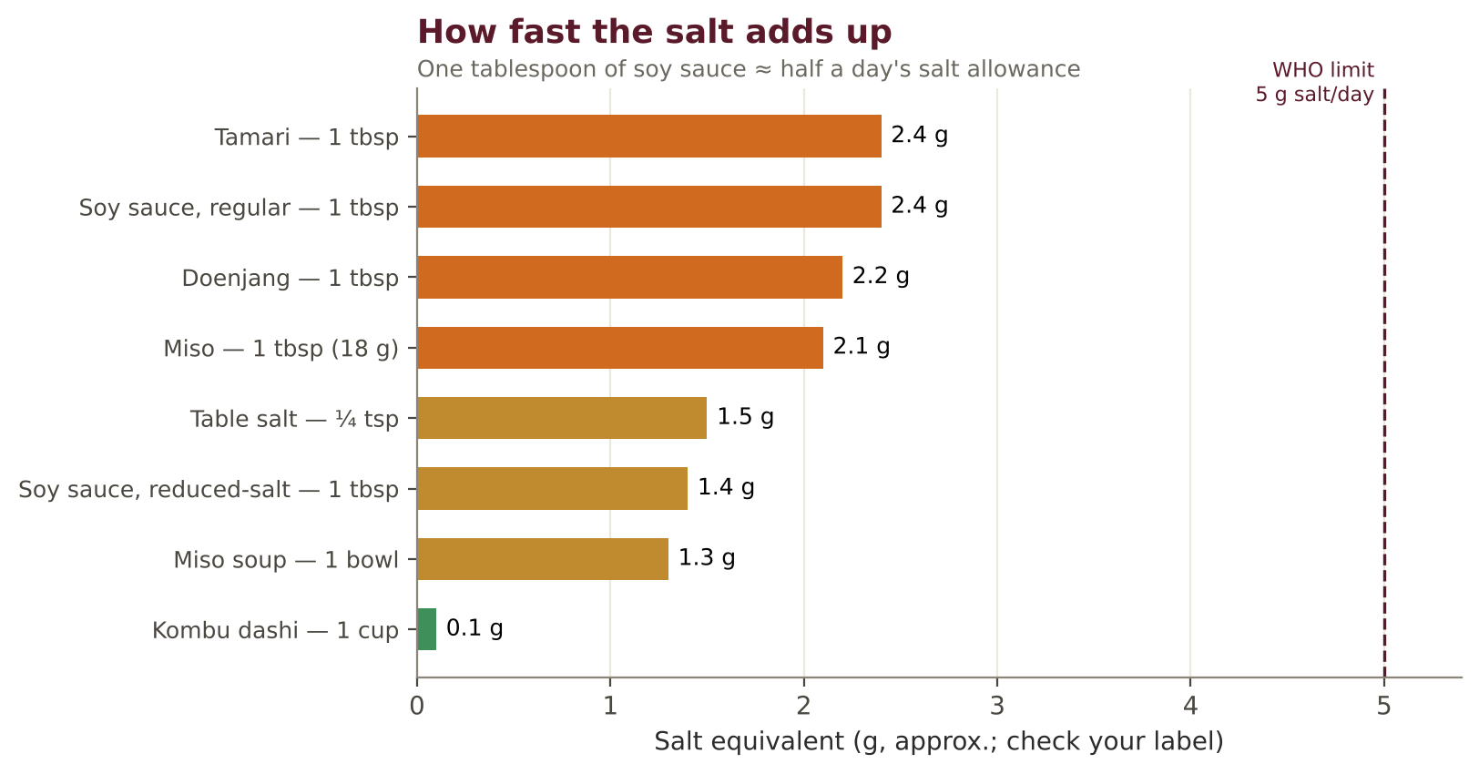
Figure. Salt in common East Asian seasonings compared with the WHO daily limit.

Halving the salt without losing flavour
- Make a strong kombu dashi — its natural umami lets you use less soy and miso.
- Use reduced-salt soy sauce and measure it with a spoon; add it at the end of cooking, where the taste is strongest.
- Dilute dipping sauces with water, vinegar or dashi; dip lightly.
- Drink half the broth of noodle soups, not all of it.
- Eat pickles in teaspoon portions; rinse them, and choose quick pickles (asazuke) over long-fermented ones.
- Use ginger, sesame, citrus, coriander, toasted spices and a pinch of jaggery to round out flavour.
- Every recipe in this book shows estimated salt per serving, including salt from soy sauce and miso.

Seaweed and iodine
Seaweeds are rich in minerals, but some are extremely high in iodine (especially kombu) and one — hijiki — contains high levels of inorganic arsenic; food-safety authorities advise against eating hijiki [13]. This book uses kombu for making stock (most is discarded), and nori and wakame in small amounts. People with thyroid conditions should ask their doctor about seaweed intake.

Medicines and East Asian foods
Food | Possible interaction | What to do
Natto (fermented soybeans) | Very high vitamin K2 — counteracts warfarin | Avoid if taking warfarin [14]
Leafy greens (bok choy, spinach, gai lan) | Vitamin K | Keep intake steady if on warfarin, do not avoid
Goji berries, dong quai, ginseng | Reported interactions with warfarin | Ask your doctor before regular use
Green tea, matcha | Caffeine; vitamin K in large amounts | Morning only; 1–2 cups
Grapefruit, pomelo | Interferes with many medicines (statins, some calcium-channel blockers) | Check your medicine leaflet
Licorice root (in some Chinese tonics) | Raises blood pressure, lowers potassium | Avoid in tonic doses if hypertensive
Soy sauce, miso | Sodium; potassium in reduced-salt salts | Watch with heart failure, kidney disease

8. Nutrition for the Fifty-Plus Reader
Nutrient | Why it matters after 50 | Daily target (approx.) | Eastern sources in this book
Protein | Protects muscle and strength | 1.0–1.2 g/kg; 1.2–1.5 g/kg with chronic illness [15] | Tofu, tempeh, edamame, adzuki, mung, peanuts, sesame, soy milk
Calcium | Bone strength; low-dairy diets may fall short | 1,200 mg (women 51+, men 71+) [16] | Calcium-set tofu (check label), sesame and tahini, bok choy, gai lan, fortified soy milk
Vitamin B12 | Absorption falls with age; absent from plant foods | 2.4 µg | Dairy, fortified soy milk or a supplement — essential for vegans
Vitamin D | Bone and muscle | 600–800 IU | Sunlight; supplement if advised
Fibre | Bowel regularity, heart, blood sugar | 25–30 g | Brown and mixed-grain rice, buckwheat, adzuki, vegetables, seaweed
Salt | Blood pressure, stroke | Less than 5 g [12] | Kombu dashi, reduced-salt soy, herbs

Rice and blood sugar
White rice is easy to digest but raises blood sugar quickly. For guests with diabetes or pre-diabetes, the Eastern kitchen has good traditional answers: mixed-grain rice (rice cooked with barley, millet, adzuki or brown rice, as in Korean japgok-bap), congee cooked with mung beans or sweet potato, and always eating rice with vegetables, tofu or beans rather than alone. Keep the rice portion to about one small bowl (150 g cooked) per meal.

Hara hachi bu and the Okinawa lesson
Okinawans traditionally practise hara hachi bu — stopping eating when 80% full. Their traditional diet was low in calories and very rich in vegetables, especially sweet potato, which in 1950 supplied most of their energy [11]. Researchers caution that no single food is a proven anti-ageing agent, and the Okinawan advantage has declined as diets have westernised. The enduring lesson matches Ayurveda: eat mostly plants, eat moderately, and eat with others.

9. Ayurvedize Any Asian Recipe in Seven Steps
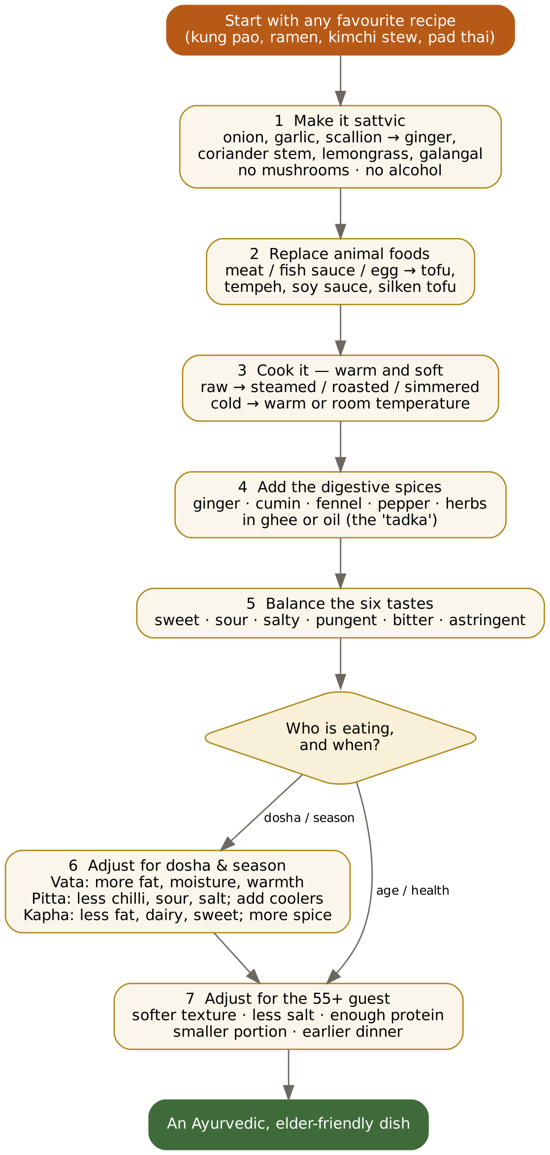
Figure. The seven-step method applied to Eastern recipes.

Five worked examples
Original | What changes | Result in this book
Kung pao chicken | Tofu in place of chicken; ginger instead of garlic and scallion; mild chilli; peanuts kept | Variation of 4.04 with peanuts
Shoyu ramen | Kombu–soy broth; udon or wheat noodles; bok choy and kabocha in place of pork and egg; drink half the broth | 5.03
Kimchi jjigae | Doenjang instead of kimchi (less sour, fermented heat); tofu, spinach and radish | 2.07
Pad thai | Soft rice noodles with tofu, tamarind, jaggery and ground peanuts; no egg or fish sauce; bean sprouts blanched | Variation of 5.05
Vegetable sushi | Warm onigiri instead of cold vinegared rice; cooked fillings; no raw fish | 6.08

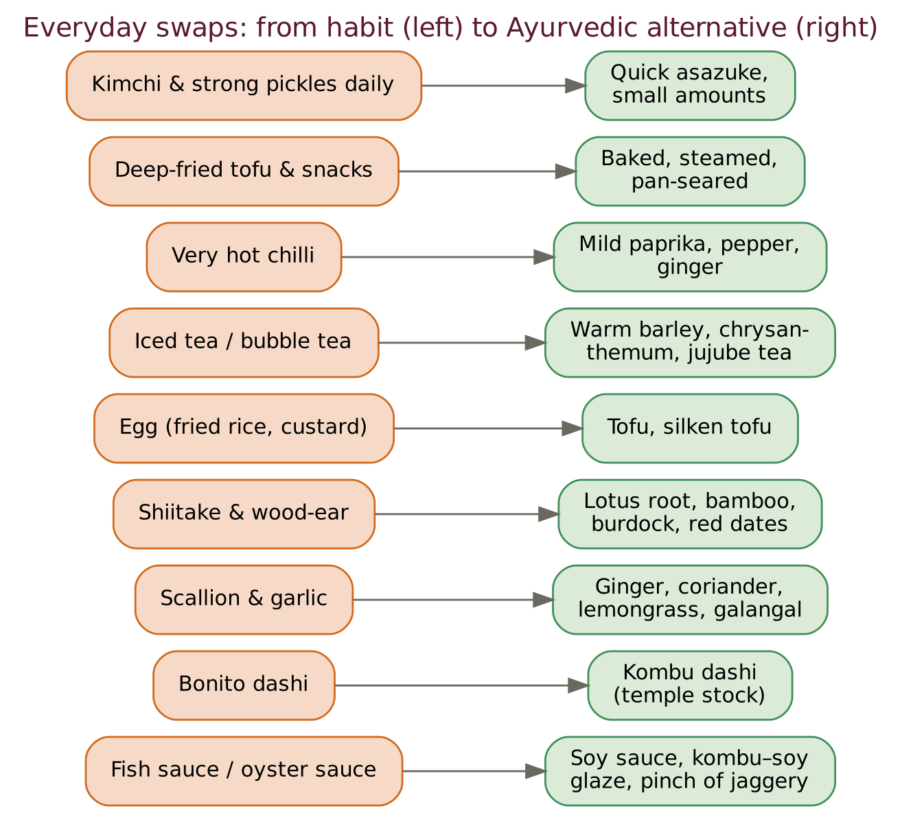
Figure. Nine everyday swaps for the Eastern kitchen.

How meals are built
The Japanese home meal is built on ichijū-sansai — one soup and three side dishes with rice — while the Indian thali gathers the six tastes on a single plate. Both achieve the same thing: variety of taste, colour and texture in modest portions.
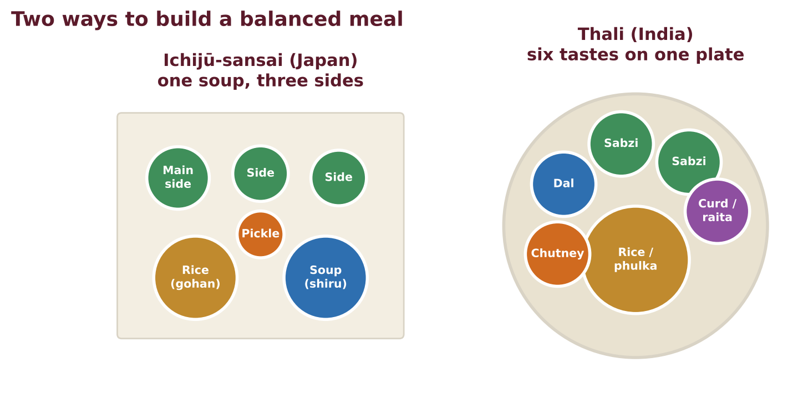
Figure. Two ways to build a balanced meal: the Japanese ichijū-sansai and the Indian thali.
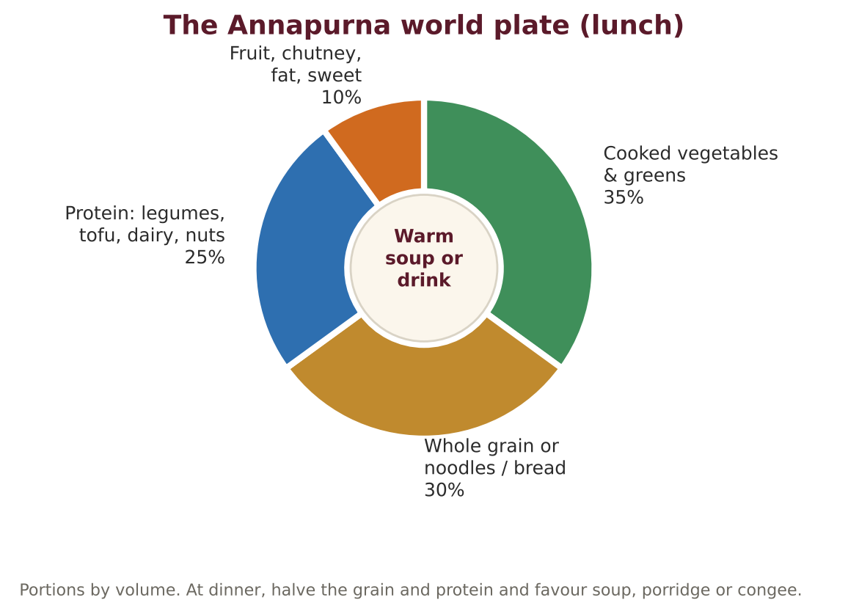
Figure. The Annapurna world plate for lunch.

How to read the recipes
Each recipe gives the region and dish that inspired it; servings, portion, time, texture, dosha and best season; an ingredient table with household measures, base quantities and a café batch (×5); a short method; estimated nutrition per serving (including salt from soy sauce and miso); a care note for 55+ guests; an Ayurvedic note; the Ayurvedic adaptations made to the original; and variations.

10. The Recipe Collection at a Glance
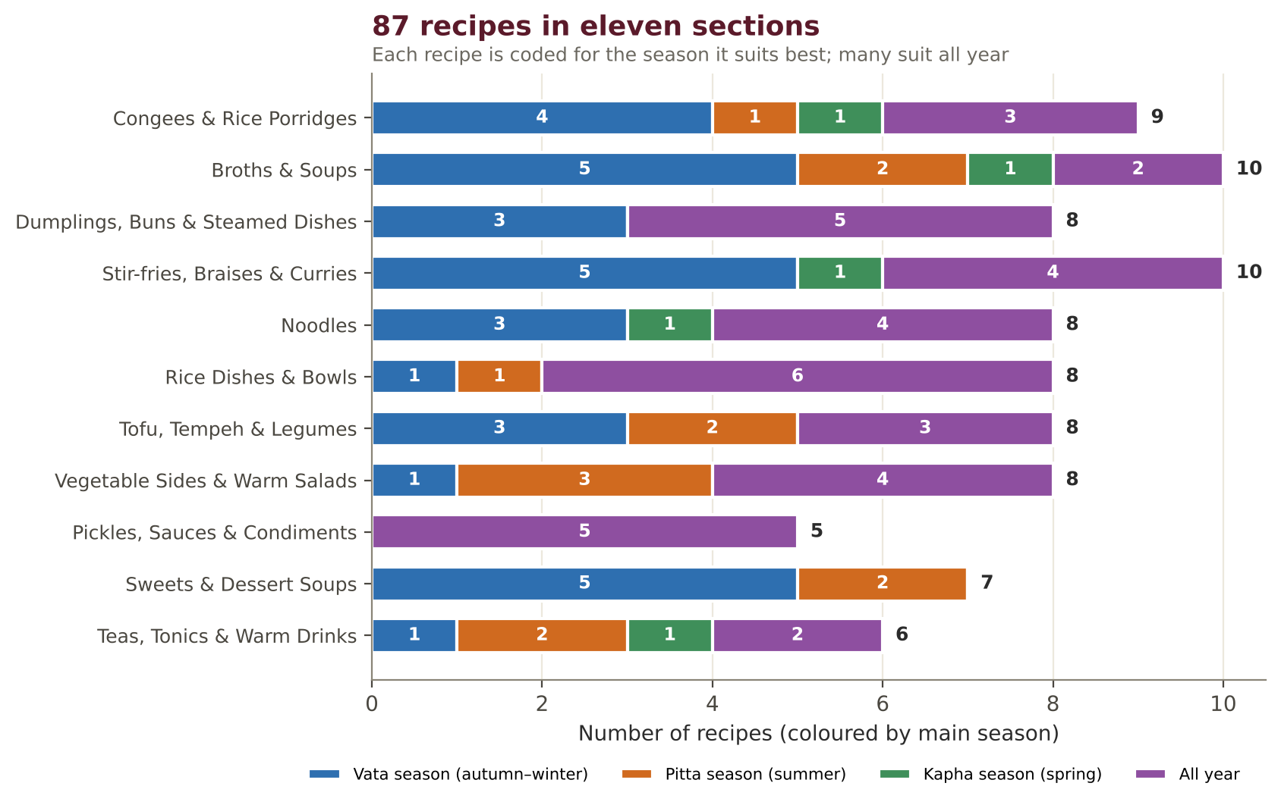
Figure. The 87 recipes by section and main season.
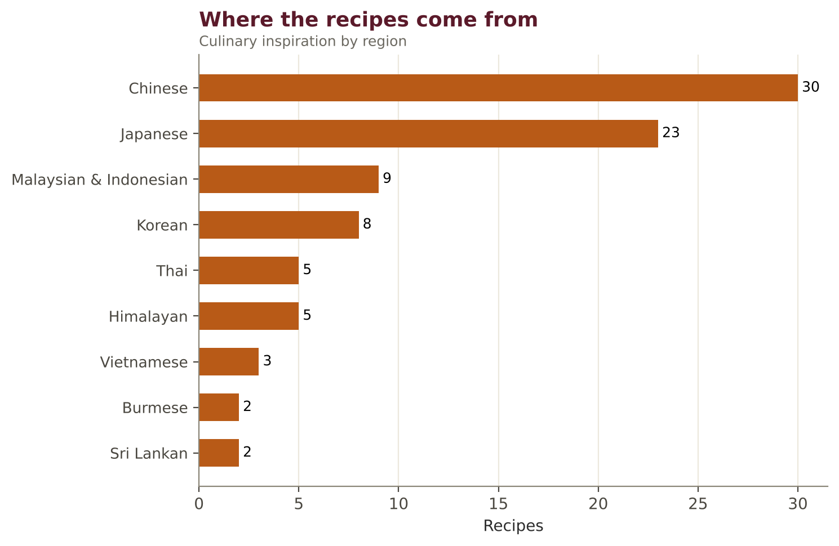
Figure. The culinary regions that inspired the recipes.
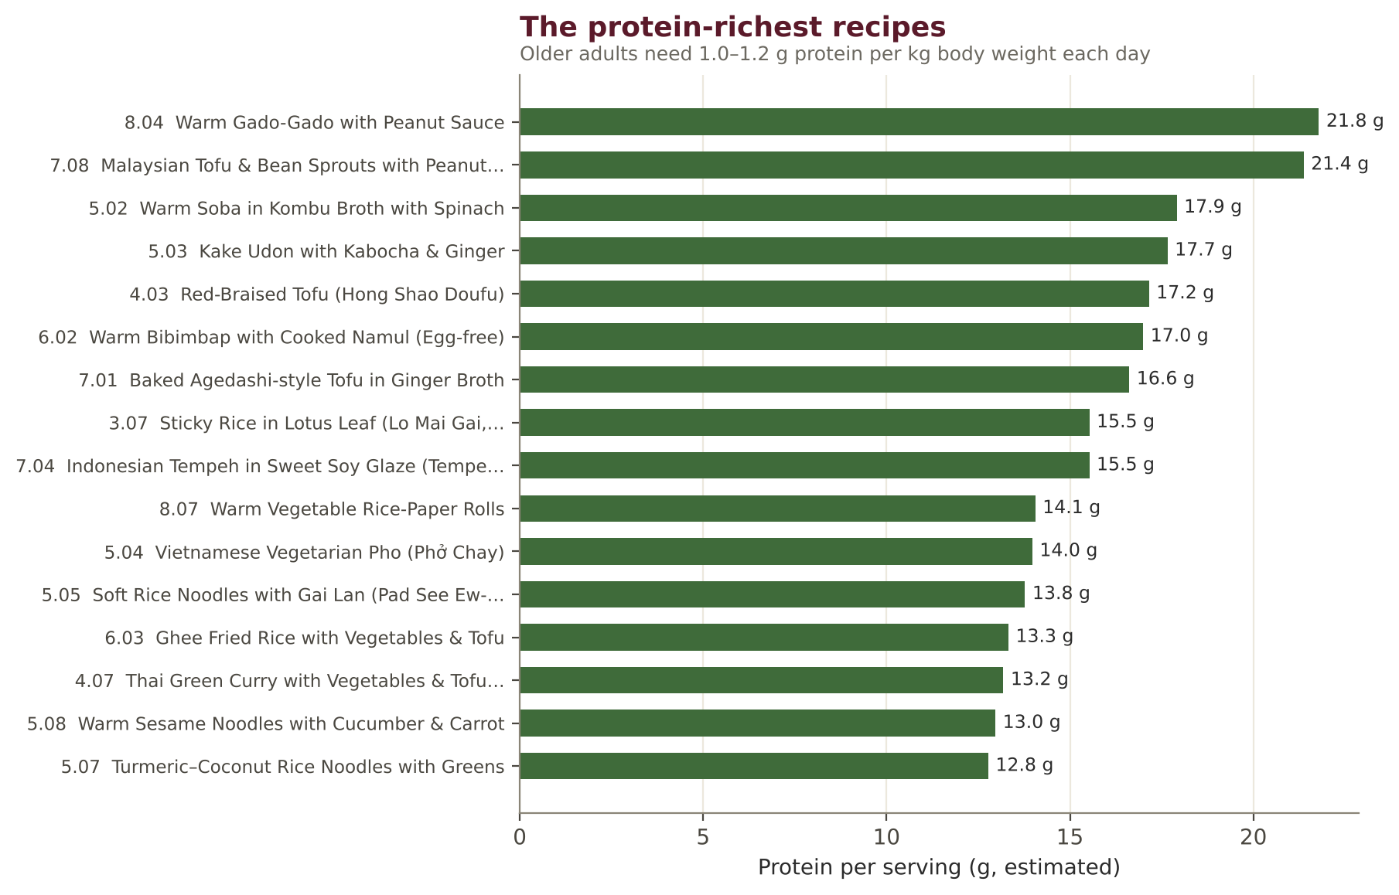
Figure. The recipes richest in protein per serving.
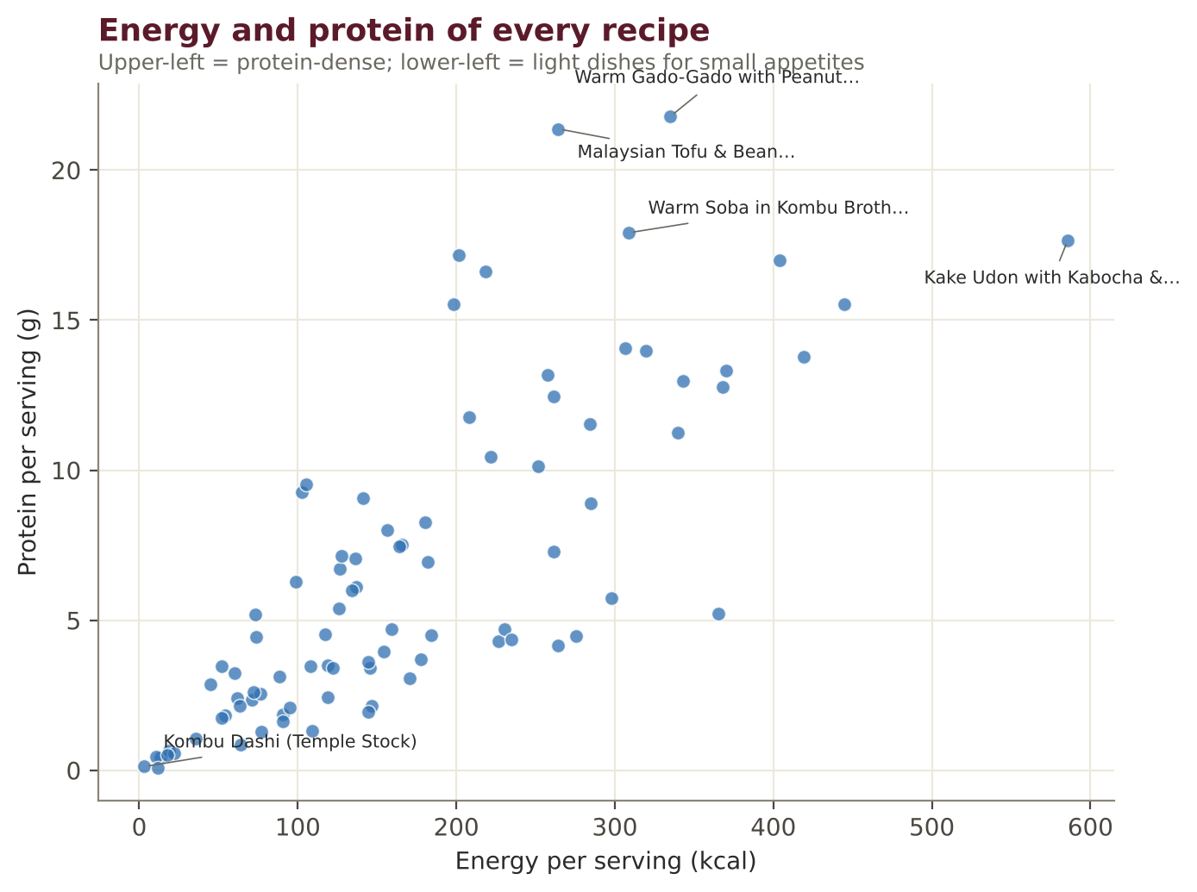
Figure. Energy and protein per serving across all 87 recipes.
PART II

Eastern Recipes
Eighty-seven dishes from the congee pot to the teapot, each rebuilt on Ayurvedic principles

1. Congees & Rice Porridges
Across East and Southeast Asia, the first food for the sick, the newborn and the elderly is rice cooked in many times its volume of water. China's zhou, Japan's okayu, Korea's juk, Vietnam's cháo, Malaysia's bubur and Sri Lanka's kenda are close cousins of Ayurveda's manda, peya and vilepi: the same gentle food, made in each kitchen's own way.
No. | Recipe | Region | Best season | kcal | Protein
1.01 | Plain Jook with Ginger & Sesame (Bai Zhou) | Chinese | All year | 119 | 2.4 g
1.02 | Okayu with Umeboshi-free Ginger & Shiso Herbs | Japanese | All year | 146 | 3.4 g
1.03 | Nanakusa-gayu (Seven-Herb Spring Rice Porridge) | Japanese | Late winter–spring | 145 | 3.6 g
1.04 | Korean Pumpkin Porridge (Hobakjuk) | Korean | Autumn–early winter | 159 | 4.7 g
1.05 | Mung Bean Congee (Lü Dou Zhou) | Chinese | Summer | 137 | 6.1 g
1.06 | Red Date & Goji Millet Porridge | Chinese | Autumn–early winter, Late winter–spring | 154 | 4.0 g
1.07 | Black Sesame Porridge (Heukimja-juk) | Korean | Autumn–early winter | 184 | 4.5 g
1.08 | Sweet Potato Congee (Fan Shu Zhou) | Chinese | Autumn–early winter | 178 | 3.7 g
1.09 | Vietnamese Ginger Rice Soup with Tofu (Cháo Đậu Hũ) | Vietnamese | All year | 208 | 11.8 g

1.01 Plain Jook with Ginger & Sesame (Bai Zhou)
CONGEE · CHINESE · Serves 4 · Portion: 1 bowl (≈350 g) · 1 h 15 min
Inspired by: Cantonese plain congee Texture: Smooth, spoonable Dosha: Tridoshic
Best season: All year
Ingredient | Household measure | Base qty | Café batch ×5
Rice, white basmati (raw) | ⅔ cup jasmine or short-grain | 120 g | 600 g
Water | 7½ cups (≈ 12:1) | 1,800 ml | 9,000 ml
Ginger, fresh | 5 thin matchsticks | 10 g | 50 g
Rock salt (sendha namak) | ⅓ tsp | 2 g | 10 g
Sesame (til) oil | 1 tsp toasted | 5 ml | 25 ml
Soy sauce / tamari (gluten-free) | 1 tsp light soy (to serve) | 5 ml | 25 ml
Coriander leaves | chopped | 5 g | 25 g
Method
1. Rinse rice; soak 30 minutes; drain. Optionally freeze overnight — frozen rice breaks down faster.
2. Bring water to a boil; add rice and half the ginger; return to a simmer.
3. Cook partly covered on the lowest heat 1 hour, stirring every 10 minutes, until the grains blossom into a silky porridge.
4. Season with salt; serve with remaining ginger, sesame oil, a few drops of soy and coriander.

Per serving (est.) | Energy  119 kcal | Protein  2.4 g | Fat  1.5 g | Carbs  24.0 g | Fibre  0.5 g | Salt  0.7 g

Care notes for 55+ guests  The classic recovery food; thin with hot water to any consistency. | Ayurvedic note  Equivalent to Ayurveda's peya — light, warm, easy for weak agni.
Ayurvedic adaptations: Pork floss / century egg → ginger, sesame and toasted peanuts
Variations & further ideas: Pumpkin jook · Sweet-potato jook · Spinach jook · Jook with silken tofu

1.02 Okayu with Umeboshi-free Ginger & Shiso Herbs
CONGEE · JAPANESE · Serves 4 · Portion: 1 bowl (≈300 g) · 50 min
Inspired by: Okayu (zen-gayu) Texture: Soft, grains visible Dosha: Pitta–Vata
Best season: All year
Ingredient | Household measure | Base qty | Café batch ×5
Rice, white basmati (raw) | ¾ cup Japanese short-grain | 150 g | 750 g
Water | 4⅓ cups (7:1, zen-gayu) | 1,050 ml | 5,250 ml
Rock salt (sendha namak) | ⅓ tsp | 2 g | 10 g
Ginger, fresh | grated | 8 g | 40 g
Sesame seeds (til) | 2 tsp toasted | 8 g | 40 g
Nori / laver (dried) | ½ sheet, shredded | 2 g | 10 g
Fresh herbs (rosemary, thyme, sage, basil, parsley, oregano, dill, tarragon) | shiso or mint | 3 g | 15 g
Method
1. Soak rinsed rice 30 minutes in the measured water.
2. Bring to a boil in a heavy pot; reduce to the lowest heat; cover with the lid ajar; cook 40 minutes without stirring.
3. Turn off the heat; rest 10 minutes; salt.
4. Top with ginger, sesame, nori and shiso.

Per serving (est.) | Energy  146 kcal | Protein  3.4 g | Fat  1.2 g | Carbs  30.3 g | Fibre  0.9 g | Salt  0.5 g

Care notes for 55+ guests  Japanese hospitals serve okayu in 5 grades from 5:1 to 20:1 — choose the thinness that suits swallowing. | Ayurvedic note  Vilepi-like when thicker; peya-like when thinner.
Ayurvedic adaptations: Umeboshi (very salty-sour) → grated ginger and a squeeze of lemon
Variations & further ideas: Kabocha okayu · Daikon-leaf okayu · Brown-rice okayu · Okayu with miso (pinch)

1.03 Nanakusa-gayu (Seven-Herb Spring Rice Porridge)
CONGEE · JAPANESE · Serves 4 · Portion: 1 bowl · 50 min
Inspired by: Jinjitsu festival porridge (7 January) Texture: Soft Dosha: Kapha–Pitta
Best season: Kapha season (late winter – spring)
Ingredient | Household measure | Base qty | Café batch ×5
Rice, white basmati (raw) | ¾ cup | 150 g | 750 g
Water | 5 cups | 1,200 ml | 6,000 ml
Radish (mooli) | small daikon with leaves, diced | 80 g | 400 g
Turnip (shalgam) | 1 small with greens | 80 g | 400 g
Spinach (palak) | young leaves | 50 g | 250 g
Fresh herbs (rosemary, thyme, sage, basil, parsley, oregano, dill, tarragon) | parsley, watercress, chickweed if available | 15 g | 75 g
Rock salt (sendha namak) | ½ tsp | 3 g | 15 g
Method
1. Cook rice in water as okayu (40 minutes).
2. Add diced daikon and turnip for the last 15 minutes.
3. Blanch greens 30 seconds; chop very finely; stir into the porridge off the heat.
4. Salt lightly.

Per serving (est.) | Energy  145 kcal | Protein  3.6 g | Fat  0.3 g | Carbs  31.9 g | Fibre  1.6 g | Salt  0.8 g

Care notes for 55+ guests  Traditionally eaten to rest the stomach after New Year feasting. | Ayurvedic note  Bitter spring greens and radish lighten Kapha after winter heaviness.
Ayurvedic adaptations: Hard-to-find wild herbs (seri, nazuna) → spinach, parsley, watercress, turnip and radish greens
Variations & further ideas: Green kanji with herbs (Vol. I) · Spring-greens khichdi · Seven-vegetable congee · Pea-shoot congee

1.04 Korean Pumpkin Porridge (Hobakjuk)
CONGEE · KOREAN · Serves 4 · Portion: 1 bowl (≈250 g) · 40 min
Inspired by: Hobakjuk Texture: Smooth Dosha: Vata–Pitta
Best season: Vata season (autumn – early winter)
Ingredient | Household measure | Base qty | Café batch ×5
Pumpkin (kaddu) | kabocha or red pumpkin, peeled | 600 g | 3,000 g
Water | 3 cups | 700 ml | 3,500 ml
Glutinous (sticky) rice | ⅓ cup glutinous rice flour | 50 g | 250 g
Adzuki beans (dry) | ¼ cup, cooked (optional) | 40 g | 200 g
Jaggery (gur) | 2 tbsp (or rice syrup) | 25 g | 125 g
Rock salt (sendha namak) | ⅓ tsp | 2 g | 10 g
Cinnamon | pinch | 0.3 g | 1.5 g
Pine nuts | 1 tbsp, to garnish | 10 g | 50 g
Method
1. Steam pumpkin 15 minutes until soft; blend with 500 ml water.
2. Simmer the purée; whisk glutinous rice flour into the remaining water; stir in.
3. Cook 8 minutes, stirring, until silky and thick; add cooked adzuki, jaggery and salt.
4. Serve warm with pine nuts and cinnamon.

Per serving (est.) | Energy  159 kcal | Protein  4.7 g | Fat  2.0 g | Carbs  32.5 g | Fibre  2.5 g | Salt  0.5 g

Care notes for 55+ guests  A Korean hospital and post-partum classic; smooth and sweet. | Ayurvedic note  Sweet, warm and heavy enough to ground Vata in autumn.
Ayurvedic adaptations: White sugar → jaggery or rice syrup
Variations & further ideas: Sweet-potato juk · Pumpkin–millet porridge · Pumpkin kheer (Vol. II) · Pumpkin congee with ginger

1.05 Mung Bean Congee (Lü Dou Zhou)
CONGEE · CHINESE · Serves 4 · Portion: 1 bowl · Soak 4 h · 1 h
Inspired by: Summer mung-bean porridge Texture: Soft Dosha: Pitta–Kapha
Best season: Pitta season (summer)
Ingredient | Household measure | Base qty | Café batch ×5
Moong, whole green | ½ cup whole mung, soaked | 80 g | 400 g
Rice, white basmati (raw) | ⅓ cup + 1 tbsp | 80 g | 400 g
Water | 6⅔ cups | 1,600 ml | 8,000 ml
Ginger, fresh | 3 slices | 5 g | 25 g
Rock salt (sendha namak) | ⅓ tsp (or 1 tbsp rock sugar for sweet) | 2 g | 10 g
Method
1. Simmer soaked mung beans 20 minutes until splitting.
2. Add rinsed rice and ginger; cook 40 minutes on low, stirring often.
3. Season with salt (savoury) or a little jaggery (sweet, the Chinese summer way).

Per serving (est.) | Energy  137 kcal | Protein  6.1 g | Fat  0.4 g | Carbs  25.4 g | Fibre  3.5 g | Salt  0.5 g

Care notes for 55+ guests  Excellent on hot days; mung is the most digestible bean. | Ayurvedic note  Mung is cooling and tridoshic; this is effectively a Chinese khichdi.
Ayurvedic adaptations: Rock sugar → a little jaggery or salt
Variations & further ideas: Moong kanji (Vol. I) · Mung–millet congee · Mung–pumpkin congee · Split-moong congee

1.06 Red Date & Goji Millet Porridge
CONGEE · CHINESE · Serves 4 · Portion: 1 bowl · 40 min
Inspired by: Xiaomi zhou (northern millet porridge) Texture: Soft Dosha: Vata–Kapha
Best season: Vata season (autumn – early winter) · Kapha season (late winter – spring)
Ingredient | Household measure | Base qty | Café batch ×5
Millet (whole) | ⅔ cup foxtail or proso millet | 120 g | 600 g
Water | 5 cups | 1,200 ml | 6,000 ml
Red dates / jujube (dried) | 6 dried red dates, pitted | 30 g | 150 g
Goji berries (dried) | 1 tbsp | 10 g | 50 g
Ginger, fresh | 3 slices | 5 g | 25 g
Jaggery (gur) | 2 tsp (optional) | 10 g | 50 g
Method
1. Dry-roast rinsed millet 3 minutes until fragrant.
2. Add water, jujubes and ginger; simmer 30 minutes, stirring often.
3. Add goji for the last 5 minutes; sweeten lightly if desired.

Per serving (est.) | Energy  154 kcal | Protein  4.0 g | Fat  1.4 g | Carbs  31.9 g | Fibre  3.4 g | Salt  0.0 g

Care notes for 55+ guests  Northern China's 'golden porridge' for elders and new mothers. | Ayurvedic note  Millet is light and warm (Kapha); dates and goji add sweetness and nourishment.
Ayurvedic adaptations: Instant oats → roasted millet
Variations & further ideas: Foxtail millet kanji (Vol. II) · Millet–pumpkin porridge · Millet with longan · Millet–mung congee

1.07 Black Sesame Porridge (Heukimja-juk)
CONGEE · KOREAN · Serves 4 · Portion: ≈200 g · Soak 2 h · 25 min
Inspired by: Heukimja-juk Texture: Smooth, velvety Dosha: Vata-pacifying
Best season: Vata season (autumn – early winter)
Ingredient | Household measure | Base qty | Café batch ×5
Rice, white basmati (raw) | ⅓ cup + 1 tbsp, soaked | 80 g | 400 g
Sesame seeds (til) | 6 tbsp black sesame, toasted | 60 g | 300 g
Water | 3¾ cups | 900 ml | 4,500 ml
Rock salt (sendha namak) | pinch | 1 g | 5 g
Honey | 1 tbsp (added warm, optional) | 15 g | 75 g
Pine nuts | 1 tbsp | 10 g | 50 g
Method
1. Grind soaked rice with 300 ml water to a fine slurry.
2. Grind toasted sesame with 300 ml water; strain through fine mesh.
3. Simmer sesame milk with the remaining water; whisk in the rice slurry; cook 12 minutes, stirring constantly.
4. Salt; cool to warm; add honey; garnish with pine nuts.

Per serving (est.) | Energy  184 kcal | Protein  4.5 g | Fat  9.3 g | Carbs  22.5 g | Fibre  2.1 g | Salt  0.3 g

Care notes for 55+ guests  A traditional Korean food for convalescence and older age. | Ayurvedic note  Sesame is the supreme Vata-pacifying seed; rice makes it gentle.
Ayurvedic adaptations: Sugar → honey added after cooling
Variations & further ideas: Pine-nut porridge (jatjuk) · Walnut porridge · Black sesame tang yuan soup · Sesame–rice milk

1.08 Sweet Potato Congee (Fan Shu Zhou)
CONGEE · CHINESE · Serves 4 · Portion: 1 bowl · 50 min
Inspired by: Taiwanese sweet-potato porridge Texture: Soft Dosha: Vata-pacifying
Best season: Vata season (autumn – early winter)
Ingredient | Household measure | Base qty | Café batch ×5
Rice, white basmati (raw) | ⅔ cup | 120 g | 600 g
Sweet potato (shakarkandi) | 1 large, cubed | 300 g | 1,500 g
Water | 6¼ cups | 1,500 ml | 7,500 ml
Ginger, fresh | 3 slices | 5 g | 25 g
Rock salt (sendha namak) | ⅓ tsp | 2 g | 10 g
Sesame seeds (til) | 1 tsp | 5 g | 25 g
Method
1. Bring water to a boil; add rice and ginger; simmer 25 minutes.
2. Add sweet potato; simmer 20 minutes more until it melts at the edges.
3. Salt; garnish with sesame.

Per serving (est.) | Energy  178 kcal | Protein  3.7 g | Fat  0.9 g | Carbs  38.9 g | Fibre  2.8 g | Salt  0.5 g

Care notes for 55+ guests  Sweet and satisfying; good for those with small appetites. | Ayurvedic note  Sweet potato's grounding sweetness balances Vata.
Ayurvedic adaptations: Pickled side dishes → a few drops of soy and sesame
Variations & further ideas: Taro congee · Pumpkin congee · Yam congee · Purple sweet potato congee

1.09 Vietnamese Ginger Rice Soup with Tofu (Cháo Đậu Hũ)
CONGEE · VIETNAMESE · Serves 4 · Portion: 1 bowl · 1 h
Inspired by: Cháo Texture: Soft Dosha: Vata–Kapha
Best season: All year
Ingredient | Household measure | Base qty | Café batch ×5
Rice, white basmati (raw) | ⅔ cup (toasted dry 3 min) | 120 g | 600 g
Vegetable stock (no onion–garlic, home-made) | 6⅔ cups (kombu or vegetable) | 1,600 ml | 8,000 ml
Ginger, fresh | 1 tbsp, julienned | 15 g | 75 g
Tofu, firm | firm, small cubes | 200 g | 1,000 g
Soy sauce / tamari (gluten-free) | 2 tsp | 10 ml | 50 ml
Fresh herbs (rosemary, thyme, sage, basil, parsley, oregano, dill, tarragon) | Thai basil, coriander | 10 g | 50 g
Lemon juice | lime wedges | 10 ml | 50 ml
Black pepper | ¼ tsp | 0.5 g | 2.5 g
Mung bean sprouts | blanched | 60 g | 300 g
Method
1. Toast dry rice in a pan until fragrant (the Vietnamese trick for flavour).
2. Simmer rice and half the ginger in stock 45 minutes.
3. Pan-sear tofu with soy; add to the porridge with blanched bean sprouts.
4. Serve with herbs, lime, pepper and remaining ginger.

Per serving (est.) | Energy  208 kcal | Protein  11.8 g | Fat  4.6 g | Carbs  30.9 g | Fibre  2.0 g | Salt  0.4 g

Care notes for 55+ guests  Blanched sprouts are tender; omit for soft diets. | Ayurvedic note  Toasted rice is lighter; ginger and pepper kindle agni.
Ayurvedic adaptations: Chicken and fried shallots → tofu, ginger and herbs
Variations & further ideas: Pumpkin cháo · Mung-bean cháo · Cháo with greens · Bubur sumsum (sweet Indonesian rice porridge)

2. Broths & Soups
In East Asia soup is drunk through the meal, not just at its start — and is usually a clear, light broth. The Buddhist temple kitchens of Japan, China and Korea perfected flavourful stocks without meat, onion or garlic, using kombu, ginger, daikon and dried vegetables: a gift to the sattvic cook.
No. | Recipe | Region | Best season | kcal | Protein
2.01 | Kombu Dashi (Temple Stock) | Japanese | All year | 3 | 0.1 g
2.02 | Miso Soup with Tofu & Wakame | Japanese | All year | 52 | 3.5 g
2.03 | Winter Melon Soup with Ginger (Dong Gua Tang) | Chinese | Summer | 71 | 2.3 g
2.04 | Lotus Root & Peanut Soup | Chinese | Autumn–early winter | 182 | 6.9 g
2.05 | Kenchin-jiru (Temple Root-Vegetable Soup) | Japanese | Autumn–early winter | 136 | 7.0 g
2.06 | Thai Coconut–Galangal Soup with Tofu (Tom Kha Tao Hu) | Thai | Autumn–early winter, All year | 222 | 10.5 g
2.07 | Korean Soybean-Paste Soup with Spinach (Sigeumchi Doenjang-guk) | Korean | Autumn–early winter, Late winter–spring | 103 | 9.3 g
2.08 | Sweet Corn & Silken Tofu Soup | Chinese | Summer, All year | 126 | 5.4 g
2.09 | Clear Daikon & Carrot Soup | Chinese | Late winter–spring | 54 | 1.8 g
2.10 | Mild Bhutanese Potato & Cheese Stew (Kewa Datshi, Gentle) | Himalayan | Autumn–early winter | 180 | 8.3 g

2.01 Kombu Dashi (Temple Stock)
SOUP · JAPANESE · Serves 8 · Portion: 250 ml · Soak 3 h or overnight · 10 min
Inspired by: Shōjin dashi Texture: Liquid Dosha: Pitta–Vata
Best season: All year
Ingredient | Household measure | Base qty | Café batch ×5
Kombu (dried kelp) | a 10×10 cm piece | 15 g | 75 g
Water | 8⅓ cups | 2,000 ml | 10,000 ml
Ginger, fresh | 2 slices (optional) | 5 g | 25 g
Method
1. Wipe kombu with a damp cloth (do not wash off the white powder — it is flavour).
2. Soak in cold water at least 3 hours, ideally overnight in the refrigerator.
3. Heat slowly; remove kombu just before the water boils (boiling makes it slimy and bitter).
4. Use as the base for miso soup, noodle broths and simmered dishes. Keeps 3 days refrigerated.

Per serving (est.) | Energy  3 kcal | Protein  0.1 g | Fat  0.0 g | Carbs  1.2 g | Fibre  0.6 g | Salt  0.0 g

Care notes for 55+ guests  Natural umami lets you use less salt in every dish. | Ayurvedic note  Light, salty-sweet and cooling; supplies minerals including iodine (use in moderation).
Ayurvedic adaptations: Bonito (fish) dashi → kombu dashi; mushroom-free (shiitake usually added)
Variations & further ideas: Kombu–daikon dashi · Kombu–dried-vegetable dashi · Roasted-soybean dashi · Ginger–corn-cob stock

2.02 Miso Soup with Tofu & Wakame
SOUP · JAPANESE · Serves 4 · Portion: 1 bowl (200 ml) · 10 min
Inspired by: Misoshiru Texture: Liquid with soft pieces Dosha: Vata–Pitta
Best season: All year
Ingredient | Household measure | Base qty | Café batch ×5
Vegetable stock (no onion–garlic, home-made) | 3⅓ cups kombu dashi | 800 ml | 4,000 ml
Miso (white or barley) | 2½ tbsp white or mixed miso | 40 g | 200 g
Tofu, silken | ½ block, cubed | 150 g | 750 g
Wakame (rehydrated) | 1 tbsp dried, soaked | 3 g | 15 g
Fresh herbs (rosemary, thyme, sage, basil, parsley, oregano, dill, tarragon) | mitsuba or coriander | 3 g | 15 g
Ginger, fresh | grated | 3 g | 15 g
Method
1. Heat dashi to a simmer; add tofu and wakame 2 minutes.
2. Turn heat to very low; dissolve miso in a ladle of broth and stir back in.
3. Do not boil after adding miso (preserves aroma and live cultures).
4. Garnish with herbs and a little ginger.

Per serving (est.) | Energy  52 kcal | Protein  3.5 g | Fat  1.6 g | Carbs  5.9 g | Fibre  0.6 g | Salt  1.2 g

Care notes for 55+ guests  ≈ 1.3 g salt per bowl — one bowl a day is plenty; use reduced-salt miso. | Ayurvedic note  Fermented, salty and warm; balancing for Vata; moderate for Pitta and Kapha.
Ayurvedic adaptations: Spring onion → mitsuba, coriander or ginger
Variations & further ideas: Miso with daikon · Miso with spinach · Miso with pumpkin · Red miso with tofu (winter)

2.03 Winter Melon Soup with Ginger (Dong Gua Tang)
SOUP · CHINESE · Serves 4 · Portion: 1 bowl · 40 min
Inspired by: Cantonese winter melon soup Texture: Very soft Dosha: Pitta-pacifying
Best season: Pitta season (summer)
Ingredient | Household measure | Base qty | Café batch ×5
Ash gourd (petha) | winter melon, peeled & cubed | 600 g | 3,000 g
Vegetable stock (no onion–garlic, home-made) | 4 cups | 1,000 ml | 5,000 ml
Ginger, fresh | 5 slices | 10 g | 50 g
Goji berries (dried) | 1 tbsp | 10 g | 50 g
Sweet corn kernels | ⅔ cup kernels | 100 g | 500 g
Rock salt (sendha namak) | ½ tsp | 3 g | 15 g
Sesame (til) oil | few drops | 3 ml | 15 ml
Coriander leaves | chopped | 5 g | 25 g
Method
1. Simmer winter melon, ginger and corn in stock 25 minutes until translucent.
2. Add goji for 5 minutes; season.
3. Finish with sesame oil and coriander.

Per serving (est.) | Energy  71 kcal | Protein  2.3 g | Fat  1.4 g | Carbs  14.2 g | Fibre  5.4 g | Salt  0.8 g

Care notes for 55+ guests  Melts in the mouth; very hydrating. | Ayurvedic note  Winter melon (ash gourd, kushmanda) is prized in both Ayurveda and Chinese medicine for cooling.
Ayurvedic adaptations: Dried scallop and pork → corn and goji
Variations & further ideas: Ash gourd soup (Vol. II) · Bottle-gourd soup · Winter melon with tofu · Winter melon with barley

2.04 Lotus Root & Peanut Soup
SOUP · CHINESE · Serves 6 · Portion: 1 bowl · Soak 3 h · 2 h
Inspired by: Lin ngau tong Texture: Soft Dosha: Vata–Pitta
Best season: Vata season (autumn – early winter)
Ingredient | Household measure | Base qty | Café batch ×5
Lotus root | 2 sections, sliced | 500 g | 2,500 g
Peanuts | ⅔ cup raw, soaked | 100 g | 500 g
Red dates / jujube (dried) | 6 red dates | 30 g | 150 g
Carrot | 1 | 150 g | 750 g
Ginger, fresh | 4 slices | 10 g | 50 g
Water | 8⅓ cups | 2,000 ml | 10,000 ml
Rock salt (sendha namak) | ¾ tsp | 4 g | 20 g
Method
1. Combine all except salt; bring to a boil; skim.
2. Simmer covered on low 1½–2 hours until peanuts are soft and the broth faintly pink.
3. Season.

Per serving (est.) | Energy  182 kcal | Protein  6.9 g | Fat  8.4 g | Carbs  23.2 g | Fibre  6.5 g | Salt  0.7 g

Care notes for 55+ guests  Long simmering makes peanuts tender; serve broth to those who cannot chew. | Ayurvedic note  Lotus root is cooling and nourishing; peanuts add warmth and fat.
Ayurvedic adaptations: Pork ribs → peanuts and red dates
Variations & further ideas: Lotus root & adzuki soup · Lotus & carrot soup · Peanut–corn soup · Lotus soup with goji

2.05 Kenchin-jiru (Temple Root-Vegetable Soup)
SOUP · JAPANESE · Serves 6 · Portion: 1 bowl · 40 min
Inspired by: Kenchō-ji temple soup, Kamakura Texture: Soft Dosha: Vata–Kapha
Best season: Vata season (autumn – early winter)
Ingredient | Household measure | Base qty | Café batch ×5
Tofu, firm | firm, crumbled by hand | 200 g | 1,000 g
Radish (mooli) | daikon, quarter-moons | 200 g | 1,000 g
Carrot | 1, half-moons | 150 g | 750 g
Burdock root (gobo) | gobo, shaved | 80 g | 400 g
Colocasia (arbi) | taro, cubed | 150 g | 750 g
Sesame (til) oil | 1 tbsp | 15 ml | 75 ml
Vegetable stock (no onion–garlic, home-made) | 5 cups kombu dashi | 1,200 ml | 6,000 ml
Soy sauce / tamari (gluten-free) | 1½ tbsp | 25 ml | 125 ml
Ginger, fresh | grated | 5 g | 25 g
Rock salt (sendha namak) | pinch | 1 g | 5 g
Method
1. Sauté vegetables in sesame oil 4 minutes (the temple technique that gives depth).
2. Add crumbled tofu; sauté 2 minutes.
3. Add dashi; simmer 20 minutes until all is tender.
4. Season with soy and ginger.

Per serving (est.) | Energy  136 kcal | Protein  7.0 g | Fat  5.6 g | Carbs  15.6 g | Fibre  3.5 g | Salt  0.8 g

Care notes for 55+ guests  Hearty and soft; cut vegetables thin. | Ayurvedic note  Root vegetables sautéed in oil then simmered — perfect for Vata season.
Ayurvedic adaptations: Konnyaku and shiitake (often used) → taro and burdock
Variations & further ideas: Miso kenchin · Kenchin udon · Root-vegetable miso soup · Kenchin with pumpkin

2.06 Thai Coconut–Galangal Soup with Tofu (Tom Kha Tao Hu)
SOUP · THAI · Serves 4 · Portion: 1 bowl · 30 min
Inspired by: Tom kha Texture: Liquid with soft pieces Dosha: Vata-pacifying
Best season: Vata season (autumn – early winter) · All year
Ingredient | Household measure | Base qty | Café batch ×5
Coconut milk, thin | 1⅔ cups | 400 ml | 2,000 ml
Vegetable stock (no onion–garlic, home-made) | 2 cups | 500 ml | 2,500 ml
Galangal (fresh) | 8 thin slices | 20 g | 100 g
Lemongrass | 2 stalks, bruised | 20 g | 100 g
Kaffir lime leaves / pandan leaf | 4 leaves, torn | 2 g | 10 g
Tofu, firm | firm, cubed | 200 g | 1,000 g
Zucchini / tori | or baby corn | 150 g | 750 g
Tomato | 1 small (optional) | 80 g | 400 g
Soy sauce / tamari (gluten-free) | 1 tbsp | 15 ml | 75 ml
Jaggery (gur) | 1 tsp | 5 g | 25 g
Lemon juice | 4 tsp lime juice | 20 ml | 100 ml
Coriander leaves | chopped | 5 g | 25 g
Green chilli (optional, deseeded) | ½, slit (optional) | 2 g | 10 g
Method
1. Simmer stock with galangal, lemongrass and lime leaves 10 minutes.
2. Add coconut milk, tofu and vegetables; simmer 8 minutes (do not boil hard).
3. Season with soy, jaggery and lime off heat.
4. Garnish with coriander. Galangal and lemongrass pieces are not eaten.

Per serving (est.) | Energy  222 kcal | Protein  10.5 g | Fat  16.6 g | Carbs  10.2 g | Fibre  2.6 g | Salt  0.5 g

Care notes for 55+ guests  Remove the woody aromatics before serving to frail guests. | Ayurvedic note  Coconut cools; galangal and lemongrass warm and aid digestion — balanced.
Ayurvedic adaptations: Fish sauce → soy sauce + pinch of jaggery · Mushrooms → zucchini or baby corn
Variations & further ideas: Tom kha with pumpkin · Coconut–lemongrass rasam · Clear tom yum (mild) · Coconut–ginger soup with rice

2.07 Korean Soybean-Paste Soup with Spinach (Sigeumchi Doenjang-guk)
SOUP · KOREAN · Serves 4 · Portion: 1 bowl · 20 min
Inspired by: Doenjang-guk Texture: Soft Dosha: Vata–Kapha
Best season: Vata season (autumn – early winter) · Kapha season (late winter – spring)
Ingredient | Household measure | Base qty | Café batch ×5
Vegetable stock (no onion–garlic, home-made) | 4 cups kombu stock | 1,000 ml | 5,000 ml
Miso (white or barley) | 2½ tbsp doenjang or brown miso | 40 g | 200 g
Spinach (palak) | 1 bunch, cut | 200 g | 1,000 g
Tofu, firm | cubed | 150 g | 750 g
Radish (mooli) | thin squares | 100 g | 500 g
Ginger, fresh | grated | 3 g | 15 g
Kashmiri chilli powder (mild) | pinch mild gochugaru (optional) | 0.3 g | 1.5 g
Method
1. Simmer radish in stock 8 minutes.
2. Dissolve doenjang in broth; add tofu; simmer 3 minutes.
3. Add spinach; cook 1 minute; season with ginger.

Per serving (est.) | Energy  103 kcal | Protein  9.3 g | Fat  4.1 g | Carbs  9.0 g | Fibre  2.9 g | Salt  1.2 g

Care notes for 55+ guests  ≈ 1.2 g salt per bowl; dilute with more stock if needed. | Ayurvedic note  Warming fermented bean paste with leafy greens — good in cold weather.
Ayurvedic adaptations: Anchovy stock → kombu stock · Garlic and green onion → ginger
Variations & further ideas: Doenjang with zucchini · Doenjang with cabbage · Bean-sprout soup (kongnamul-guk) · Seaweed soup (miyeok-guk)

2.08 Sweet Corn & Silken Tofu Soup
SOUP · CHINESE · Serves 4 · Portion: 1 bowl · 20 min
Inspired by: Sweet-corn egg-drop soup (egg-free) Texture: Smooth, thick Dosha: Vata–Pitta
Best season: Pitta season (summer) · All year
Ingredient | Household measure | Base qty | Café batch ×5
Sweet corn kernels | 2 cups (half blended) | 300 g | 1,500 g
Vegetable stock (no onion–garlic, home-made) | 3¾ cups | 900 ml | 4,500 ml
Tofu, silken | ⅔ block, mashed | 200 g | 1,000 g
Ginger, fresh | 1 tsp grated | 5 g | 25 g
Cornflour (cornstarch) | 1½ tbsp, slaked in 3 tbsp water | 15 g | 75 g
Rock salt (sendha namak) | ½ tsp | 3 g | 15 g
Black pepper | white pepper | 0.5 g | 2.5 g
Sesame (til) oil | few drops | 3 ml | 15 ml
Coriander leaves | chopped | 5 g | 25 g
Method
1. Simmer corn (half blended) and ginger in stock 10 minutes.
2. Stir in slaked starch; cook until glossy.
3. Stir in mashed silken tofu in ribbons (replacing egg).
4. Season; finish with sesame oil, pepper and coriander.

Per serving (est.) | Energy  126 kcal | Protein  5.4 g | Fat  3.2 g | Carbs  21.7 g | Fibre  2.2 g | Salt  0.8 g

Care notes for 55+ guests  Thickened soups are easier for those with mild swallowing difficulty. | Ayurvedic note  Sweet corn and tofu soothe Pitta; ginger keeps it digestible.
Ayurvedic adaptations: Egg ribbons → silken tofu
Variations & further ideas: Corn–pumpkin soup · Corn–spinach soup · Hot-and-sour soup (mild, mushroom-free) · Corn chowder (Vol. IV)

2.09 Clear Daikon & Carrot Soup
SOUP · CHINESE · Serves 4 · Portion: 1 bowl · 35 min
Inspired by: Lo bak tong Texture: Soft Dosha: Kapha-pacifying
Best season: Kapha season (late winter – spring)
Ingredient | Household measure | Base qty | Café batch ×5
Radish (mooli) | daikon, chunks | 400 g | 2,000 g
Carrot | 2 | 200 g | 1,000 g
Vegetable stock (no onion–garlic, home-made) | 5 cups | 1,200 ml | 6,000 ml
Ginger, fresh | 5 slices | 10 g | 50 g
Black pepper | ¼ tsp white | 0.5 g | 2.5 g
Rock salt (sendha namak) | ½ tsp | 3 g | 15 g
Coriander leaves | chopped | 5 g | 25 g
Method
1. Simmer daikon, carrot and ginger in stock 25 minutes until daikon is translucent.
2. Season with pepper and salt; garnish.

Per serving (est.) | Energy  54 kcal | Protein  1.8 g | Fat  0.2 g | Carbs  11.8 g | Fibre  3.1 g | Salt  0.8 g

Care notes for 55+ guests  Long-cooked daikon is soft and sweet. | Ayurvedic note  Cooked radish is light and pungent — Kapha-clearing; carrot balances.
Ayurvedic adaptations: Pork bones → kombu stock and ginger
Variations & further ideas: Daikon with tofu · Daikon miso soup · Radish–moong soup · Turnip soup

2.10 Mild Bhutanese Potato & Cheese Stew (Kewa Datshi, Gentle)
SOUP · HIMALAYAN · Serves 4 · Portion: ≈200 g · 30 min
Inspired by: Kewa datshi Texture: Soft, creamy Dosha: Vata-pacifying
Best season: Vata season (autumn – early winter)
Ingredient | Household measure | Base qty | Café batch ×5
Potato | 3, sliced | 400 g | 2,000 g
Water | 1⅔ cups | 400 ml | 2,000 ml
Ghee (cow) | 2 tsp | 10 g | 50 g
Tomato | 1 small | 80 g | 400 g
Capsicum | mild green pepper | 80 g | 400 g
Green chilli (optional, deseeded) | 1, slit (optional, traditional is many) | 3 g | 15 g
Paneer (cow's milk) | crumbled | 80 g | 400 g
Cottage cheese | ⅓ cup (in place of datshi cheese) | 80 g | 400 g
Rock salt (sendha namak) | ½ tsp | 3 g | 15 g
Coriander leaves | chopped | 5 g | 25 g
Method
1. Simmer potato, ghee, tomato, capsicum and chilli in water 15 minutes.
2. Add crumbled paneer and cottage cheese; stir gently until a creamy sauce forms (5 minutes).
3. Season; garnish with coriander; serve with red rice.

Per serving (est.) | Energy  180 kcal | Protein  8.3 g | Fat  7.7 g | Carbs  19.7 g | Fibre  2.8 g | Salt  1.0 g

Care notes for 55+ guests  A very mild version of Bhutan's national stew; remove chilli before serving. | Ayurvedic note  The original is very hot; this gentle version keeps the creamy comfort for Vata.
Ayurvedic adaptations: Onion, garlic and many chillies → mild pepper and one optional chilli
Variations & further ideas: Ema datshi (mild with peppers) · Spinach datshi · Pumpkin datshi · Bean datshi

3. Dumplings, Buns & Steamed Dishes
Steaming is the most widely used cooking method in East Asia and one of the gentlest anywhere: food stays moist, needs little oil, and turns out soft. Dumplings, buns and steamed tofu are also ideal for sharing at a table.
No. | Recipe | Region | Best season | kcal | Protein
3.01 | Cabbage, Tofu & Ginger Jiaozi | Chinese | All year | 261 | 12.5 g
3.02 | Himalayan Vegetable Momos with Paneer | Himalayan | Autumn–early winter, All year | 284 | 11.5 g
3.03 | Steamed Milk Buns (Mantou) | Chinese | All year | 108 | 3.5 g
3.04 | Steamed Silken Tofu with Ginger–Soy Dressing | Chinese | All year | 73 | 5.2 g
3.05 | Steamed Tofu Custard (Egg-free Chawanmushi) | Japanese | All year | 99 | 6.3 g
3.06 | Steamed Kabocha with Black Sesame | Japanese | Autumn–early winter | 77 | 2.6 g
3.07 | Sticky Rice in Lotus Leaf (Lo Mai Gai, Vegetarian) | Chinese | Autumn–early winter | 445 | 15.5 g
3.08 | Steamed Rice-Noodle Rolls (Cheung Fun) with Sweet Soy | Chinese | All year | 171 | 3.1 g

3.01 Cabbage, Tofu & Ginger Jiaozi
STEAMED · CHINESE · Serves 6 · Portion: 8 dumplings · 1 h 15 min
Inspired by: Northern Chinese jiaozi Texture: Soft Dosha: Vata–Pitta
Best season: All year
Ingredient | Household measure | Base qty | Café batch ×5
Whole-wheat flour (atta) | 2½ cups (or maida/all-purpose) | 300 g | 1,500 g
Water | ⅔ cup warm | 160 ml | 800 ml
Napa / Chinese cabbage | Chinese cabbage, finely chopped, salted & squeezed | 400 g | 2,000 g
Tofu, firm | firm, crumbled | 200 g | 1,000 g
Carrot | finely grated | 100 g | 500 g
Ginger, fresh | 1 tbsp grated | 15 g | 75 g
Sesame (til) oil | 1 tbsp | 15 ml | 75 ml
Soy sauce / tamari (gluten-free) | 1 tbsp | 15 ml | 75 ml
Rock salt (sendha namak) | ½ tsp | 3 g | 15 g
Black pepper | white pepper | 0.5 g | 2.5 g
Method
1. Mix flour and warm water to a soft dough; rest 30 minutes covered.
2. Salt cabbage 10 minutes; squeeze dry. Mix with tofu, carrot, ginger, sesame oil, soy and pepper.
3. Roll 48 small thin rounds; fill; pleat closed.
4. Boil in batches until they float plus 2 minutes, or steam 10 minutes. Serve with ginger–soy dip (E9).

Per serving (est.) | Energy  261 kcal | Protein  12.5 g | Fat  6.5 g | Carbs  37.3 g | Fibre  7.6 g | Salt  0.9 g

Care notes for 55+ guests  Boiled jiaozi are softest; cut in half for small bites. | Ayurvedic note  Steamed, moist wheat with a warm-spiced vegetable filling.
Ayurvedic adaptations: Pork and chives → tofu, cabbage and ginger
Variations & further ideas: Spinach–tofu jiaozi · Pumpkin jiaozi · Pan-fried guotie (potstickers) · Jiaozi in broth

3.02 Himalayan Vegetable Momos with Paneer
STEAMED · HIMALAYAN · Serves 6 · Portion: 8 momos · 1 h 15 min
Inspired by: Tibetan/Nepali momo Texture: Soft Dosha: Vata–Pitta
Best season: Vata season (autumn – early winter) · All year
Ingredient | Household measure | Base qty | Café batch ×5
Whole-wheat flour (atta) | 2½ cups | 300 g | 1,500 g
Water | ⅔ cup | 160 ml | 800 ml
Cabbage | finely shredded | 300 g | 1,500 g
Carrot | grated | 150 g | 750 g
Paneer (cow's milk) | crumbled | 150 g | 750 g
Ginger, fresh | 1 tbsp | 15 g | 75 g
Coriander leaves | chopped | 10 g | 50 g
Ghee (cow) | 1 tbsp | 15 g | 75 g
Turmeric powder | pinch | 0.3 g | 1.5 g
Rock salt (sendha namak) | ¾ tsp | 4 g | 20 g
Black pepper | ¼ tsp | 0.5 g | 2.5 g
Method
1. Make a soft dough; rest 30 minutes.
2. Sauté cabbage and carrot in ghee 3 minutes; cool; mix with paneer, ginger, coriander, turmeric, salt and pepper.
3. Roll small thin rounds; fill and pleat.
4. Steam on oiled racks 12 minutes. Serve with Nepali tomato–sesame achar (E9) or ginger–soy dip.

Per serving (est.) | Energy  284 kcal | Protein  11.5 g | Fat  8.7 g | Carbs  38.2 g | Fibre  7.6 g | Salt  0.7 g

Care notes for 55+ guests  Soft steamed momos; mild filling. | Ayurvedic note  A Himalayan favourite; steaming keeps it light, paneer adds protein.
Ayurvedic adaptations: Yak/buff meat and onion → paneer, cabbage and ginger
Variations & further ideas: Spinach–paneer momos · Jhol momo (in soup) · Sweet khuwa momos · Buckwheat momos

3.03 Steamed Milk Buns (Mantou)
STEAMED · CHINESE · Serves 12 · Portion: 1 bun · 2 h (incl. rising)
Inspired by: Mantou Texture: Fluffy, soft Dosha: Vata–Pitta (Kapha: occasional)
Best season: All year
Ingredient | Household measure | Base qty | Café batch ×5
Whole-wheat flour (atta) | 2½ cups (half all-purpose for softness) | 300 g | 1,500 g
Cow's milk, whole | ⅔ cup + 1 tbsp warm | 170 ml | 850 ml
Baking powder / bicarbonate | 1 tsp instant yeast + ½ tsp baking powder | 5 g | 25 g
Jaggery (gur) | 1½ tbsp | 20 g | 100 g
Ghee (cow) | 2 tsp | 10 g | 50 g
Rock salt (sendha namak) | pinch | 1 g | 5 g
Method
1. Mix all to a smooth dough; knead 8 minutes; rise 1 hour.
2. Knock back; roll into a log; cut 12 pieces.
3. Rest on paper squares 20 minutes.
4. Steam 15 minutes; turn off the heat and wait 5 minutes before lifting the lid (prevents collapse).

Per serving (est.) | Energy  108 kcal | Protein  3.5 g | Fat  1.8 g | Carbs  18.4 g | Fibre  2.8 g | Salt  0.1 g

Care notes for 55+ guests  Very soft bread; good with soups. | Ayurvedic note  Steamed yeast bread is lighter than baked; eat fresh and warm.
Ayurvedic adaptations: White sugar → jaggery; lard → ghee
Variations & further ideas: Pumpkin mantou · Whole-wheat mantou · Flower rolls (huajuan) · Red-bean bao (E10)

3.04 Steamed Silken Tofu with Ginger–Soy Dressing
STEAMED · CHINESE · Serves 4 · Portion: ¼ block + sauce · 15 min
Inspired by: Cantonese steamed tofu Texture: Very soft Dosha: Pitta–Vata
Best season: All year
Ingredient | Household measure | Base qty | Café batch ×5
Tofu, silken | 1 block | 400 g | 2,000 g
Ginger, fresh | 1 tbsp, fine julienne | 15 g | 75 g
Soy sauce / tamari (gluten-free) | 1 tbsp light | 15 ml | 75 ml
Water | 1 tbsp | 15 ml | 75 ml
Sesame (til) oil | 1 tsp | 5 ml | 25 ml
Jaggery (gur) | ½ tsp | 2 g | 10 g
Coriander leaves | leaves | 5 g | 25 g
Method
1. Slide tofu onto a plate; steam 8 minutes.
2. Drain water from the plate.
3. Mix soy, water and jaggery; pour over; top with ginger and coriander.
4. Heat sesame oil until hot and pour over the ginger to release its aroma.

Per serving (est.) | Energy  73 kcal | Protein  5.2 g | Fat  4.0 g | Carbs  4.3 g | Fibre  0.2 g | Salt  0.5 g

Care notes for 55+ guests  Spoon-soft, protein-rich (≈ 6 g per serving). | Ayurvedic note  Cooling tofu warmed by ginger — tofu made Vata-friendly.
Ayurvedic adaptations: Spring onion → coriander and ginger
Variations & further ideas: Steamed tofu with spinach · Steamed tofu with sesame sauce · Silken tofu with soy-ginger (cold, summer only) · Tofu custard

3.05 Steamed Tofu Custard (Egg-free Chawanmushi)
STEAMED · JAPANESE · Serves 4 · Portion: 1 cup · 30 min
Inspired by: Chawanmushi Texture: Silky Dosha: Pitta–Vata
Best season: All year
Ingredient | Household measure | Base qty | Café batch ×5
Tofu, silken | 1 block | 300 g | 1,500 g
Soy milk (unsweetened) | ¾ cup + 1 tbsp unsweetened | 200 ml | 1,000 ml
Vegetable stock (no onion–garlic, home-made) | ⅓ cup + 1 tbsp kombu dashi | 100 ml | 500 ml
Cornflour (cornstarch) | 1 tbsp | 10 g | 50 g
Rock salt (sendha namak) | ⅓ tsp | 2 g | 10 g
Soy sauce / tamari (gluten-free) | 1 tsp | 5 ml | 25 ml
Green peas, fresh | ¼ cup | 40 g | 200 g
Carrot | tiny flowers | 40 g | 200 g
Chinese yam / nagaimo | or lotus, small dice | 40 g | 200 g
Fresh herbs (rosemary, thyme, sage, basil, parsley, oregano, dill, tarragon) | mitsuba | 2 g | 10 g
Method
1. Blend silken tofu, soy milk, dashi, starch, salt and soy until perfectly smooth; sieve.
2. Divide vegetables among 4 cups; pour custard over; cover with foil.
3. Steam on gentle heat 15 minutes until just set and wobbly.
4. Garnish with mitsuba.

Per serving (est.) | Energy  99 kcal | Protein  6.3 g | Fat  3.0 g | Carbs  11.6 g | Fibre  1.3 g | Salt  0.7 g

Care notes for 55+ guests  A perfect soft-diet protein; serve warm. | Ayurvedic note  Steamed, smooth and nourishing; ginger juice can be added for Kapha.
Ayurvedic adaptations: Eggs and fish dashi → silken tofu, soy milk and kombu dashi
Variations & further ideas: Pumpkin chawanmushi · Corn chawanmushi · Sesame tofu custard · Savoury paneer custard

3.06 Steamed Kabocha with Black Sesame
STEAMED · JAPANESE · Serves 4 · Portion: ≈150 g · 20 min
Inspired by: Kabocha no gomaae Texture: Soft Dosha: Vata–Pitta
Best season: Vata season (autumn – early winter)
Ingredient | Household measure | Base qty | Café batch ×5
Pumpkin (kaddu) | kabocha, skin on, wedges | 600 g | 3,000 g
Sesame seeds (til) | 2 tbsp black sesame, toasted & ground | 20 g | 100 g
Soy sauce / tamari (gluten-free) | 1½ tsp | 8 ml | 40 ml
Brown-rice syrup / rice malt | 2 tsp (or maple) | 10 g | 50 g
Rock salt (sendha namak) | pinch | 1 g | 5 g
Method
1. Steam pumpkin 12–15 minutes until tender.
2. Mix ground sesame, soy and rice syrup to a paste.
3. Spoon over warm pumpkin.

Per serving (est.) | Energy  77 kcal | Protein  2.6 g | Fat  2.6 g | Carbs  13.0 g | Fibre  1.4 g | Salt  0.5 g

Care notes for 55+ guests  Kabocha skin softens when steamed; peel for soft diets. | Ayurvedic note  Sweet pumpkin with sesame — very nourishing for Vata.
Variations & further ideas: Steamed sweet potato · Steamed taro with sesame · Pumpkin nimono · Pumpkin salad (warm)

3.07 Sticky Rice in Lotus Leaf (Lo Mai Gai, Vegetarian)
STEAMED · CHINESE · Serves 4 · Portion: 1 parcel · Soak 4 h · 1 h
Inspired by: Dim-sum lo mai gai Texture: Soft, sticky Dosha: Vata-pacifying (heavy)
Best season: Vata season (autumn – early winter)
Ingredient | Household measure | Base qty | Café batch ×5
Glutinous (sticky) rice | 1½ cups, soaked 4 h | 300 g | 1,500 g
Peanuts | ⅓ cup, boiled soft | 50 g | 250 g
Tofu, firm | pressed, diced | 120 g | 600 g
Carrot | diced | 80 g | 400 g
Edamame (shelled) | shelled | 60 g | 300 g
Soy sauce / tamari (gluten-free) | 1 tbsp + 1 tsp | 20 ml | 100 ml
Sesame (til) oil | 2 tsp | 10 ml | 50 ml
Ginger, fresh | 2 tsp | 8 g | 40 g
Star anise / Sichuan pepper / five-spice | ½ star anise, ground | 0.3 g | 1.5 g
Fresh herbs (rosemary, thyme, sage, basil, parsley, oregano, dill, tarragon) | 4 dried lotus leaves (or banana leaves) | 4 g | 20 g
Method
1. Steam soaked rice 25 minutes; season with half the soy and sesame oil.
2. Sauté tofu, carrot, edamame, peanuts and ginger with remaining soy and star anise.
3. Soften lotus leaves in hot water; layer rice, filling, rice; fold into parcels.
4. Steam 25 minutes.

Per serving (est.) | Energy  445 kcal | Protein  15.5 g | Fat  12.6 g | Carbs  67.6 g | Fibre  5.3 g | Salt  0.7 g

Care notes for 55+ guests  Glutinous rice is sticky — take small bites; not for dysphagia. | Ayurvedic note  Heavy and sweet — a lunchtime festival dish for Vata; small portions for Kapha.
Ayurvedic adaptations: Chicken, sausage and shiitake → tofu, peanuts and edamame
Variations & further ideas: Zongzi (Dragon Boat dumplings) · Sticky rice with pumpkin · Banana-leaf rice (Southeast Asian) · Savoury glutinous rice bowl

3.08 Steamed Rice-Noodle Rolls (Cheung Fun) with Sweet Soy
STEAMED · CHINESE · Serves 4 · Portion: 3 rolls · 40 min
Inspired by: Cheung fun Texture: Very soft, silky Dosha: Pitta–Vata
Best season: All year
Ingredient | Household measure | Base qty | Café batch ×5
Rice flour | 1 cup | 120 g | 600 g
Cornflour (cornstarch) | 2 tbsp | 20 g | 100 g
Water | 1⅔ cups | 400 ml | 2,000 ml
Sesame (til) oil | 2 tsp | 10 ml | 50 ml
Rock salt (sendha namak) | pinch | 1 g | 5 g
Spinach (palak) | blanched, chopped (filling) | 100 g | 500 g
Soy sauce / tamari (gluten-free) | 1 tbsp | 15 ml | 75 ml
Jaggery (gur) | 1 tsp | 5 g | 25 g
Sesame seeds (til) | 1 tsp | 5 g | 25 g
Method
1. Whisk flours, water, salt and half the oil to a thin batter; rest 20 minutes.
2. Oil a flat tray; pour a thin layer; scatter spinach; steam 3 minutes until translucent.
3. Roll up with a scraper; repeat.
4. Warm soy with jaggery and a splash of water; pour over; sprinkle sesame.

Per serving (est.) | Energy  171 kcal | Protein  3.1 g | Fat  3.7 g | Carbs  31.1 g | Fibre  1.5 g | Salt  0.8 g

Care notes for 55+ guests  One of the softest dim-sum foods — barely needs chewing. | Ayurvedic note  Rice is light and cooling; steaming keeps it gentle.
Ayurvedic adaptations: Shrimp/char siu → spinach or plain
Variations & further ideas: Plain cheung fun with peanut–sesame sauce · Cheung fun with tofu · Pumpkin cheung fun · Rice-noodle rolls in broth

4. Stir-fries, Braises & Curries
The wok cooks quickly over high heat with little oil — perfect for keeping vegetables bright. For older digestion, stir-fry a little longer, add a splash of stock and cover for a minute (the Chinese 'stir-fry–braise'), and cut everything small.
No. | Recipe | Region | Best season | kcal | Protein
4.01 | Bok Choy with Ginger & Sesame | Chinese | All year | 62 | 2.4 g
4.02 | Buddha's Delight (Lo Han Jai, Mushroom-free) | Chinese | All year | 157 | 8.0 g
4.03 | Red-Braised Tofu (Hong Shao Doufu) | Chinese | Autumn–early winter | 202 | 17.2 g
4.04 | Mild Sattvic Mapo Tofu | Chinese | Autumn–early winter, Late winter–spring | 127 | 6.7 g
4.05 | Lotus Root & Snow Peas Stir-fry | Chinese | Late winter–spring, All year | 119 | 3.5 g
4.06 | Gai Lan with Kombu–Soy Glaze | Chinese | All year | 52 | 1.7 g
4.07 | Thai Green Curry with Vegetables & Tofu (Allium-free) | Thai | Autumn–early winter, All year | 258 | 13.2 g
4.08 | Japanese Simmered Vegetables (Nimono) | Japanese | Autumn–early winter, All year | 122 | 3.4 g
4.09 | Simmered Daikon with Miso Sauce (Furofuki Daikon) | Japanese | Autumn–early winter, Late winter–spring | 89 | 3.1 g
4.10 | Indonesian Coconut Vegetable Stew (Sayur Lodeh) | Malaysian & Indonesian | All year | 165 | 7.5 g

4.01 Bok Choy with Ginger & Sesame
STIR-FRY · CHINESE · Serves 4 · Portion: ≈120 g · 12 min
Inspired by: Stir-fried bok choy Texture: Tender Dosha: Pitta–Kapha
Best season: All year
Ingredient | Household measure | Base qty | Café batch ×5
Bok choy / pak choi | 4 heads, halved | 500 g | 2,500 g
Sesame (til) oil | 2 tsp | 10 ml | 50 ml
Ghee (cow) | 1 tsp (or more sesame oil) | 5 g | 25 g
Ginger, fresh | 1 tbsp, julienned | 15 g | 75 g
Vegetable stock (no onion–garlic, home-made) | ¼ cup | 60 ml | 300 ml
Soy sauce / tamari (gluten-free) | 2 tsp | 10 ml | 50 ml
Sesame seeds (til) | 1 tsp toasted | 5 g | 25 g
Method
1. Heat oils; add ginger 30 seconds.
2. Add bok choy, stems first; toss 2 minutes.
3. Add stock; cover 2 minutes until tender.
4. Season with soy; scatter sesame.

Per serving (est.) | Energy  62 kcal | Protein  2.4 g | Fat  4.7 g | Carbs  4.0 g | Fibre  1.5 g | Salt  0.4 g

Care notes for 55+ guests  Covering steams the stems soft. | Ayurvedic note  Light, bitter-sweet greens; ginger makes them Vata-friendly.
Ayurvedic adaptations: Garlic → ginger
Variations & further ideas: Choy sum with ginger · Spinach with sesame · Napa cabbage stir-fry · Pea shoots with ginger

4.02 Buddha's Delight (Lo Han Jai, Mushroom-free)
STIR-FRY · CHINESE · Serves 6 · Portion: ≈200 g · 45 min
Inspired by: Luohan zhai — Lunar New Year temple stew Texture: Soft Dosha: Tridoshic
Best season: All year
Ingredient | Household measure | Base qty | Café batch ×5
Napa / Chinese cabbage | Chinese cabbage | 300 g | 1,500 g
Carrot | 1 | 150 g | 750 g
Snow peas / mangetout | 1 cup | 100 g | 500 g
Bamboo shoots | shoots, sliced | 100 g | 500 g
Lotus root | thin slices | 100 g | 500 g
Tofu, firm | fried tofu puffs or firm tofu | 200 g | 1,000 g
Glass / mung-bean starch noodles (dry) | soaked | 40 g | 200 g
Ginger, fresh | 2 tsp | 10 g | 50 g
Sesame (til) oil | 1 tbsp | 15 ml | 75 ml
Soy sauce / tamari (gluten-free) | 1 tbsp + 1 tsp | 20 ml | 100 ml
Vegetable stock (no onion–garlic, home-made) | 1⅔ cups | 400 ml | 2,000 ml
Cornflour (cornstarch) | 2 tsp slaked | 8 g | 40 g
Red dates / jujube (dried) | 4 red dates | 20 g | 100 g
Method
1. Sauté ginger in sesame oil; add carrot, lotus and bamboo 3 minutes.
2. Add cabbage, tofu, dates and stock; braise 12 minutes.
3. Add snow peas and noodles for 4 minutes.
4. Season with soy; thicken lightly with starch.

Per serving (est.) | Energy  157 kcal | Protein  8.0 g | Fat  5.7 g | Carbs  20.4 g | Fibre  4.0 g | Salt  0.5 g

Care notes for 55+ guests  Braised until tender; noodles cut short. | Ayurvedic note  Eaten on the first day of Lunar New Year as a vegetarian purification — sattvic in spirit.
Ayurvedic adaptations: Shiitake, wood-ear and fermented bean curd → lotus, bamboo and red dates
Variations & further ideas: Simplified jai with cabbage and tofu · Jai with glass noodles in broth · Temple vegetable stew · Mixed vegetable sabzi (Vol. I)

4.03 Red-Braised Tofu (Hong Shao Doufu)
STIR-FRY · CHINESE · Serves 4 · Portion: ≈150 g · 30 min
Inspired by: Hong shao Texture: Soft Dosha: Vata–Kapha
Best season: Vata season (autumn – early winter)
Ingredient | Household measure | Base qty | Café batch ×5
Tofu, firm | firm, thick slices | 400 g | 2,000 g
Sesame (til) oil | 1 tbsp | 15 ml | 75 ml
Ginger, fresh | 4 slices | 10 g | 50 g
Star anise / Sichuan pepper / five-spice | 1 star anise | 0.5 g | 2.5 g
Cinnamon | small piece | 0.5 g | 2.5 g
Soy sauce / tamari (gluten-free) | 1 tbsp + 1 tsp | 20 ml | 100 ml
Jaggery (gur) | 2 tsp | 10 g | 50 g
Vegetable stock (no onion–garlic, home-made) | 1 cup + 1 tbsp | 250 ml | 1,250 ml
Bok choy / pak choi | to serve | 200 g | 1,000 g
Method
1. Pan-fry tofu slices golden on both sides.
2. Add ginger, star anise and cinnamon; then soy, jaggery and stock.
3. Braise 15 minutes until the sauce is glossy and reduced.
4. Serve with blanched bok choy and rice.

Per serving (est.) | Energy  202 kcal | Protein  17.2 g | Fat  12.6 g | Carbs  7.7 g | Fibre  3.0 g | Salt  0.7 g

Care notes for 55+ guests  Long braising softens the tofu. | Ayurvedic note  Warming spices and sweet-salty sauce make cooling tofu suit Vata and Kapha.
Ayurvedic adaptations: Pork belly → tofu · Rice wine → stock
Variations & further ideas: Red-braised daikon · Red-braised seitan · Hong shao pumpkin · Red-braised tofu puffs

4.04 Mild Sattvic Mapo Tofu
STIR-FRY · CHINESE · Serves 4 · Portion: ≈180 g · 25 min
Inspired by: Sichuan mapo doufu Texture: Soft Dosha: Vata–Kapha
Best season: Vata season (autumn – early winter) · Kapha season (late winter – spring)
Ingredient | Household measure | Base qty | Café batch ×5
Tofu, silken | or soft tofu, cubed | 400 g | 2,000 g
Sesame (til) oil | 1 tbsp | 15 ml | 75 ml
Ginger, fresh | 2 tsp minced | 10 g | 50 g
Miso (white or barley) | 1 tbsp (in place of doubanjiang) | 15 g | 75 g
Kashmiri chilli powder (mild) | pinch mild paprika | 0.5 g | 2.5 g
Black pepper | ¼ tsp ground Sichuan or black pepper | 0.5 g | 2.5 g
Green peas, fresh | ½ cup | 80 g | 400 g
Vegetable stock (no onion–garlic, home-made) | 1 cup + 1 tbsp | 250 ml | 1,250 ml
Soy sauce / tamari (gluten-free) | 1½ tsp | 8 ml | 40 ml
Cornflour (cornstarch) | 2 tsp slaked | 8 g | 40 g
Coriander leaves | chopped | 5 g | 25 g
Method
1. Blanch tofu in salted water 2 minutes; drain.
2. Sauté ginger in oil; add miso and paprika 30 seconds.
3. Add stock, soy, peas and tofu; simmer 6 minutes gently.
4. Thicken; dust with Sichuan pepper; garnish with coriander.

Per serving (est.) | Energy  127 kcal | Protein  6.7 g | Fat  6.8 g | Carbs  9.9 g | Fibre  1.5 g | Salt  0.7 g

Care notes for 55+ guests  Silky and soft; the original is very hot — this is gentle. | Ayurvedic note  Warm and pungent enough for Kapha; mild enough for Pitta.
Ayurvedic adaptations: Minced pork, garlic, leeks and chilli bean paste → peas, ginger and miso
Variations & further ideas: Mapo with spinach · Mapo eggplant-free with zucchini · Mapo with edamame · Mapo udon

4.05 Lotus Root & Snow Peas Stir-fry
STIR-FRY · CHINESE · Serves 4 · Portion: ≈130 g · 20 min
Inspired by: Cantonese lotus stir-fry Texture: Crisp-tender Dosha: Pitta–Kapha
Best season: Kapha season (late winter – spring) · All year
Ingredient | Household measure | Base qty | Café batch ×5
Lotus root | thin slices, soaked in water | 300 g | 1,500 g
Snow peas / mangetout | 1½ cups | 150 g | 750 g
Carrot | thin slices | 100 g | 500 g
Ginger, fresh | 2 tsp | 10 g | 50 g
Sesame (til) oil | 1 tbsp | 15 ml | 75 ml
Soy sauce / tamari (gluten-free) | 2 tsp | 10 ml | 50 ml
Vegetable stock (no onion–garlic, home-made) | ¼ cup | 60 ml | 300 ml
Rock salt (sendha namak) | pinch | 1 g | 5 g
Method
1. Blanch lotus root 2 minutes.
2. Stir-fry ginger in oil; add lotus and carrot 3 minutes.
3. Add snow peas and stock; cover 2 minutes; season.

Per serving (est.) | Energy  119 kcal | Protein  3.5 g | Fat  4.0 g | Carbs  18.7 g | Fibre  5.4 g | Salt  0.6 g

Care notes for 55+ guests  Blanch longer (5 minutes) for a softer texture. | Ayurvedic note  Lotus root is astringent-sweet and cooling.
Variations & further ideas: Lotus with edamame · Lotus root kinpira · Lotus–peanut soup · Lotus with sesame

4.06 Gai Lan with Kombu–Soy Glaze
STIR-FRY · CHINESE · Serves 4 · Portion: ≈120 g · 12 min
Inspired by: Gai lan with oyster sauce Texture: Tender Dosha: Pitta–Kapha
Best season: All year
Ingredient | Household measure | Base qty | Café batch ×5
Gai lan (Chinese broccoli) | Chinese broccoli | 500 g | 2,500 g
Vegetable stock (no onion–garlic, home-made) | ⅓ cup kombu dashi | 80 ml | 400 ml
Soy sauce / tamari (gluten-free) | 1 tbsp | 15 ml | 75 ml
Jaggery (gur) | 1 tsp | 5 g | 25 g
Cornflour (cornstarch) | 1 tsp slaked | 5 g | 25 g
Sesame (til) oil | 1 tsp | 5 ml | 25 ml
Ginger, fresh | 1 tsp | 5 g | 25 g
Method
1. Blanch gai lan 3 minutes until tender; drain; arrange.
2. Simmer dashi, soy, jaggery and ginger; thicken with starch; add sesame oil.
3. Pour over the greens.

Per serving (est.) | Energy  52 kcal | Protein  1.7 g | Fat  2.2 g | Carbs  7.7 g | Fibre  3.2 g | Salt  0.5 g

Care notes for 55+ guests  Peel thick stems; cut into short lengths. | Ayurvedic note  Bitter greens for Pitta and Kapha; the warm glaze balances Vata.
Ayurvedic adaptations: Oyster sauce → kombu–soy glaze
Variations & further ideas: Broccoli with glaze · Choy sum with glaze · Kale with glaze · Gai lan with ginger

4.07 Thai Green Curry with Vegetables & Tofu (Allium-free)
STIR-FRY · THAI · Serves 4 · Portion: ≈250 g · 40 min
Inspired by: Gaeng keow wan Texture: Soft Dosha: Vata–Kapha
Best season: Vata season (autumn – early winter) · All year
Ingredient | Household measure | Base qty | Café batch ×5
Coconut milk, thin | 1⅔ cups | 400 ml | 2,000 ml
Lemongrass | 2 stalks | 20 g | 100 g
Galangal (fresh) | 1 tbsp | 15 g | 75 g
Ginger, fresh | 2 tsp | 10 g | 50 g
Coriander leaves | stems + leaves | 20 g | 100 g
Kaffir lime leaves / pandan leaf | 4 | 2 g | 10 g
Green chilli (optional, deseeded) | 1–2 mild | 5 g | 25 g
Cumin (jeera) | ½ tsp | 1 g | 5 g
Coriander seed / powder | ½ tsp | 1 g | 5 g
Black pepper | ¼ tsp | 0.5 g | 2.5 g
Tofu, firm | firm | 250 g | 1,250 g
Pumpkin (kaddu) | cubed | 200 g | 1,000 g
Zucchini / tori | 1 | 150 g | 750 g
French beans | green beans | 100 g | 500 g
Soy sauce / tamari (gluten-free) | 1 tbsp | 15 ml | 75 ml
Jaggery (gur) | 1½ tsp | 8 g | 40 g
Fresh herbs (rosemary, thyme, sage, basil, parsley, oregano, dill, tarragon) | Thai basil | 8 g | 40 g
Lemon juice | 2 tsp lime | 10 ml | 50 ml
Method
1. Paste: grind lemongrass, galangal, ginger, coriander, chilli, cumin, coriander seed, pepper and 2 lime leaves with a splash of coconut milk.
2. Fry the paste in 3 tbsp thick coconut cream 3 minutes until fragrant.
3. Add remaining coconut milk, pumpkin and beans; simmer 10 minutes; add zucchini and tofu 6 minutes.
4. Season with soy, jaggery and lime; add Thai basil and remaining lime leaves.

Per serving (est.) | Energy  258 kcal | Protein  13.2 g | Fat  17.9 g | Carbs  15.0 g | Fibre  4.1 g | Salt  0.5 g

Care notes for 55+ guests  Mild version; serve with soft jasmine rice. | Ayurvedic note  Coconut cools while galangal and lemongrass warm — a balanced curry.
Ayurvedic adaptations: Shallot, garlic, shrimp paste and fish sauce → ginger, coriander stems, soy
Variations & further ideas: Yellow curry with potato · Red curry with pumpkin (mild) · Massaman-style with sweet potato · Kerala stew comparison (Vol. II)

4.08 Japanese Simmered Vegetables (Nimono)
STIR-FRY · JAPANESE · Serves 4 · Portion: ≈180 g · 40 min
Inspired by: Nishime / chikuzen-ni Texture: Very soft Dosha: Vata–Pitta
Best season: Vata season (autumn – early winter) · All year
Ingredient | Household measure | Base qty | Café batch ×5
Pumpkin (kaddu) | kabocha | 250 g | 1,250 g
Carrot | 1 | 120 g | 600 g
Radish (mooli) | daikon | 200 g | 1,000 g
Colocasia (arbi) | taro | 150 g | 750 g
Lotus root | slices | 100 g | 500 g
Snow peas / mangetout | to garnish | 40 g | 200 g
Vegetable stock (no onion–garlic, home-made) | 2 cups kombu dashi | 500 ml | 2,500 ml
Soy sauce / tamari (gluten-free) | 1 tbsp + 1 tsp | 20 ml | 100 ml
Brown-rice syrup / rice malt | 1 tbsp (or jaggery) | 15 g | 75 g
Method
1. Cut vegetables into bite-size pieces with bevelled edges (mentori — prevents breaking).
2. Simmer in dashi with an otoshibuta (drop lid, or baking paper) 20 minutes.
3. Add soy and rice syrup; simmer 10 minutes more until absorbed.
4. Rest in the liquid; serve warm with blanched snow peas.

Per serving (est.) | Energy  122 kcal | Protein  3.4 g | Fat  0.3 g | Carbs  27.9 g | Fibre  5.0 g | Salt  0.7 g

Care notes for 55+ guests  One of the softest vegetable dishes in any cuisine. | Ayurvedic note  Simmered root vegetables — the essence of Vata-pacifying food.
Ayurvedic adaptations: Chicken and konnyaku → taro and lotus root · Mirin and sake → rice syrup
Variations & further ideas: Kabocha nimono · Daikon nimono · Taro nimono · Nimono with tofu

4.09 Simmered Daikon with Miso Sauce (Furofuki Daikon)
STIR-FRY · JAPANESE · Serves 4 · Portion: 2 rounds · 50 min
Inspired by: Furofuki daikon Texture: Very soft Dosha: Kapha–Vata
Best season: Vata season (autumn – early winter) · Kapha season (late winter – spring)
Ingredient | Household measure | Base qty | Café batch ×5
Radish (mooli) | daikon, 3-cm rounds, peeled | 800 g | 4,000 g
Rice, white basmati (raw) | 1 tbsp (to blanch) | 15 g | 75 g
Kombu (dried kelp) | 1 piece | 5 g | 25 g
Water | 4 cups | 1,000 ml | 5,000 ml
Miso (white or barley) | 2 tbsp | 30 g | 150 g
Brown-rice syrup / rice malt | 1 tbsp | 15 g | 75 g
Sesame seeds (til) | 1 tbsp ground | 10 g | 50 g
Ginger, fresh | grated | 3 g | 15 g
Method
1. Bevel the daikon edges; score one side with a cross.
2. Simmer 10 minutes with a spoon of rice (removes bitterness); rinse.
3. Simmer in water with kombu 30 minutes until a skewer slides through.
4. Warm miso, rice syrup, sesame and 2 tbsp cooking liquid to a sauce; spoon over.

Per serving (est.) | Energy  89 kcal | Protein  3.1 g | Fat  1.9 g | Carbs  16.1 g | Fibre  4.3 g | Salt  0.9 g

Care notes for 55+ guests  Melts like butter; ideal for poor teeth. | Ayurvedic note  Cooked daikon is light and digestive for Kapha; miso warms for Vata.
Variations & further ideas: Daikon with ginger glaze · Turnip furofuki · Daikon in oden broth · Radish sabzi (Vol. I)

4.10 Indonesian Coconut Vegetable Stew (Sayur Lodeh)
STIR-FRY · MALAYSIAN & INDONESIAN · Serves 6 · Portion: ≈250 g · 40 min
Inspired by: Sayur lodeh Texture: Soft Dosha: Vata–Pitta
Best season: All year
Ingredient | Household measure | Base qty | Café batch ×5
Coconut milk, thin | 1⅔ cups | 400 ml | 2,000 ml
Vegetable stock (no onion–garlic, home-made) | 1⅔ cups | 400 ml | 2,000 ml
Galangal (fresh) | 4 slices | 15 g | 75 g
Lemongrass | 1 stalk | 15 g | 75 g
Bay leaf (tej patta) | 2 (salam or bay) | 0.5 g | 2.5 g
Turmeric powder | ½ tsp | 1 g | 5 g
Coriander seed / powder | ½ tsp | 1 g | 5 g
Ginger, fresh | 2 tsp | 10 g | 50 g
Cabbage | chunks | 200 g | 1,000 g
French beans | long beans | 150 g | 750 g
Pumpkin (kaddu) | chayote or pumpkin | 200 g | 1,000 g
Tofu, firm | or tempeh | 200 g | 1,000 g
Jaggery (gur) | 1½ tsp | 8 g | 40 g
Rock salt (sendha namak) | ¾ tsp | 4 g | 20 g
Method
1. Grind ginger, turmeric and coriander seed to a paste; fry in 1 tbsp coconut cream.
2. Add stock, galangal, lemongrass, bay leaves and pumpkin; simmer 10 minutes.
3. Add beans, cabbage and tofu; then coconut milk; simmer 10 minutes gently.
4. Season with jaggery and salt; serve with rice.

Per serving (est.) | Energy  165 kcal | Protein  7.5 g | Fat  11.1 g | Carbs  11.5 g | Fibre  3.1 g | Salt  0.7 g

Care notes for 55+ guests  Soft vegetables in mild coconut broth. | Ayurvedic note  Very similar to Kerala's olan and avial — coconut and turmeric.
Ayurvedic adaptations: Shallots, garlic, candlenut and shrimp paste → ginger, turmeric, coriander seed
Variations & further ideas: Olan (Vol. II) · Lodeh with jackfruit · Lodeh with rice cakes (lontong) · Malaysian vegetable kurma

5. Noodles
Noodles symbolise long life in Chinese, Japanese and Korean tradition and are served at birthdays — fitting for a book written for elders. Wheat, buckwheat, rice and mung-bean noodles each have different qualities; serve them in warm broth or warm sauces, not cold.
No. | Recipe | Region | Best season | kcal | Protein
5.01 | Japchae — Glass Noodles with Vegetables (Egg-free) | Korean | All year | 285 | 8.9 g
5.02 | Warm Soba in Kombu Broth with Spinach | Japanese | Late winter–spring, Autumn–early winter | 309 | 17.9 g
5.03 | Kake Udon with Kabocha & Ginger | Japanese | Autumn–early winter, All year | 586 | 17.7 g
5.04 | Vietnamese Vegetarian Pho (Phở Chay) | Vietnamese | Autumn–early winter, Late winter–spring | 320 | 14.0 g
5.05 | Soft Rice Noodles with Gai Lan (Pad See Ew-style) | Thai | All year | 419 | 13.8 g
5.06 | Tibetan Noodle Soup (Thukpa) | Himalayan | Autumn–early winter, Late winter–spring | 252 | 10.1 g
5.07 | Turmeric–Coconut Rice Noodles with Greens | Burmese | All year | 368 | 12.8 g
5.08 | Warm Sesame Noodles with Cucumber & Carrot | Chinese | All year | 343 | 13.0 g

5.01 Japchae — Glass Noodles with Vegetables (Egg-free)
NOODLE · KOREAN · Serves 4 · Portion: ≈200 g · 40 min
Inspired by: Japchae Texture: Soft, slippery Dosha: Vata–Pitta
Best season: All year
Ingredient | Household measure | Base qty | Café batch ×5
Glass / mung-bean starch noodles (dry) | sweet-potato starch noodles | 150 g | 750 g
Spinach (palak) | blanched | 200 g | 1,000 g
Carrot | julienned | 100 g | 500 g
Capsicum | julienned | 100 g | 500 g
Tofu, firm | strips | 150 g | 750 g
Sesame (til) oil | 1 tbsp + 1 tsp | 20 ml | 100 ml
Soy sauce / tamari (gluten-free) | 1½ tbsp | 25 ml | 125 ml
Jaggery (gur) | 2 tsp | 10 g | 50 g
Sesame seeds (til) | 2 tsp | 10 g | 50 g
Ginger, fresh | 1 tsp | 5 g | 25 g
Black pepper | pinch | 0.3 g | 1.5 g
Method
1. Boil noodles 6 minutes until soft; drain; snip into shorter lengths; toss with 1 tsp sesame oil and 1 tsp soy.
2. Stir-fry each vegetable and tofu separately with a little oil and salt (keeps colours).
3. Combine everything with soy, jaggery, ginger, sesame oil, pepper and seeds.
4. Serve warm or at room temperature.

Per serving (est.) | Energy  285 kcal | Protein  8.9 g | Fat  9.9 g | Carbs  42.2 g | Fibre  3.7 g | Salt  0.9 g

Care notes for 55+ guests  Snip noodles short to prevent choking. | Ayurvedic note  Five colours, mildly sweet-salty — Korea's royal-court dish made sattvic.
Ayurvedic adaptations: Beef, egg garnish and garlic → tofu and ginger · Shiitake → capsicum
Variations & further ideas: Japchae with bok choy · Japchae rice bowl · Glass noodle soup · Mung-bean noodle salad (warm)

5.02 Warm Soba in Kombu Broth with Spinach
NOODLE · JAPANESE · Serves 4 · Portion: 1 bowl · 20 min
Inspired by: Kake soba Texture: Soft Dosha: Kapha–Vata
Best season: Kapha season (late winter – spring) · Vata season (autumn – early winter)
Ingredient | Household measure | Base qty | Café batch ×5
Soba — buckwheat noodles (dry) | buckwheat noodles | 250 g | 1,250 g
Vegetable stock (no onion–garlic, home-made) | 5 cups kombu dashi | 1,200 ml | 6,000 ml
Soy sauce / tamari (gluten-free) | 2 tbsp + 1 tsp | 35 ml | 175 ml
Brown-rice syrup / rice malt | 1 tbsp (mirin-style) | 15 g | 75 g
Spinach (palak) | blanched | 200 g | 1,000 g
Tofu, firm | fried tofu (aburaage) or firm | 150 g | 750 g
Ginger, fresh | grated | 5 g | 25 g
Nori / laver (dried) | strips | 2 g | 10 g
Method
1. Simmer dashi with soy and rice syrup; add tofu.
2. Cook soba 1 minute longer than the packet; rinse briefly in warm water.
3. Bowl the noodles; pour hot broth; top with spinach, ginger and nori.

Per serving (est.) | Energy  309 kcal | Protein  17.9 g | Fat  4.0 g | Carbs  56.3 g | Fibre  4.7 g | Salt  1.3 g

Care notes for 55+ guests  Drink only some of the broth to limit salt (≈ 2 g per bowl if drunk fully). | Ayurvedic note  Buckwheat is warm and light — ideal for Kapha; broth moistens for Vata.
Ayurvedic adaptations: Spring onion and fish-based tsuyu → ginger and kombu–soy broth
Variations & further ideas: Kitsune soba (sweet tofu) · Soba with tempura-free vegetables · Toshikoshi soba (New Year's Eve) · Buckwheat noodles with miso broth

5.03 Kake Udon with Kabocha & Ginger
NOODLE · JAPANESE · Serves 4 · Portion: 1 bowl · 25 min
Inspired by: Kake udon Texture: Very soft Dosha: Vata–Pitta
Best season: Vata season (autumn – early winter) · All year
Ingredient | Household measure | Base qty | Café batch ×5
Udon / wheat noodles (dry) | 4 portions frozen/fresh | 600 g | 3,000 g
Vegetable stock (no onion–garlic, home-made) | 5 cups kombu dashi | 1,200 ml | 6,000 ml
Soy sauce / tamari (gluten-free) | 2 tbsp | 30 ml | 150 ml
Brown-rice syrup / rice malt | 1 tbsp | 15 g | 75 g
Pumpkin (kaddu) | thin wedges, simmered | 250 g | 1,250 g
Bok choy / pak choi | blanched | 150 g | 750 g
Ginger, fresh | grated | 8 g | 40 g
Sesame seeds (til) | 1 tsp | 5 g | 25 g
Method
1. Simmer pumpkin in a little dashi with soy until tender.
2. Heat remaining dashi with soy and rice syrup.
3. Warm udon in boiling water 1–2 minutes; drain.
4. Bowl udon; add broth, pumpkin, bok choy, ginger and sesame.

Per serving (est.) | Energy  586 kcal | Protein  17.7 g | Fat  2.3 g | Carbs  121.4 g | Fibre  4.7 g | Salt  1.1 g

Care notes for 55+ guests  Udon is the softest noodle; easy to cut with a spoon. | Ayurvedic note  Soft wheat noodles in warm broth — deeply grounding.
Ayurvedic adaptations: Fish cake and tempura bits → pumpkin and bok choy
Variations & further ideas: Kitsune udon · Miso udon · Curry udon (mild) · Kenchin udon

5.04 Vietnamese Vegetarian Pho (Phở Chay)
NOODLE · VIETNAMESE · Serves 4 · Portion: 1 bowl · 1 h
Inspired by: Phở chay Texture: Soft Dosha: Vata–Kapha
Best season: Vata season (autumn – early winter) · Kapha season (late winter – spring)
Ingredient | Household measure | Base qty | Café batch ×5
Rice noodles (dry) | flat rice noodles | 200 g | 1,000 g
Vegetable stock (no onion–garlic, home-made) | 6⅔ cups | 1,600 ml | 8,000 ml
Ginger, fresh | charred, sliced | 30 g | 150 g
Star anise / Sichuan pepper / five-spice | 2 star anise | 1 g | 5 g
Cinnamon | 1 stick | 1 g | 5 g
Clove | 3 | 0.3 g | 1.5 g
Coriander seed / powder | 1 tsp | 2 g | 10 g
Fennel (saunf) | 1 tsp | 2 g | 10 g
Carrot | for broth | 150 g | 750 g
Radish (mooli) | daikon for broth | 150 g | 750 g
Soy sauce / tamari (gluten-free) | 1½ tbsp | 25 ml | 125 ml
Tofu, firm | sliced | 200 g | 1,000 g
Mung bean sprouts | blanched | 100 g | 500 g
Fresh herbs (rosemary, thyme, sage, basil, parsley, oregano, dill, tarragon) | Thai basil, coriander, mint | 15 g | 75 g
Lemon juice | lime wedges | 20 ml | 100 ml
Method
1. Char ginger in a dry pan; toast star anise, cinnamon, clove, coriander and fennel.
2. Simmer stock with spices, ginger, carrot and daikon 40 minutes; strain; season with soy.
3. Soak or boil noodles until soft.
4. Bowl noodles and tofu; pour boiling broth; add blanched sprouts, herbs and lime.

Per serving (est.) | Energy  320 kcal | Protein  14.0 g | Fat  5.1 g | Carbs  54.8 g | Fibre  4.8 g | Salt  0.9 g

Care notes for 55+ guests  Blanch sprouts and chop herbs; snip noodles short. | Ayurvedic note  Warming spice broth (similar to a garam masala infusion) that kindles agni.
Ayurvedic adaptations: Beef bones and charred onion → charred ginger, daikon and carrot
Variations & further ideas: Pho with pumpkin · Pho with bok choy · Bún riêu-style tomato noodle soup (mild) · Spiced rasam noodles

5.05 Soft Rice Noodles with Gai Lan (Pad See Ew-style)
NOODLE · THAI · Serves 4 · Portion: ≈250 g · 25 min
Inspired by: Phat si-io Texture: Soft Dosha: Vata–Pitta
Best season: All year
Ingredient | Household measure | Base qty | Café batch ×5
Rice noodles (dry) | fresh wide rice noodles | 300 g | 1,500 g
Gai lan (Chinese broccoli) | Chinese broccoli | 250 g | 1,250 g
Tofu, firm | firm, sliced | 200 g | 1,000 g
Sesame (til) oil | 1 tbsp + 1 tsp | 20 ml | 100 ml
Ginger, fresh | 2 tsp | 8 g | 40 g
Soy sauce / tamari (gluten-free) | 2 tbsp (light + dark) | 30 ml | 150 ml
Jaggery (gur) | 2 tsp | 10 g | 50 g
Black pepper | white pepper | 0.5 g | 2.5 g
Vegetable stock (no onion–garlic, home-made) | ¼ cup | 60 ml | 300 ml
Method
1. Separate noodles (warm briefly if refrigerated).
2. Stir-fry tofu golden; add ginger and gai lan stems 2 minutes, then leaves.
3. Add noodles, soy, jaggery and stock; toss until glossy and soft.
4. Season with pepper.

Per serving (est.) | Energy  419 kcal | Protein  13.8 g | Fat  10.3 g | Carbs  67.1 g | Fibre  4.0 g | Salt  1.1 g

Care notes for 55+ guests  Fresh rice noodles are tender; avoid crisped edges. | Ayurvedic note  Sweet-salty and soft — a comfort dish.
Ayurvedic adaptations: Egg and garlic → tofu and ginger · Fish sauce → soy
Variations & further ideas: Rad na (in gravy) · Pad see ew with broccoli · Char kway teow (mild, egg-free) · Rice noodles with greens

5.06 Tibetan Noodle Soup (Thukpa)
NOODLE · HIMALAYAN · Serves 4 · Portion: 1 bowl · 40 min
Inspired by: Thukpa Texture: Soft Dosha: Vata–Kapha
Best season: Vata season (autumn – early winter) · Kapha season (late winter – spring)
Ingredient | Household measure | Base qty | Café batch ×5
Whole-wheat pasta (dry) | whole-wheat noodles or hand-pulled | 200 g | 1,000 g
Vegetable stock (no onion–garlic, home-made) | 6 cups | 1,400 ml | 7,000 ml
Ghee (cow) | 2 tsp | 10 g | 50 g
Ginger, fresh | 1 tbsp | 15 g | 75 g
Tomato | 1 | 100 g | 500 g
Carrot | 1 | 100 g | 500 g
Cabbage | shredded | 150 g | 750 g
Spinach (palak) | chopped | 100 g | 500 g
Cumin (jeera) | ½ tsp | 1 g | 5 g
Turmeric powder | ¼ tsp | 0.5 g | 2.5 g
Sattvic garam masala (no onion-garlic) | ½ tsp | 1 g | 5 g
Soy sauce / tamari (gluten-free) | 1 tbsp | 15 ml | 75 ml
Rock salt (sendha namak) | ⅓ tsp | 2 g | 10 g
Coriander leaves | chopped | 5 g | 25 g
Lemon juice | wedges | 10 ml | 50 ml
Method
1. Sauté cumin and ginger in ghee; add tomato, turmeric and garam masala.
2. Add carrot, cabbage and stock; simmer 12 minutes.
3. Add noodles and spinach; cook until soft.
4. Season with soy and salt; serve with lemon and coriander.

Per serving (est.) | Energy  252 kcal | Protein  10.1 g | Fat  4.1 g | Carbs  46.8 g | Fibre  7.3 g | Salt  1.0 g

Care notes for 55+ guests  Hearty mountain soup; cut noodles short. | Ayurvedic note  Warming spiced broth for cold Himalayan winters — and Vata/Kapha seasons everywhere.
Ayurvedic adaptations: Mutton and onion → vegetables and ginger
Variations & further ideas: Thenthuk (hand-torn noodles) · Thukpa with paneer · Buckwheat thukpa · Gya thuk with tofu

5.07 Turmeric–Coconut Rice Noodles with Greens
NOODLE · BURMESE · Serves 4 · Portion: 1 bowl · 35 min
Inspired by: Ohn no khao swè Texture: Soft Dosha: Vata–Pitta
Best season: All year
Ingredient | Household measure | Base qty | Café batch ×5
Rice noodles (dry) | thin rice noodles or wheat | 200 g | 1,000 g
Coconut milk, thin | 1¼ cups | 300 ml | 1,500 ml
Vegetable stock (no onion–garlic, home-made) | 3 cups | 700 ml | 3,500 ml
Gram flour (besan) | 2 tbsp chickpea flour, slaked | 20 g | 100 g
Turmeric powder | ½ tsp | 1 g | 5 g
Ginger, fresh | 2 tsp | 10 g | 50 g
Lemongrass | 1 stalk | 10 g | 50 g
Tofu, firm | cubed | 150 g | 750 g
Spinach (palak) | or bok choy | 150 g | 750 g
Soy sauce / tamari (gluten-free) | 1 tbsp | 15 ml | 75 ml
Lemon juice | lime wedges | 15 ml | 75 ml
Coriander leaves | chopped | 5 g | 25 g
Method
1. Simmer stock, ginger, lemongrass and turmeric 10 minutes.
2. Whisk in slaked chickpea flour; cook 5 minutes until lightly thickened.
3. Add coconut milk, tofu and greens; simmer 5 minutes; season.
4. Pour over soft noodles; serve with lime and coriander.

Per serving (est.) | Energy  368 kcal | Protein  12.8 g | Fat  13.1 g | Carbs  50.2 g | Fibre  3.6 g | Salt  0.5 g

Care notes for 55+ guests  Creamy broth thickened with besan — easy to sip. | Ayurvedic note  Turmeric, ginger and coconut — a golden, gently warming bowl.
Ayurvedic adaptations: Chicken, shallot and garlic → tofu and ginger
Variations & further ideas: Khao soi-style (mild) · Laksa-style (mild, nut-free) · Turmeric noodle soup with pumpkin · Coconut sevai (South Indian link)

5.08 Warm Sesame Noodles with Cucumber & Carrot
NOODLE · CHINESE · Serves 4 · Portion: ≈220 g · 20 min
Inspired by: Ma jiang mian Texture: Soft Dosha: Vata-pacifying
Best season: All year
Ingredient | Household measure | Base qty | Café batch ×5
Whole-wheat pasta (dry) | wheat noodles | 250 g | 1,250 g
Tahini (sesame paste) | 2½ tbsp (or Chinese sesame paste) | 40 g | 200 g
Soy sauce / tamari (gluten-free) | 1 tbsp + 1 tsp | 20 ml | 100 ml
Apple-cider or rice vinegar | 2 tsp rice vinegar | 10 ml | 50 ml
Jaggery (gur) | 1½ tsp | 8 g | 40 g
Ginger, fresh | 2 tsp grated | 8 g | 40 g
Water | ¼ cup warm | 60 ml | 300 ml
Sesame (til) oil | 1 tsp | 5 ml | 25 ml
Carrot | julienned & blanched | 100 g | 500 g
Cucumber | julienned | 100 g | 500 g
Peanuts | crushed (optional) | 20 g | 100 g
Method
1. Whisk tahini, soy, vinegar, jaggery, ginger and warm water to a smooth sauce.
2. Cook noodles soft; drain; toss warm with sauce and sesame oil.
3. Top with carrot, cucumber and peanuts.

Per serving (est.) | Energy  343 kcal | Protein  13.0 g | Fat  10.8 g | Carbs  53.1 g | Fibre  7.9 g | Salt  0.7 g

Care notes for 55+ guests  Serve warm, not cold as in summer restaurants; omit peanuts for dentures. | Ayurvedic note  Sesame is grounding and warm; cucumber adds a cooling note for Pitta.
Ayurvedic adaptations: Chilli oil and garlic → ginger
Variations & further ideas: Peanut noodles · Dan dan-style (mild, mushroom-free) · Soba with sesame sauce · Sesame rice noodles

6. Rice Dishes & Bowls
Rice is the centre of the East and Southeast Asian table. Mixed rice, coconut rice, seasoned rice and rice bowls are complete meals with very little effort.
No. | Recipe | Region | Best season | kcal | Protein
6.01 | Takikomi Gohan — Seasoned Rice with Root Vegetables | Japanese | Autumn–early winter | 340 | 11.3 g
6.02 | Warm Bibimbap with Cooked Namul (Egg-free) | Korean | All year | 404 | 17.0 g
6.03 | Ghee Fried Rice with Vegetables & Tofu | Chinese | All year | 370 | 13.3 g
6.04 | Indonesian Turmeric Coconut Rice (Nasi Kuning) | Malaysian & Indonesian | All year | 227 | 4.3 g
6.05 | Pandan Jasmine Rice | Malaysian & Indonesian | Summer, All year | 230 | 4.7 g
6.06 | Burmese Coconut Rice (Ohn Htamin) | Burmese | All year | 298 | 5.7 g
6.07 | Sri Lankan Milk Rice (Kiribath) | Sri Lankan | All year | 235 | 4.4 g
6.08 | Rice Balls with Sesame & Nori (Onigiri) | Japanese | All year | 261 | 7.3 g

6.01 Takikomi Gohan — Seasoned Rice with Root Vegetables
RICE · JAPANESE · Serves 4 · Portion: ≈200 g · 1 h
Inspired by: Takikomi gohan Texture: Soft Dosha: Vata–Kapha
Best season: Vata season (autumn – early winter)
Ingredient | Household measure | Base qty | Café batch ×5
Rice, white basmati (raw) | 1½ cups short-grain | 300 g | 1,500 g
Vegetable stock (no onion–garlic, home-made) | 1½ cups kombu dashi | 360 ml | 1,800 ml
Soy sauce / tamari (gluten-free) | 1 tbsp + 1 tsp | 20 ml | 100 ml
Brown-rice syrup / rice malt | 2 tsp | 10 g | 50 g
Carrot | thin matchsticks | 80 g | 400 g
Burdock root (gobo) | shaved | 50 g | 250 g
Tofu, firm | fried tofu, strips | 80 g | 400 g
Edamame (shelled) | shelled | 50 g | 250 g
Ginger, fresh | julienned | 5 g | 25 g
Method
1. Rinse rice; soak 30 minutes; drain.
2. Combine rice, dashi, soy and rice syrup in a pot or rice cooker; lay vegetables and tofu on top (do not stir).
3. Cook: bring to a boil, then lowest heat 15 minutes covered; rest 10 minutes.
4. Fold gently; add edamame and ginger.

Per serving (est.) | Energy  340 kcal | Protein  11.3 g | Fat  2.9 g | Carbs  67.6 g | Fibre  3.1 g | Salt  0.7 g

Care notes for 55+ guests  Soft, flavoured rice — a complete simple meal. | Ayurvedic note  Root vegetables and warm rice ground Vata.
Ayurvedic adaptations: Chicken and shiitake → tofu, burdock and edamame
Variations & further ideas: Kuri gohan (chestnut rice) · Sweet-potato rice · Bean rice · Corn rice (summer)

6.02 Warm Bibimbap with Cooked Namul (Egg-free)
RICE · KOREAN · Serves 4 · Portion: 1 bowl · 50 min
Inspired by: Bibimbap Texture: Soft Dosha: Tridoshic
Best season: All year
Ingredient | Household measure | Base qty | Café batch ×5
Rice, white basmati (raw) | 1¼ cups, cooked soft | 250 g | 1,250 g
Spinach (palak) | blanched | 200 g | 1,000 g
Mung bean sprouts | blanched | 150 g | 750 g
Carrot | julienned, sautéed | 120 g | 600 g
Zucchini / tori | sautéed | 120 g | 600 g
Tofu, firm | pan-seared | 200 g | 1,000 g
Sesame (til) oil | 1 tbsp + 1 tsp | 20 ml | 100 ml
Soy sauce / tamari (gluten-free) | 1 tbsp | 15 ml | 75 ml
Sesame seeds (til) | 2 tsp | 10 g | 50 g
Miso (white or barley) | 1 tbsp (mild sauce) | 15 g | 75 g
Jaggery (gur) | 1 tsp | 5 g | 25 g
Kashmiri chilli powder (mild) | pinch paprika (instead of gochujang) | 0.3 g | 1.5 g
Method
1. Season each vegetable separately with a little sesame oil and salt.
2. Sear tofu with soy.
3. Mix miso, jaggery, paprika and water to a mild sauce.
4. Bowl rice; arrange toppings in a circle; add sauce; mix at the table.

Per serving (est.) | Energy  404 kcal | Protein  17.0 g | Fat  11.6 g | Carbs  60.9 g | Fibre  5.4 g | Salt  1.0 g

Care notes for 55+ guests  A dolsot (stone pot) version makes a crust — skip it for soft eating. | Ayurvedic note  Five colours, many tastes, cooked vegetables — balanced for all doshas.
Ayurvedic adaptations: Beef and fried egg → tofu · Hot gochujang → mild miso sauce
Variations & further ideas: Bibimbap with quinoa · Bibimbap with seasonal greens · Temple bibimbap · Brown-rice bibimbap

6.03 Ghee Fried Rice with Vegetables & Tofu
RICE · CHINESE · Serves 4 · Portion: ≈250 g · 20 min
Inspired by: Yangzhou fried rice Texture: Soft grains Dosha: Vata–Pitta
Best season: All year
Ingredient | Household measure | Base qty | Café batch ×5
Rice, white basmati (raw) | cooked & cooled overnight (≈ 700 g cooked) | 250 g | 1,250 g
Ghee (cow) | 4 tsp | 20 g | 100 g
Ginger, fresh | 2 tsp | 8 g | 40 g
Green peas, fresh | ⅔ cup | 100 g | 500 g
Carrot | diced | 100 g | 500 g
Sweet corn kernels | ½ cup | 80 g | 400 g
Tofu, firm | crumbled & seared | 150 g | 750 g
Soy sauce / tamari (gluten-free) | 1 tbsp + 1 tsp | 20 ml | 100 ml
Black pepper | white pepper | 0.5 g | 2.5 g
Coriander leaves | chopped | 5 g | 25 g
Method
1. Heat ghee; add ginger and vegetables 3 minutes (add a splash of water and cover 1 minute to soften).
2. Add tofu and rice; toss over high heat 4 minutes.
3. Season with soy and pepper; garnish with coriander.

Per serving (est.) | Energy  370 kcal | Protein  13.3 g | Fat  9.1 g | Carbs  60.3 g | Fibre  4.3 g | Salt  0.7 g

Care notes for 55+ guests  Re-steam leftover rice before frying for softness; eat fresh — do not store fried rice. | Ayurvedic note  Ghee makes it nourishing; reheat rice only once.
Ayurvedic adaptations: Egg, ham and spring onion → tofu, peas and coriander
Variations & further ideas: Pineapple fried rice (Thai, Pitta) · Kimchi-free Korean fried rice · Nasi goreng (mild) · Vegetable pulao link (Vol. I)

6.04 Indonesian Turmeric Coconut Rice (Nasi Kuning)
RICE · MALAYSIAN & INDONESIAN · Serves 6 · Portion: ≈180 g · 45 min
Inspired by: Nasi kuning (tumpeng) Texture: Soft Dosha: Vata–Pitta
Best season: All year
Ingredient | Household measure | Base qty | Café batch ×5
Rice, white basmati (raw) | 1½ cups jasmine | 300 g | 1,500 g
Coconut milk, thin | 1 cup + 1 tbsp | 250 ml | 1,250 ml
Water | 1 cup + 1 tbsp | 250 ml | 1,250 ml
Turmeric powder | 1 tsp (or 10 g fresh) | 2 g | 10 g
Lemongrass | 1 stalk | 10 g | 50 g
Bay leaf (tej patta) | 2 | 0.5 g | 2.5 g
Galangal (fresh) | 2 slices | 5 g | 25 g
Rock salt (sendha namak) | ¾ tsp | 4 g | 20 g
Method
1. Rinse rice; combine everything in a pot.
2. Bring to a boil; stir; cover; cook on lowest heat 15 minutes.
3. Rest 10 minutes; remove aromatics; fluff.

Per serving (est.) | Energy  227 kcal | Protein  4.3 g | Fat  5.3 g | Carbs  40.5 g | Fibre  1.0 g | Salt  0.7 g

Care notes for 55+ guests  Fragrant and soft. | Ayurvedic note  Turmeric and coconut — the same pairing as South Indian coconut rice.
Variations & further ideas: Nasi lemak (with pandan, mild sambal-free) · Coconut rice (Vol. II) · Turmeric quinoa · Ghee rice

6.05 Pandan Jasmine Rice
RICE · MALAYSIAN & INDONESIAN · Serves 4 · Portion: ≈150 g · 30 min
Inspired by: Pandan rice Texture: Soft Dosha: Pitta–Vata
Best season: Pitta season (summer) · All year
Ingredient | Household measure | Base qty | Café batch ×5
Rice, white basmati (raw) | 1¼ cups jasmine | 250 g | 1,250 g
Water | 1½ cups + 1 tbsp | 380 ml | 1,900 ml
Fresh herbs (rosemary, thyme, sage, basil, parsley, oregano, dill, tarragon) | 2 pandan leaves, knotted (or 1 bay leaf + ½ tsp vanilla) | 3 g | 15 g
Coconut oil | 1 tsp | 5 g | 25 g
Rock salt (sendha namak) | ⅓ tsp | 2 g | 10 g
Method
1. Rinse rice; combine with water, pandan, oil and salt.
2. Boil; cover; lowest heat 15 minutes; rest 10.

Per serving (est.) | Energy  230 kcal | Protein  4.7 g | Fat  1.6 g | Carbs  48.8 g | Fibre  0.8 g | Salt  0.5 g

Care notes for 55+ guests  Soft, aromatic everyday rice. | Ayurvedic note  Pandan is cooling and fragrant.
Variations & further ideas: Lemongrass rice · Ginger rice · Coconut–pandan rice · Brown jasmine rice

6.06 Burmese Coconut Rice (Ohn Htamin)
RICE · BURMESE · Serves 4 · Portion: ≈180 g · 35 min
Inspired by: Ohn htamin Texture: Soft Dosha: Vata–Pitta
Best season: All year
Ingredient | Household measure | Base qty | Café batch ×5
Rice, white basmati (raw) | 1¼ cups | 250 g | 1,250 g
Coconut milk, thin | ¾ cup + 1 tbsp | 200 ml | 1,000 ml
Water | ¾ cup + 1 tbsp | 200 ml | 1,000 ml
Rock salt (sendha namak) | ½ tsp | 3 g | 15 g
Jaggery (gur) | 1 tsp | 5 g | 25 g
Sesame seeds (til) | 2 tsp toasted | 10 g | 50 g
Method
1. Cook rice with coconut milk, water, salt and jaggery: boil, cover, low heat 15 minutes.
2. Rest; fluff; top with sesame.

Per serving (est.) | Energy  298 kcal | Protein  5.7 g | Fat  7.6 g | Carbs  51.9 g | Fibre  1.4 g | Salt  0.8 g

Care notes for 55+ guests  Mildly sweet and soft; pairs with curries. | Ayurvedic note  Coconut cools Pitta; rice grounds Vata.
Variations & further ideas: Coconut rice with peas · Nasi lemak · Kiribath (next) · Thengai sadam (Vol. II)

6.07 Sri Lankan Milk Rice (Kiribath)
RICE · SRI LANKAN · Serves 6 · Portion: 1 diamond · 35 min
Inspired by: Kiribath — New Year & auspicious days Texture: Soft, sliceable Dosha: Vata–Pitta
Best season: All year
Ingredient | Household measure | Base qty | Café batch ×5
Rice, white basmati (raw) | 1½ cups short-grain (or red rice) | 300 g | 1,500 g
Water | 2½ cups | 600 ml | 3,000 ml
Coconut milk, thin | 1¼ cups thick | 300 ml | 1,500 ml
Rock salt (sendha namak) | ¾ tsp | 4 g | 20 g
Method
1. Boil rice in water until very soft and the water is absorbed (20 minutes).
2. Add coconut milk and salt; cook on low, stirring, 8 minutes until creamy and thick.
3. Spread 3 cm thick on a plate; smooth with a banana leaf; cut into diamonds when slightly cooled.
4. Serve with coconut sambol (mild) or jaggery.

Per serving (est.) | Energy  235 kcal | Protein  4.4 g | Fat  6.3 g | Carbs  40.4 g | Fibre  0.9 g | Salt  0.7 g

Care notes for 55+ guests  Soft and sliceable; a celebratory first food of the Sinhala-Tamil New Year (April). | Ayurvedic note  Milky, sweet and grounding — like a firm payasam.
Ayurvedic adaptations: Hot lunu miris (onion–chilli relish) → mild coconut–lime relish or jaggery
Variations & further ideas: Mung kiribath · Red-rice kiribath · Kiribath with jaggery syrup · Pongal comparison (Vol. I)

6.08 Rice Balls with Sesame & Nori (Onigiri)
RICE · JAPANESE · Serves 4 · Portion: 2 balls · 40 min
Inspired by: Onigiri Texture: Soft Dosha: Vata–Pitta
Best season: All year
Ingredient | Household measure | Base qty | Café batch ×5
Rice, white basmati (raw) | 1¼ cups short-grain, freshly cooked | 250 g | 1,250 g
Rock salt (sendha namak) | ½ tsp (on hands) | 3 g | 15 g
Sesame seeds (til) | 1 tbsp | 15 g | 75 g
Nori / laver (dried) | 4 strips | 6 g | 30 g
Pumpkin (kaddu) | steamed, mashed (filling) | 80 g | 400 g
Miso (white or barley) | 1½ tsp (filling) | 8 g | 40 g
Edamame (shelled) | chopped | 30 g | 150 g
Method
1. Cook rice; let it cool until warm enough to handle.
2. Mix pumpkin with miso, or edamame with sesame, for fillings.
3. Wet and salt hands; shape triangles around a teaspoon of filling.
4. Wrap with nori strips just before eating.

Per serving (est.) | Energy  261 kcal | Protein  7.3 g | Fat  2.8 g | Carbs  52.7 g | Fibre  2.3 g | Salt  1.0 g

Care notes for 55+ guests  Small, soft rice balls; nori can be cut small or omitted. | Ayurvedic note  Warm rice and simple fillings — portable lunch.
Ayurvedic adaptations: Tuna-mayo and salmon → pumpkin–miso or edamame–sesame
Variations & further ideas: Yaki onigiri (grilled with soy) · Furikake onigiri · Kimbap (vegetable) · Brown-rice onigiri

7. Tofu, Tempeh & Legumes
Tofu, tempeh, soy milk, edamame and adzuki beans give the East Asian vegetarian kitchen its protein — exactly what older adults need more of. Ayurveda considers soy cool, heavy and somewhat hard to digest, so these recipes always add warming spice, cook thoroughly and keep portions moderate.
No. | Recipe | Region | Best season | kcal | Protein
7.01 | Baked Agedashi-style Tofu in Ginger Broth | Japanese | All year | 218 | 16.6 g
7.02 | Sesame Tofu (Goma-dōfu) | Japanese | All year | 91 | 1.9 g
7.03 | Adzuki & Kabocha Simmer (Itoko-ni) | Japanese | Autumn–early winter, Late winter–spring | 127 | 7.1 g
7.04 | Indonesian Tempeh in Sweet Soy Glaze (Tempe Bacem, Gentle) | Malaysian & Indonesian | Autumn–early winter, Late winter–spring | 198 | 15.5 g
7.05 | Cooked Mung Bean Sprouts with Sesame (Sukju Namul) | Korean | Summer, Late winter–spring | 60 | 3.2 g
7.06 | Edamame, Corn & Ginger Stir-fry | Japanese | Summer | 141 | 9.1 g
7.07 | Soy-Braised Tofu Puffs with Bok Choy | Chinese | Autumn–early winter | 105 | 9.5 g
7.08 | Malaysian Tofu & Bean Sprouts with Peanut Sauce (Tauhu Bakar) | Malaysian & Indonesian | All year | 264 | 21.4 g

7.01 Baked Agedashi-style Tofu in Ginger Broth
PROTEIN · JAPANESE · Serves 4 · Portion: ¼ block + broth · 35 min
Inspired by: Agedashi dōfu Texture: Soft inside, light coat Dosha: Vata–Pitta
Best season: All year
Ingredient | Household measure | Base qty | Café batch ×5
Tofu, firm | firm, pressed, 8 cubes | 400 g | 2,000 g
Arrowroot / kudzu starch | 3 tbsp (or potato starch) | 25 g | 125 g
Sesame (til) oil | 1 tbsp | 15 ml | 75 ml
Vegetable stock (no onion–garlic, home-made) | 1¼ cups kombu dashi | 300 ml | 1,500 ml
Soy sauce / tamari (gluten-free) | 1 tbsp + 1 tsp | 20 ml | 100 ml
Brown-rice syrup / rice malt | 2 tsp | 10 g | 50 g
Radish (mooli) | grated daikon | 60 g | 300 g
Ginger, fresh | grated | 8 g | 40 g
Nori / laver (dried) | shredded | 1 g | 5 g
Method
1. Coat tofu in starch; brush with oil; bake at 220 °C (425 °F) 20 minutes, turning once.
2. Simmer dashi, soy and rice syrup.
3. Place tofu in bowls; pour broth around; top with daikon, ginger and nori.

Per serving (est.) | Energy  218 kcal | Protein  16.6 g | Fat  12.5 g | Carbs  12.2 g | Fibre  2.9 g | Salt  0.7 g

Care notes for 55+ guests  The coating softens in broth — eat promptly. | Ayurvedic note  Ginger and daikon aid the digestion of tofu.
Ayurvedic adaptations: Deep-frying → baking · Bonito flakes → nori
Variations & further ideas: Agedashi with pumpkin · Tofu in miso broth · Pan-fried tofu with ginger glaze · Tofu steak teriyaki-style (jaggery)

7.02 Sesame Tofu (Goma-dōfu)
PROTEIN · JAPANESE · Serves 6 · Portion: 1 square · 40 min + 2 h setting
Inspired by: Kōya-san temple goma-dōfu Texture: Silky, firm-set Dosha: Vata-pacifying
Best season: All year
Ingredient | Household measure | Base qty | Café batch ×5
Tahini (sesame paste) | ¼ cup white sesame paste | 60 g | 300 g
Arrowroot / kudzu starch | ⅓ cup (kuzu starch traditional) | 50 g | 250 g
Water | 2 cups | 500 ml | 2,500 ml
Rock salt (sendha namak) | pinch | 1 g | 5 g
Soy sauce / tamari (gluten-free) | 2 tsp (to serve) | 10 ml | 50 ml
Ginger, fresh | grated (to serve) | 5 g | 25 g
Method
1. Whisk sesame paste, starch, water and salt; strain.
2. Cook over medium-low heat, stirring constantly with a wooden spatula, 15–20 minutes until very thick and glossy.
3. Pour into a wet mould; cover surface; set 2 hours (cool, not refrigerated).
4. Cut into squares; serve with soy and ginger.

Per serving (est.) | Energy  91 kcal | Protein  1.9 g | Fat  5.4 g | Carbs  9.7 g | Fibre  1.2 g | Salt  0.4 g

Care notes for 55+ guests  A 'tofu' with no soy — smooth and easy to swallow. | Ayurvedic note  Sesame and starch — warm, unctuous, deeply Vata-pacifying. A Zen temple delicacy.
Variations & further ideas: Peanut tofu (jimami-dōfu, Okinawa) · Almond tofu (sweet) · Black-sesame tofu · Walnut goma-dofu

7.03 Adzuki & Kabocha Simmer (Itoko-ni)
PROTEIN · JAPANESE · Serves 4 · Portion: ≈180 g · Soak 4 h · 1 h
Inspired by: Itoko-ni (temple dish) Texture: Very soft Dosha: Tridoshic
Best season: Vata season (autumn – early winter) · Kapha season (late winter – spring)
Ingredient | Household measure | Base qty | Café batch ×5
Adzuki beans (dry) | ⅔ cup, soaked | 120 g | 600 g
Kombu (dried kelp) | small piece | 3 g | 15 g
Water | 3⅓ cups | 800 ml | 4,000 ml
Pumpkin (kaddu) | kabocha, cubed | 400 g | 2,000 g
Rock salt (sendha namak) | ½ tsp | 3 g | 15 g
Soy sauce / tamari (gluten-free) | 1 tsp | 5 ml | 25 ml
Ginger, fresh | grated | 5 g | 25 g
Method
1. Simmer adzuki with kombu 40 minutes until almost tender.
2. Lay pumpkin on top; cover; simmer 15 minutes.
3. Season with salt and soy; stir gently; finish with ginger.

Per serving (est.) | Energy  127 kcal | Protein  7.1 g | Fat  0.3 g | Carbs  26.1 g | Fibre  4.6 g | Salt  0.9 g

Care notes for 55+ guests  Soft beans and pumpkin; ≈ 9 g protein per serving. | Ayurvedic note  Macrobiotic and Ayurvedic cooks both praise adzuki as the lightest bean after mung.
Variations & further ideas: Adzuki with squash and rice · Adzuki–mung dal · Adzuki soup (sweet) · Adzuki with burdock

7.04 Indonesian Tempeh in Sweet Soy Glaze (Tempe Bacem, Gentle)
PROTEIN · MALAYSIAN & INDONESIAN · Serves 4 · Portion: ≈100 g · 45 min
Inspired by: Tempe bacem / kecap Texture: Tender Dosha: Vata–Kapha
Best season: Vata season (autumn – early winter) · Kapha season (late winter – spring)
Ingredient | Household measure | Base qty | Café batch ×5
Tempeh | cubed | 300 g | 1,500 g
Water | 1⅔ cups | 400 ml | 2,000 ml
Galangal (fresh) | 3 slices | 10 g | 50 g
Coriander seed / powder | ½ tsp | 1 g | 5 g
Bay leaf (tej patta) | 2 | 0.5 g | 2.5 g
Jaggery (gur) | 2 tbsp | 25 g | 125 g
Soy sauce / tamari (gluten-free) | 1 tbsp + 1 tsp | 20 ml | 100 ml
Tamarind pulp | 1 tsp paste | 5 g | 25 g
Sesame (til) oil | 2 tsp | 10 ml | 50 ml
Method
1. Steam tempeh 10 minutes (removes bitterness and softens).
2. Simmer in water with galangal, coriander, bay, jaggery, soy and tamarind 20 minutes until liquid reduces.
3. Pan-sear in sesame oil to caramelise.

Per serving (est.) | Energy  198 kcal | Protein  15.5 g | Fat  10.8 g | Carbs  13.2 g | Fibre  3.2 g | Salt  0.7 g

Care notes for 55+ guests  Steaming first makes tempeh tender. | Ayurvedic note  Fermentation makes tempeh easier to digest than plain soy; warming spices balance it.
Ayurvedic adaptations: Shallots and garlic → coriander seed and galangal
Variations & further ideas: Tempeh with peanut sauce · Tempeh curry (lodeh) · Tempeh stir-fry · Tempeh 'mince' with peas

7.05 Cooked Mung Bean Sprouts with Sesame (Sukju Namul)
PROTEIN · KOREAN · Serves 4 · Portion: ≈100 g · 10 min
Inspired by: Sukju namul Texture: Tender Dosha: Pitta–Kapha
Best season: Pitta season (summer) · Kapha season (late winter – spring)
Ingredient | Household measure | Base qty | Café batch ×5
Mung bean sprouts | mung sprouts, trimmed | 400 g | 2,000 g
Sesame (til) oil | 2 tsp | 10 ml | 50 ml
Sesame seeds (til) | 1 tsp | 5 g | 25 g
Rock salt (sendha namak) | ⅓ tsp | 2 g | 10 g
Ginger, fresh | ½ tsp | 3 g | 15 g
Method
1. Blanch sprouts 2 minutes in boiling salted water; drain well.
2. Toss with sesame oil, salt, ginger and seeds.

Per serving (est.) | Energy  60 kcal | Protein  3.2 g | Fat  3.3 g | Carbs  6.3 g | Fibre  2.0 g | Salt  0.5 g

Care notes for 55+ guests  Blanch 3 minutes for softer texture. | Ayurvedic note  Cooked sprouts are light; raw sprouts are hard on Vata.
Ayurvedic adaptations: Garlic and green onion → ginger
Variations & further ideas: Soybean sprout namul · Spinach namul · Sprouted moong salad (cooked) · Bean sprout soup

7.06 Edamame, Corn & Ginger Stir-fry
PROTEIN · JAPANESE · Serves 4 · Portion: ≈120 g · 12 min
Inspired by: Edamame side dish Texture: Tender Dosha: Pitta–Vata
Best season: Pitta season (summer)
Ingredient | Household measure | Base qty | Café batch ×5
Edamame (shelled) | shelled | 250 g | 1,250 g
Sweet corn kernels | 1 cup | 150 g | 750 g
Carrot | diced | 80 g | 400 g
Sesame (til) oil | 2 tsp | 10 ml | 50 ml
Ginger, fresh | 2 tsp | 8 g | 40 g
Soy sauce / tamari (gluten-free) | 1½ tsp | 8 ml | 40 ml
Lemon juice | 1 tsp | 5 ml | 25 ml
Method
1. Boil edamame 5 minutes until tender.
2. Stir-fry ginger and carrot 2 minutes; add corn and edamame 3 minutes.
3. Season with soy and lemon.

Per serving (est.) | Energy  141 kcal | Protein  9.1 g | Fat  6.3 g | Carbs  15.2 g | Fibre  4.9 g | Salt  0.3 g

Care notes for 55+ guests  ≈ 9 g protein per serving; mash slightly for soft diets. | Ayurvedic note  Young soybeans are lighter than mature soy.
Variations & further ideas: Edamame hummus · Edamame rice · Edamame–pea mash · Edamame with sea salt (snack)

7.07 Soy-Braised Tofu Puffs with Bok Choy
PROTEIN · CHINESE · Serves 4 · Portion: ≈150 g · 25 min
Inspired by: Braised tau pok Texture: Soft, spongy Dosha: Vata-pacifying
Best season: Vata season (autumn – early winter)
Ingredient | Household measure | Base qty | Café batch ×5
Tofu, firm | tofu puffs (or baked firm tofu) | 200 g | 1,000 g
Bok choy / pak choi | halved | 300 g | 1,500 g
Vegetable stock (no onion–garlic, home-made) | 1¼ cups | 300 ml | 1,500 ml
Soy sauce / tamari (gluten-free) | 1 tbsp | 15 ml | 75 ml
Ginger, fresh | slices | 8 g | 40 g
Star anise / Sichuan pepper / five-spice | ½ star anise | 0.3 g | 1.5 g
Jaggery (gur) | 1 tsp | 5 g | 25 g
Sesame (til) oil | 1 tsp | 5 ml | 25 ml
Method
1. Simmer stock with soy, ginger, star anise and jaggery 5 minutes.
2. Add tofu puffs; braise 10 minutes so they soak up the sauce.
3. Add bok choy for 4 minutes; finish with sesame oil.

Per serving (est.) | Energy  105 kcal | Protein  9.5 g | Fat  5.8 g | Carbs  5.6 g | Fibre  2.0 g | Salt  0.5 g

Care notes for 55+ guests  Tofu puffs become soft and juicy. | Ayurvedic note  Warm-spiced braise; tofu absorbs the warming aromatics.
Variations & further ideas: Tofu puffs in curry · Tofu puffs with glass noodles · Stuffed tofu puffs · Tofu puffs in soup

7.08 Malaysian Tofu & Bean Sprouts with Peanut Sauce (Tauhu Bakar)
PROTEIN · MALAYSIAN & INDONESIAN · Serves 4 · Portion: ≈150 g · 30 min
Inspired by: Tauhu bakar / tahu tek Texture: Soft Dosha: Vata-pacifying
Best season: All year
Ingredient | Household measure | Base qty | Café batch ×5
Tofu, firm | firm, grilled or baked | 400 g | 2,000 g
Mung bean sprouts | blanched | 150 g | 750 g
Cucumber | julienned | 100 g | 500 g
Peanuts | ⅓ cup, roasted & ground | 60 g | 300 g
Jaggery (gur) | 1 tbsp | 15 g | 75 g
Soy sauce / tamari (gluten-free) | 1 tbsp | 15 ml | 75 ml
Tamarind pulp | 1 tsp | 5 g | 25 g
Ginger, fresh | 1 tsp | 5 g | 25 g
Water | ⅓ cup | 80 ml | 400 ml
Method
1. Bake tofu at 220 °C 20 minutes; cut into a pocket or cubes.
2. Simmer ground peanuts with water, jaggery, soy, tamarind and ginger 5 minutes to a sauce.
3. Fill or top tofu with blanched sprouts and cucumber; spoon over warm sauce.

Per serving (est.) | Energy  264 kcal | Protein  21.4 g | Fat  16.2 g | Carbs  13.1 g | Fibre  4.5 g | Salt  0.5 g

Care notes for 55+ guests  Sprouts blanched; cucumber optional. | Ayurvedic note  Peanut sauce warms and nourishes; cucumber adds coolness.
Ayurvedic adaptations: Chilli–garlic peanut sauce → ginger–tamarind peanut sauce
Variations & further ideas: Gado-gado (E8) · Satay-style tofu skewers · Peanut tofu bowl · Tofu with sesame sauce

8. Vegetable Sides & Warm Salads
The small vegetable side dishes of Japan (o-sōzai), Korea (namul and banchan) and Southeast Asia bring many colours and tastes to the table in modest portions — the six-taste principle in miniature.
No. | Recipe | Region | Best season | kcal | Protein
8.01 | Spinach with Sesame Dressing (Hōrensō no Gomaae) | Japanese | All year | 74 | 4.4 g
8.02 | Korean Namul Trio (Spinach, Carrot, Zucchini) | Korean | All year | 72 | 2.6 g
8.03 | Kinpira — Braised Burdock & Carrot | Japanese | Autumn–early winter, Late winter–spring | 91 | 1.6 g
8.04 | Warm Gado-Gado with Peanut Sauce | Malaysian & Indonesian | All year | 335 | 21.8 g
8.05 | Water Spinach with Ginger (Kangkung) | Malaysian & Indonesian | Summer, All year | 45 | 2.9 g
8.06 | Gotu Kola & Coconut Mallum | Sri Lankan | All year | 77 | 1.3 g
8.07 | Warm Vegetable Rice-Paper Rolls | Vietnamese | Summer | 307 | 14.1 g
8.08 | Warm Cucumber, Sesame & Peanut Salad | Chinese | Summer | 63 | 2.1 g

8.01 Spinach with Sesame Dressing (Hōrensō no Gomaae)
VEGETABLE · JAPANESE · Serves 4 · Portion: ≈80 g · 15 min
Inspired by: Gomaae Texture: Tender Dosha: Vata–Pitta
Best season: All year
Ingredient | Household measure | Base qty | Café batch ×5
Spinach (palak) | 2 bunches | 400 g | 2,000 g
Sesame seeds (til) | 3 tbsp, toasted & ground | 30 g | 150 g
Soy sauce / tamari (gluten-free) | 2 tsp | 10 ml | 50 ml
Brown-rice syrup / rice malt | 1½ tsp | 8 g | 40 g
Water | 2 tsp | 10 ml | 50 ml
Method
1. Blanch spinach 45 seconds; cool in water; squeeze; cut into 3-cm lengths.
2. Grind sesame in a suribachi or mortar; mix with soy, rice syrup and water.
3. Toss with spinach.

Per serving (est.) | Energy  74 kcal | Protein  4.4 g | Fat  4.1 g | Carbs  7.1 g | Fibre  3.1 g | Salt  0.4 g

Care notes for 55+ guests  Chop finely; sesame dressing adds calcium. | Ayurvedic note  Cooked spinach with sesame — the oil balances its dryness.
Variations & further ideas: Green-bean gomaae · Broccoli gomaae · Carrot shira-ae (tofu dressing) · Kale gomaae

8.02 Korean Namul Trio (Spinach, Carrot, Zucchini)
VEGETABLE · KOREAN · Serves 6 · Portion: 3 small mounds · 30 min
Inspired by: Banchan namul Texture: Tender Dosha: Tridoshic
Best season: All year
Ingredient | Household measure | Base qty | Café batch ×5
Spinach (palak) | blanched | 300 g | 1,500 g
Carrot | julienned | 200 g | 1,000 g
Zucchini / tori | half-moons | 250 g | 1,250 g
Sesame (til) oil | 1 tbsp + 1 tsp | 20 ml | 100 ml
Sesame seeds (til) | 2 tsp | 10 g | 50 g
Rock salt (sendha namak) | ¾ tsp | 4 g | 20 g
Soy sauce / tamari (gluten-free) | 1 tsp | 5 ml | 25 ml
Ginger, fresh | ½ tsp | 3 g | 15 g
Method
1. Spinach: squeeze; season with sesame oil, soy and seeds.
2. Carrot: sauté 3 minutes with sesame oil and salt.
3. Zucchini: salt 10 minutes; squeeze; sauté 3 minutes with ginger.
4. Serve as three small mounds.

Per serving (est.) | Energy  72 kcal | Protein  2.6 g | Fat  4.6 g | Carbs  6.8 g | Fibre  2.7 g | Salt  0.8 g

Care notes for 55+ guests  Small portions of many vegetables — excellent variety. | Ayurvedic note  Many colours and gentle seasoning; all cooked.
Ayurvedic adaptations: Garlic → ginger; spring onion → sesame
Variations & further ideas: Radish namul · Bean-sprout namul · Pumpkin namul · Bracken-free mountain greens namul

8.03 Kinpira — Braised Burdock & Carrot
VEGETABLE · JAPANESE · Serves 4 · Portion: ≈70 g · 20 min
Inspired by: Kinpira gobō Texture: Tender-crisp Dosha: Kapha–Vata
Best season: Vata season (autumn – early winter) · Kapha season (late winter – spring)
Ingredient | Household measure | Base qty | Café batch ×5
Burdock root (gobo) | gobo, fine julienne (or parsnip) | 200 g | 1,000 g
Carrot | fine julienne | 150 g | 750 g
Sesame (til) oil | 2 tsp | 10 ml | 50 ml
Soy sauce / tamari (gluten-free) | 1 tbsp | 15 ml | 75 ml
Brown-rice syrup / rice malt | 2 tsp | 10 g | 50 g
Water | ¼ cup | 60 ml | 300 ml
Sesame seeds (til) | 1 tsp | 5 g | 25 g
Method
1. Soak burdock in water 5 minutes; drain.
2. Sauté burdock and carrot in sesame oil 3 minutes.
3. Add water, soy and rice syrup; cook until absorbed and tender (8 minutes).
4. Sprinkle sesame.

Per serving (est.) | Energy  91 kcal | Protein  1.6 g | Fat  3.3 g | Carbs  14.6 g | Fibre  2.9 g | Salt  0.5 g

Care notes for 55+ guests  Cook longer for softer texture, or substitute parsnip. | Ayurvedic note  Burdock is a bitter, cleansing root — light for Kapha; sesame oil grounds Vata.
Ayurvedic adaptations: Chilli flakes → a pinch of ginger
Variations & further ideas: Lotus-root kinpira · Parsnip kinpira · Carrot kinpira · Celery-root kinpira

8.04 Warm Gado-Gado with Peanut Sauce
VEGETABLE · MALAYSIAN & INDONESIAN · Serves 4 · Portion: ≈250 g · 35 min
Inspired by: Gado-gado Texture: Tender Dosha: Vata–Pitta
Best season: All year
Ingredient | Household measure | Base qty | Café batch ×5
Potato | boiled, sliced | 200 g | 1,000 g
French beans | steamed | 150 g | 750 g
Cabbage | steamed | 150 g | 750 g
Mung bean sprouts | blanched | 100 g | 500 g
Carrot | steamed | 100 g | 500 g
Tofu, firm | baked | 200 g | 1,000 g
Tempeh | steamed & seared | 100 g | 500 g
Cucumber | slices | 100 g | 500 g
Peanuts | ½ cup roasted | 80 g | 400 g
Jaggery (gur) | 1 tbsp | 15 g | 75 g
Tamarind pulp | 1 tsp | 5 g | 25 g
Soy sauce / tamari (gluten-free) | 1 tbsp | 15 ml | 75 ml
Galangal (fresh) | 1 tsp | 5 g | 25 g
Water | ⅔ cup | 150 ml | 750 ml
Lemon juice | lime | 10 ml | 50 ml
Method
1. Steam or boil each vegetable until tender.
2. Grind peanuts; simmer with water, jaggery, tamarind, soy and galangal to a pouring sauce.
3. Arrange warm vegetables, tofu and tempeh; pour sauce; serve with lime.

Per serving (est.) | Energy  335 kcal | Protein  21.8 g | Fat  17.2 g | Carbs  29.5 g | Fibre  8.6 g | Salt  0.5 g

Care notes for 55+ guests  A protein-rich composed salad (≈ 16 g protein per serving). | Ayurvedic note  All cooked except cucumber; peanut sauce warms.
Ayurvedic adaptations: Egg and shrimp crackers → tofu, tempeh · Chilli–garlic sauce → ginger–tamarind
Variations & further ideas: Pecel (Javanese, with greens) · Karedok (raw — summer lunch only) · Lotek · Peanut-sauce rice bowl

8.05 Water Spinach with Ginger (Kangkung)
VEGETABLE · MALAYSIAN & INDONESIAN · Serves 4 · Portion: ≈100 g · 10 min
Inspired by: Kangkung goreng Texture: Tender Dosha: Pitta–Kapha
Best season: Pitta season (summer) · All year
Ingredient | Household measure | Base qty | Café batch ×5
Water spinach (kangkung / kalmi) | (or spinach) | 400 g | 2,000 g
Sesame (til) oil | 2 tsp | 10 ml | 50 ml
Ginger, fresh | 2 tsp | 10 g | 50 g
Soy sauce / tamari (gluten-free) | 2 tsp | 10 ml | 50 ml
Kashmiri chilli powder (mild) | pinch (optional) | 0.2 g | 1 g
Vegetable stock (no onion–garlic, home-made) | 2 tbsp | 30 ml | 150 ml
Method
1. Cut stems and leaves separately.
2. Stir-fry ginger; add stems 2 minutes, leaves and stock 1 minute.
3. Season with soy.

Per serving (est.) | Energy  45 kcal | Protein  2.9 g | Fat  2.7 g | Carbs  3.8 g | Fibre  2.2 g | Salt  0.4 g

Care notes for 55+ guests  Chop finely; use only tender tops. | Ayurvedic note  Cooling leafy green; ginger balances.
Ayurvedic adaptations: Belacan (shrimp paste) and garlic → ginger and soy
Variations & further ideas: Rau muống xào (Vietnamese) · Morning glory with tofu · Spinach with ginger · Amaranth stir-fry

8.06 Gotu Kola & Coconut Mallum
VEGETABLE · SRI LANKAN · Serves 4 · Portion: ≈60 g · 15 min
Inspired by: Gotu kola sambola / mallum Texture: Finely chopped Dosha: Pitta–Vata
Best season: All year
Ingredient | Household measure | Base qty | Café batch ×5
Fresh herbs (rosemary, thyme, sage, basil, parsley, oregano, dill, tarragon) | gotu kola (brahmi) leaves, finely shredded — or spinach + coriander | 100 g | 500 g
Coconut, fresh grated | ⅔ cup grated | 60 g | 300 g
Turmeric powder | pinch | 0.3 g | 1.5 g
Green chilli (optional, deseeded) | ½, minced (optional) | 2 g | 10 g
Lemon juice | 2 tsp lime | 10 ml | 50 ml
Rock salt (sendha namak) | ⅓ tsp | 2 g | 10 g
Coconut oil | 1 tsp | 5 g | 25 g
Mustard seeds | ½ tsp | 1 g | 5 g
Method
1. Pop mustard seeds in coconut oil; add turmeric and chilli.
2. Add shredded greens and coconut; toss 1–2 minutes only (a 'mallum' is just wilted).
3. Season with salt and lime.

Per serving (est.) | Energy  77 kcal | Protein  1.3 g | Fat  6.4 g | Carbs  4.4 g | Fibre  2.4 g | Salt  0.5 g

Care notes for 55+ guests  Shred very finely; cook a little longer for softer texture. | Ayurvedic note  Gotu kola (mandukaparni) is a classic Ayurvedic medhya (mind-nourishing) herb.
Ayurvedic adaptations: Red onion and Maldive fish → mustard seeds and turmeric
Variations & further ideas: Cabbage mallum · Kale mallum · Thoran (Vol. II) · Moringa-leaf mallum

8.07 Warm Vegetable Rice-Paper Rolls
VEGETABLE · VIETNAMESE · Serves 4 · Portion: 3 rolls · 40 min
Inspired by: Gỏi cuốn Texture: Soft Dosha: Pitta–Kapha
Best season: Pitta season (summer)
Ingredient | Household measure | Base qty | Café batch ×5
Rice paper wrappers | 12 sheets | 90 g | 450 g
Rice noodles (dry) | vermicelli, cooked soft | 80 g | 400 g
Tofu, firm | baked, strips | 200 g | 1,000 g
Carrot | julienned, blanched | 100 g | 500 g
Lettuce | soft leaves | 60 g | 300 g
Fresh herbs (rosemary, thyme, sage, basil, parsley, oregano, dill, tarragon) | mint, Thai basil, coriander | 15 g | 75 g
Cucumber | strips | 80 g | 400 g
Peanuts | for sauce | 40 g | 200 g
Miso (white or barley) | 2 tsp | 10 g | 50 g
Jaggery (gur) | 1½ tsp | 8 g | 40 g
Lemon juice | lime | 10 ml | 50 ml
Water | ¼ cup warm | 60 ml | 300 ml
Method
1. Dip each rice paper 3 seconds in warm water.
2. Layer lettuce, noodles, tofu, carrot, cucumber and herbs; roll tightly.
3. Blend peanuts, miso, jaggery, lime and warm water to a dipping sauce.
4. Serve the same day at room temperature.

Per serving (est.) | Energy  307 kcal | Protein  14.1 g | Fat  9.8 g | Carbs  44.0 g | Fibre  3.8 g | Salt  0.3 g

Care notes for 55+ guests  Rice paper can be chewy — cut rolls into thirds. | Ayurvedic note  Light, fresh, Pitta-cooling — summer lunch.
Ayurvedic adaptations: Prawns and pork → tofu · Hoisin → miso–peanut sauce
Variations & further ideas: Pumpkin rolls · Mango–mint rolls · Rolls with tempeh · Steamed rice-paper parcels (warm)

8.08 Warm Cucumber, Sesame & Peanut Salad
VEGETABLE · CHINESE · Serves 4 · Portion: ≈100 g · 15 min
Inspired by: Smashed cucumber salad (pai huang gua) Texture: Crisp (lightly warmed) Dosha: Pitta-pacifying
Best season: Pitta season (summer)
Ingredient | Household measure | Base qty | Café batch ×5
Cucumber | 2, smashed & cut | 400 g | 2,000 g
Rock salt (sendha namak) | ⅓ tsp | 2 g | 10 g
Sesame (til) oil | 1½ tsp | 8 ml | 40 ml
Apple-cider or rice vinegar | 1½ tsp rice vinegar | 8 ml | 40 ml
Soy sauce / tamari (gluten-free) | 1 tsp | 5 ml | 25 ml
Ginger, fresh | grated | 5 g | 25 g
Peanuts | crushed | 20 g | 100 g
Coriander leaves | leaves | 5 g | 25 g
Method
1. Salt smashed cucumber 10 minutes; drain.
2. Warm sesame oil with ginger 20 seconds; pour over cucumber.
3. Add vinegar, soy, peanuts and coriander.

Per serving (est.) | Energy  63 kcal | Protein  2.1 g | Fat  4.6 g | Carbs  4.8 g | Fibre  1.0 g | Salt  0.7 g

Care notes for 55+ guests  Peel and seed cucumber; omit peanuts for dentures. | Ayurvedic note  Summer Pitta side; warm ginger oil softens its coldness.
Ayurvedic adaptations: Raw garlic and chilli oil → warm ginger–sesame oil
Variations & further ideas: Cucumber sunomono (Japanese) · Oi-muchim (Korean, mild) · Cucumber raita · Cucumber–mint salad (Vol. IV)

9. Pickles, Sauces & Condiments
East Asian meals rely on a few strong condiments — pickles, dipping sauces, seasoned salts. Used in small amounts they provide the salty, sour and pungent tastes that complete a meal.
No. | Recipe | Region | Best season | kcal | Protein
9.01 | Quick Ginger–Daikon Pickle (Asazuke) | Japanese | All year | 13 | 0.4 g
9.02 | Nepali Tomato–Sesame Achar | Himalayan | All year | 36 | 1.1 g
9.03 | Ginger–Soy Dipping Sauce | Chinese | All year | 11 | 0.4 g
9.04 | Sesame–Nori Furikake | Japanese | All year | 19 | 0.7 g
9.05 | Warm Peanut–Sesame Sauce | Malaysian & Indonesian | All year | 117 | 4.5 g

9.01 Quick Ginger–Daikon Pickle (Asazuke)
CONDIMENT · JAPANESE · Serves 8 · Portion: 2 tbsp · 15 min + 2 h
Inspired by: Asazuke / tsukemono Texture: Crisp Dosha: Kapha–Vata
Best season: All year
Ingredient | Household measure | Base qty | Café batch ×5
Radish (mooli) | daikon, thin slices | 300 g | 1,500 g
Carrot | thin slices | 100 g | 500 g
Ginger, fresh | julienned | 15 g | 75 g
Rock salt (sendha namak) | 1 tsp | 5 g | 25 g
Kombu (dried kelp) | thin strips | 3 g | 15 g
Lemon juice | 2 tsp (or yuzu) | 10 ml | 50 ml
Method
1. Massage vegetables with salt; add kombu, ginger and lemon.
2. Press under a weight 2 hours; squeeze before serving.

Per serving (est.) | Energy  13 kcal | Protein  0.4 g | Fat  0.1 g | Carbs  3.1 g | Fibre  1.1 g | Salt  0.6 g

Care notes for 55+ guests  Small portions; rinse for a lower-salt version. | Ayurvedic note  Pungent and salty — awakens appetite; Kapha-light.
Ayurvedic adaptations: Bright artificial colours → natural
Variations & further ideas: Cucumber asazuke · Cabbage asazuke · Turnip pickle · Ginger–lemon pickle (Vol. I)

9.02 Nepali Tomato–Sesame Achar
CONDIMENT · HIMALAYAN · Serves 8 · Portion: 1 tbsp · 25 min
Inspired by: Golbheda ko achar Texture: Smooth Dosha: Vata–Kapha
Best season: All year
Ingredient | Household measure | Base qty | Café batch ×5
Tomato | 3, roasted | 300 g | 1,500 g
Sesame seeds (til) | 3 tbsp, toasted | 30 g | 150 g
Ginger, fresh | 2 tsp | 8 g | 40 g
Cumin (jeera) | ½ tsp toasted | 1 g | 5 g
Green chilli (optional, deseeded) | ½ (optional) | 2 g | 10 g
Lemon juice | 2 tsp | 10 ml | 50 ml
Rock salt (sendha namak) | ½ tsp | 3 g | 15 g
Coriander leaves | leaves | 8 g | 40 g
Mustard oil | 1 tsp (or sesame) | 5 g | 25 g
Turmeric powder | pinch | 0.3 g | 1.5 g
Method
1. Roast tomatoes until blistered; peel.
2. Grind toasted sesame and cumin to a powder.
3. Blend tomato, sesame powder, ginger, chilli, lemon, salt and coriander.
4. Temper turmeric in hot oil; pour over.

Per serving (est.) | Energy  36 kcal | Protein  1.1 g | Fat  2.6 g | Carbs  2.8 g | Fibre  1.0 g | Salt  0.4 g

Care notes for 55+ guests  Smooth; mild without chilli. | Ayurvedic note  Sesame and roasted tomato — warming; small amounts.
Ayurvedic adaptations: Garlic → ginger
Variations & further ideas: Timur-free mild achar · Coriander achar · Peanut achar · Tomato chutney (Vol. I)

9.03 Ginger–Soy Dipping Sauce
CONDIMENT · CHINESE · Serves 6 · Portion: 1 tbsp · 5 min
Inspired by: Dumpling dip Texture: Liquid Dosha: Vata–Kapha
Best season: All year
Ingredient | Household measure | Base qty | Café batch ×5
Soy sauce / tamari (gluten-free) | 2 tbsp (reduced-salt) | 30 ml | 150 ml
Apple-cider or rice vinegar | 1 tbsp rice or black vinegar | 15 ml | 75 ml
Water | 1 tbsp | 15 ml | 75 ml
Ginger, fresh | 1 tbsp, fine julienne | 15 g | 75 g
Sesame (til) oil | few drops | 3 ml | 15 ml
Jaggery (gur) | ½ tsp | 2 g | 10 g
Method
1. Combine; rest 5 minutes so the ginger infuses.

Per serving (est.) | Energy  11 kcal | Protein  0.4 g | Fat  0.6 g | Carbs  1.0 g | Fibre  0.1 g | Salt  0.7 g

Care notes for 55+ guests  Dip lightly; diluted with water to cut salt. | Ayurvedic note  Ginger is the universal digestive — essential with dumplings.
Ayurvedic adaptations: Garlic–chilli oil → ginger
Variations & further ideas: Ginger–vinegar (Shanghai style) · Ponzu-style (citrus–soy) · Sesame dip · Coriander–lime dip

9.04 Sesame–Nori Furikake
CONDIMENT · JAPANESE · Serves 20 · Portion: 1 tsp · 15 min
Inspired by: Furikake Texture: Dry flakes Dosha: Vata-pacifying
Best season: All year
Ingredient | Household measure | Base qty | Café batch ×5
Sesame seeds (til) | 6 tbsp (white + black) | 60 g | 300 g
Nori / laver (dried) | 2 sheets | 6 g | 30 g
Rock salt (sendha namak) | ½ tsp | 3 g | 15 g
Jaggery (gur) | ½ tsp | 3 g | 15 g
Kombu (dried kelp) | used kombu from dashi, dried & minced (optional) | 3 g | 15 g
Method
1. Toast sesame until golden.
2. Toast nori over a flame; crumble.
3. Mix with salt and jaggery (and minced kombu if using).
4. Store airtight 2 weeks.

Per serving (est.) | Energy  19 kcal | Protein  0.7 g | Fat  1.5 g | Carbs  1.1 g | Fibre  0.5 g | Salt  0.2 g

Care notes for 55+ guests  Sprinkle on rice or porridge to tempt the appetite. | Ayurvedic note  Sesame warms; seaweed adds minerals.
Ayurvedic adaptations: Bonito flakes → sesame and kombu
Variations & further ideas: Shiso furikake · Pumpkin-seed furikake · Gomashio (sesame salt) · Podi comparison (Vol. II)

9.05 Warm Peanut–Sesame Sauce
CONDIMENT · MALAYSIAN & INDONESIAN · Serves 8 · Portion: 2 tbsp · 15 min
Inspired by: Bumbu kacang Texture: Smooth Dosha: Vata-pacifying
Best season: All year
Ingredient | Household measure | Base qty | Café batch ×5
Peanuts | ¾ cup roasted | 120 g | 600 g
Sesame seeds (til) | 1 tbsp | 15 g | 75 g
Jaggery (gur) | 1½ tbsp | 20 g | 100 g
Soy sauce / tamari (gluten-free) | 1 tbsp | 15 ml | 75 ml
Tamarind pulp | 1½ tsp | 8 g | 40 g
Ginger, fresh | 2 tsp | 8 g | 40 g
Galangal (fresh) | 1 tsp | 5 g | 25 g
Water | ¾ cup + 1 tbsp | 200 ml | 1,000 ml
Coconut milk, thin | 3 tbsp (optional) | 50 ml | 250 ml
Method
1. Grind peanuts and sesame.
2. Simmer with water, jaggery, soy, tamarind, ginger and galangal 8 minutes, stirring.
3. Add coconut milk; adjust thickness. Serve warm.

Per serving (est.) | Energy  117 kcal | Protein  4.5 g | Fat  9.1 g | Carbs  6.4 g | Fibre  1.6 g | Salt  0.3 g

Care notes for 55+ guests  Smooth sauce adds calories and protein to vegetables. | Ayurvedic note  Heavy and warm — Vata-friendly; small amounts for Kapha and Pitta.
Ayurvedic adaptations: Shallot, garlic and chilli → ginger and galangal
Variations & further ideas: Satay sauce · Peanut–miso sauce · Peanut chutney (Vol. I) · Sesame–tahini sauce

10. Sweets & Dessert Soups
In China, Korea and Southeast Asia, many desserts are warm, sweet soups (tong sui, 'sugar water') made from beans, grains, seeds and fruit — remarkably close to Ayurvedic payasam and kheer. They are served warm, in small bowls, often as nourishing tonics.
No. | Recipe | Region | Best season | kcal | Protein
10.01 | Mango Sticky Rice (Khao Niao Mamuang) | Thai | Summer | 365 | 5.2 g
10.02 | Red Bean Soup with Dried Tangerine Peel (Hong Dou Tang Shui) | Chinese | Autumn–early winter, Late winter–spring | 147 | 2.2 g
10.03 | Black Sesame Tang Yuan in Ginger Syrup | Chinese | Autumn–early winter | 264 | 4.1 g
10.04 | Sweet Potato in Ginger Syrup (Fan Shu Tang) | Chinese | Autumn–early winter | 144 | 2.0 g
10.05 | Mung Bean Dessert Soup with Pandan (Lü Dou Tang) | Chinese | Summer | 134 | 6.0 g
10.06 | Pumpkin–Coconut Agar Custard | Thai | Autumn–early winter | 109 | 1.3 g
10.07 | Tibetan Sweet Butter Rice (Dresil) | Himalayan | Autumn–early winter | 275 | 4.5 g

10.01 Mango Sticky Rice (Khao Niao Mamuang)
SWEET · THAI · Serves 4 · Portion: ≈180 g · Soak 4 h · 40 min
Inspired by: Khao niao mamuang Texture: Soft, sticky Dosha: Vata–Pitta
Best season: Pitta season (summer)
Ingredient | Household measure | Base qty | Café batch ×5
Glutinous (sticky) rice | 1 cup, soaked 4 h | 200 g | 1,000 g
Coconut milk, thin | 1 cup + 1 tbsp | 250 ml | 1,250 ml
Jaggery (gur) | 3 tbsp (or palm sugar) | 40 g | 200 g
Rock salt (sendha namak) | pinch | 1 g | 5 g
Mango, ripe | 2 ripe mangoes | 400 g | 2,000 g
Sesame seeds (til) | 1 tsp toasted | 5 g | 25 g
Green cardamom | pinch | 0.3 g | 1.5 g
Method
1. Steam soaked rice 25 minutes.
2. Warm 200 ml coconut milk with jaggery, salt and cardamom (do not boil); pour over the hot rice; cover 15 minutes.
3. Thicken remaining coconut milk lightly to a drizzle.
4. Serve with sliced mango and sesame.

Per serving (est.) | Energy  365 kcal | Protein  5.2 g | Fat  8.8 g | Carbs  67.1 g | Fibre  3.5 g | Salt  0.3 g

Care notes for 55+ guests  Sticky — small spoonfuls; not for dysphagia. | Ayurvedic note  Ripe mango is sweet and Vata–Pitta pacifying; coconut cools.
Ayurvedic adaptations: White sugar → jaggery
Variations & further ideas: Mango with coconut rice pudding · Sticky rice with peaches · Black sticky rice pudding · Aamras (Vol. II)

10.02 Red Bean Soup with Dried Tangerine Peel (Hong Dou Tang Shui)
SWEET · CHINESE · Serves 6 · Portion: 1 small bowl · Soak 4 h · 1 h 30 min
Inspired by: Cantonese tong sui Texture: Thick, soft Dosha: Vata–Kapha
Best season: Vata season (autumn – early winter) · Kapha season (late winter – spring)
Ingredient | Household measure | Base qty | Café batch ×5
Red bean (adzuki) paste, sweetened | 1 cup adzuki, soaked | 200 g | 1,000 g
Water | 6¼ cups | 1,500 ml | 7,500 ml
Orange / kinnow | dried peel (chenpi) or fresh zest | 5 g | 25 g
Jaggery (gur) | ⅓ cup | 60 g | 300 g
Glutinous (sticky) rice | 3 tbsp glutinous-rice balls (optional) | 30 g | 150 g
Coconut milk, thin | 3 tbsp (optional) | 50 ml | 250 ml
Method
1. Simmer beans and peel 1–1½ hours until they break down.
2. Mash some beans for creaminess; add jaggery.
3. Optional: add small glutinous-rice balls or a swirl of coconut milk.

Per serving (est.) | Energy  147 kcal | Protein  2.2 g | Fat  1.1 g | Carbs  31.2 g | Fibre  2.2 g | Salt  0.0 g

Care notes for 55+ guests  Warm, smooth and filling. | Ayurvedic note  Adzuki is light and drying; jaggery and coconut balance it.
Ayurvedic adaptations: Rock sugar → jaggery
Variations & further ideas: Mung-bean tong sui · Red bean with lotus seeds · Red bean with sago · Patbingsu-free warm red bean (Korean danpatjuk)

10.03 Black Sesame Tang Yuan in Ginger Syrup
SWEET · CHINESE · Serves 6 · Portion: 4 balls + syrup · 1 h
Inspired by: Tang yuan (Lantern Festival & Dongzhi) Texture: Soft, chewy Dosha: Vata-pacifying
Best season: Vata season (autumn – early winter)
Ingredient | Household measure | Base qty | Café batch ×5
Glutinous (sticky) rice | 1⅔ cups glutinous rice flour | 200 g | 1,000 g
Water | 170 ml for dough + syrup water | 400 ml | 2,000 ml
Sesame seeds (til) | 6 tbsp black sesame, ground | 60 g | 300 g
Ghee (cow) | 4 tsp | 20 g | 100 g
Jaggery (gur) | ⅓ cup + 1 tbsp (filling and syrup) | 80 g | 400 g
Ginger, fresh | 5 slices | 20 g | 100 g
Method
1. Filling: mix ground sesame, ghee and 30 g jaggery; chill 20 minutes; roll into 24 small balls.
2. Dough: mix flour with ≈ 170 ml warm water to a soft play-dough consistency.
3. Wrap each filling ball in a piece of dough; roll smooth.
4. Simmer ginger and remaining jaggery in 1 L water 10 minutes; boil tang yuan in it until they float plus 2 minutes.

Per serving (est.) | Energy  264 kcal | Protein  4.1 g | Fat  8.5 g | Carbs  42.6 g | Fibre  2.2 g | Salt  0.0 g

Care notes for 55+ guests  Chewy — cut in halves; supervise those with swallowing difficulty. | Ayurvedic note  Sesame and ghee are Vata's best friends; ginger syrup warms.
Ayurvedic adaptations: Lard → ghee
Variations & further ideas: Peanut tang yuan · Plain tang yuan in sweet soup · Fermented rice-free tang yuan · Sesame ladoo (Vol. I)

10.04 Sweet Potato in Ginger Syrup (Fan Shu Tang)
SWEET · CHINESE · Serves 4 · Portion: 1 bowl · 30 min
Inspired by: Ginger sweet-potato dessert soup Texture: Soft Dosha: Vata–Kapha
Best season: Vata season (autumn – early winter)
Ingredient | Household measure | Base qty | Café batch ×5
Sweet potato (shakarkandi) | cubed | 400 g | 2,000 g
Ginger, fresh | 8 slices, smashed | 30 g | 150 g
Jaggery (gur) | 3 tbsp | 40 g | 200 g
Water | 3¾ cups | 900 ml | 4,500 ml
Red dates / jujube (dried) | 4 red dates | 20 g | 100 g
Method
1. Simmer ginger and dates in water 10 minutes.
2. Add sweet potato; simmer 15 minutes until tender.
3. Add jaggery; dissolve; serve warm.

Per serving (est.) | Energy  144 kcal | Protein  2.0 g | Fat  0.2 g | Carbs  34.5 g | Fibre  3.5 g | Salt  0.0 g

Care notes for 55+ guests  A warming winter dessert; diabetic guests take only the sweet potato. | Ayurvedic note  Ginger syrup is a classic Chinese winter warmer — like a Vata kadha.
Variations & further ideas: Taro in coconut · Ginger–pear soup · Sweet potato kheer · Ginger tea with dates

10.05 Mung Bean Dessert Soup with Pandan (Lü Dou Tang)
SWEET · CHINESE · Serves 6 · Portion: 1 small bowl · Soak 3 h · 50 min
Inspired by: Lü dou tang / bubur kacang hijau Texture: Soft Dosha: Pitta-pacifying
Best season: Pitta season (summer)
Ingredient | Household measure | Base qty | Café batch ×5
Moong, whole green | ¾ cup whole mung, soaked | 150 g | 750 g
Water | 6¼ cups | 1,500 ml | 7,500 ml
Fresh herbs (rosemary, thyme, sage, basil, parsley, oregano, dill, tarragon) | 1 pandan leaf | 2 g | 10 g
Jaggery (gur) | ¼ cup | 50 g | 250 g
Coconut milk, thin | ⅓ cup + 1 tbsp | 100 ml | 500 ml
Rock salt (sendha namak) | pinch | 0.5 g | 2.5 g
Method
1. Simmer mung beans with pandan 40 minutes until burst.
2. Add jaggery and salt; dissolve.
3. Swirl in coconut milk; serve warm or at room temperature in summer.

Per serving (est.) | Energy  134 kcal | Protein  6.0 g | Fat  2.3 g | Carbs  20.4 g | Fibre  4.1 g | Salt  0.1 g

Care notes for 55+ guests  Hydrating in summer; very digestible. | Ayurvedic note  Mung is cooling and tridoshic — a summer Pitta classic.
Ayurvedic adaptations: Rock sugar → jaggery
Variations & further ideas: Moong payasam (Vol. II) · Mung bean with sago · Mung bean with barley · Bubur kacang hijau (Malaysian)

10.06 Pumpkin–Coconut Agar Custard
SWEET · THAI · Serves 6 · Portion: 1 slice · 30 min + 1 h setting
Inspired by: Sangkhaya fak thong (egg-free) Texture: Soft-set Dosha: Vata–Pitta
Best season: Vata season (autumn – early winter)
Ingredient | Household measure | Base qty | Café batch ×5
Pumpkin (kaddu) | steamed & puréed | 400 g | 2,000 g
Coconut milk, thin | 1¼ cups | 300 ml | 1,500 ml
Agar-agar | 1 tsp powder | 3 g | 15 g
Jaggery (gur) | ¼ cup | 50 g | 250 g
Green cardamom | pinch | 0.3 g | 1.5 g
Rock salt (sendha namak) | pinch | 0.5 g | 2.5 g
Water | ⅓ cup + 1 tbsp | 100 ml | 500 ml
Method
1. Dissolve agar in water; boil 2 minutes.
2. Add coconut milk, pumpkin purée, jaggery, cardamom and salt; simmer 3 minutes.
3. Pour into a mould; set 1 hour (at room temperature it sets firmly).
4. Slice; serve at room temperature.

Per serving (est.) | Energy  109 kcal | Protein  1.3 g | Fat  6.1 g | Carbs  13.7 g | Fibre  0.6 g | Salt  0.1 g

Care notes for 55+ guests  Soft-set; easy to cut with a spoon. | Ayurvedic note  Sweet pumpkin and coconut — grounding and cooling at once.
Ayurvedic adaptations: Eggs → agar
Variations & further ideas: Coconut agar jelly · Mango agar · Taro custard · Pandan–coconut layer cake (kuih lapis, steamed)

10.07 Tibetan Sweet Butter Rice (Dresil)
SWEET · HIMALAYAN · Serves 6 · Portion: ≈150 g · 40 min
Inspired by: Dresil — Losar (Tibetan New Year) Texture: Soft Dosha: Vata-pacifying
Best season: Vata season (autumn – early winter)
Ingredient | Household measure | Base qty | Café batch ×5
Rice, white basmati (raw) | 1¼ cups | 250 g | 1,250 g
Water | 2 cups | 500 ml | 2,500 ml
Ghee (cow) | 2 tbsp | 30 g | 150 g
Raisins (kishmish) | ¼ cup | 40 g | 200 g
Cashew nuts | ¼ cup | 30 g | 150 g
Jaggery (gur) | 3 tbsp | 40 g | 200 g
Sweet potato (shakarkandi) | small cubes (in place of droma root) | 80 g | 400 g
Green cardamom | pinch | 0.3 g | 1.5 g
Method
1. Cook rice in water until soft.
2. Warm ghee; fry cashews, raisins and sweet-potato cubes until soft.
3. Fold everything into the rice with jaggery and cardamom.
4. Serve warm for New Year breakfast.

Per serving (est.) | Energy  275 kcal | Protein  4.5 g | Fat  7.5 g | Carbs  48.3 g | Fibre  1.4 g | Salt  0.0 g

Care notes for 55+ guests  Soft and festive. | Ayurvedic note  Sweet rice with ghee and dried fruit — like a dry kesari bhat.
Ayurvedic adaptations: Droma (silverweed root) → sweet potato
Variations & further ideas: Meetha chawal (Vol. II) · Sweet saffron rice · Losar khapse (biscuits, occasional) · Sweet tsampa with butter tea-free milk

11. Teas, Tonics & Warm Drinks
Tea is the national drink of half of Asia, and herbal 'teas' (tisanes) form a vast pharmacy of everyday tonics. Most green and black teas contain caffeine; these recipes favour caffeine-free brews and use real tea only occasionally and early in the day.
No. | Recipe | Region | Best season | kcal | Protein
11.01 | Ginger–Jujube Tea (Daechu-saenggang-cha) | Korean | Autumn–early winter, Late winter–spring | 64 | 0.8 g
11.02 | Chrysanthemum & Goji Infusion (Ju Hua Gou Qi Cha) | Chinese | Summer | 22 | 0.6 g
11.03 | Roasted Barley Tea (Mugicha / Boricha) | Japanese | Summer, Late winter–spring | 18 | 0.5 g
11.04 | Lemongrass–Pandan–Ginger Tea | Malaysian & Indonesian | All year | 12 | 0.1 g
11.05 | Matcha–Oat Latte (Occasional, Morning Only) | Japanese | Late winter–spring | 95 | 2.1 g
11.06 | Warm Five-Grain Soy Milk (Wu Gu Doujiang) | Chinese | All year | 164 | 7.5 g

11.01 Ginger–Jujube Tea (Daechu-saenggang-cha)
DRINK · KOREAN · Serves 4 · Portion: 200 ml · 40 min
Inspired by: Daechu-cha Texture: Liquid Dosha: Vata–Kapha
Best season: Vata season (autumn – early winter) · Kapha season (late winter – spring)
Ingredient | Household measure | Base qty | Café batch ×5
Red dates / jujube (dried) | 12 dried red dates, sliced | 60 g | 300 g
Ginger, fresh | 8 slices | 20 g | 100 g
Cinnamon | 1 small stick | 1 g | 5 g
Water | 5 cups | 1,200 ml | 6,000 ml
Honey | 1½ tsp (added warm) | 10 g | 50 g
Pine nuts | to float | 5 g | 25 g
Method
1. Simmer dates, ginger and cinnamon 30 minutes until reduced by a third.
2. Strain (or mash the dates in for a thicker tea).
3. Cool to warm; add honey; float a few pine nuts.

Per serving (est.) | Energy  64 kcal | Protein  0.8 g | Fat  1.1 g | Carbs  14.2 g | Fibre  1.1 g | Salt  0.0 g

Care notes for 55+ guests  Warming and gently sweet; good in cold weather. | Ayurvedic note  Jujube is sweet and nourishing; ginger and cinnamon warm.
Variations & further ideas: Yuja-cha (citron tea, with honey) · Ginger tea with jaggery · Date milk · Cinnamon punch (sujeonggwa, warm)

11.02 Chrysanthemum & Goji Infusion (Ju Hua Gou Qi Cha)
DRINK · CHINESE · Serves 2 · Portion: 250 ml · 8 min
Inspired by: Ju hua cha Texture: Liquid Dosha: Pitta-pacifying
Best season: Pitta season (summer)
Ingredient | Household measure | Base qty | Café batch ×5
Tea leaves / herbal flowers (infused) | 8 dried chrysanthemum flowers | 3 g | 15 g
Goji berries (dried) | 1 tbsp | 8 g | 40 g
Water | 2 cups, ≈ 90 °C | 500 ml | 2,500 ml
Brown-rice syrup / rice malt | 1 tsp (optional) | 5 g | 25 g
Method
1. Steep flowers and goji in hot water 5 minutes.
2. Sweeten lightly if desired; refill the pot twice.

Per serving (est.) | Energy  22 kcal | Protein  0.6 g | Fat  0.0 g | Carbs  5.1 g | Fibre  0.5 g | Salt  0.0 g

Care notes for 55+ guests  Caffeine-free; traditionally drunk for tired eyes and summer heat. | Ayurvedic note  Bitter-sweet and cooling — a Pitta tea.
Variations & further ideas: Chrysanthemum–mint · Rose–goji · Coriander-seed tea · Fennel–rose (Vol. IV)

11.03 Roasted Barley Tea (Mugicha / Boricha)
DRINK · JAPANESE · Serves 6 · Portion: 250 ml · 15 min
Inspired by: Mugicha / Korean boricha Texture: Liquid Dosha: Kapha–Pitta
Best season: Pitta season (summer) · Kapha season (late winter – spring)
Ingredient | Household measure | Base qty | Café batch ×5
Barley (jau), pearled | 3 tbsp roasted barley | 30 g | 150 g
Water | 6¼ cups | 1,500 ml | 7,500 ml
Method
1. Dry-roast barley until deep brown (or buy roasted).
2. Simmer 8 minutes; steep 5 minutes; strain.
3. Serve warm in winter, at room temperature in summer.

Per serving (est.) | Energy  18 kcal | Protein  0.5 g | Fat  0.1 g | Carbs  3.7 g | Fibre  0.8 g | Salt  0.0 g

Care notes for 55+ guests  Caffeine-free all-day drink — helps hydration. | Ayurvedic note  Barley is cooling, light and diuretic — Kapha and Pitta.
Ayurvedic adaptations: Iced barley tea → room-temperature
Variations & further ideas: Corn tea (oksusu-cha) · Brown-rice tea (genmaicha without tea leaves) · Barley water (Vol. I) · Buckwheat tea (sobacha)

11.04 Lemongrass–Pandan–Ginger Tea
DRINK · MALAYSIAN & INDONESIAN · Serves 4 · Portion: 200 ml · 15 min
Inspired by: Serai–pandan tea Texture: Liquid Dosha: Kapha–Vata
Best season: All year
Ingredient | Household measure | Base qty | Café batch ×5
Lemongrass | 2 stalks, bruised | 30 g | 150 g
Fresh herbs (rosemary, thyme, sage, basil, parsley, oregano, dill, tarragon) | 2 pandan leaves | 3 g | 15 g
Ginger, fresh | 4 slices | 10 g | 50 g
Water | 4 cups | 1,000 ml | 5,000 ml
Jaggery (gur) | 2 tsp (optional) | 10 g | 50 g
Method
1. Simmer everything 10 minutes.
2. Strain; sweeten lightly.

Per serving (est.) | Energy  12 kcal | Protein  0.1 g | Fat  0.0 g | Carbs  2.9 g | Fibre  0.1 g | Salt  0.0 g

Care notes for 55+ guests  Fragrant, caffeine-free and soothing after meals. | Ayurvedic note  Lemongrass and ginger kindle digestion; pandan cools.
Variations & further ideas: Lemongrass–mint · Lemongrass chai (Vol. II) · Pandan coconut drink · Ginger–lime tea

11.05 Matcha–Oat Latte (Occasional, Morning Only)
DRINK · JAPANESE · Serves 1 · Portion: 200 ml · 5 min
Inspired by: Matcha latte Texture: Liquid Dosha: Kapha-pacifying
Best season: Kapha season (late winter – spring)
Ingredient | Household measure | Base qty | Café batch ×5
Matcha green tea powder | ¾ tsp | 1.5 g | 7.5 g
Water | 3 tbsp, 80 °C | 40 ml | 200 ml
Oat milk (unsweetened) | ⅔ cup, warm | 160 ml | 800 ml
Brown-rice syrup / rice malt | 1 tsp | 5 g | 25 g
Green cardamom | pinch | 0.2 g | 1 g
Method
1. Whisk matcha with hot water to a smooth froth.
2. Add warm oat milk, rice syrup and cardamom.

Per serving (est.) | Energy  95 kcal | Protein  2.1 g | Fat  2.5 g | Carbs  15.8 g | Fibre  1.9 g | Salt  0.0 g

Care notes for 55+ guests  Contains caffeine (≈ 50–70 mg) — mornings only, not for those with sleep problems, palpitations or on interacting medicines. | Ayurvedic note  Bitter and astringent — lightens Kapha; too much aggravates Vata.
Ayurvedic adaptations: Daily coffee → occasional matcha with milk
Variations & further ideas: Hojicha latte (lower caffeine) · Genmaicha · Barley latte · Golden latte (Vol. IV)

11.06 Warm Five-Grain Soy Milk (Wu Gu Doujiang)
DRINK · CHINESE · Serves 4 · Portion: 250 ml · Soak overnight · 30 min
Inspired by: Doujiang breakfast drink Texture: Liquid, light body Dosha: Pitta–Vata
Best season: All year
Ingredient | Household measure | Base qty | Café batch ×5
Soy milk (unsweetened) | 2½ cups (or 60 g soaked soybeans blended) | 600 ml | 3,000 ml
Rice, white basmati (raw) | 1 tbsp | 15 g | 75 g
Millet (whole) | 1 tbsp | 15 g | 75 g
Oats, rolled / steel-cut | 2 tbsp | 15 g | 75 g
Sesame seeds (til) | 1 tbsp black | 10 g | 50 g
Moong, whole green | 1 tbsp, soaked | 15 g | 75 g
Water | 1⅔ cups | 400 ml | 2,000 ml
Ginger, fresh | 1 slice | 3 g | 15 g
Jaggery (gur) | 1 tbsp | 15 g | 75 g
Method
1. Soak the grains and mung overnight.
2. Blend with water and sesame; simmer 15 minutes, stirring, with ginger.
3. Add soy milk; heat through (soy milk must always be fully boiled if homemade); sweeten.
4. Strain if a smooth drink is preferred.

Per serving (est.) | Energy  164 kcal | Protein  7.5 g | Fat  4.4 g | Carbs  23.2 g | Fibre  2.6 g | Salt  0.0 g

Care notes for 55+ guests  A protein-rich warm breakfast drink (≈ 8 g protein per glass). | Ayurvedic note  Grains and ginger make soy milk warmer and easier to digest.
Ayurvedic adaptations: Sweetened cold soy milk → warm grain soy milk
Variations & further ideas: Black-bean soy milk · Peanut milk · Almond–rice milk · Sesame milk
PART III

Menus for Eastern Kitchens
Four seasonal weeks, festival tables of Asia and the daily foundation — with Indian favourites from Volumes I and II

Using the Eastern Menus
These four seven-day menus are written for readers in East and Southeast Asia, for Asian families abroad, and for anyone who loves the Eastern table. They are separate from the Haridwar monthly menus of Volume I. Each day combines recipes from this volume (numbered, e.g. 1.04) with Indian dishes from Volumes I and II — especially South Indian dishes, whose rice, coconut, steamed batters and mild broths sit naturally beside congee, dumplings and noodle soups.

The shape of a day
Time | Meal | Principle | Typical choices
On waking | Warm drink | Wakes agni gently | Lemongrass–ginger tea, ginger–jujube tea, chrysanthemum in summer
Breakfast | Congee, porridge, steamed buns, idli | Warm, soft, moderate | Jook, okayu, juk, millet porridge, cheung fun
Lunch — main meal | Rice or noodles + soup + two or three sides | Ichijū-sansai and thali principles | Bibimbap, takikomi gohan, curry with rice, noodle soup
Afternoon | Tea and a small sweet or fruit | Caffeine-free tea; tong sui | Barley tea, red-bean soup, steamed sweet potato
Dinner — light | Soup, congee, noodles in broth | Finish 2–3 hours before bed | Miso soup with onigiri, cháo, thukpa, kenchin-jiru
Bedtime (optional) | Warm drink | Calms Vata | Warm soy milk or golden milk

The daily foundation

Daily foundation items (per person)
- With breakfast: 15 g nuts or 1 tbsp toasted sesame (or furikake, Recipe 9.04).
- With lunch: a small bowl of rice (about 150 g cooked) if not already included — mixed-grain rice for those watching blood sugar.
- With lunch: 100 g tofu, edamame or a small bowl of dal or adzuki beans if the lunch main has less than 12 g protein.
- Afternoon: one piece of seasonal fruit — Asian pear, persimmon, mango or orange in season; steamed pear in dry autumn weather.
- Bedtime: 200 ml warm milk or fortified soy milk with ginger or cardamom.
- Together these add roughly 600 kcal and 22 g protein to the day.

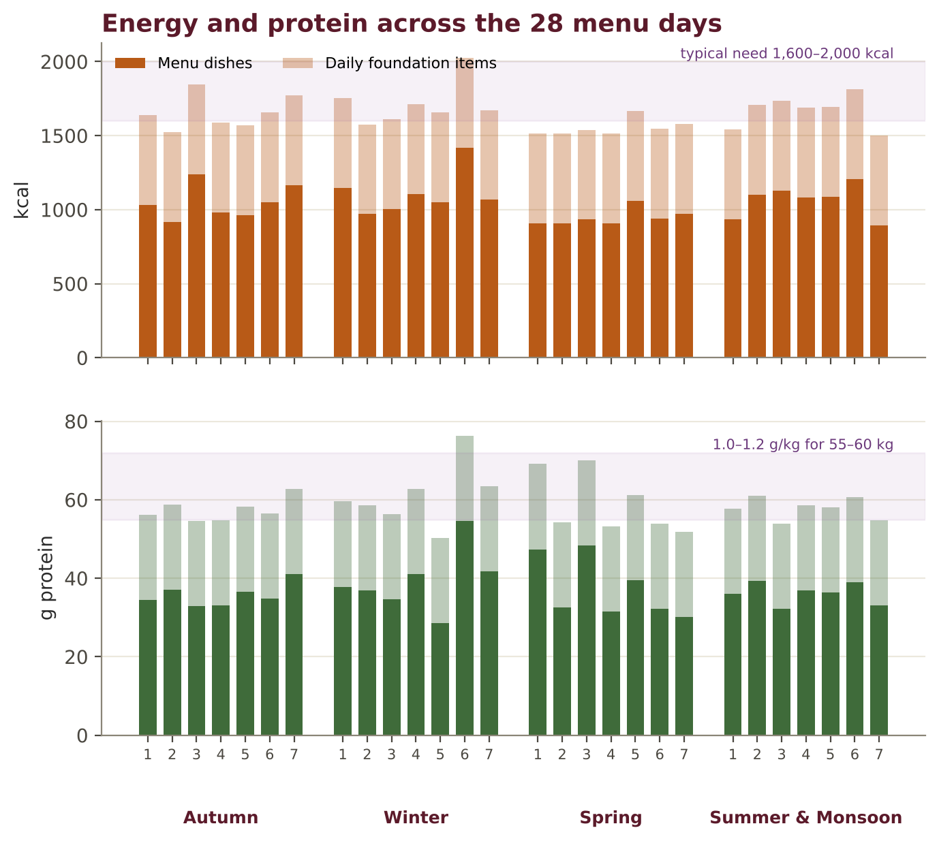
Figure. Estimated energy and protein of each menu day, including the daily foundation items.
With the foundation items, every day falls within or close to the range most adults over fifty need. Salt in these menus averages well under 5 g a day from the dishes themselves — provided dipping sauces and pickles are used in the spoonful amounts given in the recipes.

Autumn Week — Vata season
When: Sep – Nov (temperate Asia) · Post-monsoon (tropical Asia)
Focus: Congees with pumpkin and sweet potato; root-vegetable simmered dishes; sesame, ginger, red dates; warm broths with every meal.
Day | On waking | Breakfast | Lunch (main meal) | Afternoon | Dinner (light)
1 | 11.04 Lemongrass–Pandan–Ginger Tea | 1.04 Korean Pumpkin Porridge (Hobakjuk) | 6.01 Takikomi Gohan — Seasoned Rice with Root Vegetables + 2.02 Miso Soup with Tofu & Wakame + 8.03 Kinpira — Braised Burdock & Carrot | 11.01 Ginger–Jujube Tea (Daechu-saenggang-cha) + Stewed Pear with Cinnamon & Clove (Vol. I) | 1.09 Vietnamese Ginger Rice Soup with Tofu (Cháo Đậu Hũ)
2 | Morning Jeera–Ginger Water (Vol. I) | 1.08 Sweet Potato Congee (Fan Shu Zhou) | 4.03 Red-Braised Tofu (Hong Shao Doufu) + 6.05 Pandan Jasmine Rice + 4.01 Bok Choy with Ginger & Sesame | 7.02 Sesame Tofu (Goma-dōfu) + 11.04 Lemongrass–Pandan–Ginger Tea | 2.05 Kenchin-jiru (Temple Root-Vegetable Soup)
3 | 11.01 Ginger–Jujube Tea (Daechu-saenggang-cha) | Savoury Kozhukattai (Steamed Rice Dumplings) (Vol. II) | 5.03 Kake Udon with Kabocha & Ginger + 8.01 Spinach with Sesame Dressing (Hōrensō no Gomaae) | 10.04 Sweet Potato in Ginger Syrup (Fan Shu Tang) | Rice Kanji with Ghee, Cumin & Ginger · Payar (Vol. I)
4 | 11.04 Lemongrass–Pandan–Ginger Tea | 1.07 Black Sesame Porridge (Heukimja-juk) | 4.07 Thai Green Curry with Vegetables & Tofu (Allium-free) + 6.05 Pandan Jasmine Rice | CCF Tea (Cumin–Coriander–Fennel) (Vol. I) | 2.04 Lotus Root & Peanut Soup + 3.03 Steamed Milk Buns (Mantou)
5 | Morning Jeera–Ginger Water (Vol. I) | 1.01 Plain Jook with Ginger & Sesame (Bai Zhou) | 6.02 Warm Bibimbap with Cooked Namul (Egg-free) + 2.07 Korean Soybean-Paste Soup with Spinach (Sigeumchi Doenjang-guk) | 11.01 Ginger–Jujube Tea (Daechu-saenggang-cha) | 4.08 Japanese Simmered Vegetables (Nimono) + 1.02 Okayu with Umeboshi-free Ginger & Shiso Herbs
6 | 11.04 Lemongrass–Pandan–Ginger Tea | 1.06 Red Date & Goji Millet Porridge | 4.10 Indonesian Coconut Vegetable Stew (Sayur Lodeh) + 6.04 Indonesian Turmeric Coconut Rice (Nasi Kuning) + Kundru (Ivy Gourd) Thoran (Vol. II) | 11.06 Warm Five-Grain Soy Milk (Wu Gu Doujiang) | 5.06 Tibetan Noodle Soup (Thukpa)
7 | 11.01 Ginger–Jujube Tea (Daechu-saenggang-cha) | Ven Pongal (Pepper–Ghee Rice & Moong) (Vol. I) | 3.01 Cabbage, Tofu & Ginger Jiaozi + 2.08 Sweet Corn & Silken Tofu Soup + 9.03 Ginger–Soy Dipping Sauce | 11.04 Lemongrass–Pandan–Ginger Tea | 2.06 Thai Coconut–Galangal Soup with Tofu (Tom Kha Tao Hu) + 6.05 Pandan Jasmine Rice

Indian bridge dishes this week (7): Stewed Pear with Cinnamon & Clove (Vol. I) · Morning Jeera–Ginger Water (Vol. I) · Savoury Kozhukattai (Steamed Rice Dumplings) (Vol. II) · Rice Kanji with Ghee, Cumin & Ginger · Payar (Vol. I) · CCF Tea (Cumin–Coriander–Fennel) (Vol. I) · Kundru (Ivy Gourd) Thoran (Vol. II) · Ven Pongal (Pepper–Ghee Rice & Moong) (Vol. I)

Shopping list for the autumn week (2 people)
Totals for all menu dishes for two people for seven days, before the daily foundation items. Round up to market sizes; salt, water and pantry spices in very small amounts are omitted when under 1 g.
Ingredient | Week | Ingredient | Week | Ingredient | Week
Vegetable stock | 4.8 L | Mung bean sprouts | 110 g | Pine nuts | 20 g
Rice, white basmati | 1.1 kg | Lemongrass | 100 g | Tahini | 20 g
Tofu, firm | 940 g | French beans | 100 g | Coriander leaves | 20 g
Pumpkin | 720 g | Whole-wheat pasta | 100 g | Snow peas / mangetout | 20 g
Coconut milk, thin | 620 ml | Jaggery | 100 g | Arrowroot / kudzu starch | 17 g
Spinach | 450 g | Tomato | 90 g | Coconut oil | 15 g
Bok choy / pak choi | 430 g | Rice flour | 80 g | Cumin | 9 g
Carrot | 420 g | Sesame seeds | 70 g | Raisins | 8 g
Sweet potato | 350 g | Millet | 70 g | Oats, rolled / steel-cut | 8 g
Udon / wheat noodles | 300 g | Rice, Kerala red matta | 50 g | Cashew nuts | 8 g
Soy milk | 300 ml | Miso | 48 g | Cornflour | 8 g
Pear | 250 g | Sesame oil | 43 g | Goji berries | 5 g
Radish | 220 g | Coconut, fresh grated | 43 g | Apple-cider or rice vinegar | 5 ml
Lotus root | 220 g | Peanuts | 33 g | Green chilli | 4 g
Zucchini / tori | 210 g | Moong, whole green | 33 g | Cinnamon | 3 g
Ginger, fresh | 180 g | Ghee | 32 g | Urad dal, split | 3 g
Tofu, silken | 180 g | Moong dal, yellow split | 30 g | Curry leaves | 2 g
Red dates / jujube | 160 g | Brown-rice syrup / rice malt | 29 g | Kaffir lime leaves / pandan leaf | 2 g
Burdock root | 150 g | Cow's milk, whole | 28 ml | Black pepper | 2 g
Whole-wheat flour | 150 g | Honey | 28 g | Coriander seed / powder | 2 g
Ivy gourd | 150 g | Glutinous rice | 25 g | Wakame | 2 g
Sweet corn kernels | 150 g | Edamame | 25 g | Mustard seeds | 2 g
Cabbage | 140 g | Lemon juice | 25 ml | Turmeric powder | 2 g
Napa / Chinese cabbage | 130 g | Galangal | 24 g | Fennel | 1 g
Soy sauce / tamari | 130 ml | Fresh herbs | 24 g | Nori / laver | 1 g
Colocasia | 130 g | Adzuki beans | 20 g

Winter Week — Vata → Kapha
When: Dec – Feb (temperate Asia) · Cool dry season (tropical Asia)
Focus: Hearty noodle soups, dumplings, braised tofu and adzuki; ginger and jujube teas; from late winter, lighten with daikon, buckwheat and millet.
Day | On waking | Breakfast | Lunch (main meal) | Afternoon | Dinner (light)
1 | 11.01 Ginger–Jujube Tea (Daechu-saenggang-cha) | 1.06 Red Date & Goji Millet Porridge | 5.06 Tibetan Noodle Soup (Thukpa) + 3.02 Himalayan Vegetable Momos with Paneer | 10.04 Sweet Potato in Ginger Syrup (Fan Shu Tang) | Makar Sankranti Moong–Rice Vegetable Khichdi (Vol. I)
2 | Morning Jeera–Ginger Water (Vol. I) | 1.07 Black Sesame Porridge (Heukimja-juk) | 4.09 Simmered Daikon with Miso Sauce (Furofuki Daikon) + 6.01 Takikomi Gohan — Seasoned Rice with Root Vegetables + 2.02 Miso Soup with Tofu & Wakame | 11.06 Warm Five-Grain Soy Milk (Wu Gu Doujiang) | 2.05 Kenchin-jiru (Temple Root-Vegetable Soup)
3 | 11.01 Ginger–Jujube Tea (Daechu-saenggang-cha) | 1.04 Korean Pumpkin Porridge (Hobakjuk) | 4.04 Mild Sattvic Mapo Tofu + 6.05 Pandan Jasmine Rice + 4.06 Gai Lan with Kombu–Soy Glaze | Herbal Spice Tea with Toasted Sesame–Walnut Mix (Vol. I) | 1.09 Vietnamese Ginger Rice Soup with Tofu (Cháo Đậu Hũ)
4 | Morning Jeera–Ginger Water (Vol. I) | 3.03 Steamed Milk Buns (Mantou) | 4.02 Buddha's Delight (Lo Han Jai, Mushroom-free) + 6.03 Ghee Fried Rice with Vegetables & Tofu | 10.02 Red Bean Soup with Dried Tangerine Peel (Hong Dou Tang Shui) | 5.04 Vietnamese Vegetarian Pho (Phở Chay)
5 | 11.01 Ginger–Jujube Tea (Daechu-saenggang-cha) | Sakkarai Pongal (Sweet Jaggery Pongal) (Vol. II) | 7.03 Adzuki & Kabocha Simmer (Itoko-ni) + 6.08 Rice Balls with Sesame & Nori (Onigiri) + 8.02 Korean Namul Trio (Spinach, Carrot, Zucchini) | 11.04 Lemongrass–Pandan–Ginger Tea | Carrot–Ginger Soup with Ghee Rice (Vol. I)
6 | Morning Jeera–Ginger Water (Vol. I) | 1.08 Sweet Potato Congee (Fan Shu Zhou) | 7.04 Indonesian Tempeh in Sweet Soy Glaze (Tempe Bacem, Gentle) + 4.10 Indonesian Coconut Vegetable Stew (Sayur Lodeh) + 6.06 Burmese Coconut Rice (Ohn Htamin) | 10.03 Black Sesame Tang Yuan in Ginger Syrup | 5.02 Warm Soba in Kombu Broth with Spinach
7 | 11.01 Ginger–Jujube Tea (Daechu-saenggang-cha) | 10.07 Tibetan Sweet Butter Rice (Dresil) | 3.01 Cabbage, Tofu & Ginger Jiaozi + 4.03 Red-Braised Tofu (Hong Shao Doufu) + 4.01 Bok Choy with Ginger & Sesame | Haldi–Adrak–Gud Kadha (Vol. I) | 2.09 Clear Daikon & Carrot Soup + 1.01 Plain Jook with Ginger & Sesame (Bai Zhou)

Indian bridge dishes this week (6): Makar Sankranti Moong–Rice Vegetable Khichdi (Vol. I) · Morning Jeera–Ginger Water (Vol. I) · Herbal Spice Tea with Toasted Sesame–Walnut Mix (Vol. I) · Sakkarai Pongal (Sweet Jaggery Pongal) (Vol. II) · Carrot–Ginger Soup with Ghee Rice (Vol. I) · Haldi–Adrak–Gud Kadha (Vol. I)

Shopping list for the winter week (2 people)
Totals for all menu dishes for two people for seven days, before the daily foundation items. Round up to market sizes; salt, water and pantry spices in very small amounts are omitted when under 1 g.
Ingredient | Week | Ingredient | Week | Ingredient | Week
Vegetable stock | 5.1 L | Cow's milk, whole | 100 ml | Brown-rice syrup / rice malt | 20 g
Rice, white basmati | 1.1 kg | Sesame seeds | 90 g | Walnuts | 20 g
Tofu, firm | 860 g | Zucchini / tori | 80 g | Lemongrass | 20 g
Carrot | 860 g | Adzuki beans | 80 g | Fresh herbs | 17 g
Radish | 740 g | Mung bean sprouts | 80 g | Coriander leaves | 16 g
Pumpkin | 610 g | Moong dal, yellow split | 80 g | Cashew nuts | 15 g
Sweet potato | 380 g | Ghee | 70 g | Glass / mung-bean starch noodles | 13 g
Bok choy / pak choi | 350 g | Millet | 70 g | Pumpkin seeds | 10 g
Soy milk | 300 ml | Red bean paste, sweetened | 70 g | Galangal | 10 g
Tofu, silken | 280 g | Burdock root | 50 g | Cornflour | 9 g
Spinach | 250 g | Sesame oil | 50 g | Cumin | 8 g
Whole-wheat flour | 250 g | Tomato | 50 g | Oats, rolled / steel-cut | 8 g
Gai lan | 250 g | Paneer | 50 g | Moong, whole green | 8 g
Coconut milk, thin | 250 ml | Colocasia | 50 g | Goji berries | 5 g
Cabbage | 240 g | French beans | 50 g | Cinnamon | 4 g
Napa / Chinese cabbage | 230 g | Miso | 47 g | Kombu | 4 g
Ginger, fresh | 210 g | Cauliflower | 40 g | Nori / laver | 4 g
Jaggery | 200 g | Edamame | 40 g | Coconut oil | 3 g
Red dates / jujube | 150 g | Sweet corn kernels | 40 g | Tamarind pulp | 3 g
Tempeh | 150 g | Snow peas / mangetout | 33 g | Black pepper | 2 g
Soy sauce / tamari | 130 ml | Bamboo shoots | 33 g | Turmeric powder | 2 g
Soba — buckwheat noodles | 130 g | Lotus root | 33 g | Fennel | 2 g
Green peas, fresh | 120 g | Lemon juice | 30 ml | Coriander seed / powder | 2 g
Glutinous rice | 100 g | Honey | 28 g | Orange / kinnow | 2 g
Whole-wheat pasta | 100 g | Raisins | 27 g | Wakame | 2 g
Rice noodles | 100 g | Pine nuts | 20 g | Tulsi leaves | 2 g

Spring Week — Kapha season
When: Mar – May (temperate Asia) · Hot dry season begins (tropical Asia)
Focus: Spring greens and herbs, buckwheat soba, daikon, sprouts and light tofu dishes; less sticky rice, coconut and sweets; pungent ginger and pepper.
Day | On waking | Breakfast | Lunch (main meal) | Afternoon | Dinner (light)
1 | 11.04 Lemongrass–Pandan–Ginger Tea | 1.03 Nanakusa-gayu (Seven-Herb Spring Rice Porridge) | 5.02 Warm Soba in Kombu Broth with Spinach + 8.01 Spinach with Sesame Dressing (Hōrensō no Gomaae) + 7.01 Baked Agedashi-style Tofu in Ginger Broth | 11.03 Roasted Barley Tea (Mugicha / Boricha) | 2.09 Clear Daikon & Carrot Soup + Soft Phulka (House Standard) (Vol. I)
2 | Morning Jeera–Ginger Water (Vol. I) | 1.06 Red Date & Goji Millet Porridge | 4.04 Mild Sattvic Mapo Tofu + 6.05 Pandan Jasmine Rice + 8.05 Water Spinach with Ginger (Kangkung) | Amla–Ginger–Honey Warm Tea (Vol. I) | 5.04 Vietnamese Vegetarian Pho (Phở Chay)
3 | 11.04 Lemongrass–Pandan–Ginger Tea | Sattvic Pesarattu (Green Moong Dosa) (Vol. II) | 6.02 Warm Bibimbap with Cooked Namul (Egg-free) + 2.07 Korean Soybean-Paste Soup with Spinach (Sigeumchi Doenjang-guk) | 11.03 Roasted Barley Tea (Mugicha / Boricha) | 1.09 Vietnamese Ginger Rice Soup with Tofu (Cháo Đậu Hũ)
4 | Morning Jeera–Ginger Water (Vol. I) | 1.01 Plain Jook with Ginger & Sesame (Bai Zhou) | 7.05 Cooked Mung Bean Sprouts with Sesame (Sukju Namul) + 4.05 Lotus Root & Snow Peas Stir-fry + 6.03 Ghee Fried Rice with Vegetables & Tofu | 11.04 Lemongrass–Pandan–Ginger Tea | Vegetable Dalia Khichdi (Vol. I)
5 | Morning Jeera–Ginger Water (Vol. I) | 1.02 Okayu with Umeboshi-free Ginger & Shiso Herbs | 4.06 Gai Lan with Kombu–Soy Glaze + 7.01 Baked Agedashi-style Tofu in Ginger Broth + 6.05 Pandan Jasmine Rice | 11.05 Matcha–Oat Latte (Occasional, Morning Only) | 2.02 Miso Soup with Tofu & Wakame + 6.08 Rice Balls with Sesame & Nori (Onigiri)
6 | Morning Jeera–Ginger Water (Vol. I) | Foxtail-Millet Vegetable Upma (Vol. II) | 5.05 Soft Rice Noodles with Gai Lan (Pad See Ew-style) + 8.02 Korean Namul Trio (Spinach, Carrot, Zucchini) | 11.03 Roasted Barley Tea (Mugicha / Boricha) | 2.08 Sweet Corn & Silken Tofu Soup + 3.03 Steamed Milk Buns (Mantou)
7 | 11.04 Lemongrass–Pandan–Ginger Tea | 3.08 Steamed Rice-Noodle Rolls (Cheung Fun) with Sweet Soy | 7.03 Adzuki & Kabocha Simmer (Itoko-ni) + 8.03 Kinpira — Braised Burdock & Carrot + 6.05 Pandan Jasmine Rice | Lemongrass–Tulsi Tea (Vol. II) | Moong Yusha (Classical Moong Soup) with Soft Phulka (Vol. I)

Indian bridge dishes this week (8): Soft Phulka (House Standard) (Vol. I) · Morning Jeera–Ginger Water (Vol. I) · Amla–Ginger–Honey Warm Tea (Vol. I) · Sattvic Pesarattu (Green Moong Dosa) (Vol. II) · Vegetable Dalia Khichdi (Vol. I) · Foxtail-Millet Vegetable Upma (Vol. II) · Lemongrass–Tulsi Tea (Vol. II) · Moong Yusha (Classical Moong Soup) with Soft Phulka (Vol. I)

Shopping list for the spring week (2 people)
Totals for all menu dishes for two people for seven days, before the daily foundation items. Round up to market sizes; salt, water and pantry spices in very small amounts are omitted when under 1 g.
Ingredient | Week | Ingredient | Week | Ingredient | Week
Vegetable stock | 4.7 L | Sesame oil | 80 g | Cornflour | 24 g
Rice, white basmati | 1.0 kg | Moong, whole green | 80 g | Coriander leaves | 18 g
Tofu, firm | 1.0 kg | Foxtail millet | 80 g | Honey | 18 g
Spinach | 680 g | Snow peas / mangetout | 80 g | Red dates / jujube | 15 g
Carrot | 540 g | Lemongrass | 70 g | Edamame | 15 g
Radish | 430 g | Millet | 60 g | Cumin | 11 g
Tofu, silken | 380 g | Rice flour | 60 g | Coconut oil | 8 g
Gai lan | 380 g | Adzuki beans | 60 g | Nori / laver | 6 g
Mung bean sprouts | 360 g | Miso | 60 g | Goji berries | 5 g
Oat milk | 320 ml | Ghee | 50 g | Matcha green tea powder | 3 g
Rice noodles | 250 g | Broken wheat | 50 g | Urad dal, split | 3 g
Pumpkin | 240 g | Bottle gourd | 50 g | Black pepper | 2 g
Water spinach | 200 g | Sesame seeds | 42 g | Tulsi leaves | 2 g
Whole-wheat flour | 190 g | Jaggery | 41 g | Wakame | 2 g
Sweet corn kernels | 190 g | Turnip | 40 g | Kombu | 2 g
Lotus root | 150 g | Brown-rice syrup / rice malt | 37 g | Cinnamon | 1 g
Ginger, fresh | 150 g | Fresh herbs | 34 g | Coriander seed / powder | 1 g
Zucchini / tori | 140 g | Barley , pearled | 30 g | Fennel | 1 g
Soy sauce / tamari | 140 ml | Amla | 30 g | Green chilli | 1 g
Green peas, fresh | 130 g | Cow's milk, whole | 28 ml | Turmeric powder | 1 g
Soba — buckwheat noodles | 130 g | Arrowroot / kudzu starch | 25 g | Mustard seeds | 1 g
Moong dal, yellow split | 100 g | Lemon juice | 25 ml
Burdock root | 100 g | French beans | 25 g

Summer & Monsoon Week — Pitta season
When: Jun – Aug (temperate Asia) · Hot & wet seasons (tropical Asia)
Focus: Mung bean, winter melon, cucumber, coconut and rice; chrysanthemum and barley teas at room temperature; less chilli, sour pickle and fried food. In the monsoon, cook everything and add ginger.
Day | On waking | Breakfast | Lunch (main meal) | Afternoon | Dinner (light)
1 | 11.02 Chrysanthemum & Goji Infusion (Ju Hua Gou Qi Cha) | 1.05 Mung Bean Congee (Lü Dou Zhou) | 5.07 Turmeric–Coconut Rice Noodles with Greens + 8.07 Warm Vegetable Rice-Paper Rolls | Rose–Fennel Cooler (Vol. II) | 2.03 Winter Melon Soup with Ginger (Dong Gua Tang)
2 | Jau Pani (Barley Water with Lemon) (Vol. II) | 3.08 Steamed Rice-Noodle Rolls (Cheung Fun) with Sweet Soy | 6.04 Indonesian Turmeric Coconut Rice (Nasi Kuning) + 4.10 Indonesian Coconut Vegetable Stew (Sayur Lodeh) + 7.06 Edamame, Corn & Ginger Stir-fry | 10.05 Mung Bean Dessert Soup with Pandan (Lü Dou Tang) | 1.02 Okayu with Umeboshi-free Ginger & Shiso Herbs + 3.04 Steamed Silken Tofu with Ginger–Soy Dressing
3 | 11.02 Chrysanthemum & Goji Infusion (Ju Hua Gou Qi Cha) | Savoury Kozhukattai (Steamed Rice Dumplings) (Vol. II) | 5.01 Japchae — Glass Noodles with Vegetables (Egg-free) + 7.06 Edamame, Corn & Ginger Stir-fry | 10.01 Mango Sticky Rice (Khao Niao Mamuang) | 2.08 Sweet Corn & Silken Tofu Soup
4 | Jau Pani (Barley Water with Lemon) (Vol. II) | 1.05 Mung Bean Congee (Lü Dou Zhou) | 7.01 Baked Agedashi-style Tofu in Ginger Broth + 4.01 Bok Choy with Ginger & Sesame + 6.06 Burmese Coconut Rice (Ohn Htamin) | 11.04 Lemongrass–Pandan–Ginger Tea | Ash-Gourd Soup with Coconut Milk (Vol. II) + Neer Dosa (Soft Rice Crêpes) (Vol. II)
5 | 11.02 Chrysanthemum & Goji Infusion (Ju Hua Gou Qi Cha) | Neer Dosa (Soft Rice Crêpes) (Vol. II) | 6.02 Warm Bibimbap with Cooked Namul (Egg-free) + 8.06 Gotu Kola & Coconut Mallum | 11.03 Roasted Barley Tea (Mugicha / Boricha) | 5.08 Warm Sesame Noodles with Cucumber & Carrot
6 | Jau Pani (Barley Water with Lemon) (Vol. II) | 1.01 Plain Jook with Ginger & Sesame (Bai Zhou) | 7.08 Malaysian Tofu & Bean Sprouts with Peanut Sauce (Tauhu Bakar) + 6.05 Pandan Jasmine Rice + 8.05 Water Spinach with Ginger (Kangkung) | Panakam (Jaggery–Ginger–Cardamom Water) (Vol. II) | Vegetable Ishtu (Kerala Stew) with Idiyappam (Vol. I)
7 | 11.02 Chrysanthemum & Goji Infusion (Ju Hua Gou Qi Cha) | 1.02 Okayu with Umeboshi-free Ginger & Shiso Herbs | 3.01 Cabbage, Tofu & Ginger Jiaozi + 4.05 Lotus Root & Snow Peas Stir-fry | Lauki Kheer (Vol. II) + 11.04 Lemongrass–Pandan–Ginger Tea | Foxtail-Millet & Moong Khichdi (Vol. II)

Indian bridge dishes this week (9): Rose–Fennel Cooler (Vol. II) · Jau Pani (Barley Water with Lemon) (Vol. II) · Savoury Kozhukattai (Steamed Rice Dumplings) (Vol. II) · Ash-Gourd Soup with Coconut Milk (Vol. II) · Neer Dosa (Soft Rice Crêpes) (Vol. II) · Panakam (Jaggery–Ginger–Cardamom Water) (Vol. II) · Vegetable Ishtu (Kerala Stew) with Idiyappam (Vol. I) · Lauki Kheer (Vol. II) · Foxtail-Millet & Moong Khichdi (Vol. II)

Shopping list for the summer & monsoon week (2 people)
Totals for all menu dishes for two people for seven days, before the daily foundation items. Round up to market sizes; salt, water and pantry spices in very small amounts are omitted when under 1 g.
Ingredient | Week | Ingredient | Week | Ingredient | Week
Vegetable stock | 1.7 L | Glutinous rice | 100 g | Brown-rice syrup / rice malt | 25 g
Coconut milk, thin | 980 ml | Whole-wheat flour | 100 g | Green peas, fresh | 25 g
Rice, white basmati | 970 g | French beans | 90 g | Tahini | 20 g
Tofu, firm | 880 g | Sesame oil | 80 g | Cornflour | 18 g
Ash gourd | 550 g | Coconut, fresh grated | 80 g | Gulkand | 15 g
Carrot | 420 g | Glass / mung-bean starch noodles | 80 g | Ghee | 14 g
Sweet corn kernels | 350 g | Potato | 80 g | Coriander leaves | 13 g
Spinach | 330 g | Snow peas / mangetout | 80 g | Miso | 13 g
Tofu, silken | 300 g | Cabbage | 70 g | Arrowroot / kudzu starch | 13 g
Cow's milk, whole | 270 ml | Pumpkin | 70 g | Tea leaves / herbal flowers | 12 g
Edamame | 250 g | Fresh herbs | 70 g | Gram flour | 10 g
Bok choy / pak choi | 250 g | Peanuts | 60 g | Galangal | 7 g
Rice flour | 240 g | Barley , pearled | 60 g | Apple-cider or rice vinegar | 5 ml
Mango, ripe | 200 g | Zucchini / tori | 60 g | Fennel | 4 g
Water spinach | 200 g | Lemon juice | 50 ml | Almonds | 3 g
Mung bean sprouts | 150 g | Capsicum | 50 g | Rose water | 3 ml
Lotus root | 150 g | Foxtail millet | 50 g | Nori / laver | 3 g
Rice noodles | 140 g | Rice paper wrappers | 45 g | Urad dal, split | 3 g
Cucumber | 140 g | Lemongrass | 43 g | Tamarind pulp | 3 g
Napa / Chinese cabbage | 130 g | Moong dal, yellow split | 40 g | Green chilli | 2 g
Bottle gourd | 130 g | Goji berries | 37 g | Turmeric powder | 2 g
Moong, whole green | 130 g | Mishri / sugar | 37 g | Black pepper | 2 g
Whole-wheat pasta | 130 g | Sesame seeds | 31 g | Curry leaves | 2 g
Jaggery | 110 g | Lettuce | 30 g | Cumin | 2 g
Ginger, fresh | 110 g | Radish | 30 g | Mustard seeds | 1 g
Soy sauce / tamari | 100 ml | Coconut oil | 28 g

Festival Tables of Asia
The great festivals of East and Southeast Asia are rich in vegetarian traditions — Buddhist temple feasts, first-day-of-the-year vegetarian meals, and offerings of rice, beans and fruit. These tables honour them in the sattvic style of the Annapurna Kitchen.

Lunar New Year (Chūn Jié)
When: Late Jan – Feb Many Buddhist families eat vegetarian on the first day; Buddha's Delight and dumplings are traditional, and tang yuan close the season at the Lantern Festival.
Course | Dish | Source
1 | Ginger–Jujube Tea (Daechu-saenggang-cha) | Recipe 11.01
2 | Buddha's Delight (Lo Han Jai, Mushroom-free) | Recipe 4.02
3 | Cabbage, Tofu & Ginger Jiaozi | Recipe 3.01
4 | Ginger–Soy Dipping Sauce | Recipe 9.03
5 | Ghee Fried Rice with Vegetables & Tofu | Recipe 6.03
6 | Bok Choy with Ginger & Sesame | Recipe 4.01
7 | Black Sesame Tang Yuan in Ginger Syrup | Recipe 10.03

Mid-Autumn Festival
When: 15th day, 8th lunar month (Sep–Oct) A moon-viewing supper; serve lotus, pumpkin and red-bean dishes instead of very rich mooncakes, with Asian pears and persimmons.
Course | Dish | Source
1 | Lemongrass–Pandan–Ginger Tea | Recipe 11.04
2 | Lotus Root & Peanut Soup | Recipe 2.04
3 | Takikomi Gohan — Seasoned Rice with Root Vegetables | Recipe 6.01
4 | Japanese Simmered Vegetables (Nimono) | Recipe 4.08
5 | Steamed Kabocha with Black Sesame | Recipe 3.06
6 | Red Bean Soup with Dried Tangerine Peel (Hong Dou Tang Shui) | Recipe 10.02

Vesak / Buddha Purnima
When: Full moon of April–May A white-and-gold temple meal honouring the Buddha's birth, awakening and passing — simple, pure, shared.
Course | Dish | Source
1 | Roasted Barley Tea (Mugicha / Boricha) | Recipe 11.03
2 | Okayu with Umeboshi-free Ginger & Shiso Herbs | Recipe 1.02
3 | Sesame Tofu (Goma-dōfu) | Recipe 7.02
4 | Kenchin-jiru (Temple Root-Vegetable Soup) | Recipe 2.05
5 | Spinach with Sesame Dressing (Hōrensō no Gomaae) | Recipe 8.01
6 | Sri Lankan Milk Rice (Kiribath) | Recipe 6.07
7 | Mung Bean Dessert Soup with Pandan (Lü Dou Tang) | Recipe 10.05

Dōngzhì — Winter Solstice
When: ≈ 21–22 December Families gather for tang yuan (south) or dumplings (north) on the longest night.
Course | Dish | Source
1 | Ginger–Jujube Tea (Daechu-saenggang-cha) | Recipe 11.01
2 | Cabbage, Tofu & Ginger Jiaozi | Recipe 3.01
3 | Tibetan Noodle Soup (Thukpa) | Recipe 5.06
4 | Adzuki & Kabocha Simmer (Itoko-ni) | Recipe 7.03
5 | Black Sesame Tang Yuan in Ginger Syrup | Recipe 10.03

Chuseok — Korean Harvest
When: 15th day, 8th lunar month Gratitude for the harvest with namul, japchae, rice and pumpkin porridge.
Course | Dish | Source
1 | Ginger–Jujube Tea (Daechu-saenggang-cha) | Recipe 11.01
2 | Korean Pumpkin Porridge (Hobakjuk) | Recipe 1.04
3 | Korean Namul Trio (Spinach, Carrot, Zucchini) | Recipe 8.02
4 | Japchae — Glass Noodles with Vegetables (Egg-free) | Recipe 5.01
5 | Warm Bibimbap with Cooked Namul (Egg-free) | Recipe 6.02
6 | Korean Soybean-Paste Soup with Spinach (Sigeumchi Doenjang-guk) | Recipe 2.07

Sinhala & Tamil New Year · Losar
When: April (Sri Lanka) · Feb–Mar (Tibet) Milk rice for auspicious beginnings in Sri Lanka; sweet butter rice, thukpa and momos for Tibetan Losar.
Course | Dish | Source
1 | Sri Lankan Milk Rice (Kiribath) | Recipe 6.07
2 | Gotu Kola & Coconut Mallum | Recipe 8.06
3 | Burmese Coconut Rice (Ohn Htamin) | Recipe 6.06
4 | Tibetan Sweet Butter Rice (Dresil) | Recipe 10.07
5 | Tibetan Noodle Soup (Thukpa) | Recipe 5.06
6 | Himalayan Vegetable Momos with Paneer | Recipe 3.02
7 | Ginger–Jujube Tea (Daechu-saenggang-cha) | Recipe 11.01

Indian–Asian Bridge Thali
When: Any season For guests who move between both worlds: kanji meets congee, thoran meets namul.
Course | Dish | Source
1 | Morning Jeera–Ginger Water | Vol. I
2 | Rice Kanji with Ghee, Cumin & Ginger · Payar | Vol. I
3 | Vietnamese Ginger Rice Soup with Tofu (Cháo Đậu Hũ) | Recipe 1.09
4 | Beans–Coconut Thoran | Vol. II
5 | Korean Namul Trio (Spinach, Carrot, Zucchini) | Recipe 8.02
6 | Cherupayar Curry (Kerala Whole Moong) | Vol. II
7 | Pandan Jasmine Rice | Recipe 6.05
8 | Mung Bean Dessert Soup with Pandan (Lü Dou Tang) | Recipe 10.05

Recipe Index and Nutrition Summary
Estimated values per serving. Salt includes salt from soy sauce, miso, cheese and olives.
No. | Recipe | Region | kcal | Protein g | Fibre g | Salt g
1.01 | Plain Jook with Ginger & Sesame (Bai Zhou) | Chinese | 119 | 2.4 | 0.5 | 0.7
1.02 | Okayu with Umeboshi-free Ginger & Shiso Herbs | Japanese | 146 | 3.4 | 0.9 | 0.5
1.03 | Nanakusa-gayu (Seven-Herb Spring Rice Porridge) | Japanese | 145 | 3.6 | 1.6 | 0.8
1.04 | Korean Pumpkin Porridge (Hobakjuk) | Korean | 159 | 4.7 | 2.5 | 0.5
1.05 | Mung Bean Congee (Lü Dou Zhou) | Chinese | 137 | 6.1 | 3.5 | 0.5
1.06 | Red Date & Goji Millet Porridge | Chinese | 154 | 4.0 | 3.4 | 0.0
1.07 | Black Sesame Porridge (Heukimja-juk) | Korean | 184 | 4.5 | 2.1 | 0.3
1.08 | Sweet Potato Congee (Fan Shu Zhou) | Chinese | 178 | 3.7 | 2.8 | 0.5
1.09 | Vietnamese Ginger Rice Soup with Tofu (Cháo Đậu Hũ) | Vietnamese | 208 | 11.8 | 2.0 | 0.4
2.01 | Kombu Dashi (Temple Stock) | Japanese | 3 | 0.1 | 0.6 | 0.0
2.02 | Miso Soup with Tofu & Wakame | Japanese | 52 | 3.5 | 0.6 | 1.2
2.03 | Winter Melon Soup with Ginger (Dong Gua Tang) | Chinese | 71 | 2.3 | 5.4 | 0.8
2.04 | Lotus Root & Peanut Soup | Chinese | 182 | 6.9 | 6.5 | 0.7
2.05 | Kenchin-jiru (Temple Root-Vegetable Soup) | Japanese | 136 | 7.0 | 3.5 | 0.8
2.06 | Thai Coconut–Galangal Soup with Tofu (Tom Kha Tao Hu) | Thai | 222 | 10.5 | 2.6 | 0.5
2.07 | Korean Soybean-Paste Soup with Spinach (Sigeumchi Doenjang-guk) | Korean | 103 | 9.3 | 2.9 | 1.2
2.08 | Sweet Corn & Silken Tofu Soup | Chinese | 126 | 5.4 | 2.2 | 0.8
2.09 | Clear Daikon & Carrot Soup | Chinese | 54 | 1.8 | 3.1 | 0.8
2.10 | Mild Bhutanese Potato & Cheese Stew (Kewa Datshi, Gentle) | Himalayan | 180 | 8.3 | 2.8 | 1.0
3.01 | Cabbage, Tofu & Ginger Jiaozi | Chinese | 261 | 12.5 | 7.6 | 0.9
3.02 | Himalayan Vegetable Momos with Paneer | Himalayan | 284 | 11.5 | 7.6 | 0.7
3.03 | Steamed Milk Buns (Mantou) | Chinese | 108 | 3.5 | 2.8 | 0.1
3.04 | Steamed Silken Tofu with Ginger–Soy Dressing | Chinese | 73 | 5.2 | 0.2 | 0.5
3.05 | Steamed Tofu Custard (Egg-free Chawanmushi) | Japanese | 99 | 6.3 | 1.3 | 0.7
3.06 | Steamed Kabocha with Black Sesame | Japanese | 77 | 2.6 | 1.4 | 0.5
3.07 | Sticky Rice in Lotus Leaf (Lo Mai Gai, Vegetarian) | Chinese | 445 | 15.5 | 5.3 | 0.7
3.08 | Steamed Rice-Noodle Rolls (Cheung Fun) with Sweet Soy | Chinese | 171 | 3.1 | 1.5 | 0.8
4.01 | Bok Choy with Ginger & Sesame | Chinese | 62 | 2.4 | 1.5 | 0.4
4.02 | Buddha's Delight (Lo Han Jai, Mushroom-free) | Chinese | 157 | 8.0 | 4.0 | 0.5
4.03 | Red-Braised Tofu (Hong Shao Doufu) | Chinese | 202 | 17.2 | 3.0 | 0.7
4.04 | Mild Sattvic Mapo Tofu | Chinese | 127 | 6.7 | 1.5 | 0.7
4.05 | Lotus Root & Snow Peas Stir-fry | Chinese | 119 | 3.5 | 5.4 | 0.6
4.06 | Gai Lan with Kombu–Soy Glaze | Chinese | 52 | 1.7 | 3.2 | 0.5
4.07 | Thai Green Curry with Vegetables & Tofu (Allium-free) | Thai | 258 | 13.2 | 4.1 | 0.5
4.08 | Japanese Simmered Vegetables (Nimono) | Japanese | 122 | 3.4 | 5.0 | 0.7
4.09 | Simmered Daikon with Miso Sauce (Furofuki Daikon) | Japanese | 89 | 3.1 | 4.3 | 0.9
4.10 | Indonesian Coconut Vegetable Stew (Sayur Lodeh) | Malaysian & Indonesian | 165 | 7.5 | 3.1 | 0.7
5.01 | Japchae — Glass Noodles with Vegetables (Egg-free) | Korean | 285 | 8.9 | 3.7 | 0.9
5.02 | Warm Soba in Kombu Broth with Spinach | Japanese | 309 | 17.9 | 4.7 | 1.3
5.03 | Kake Udon with Kabocha & Ginger | Japanese | 586 | 17.7 | 4.7 | 1.1
5.04 | Vietnamese Vegetarian Pho (Phở Chay) | Vietnamese | 320 | 14.0 | 4.8 | 0.9
5.05 | Soft Rice Noodles with Gai Lan (Pad See Ew-style) | Thai | 419 | 13.8 | 4.0 | 1.1
5.06 | Tibetan Noodle Soup (Thukpa) | Himalayan | 252 | 10.1 | 7.3 | 1.0
5.07 | Turmeric–Coconut Rice Noodles with Greens | Burmese | 368 | 12.8 | 3.6 | 0.5
5.08 | Warm Sesame Noodles with Cucumber & Carrot | Chinese | 343 | 13.0 | 7.9 | 0.7
6.01 | Takikomi Gohan — Seasoned Rice with Root Vegetables | Japanese | 340 | 11.3 | 3.1 | 0.7
6.02 | Warm Bibimbap with Cooked Namul (Egg-free) | Korean | 404 | 17.0 | 5.4 | 1.0
6.03 | Ghee Fried Rice with Vegetables & Tofu | Chinese | 370 | 13.3 | 4.3 | 0.7
6.04 | Indonesian Turmeric Coconut Rice (Nasi Kuning) | Malaysian & Indonesian | 227 | 4.3 | 1.0 | 0.7
6.05 | Pandan Jasmine Rice | Malaysian & Indonesian | 230 | 4.7 | 0.8 | 0.5
6.06 | Burmese Coconut Rice (Ohn Htamin) | Burmese | 298 | 5.7 | 1.4 | 0.8
6.07 | Sri Lankan Milk Rice (Kiribath) | Sri Lankan | 235 | 4.4 | 0.9 | 0.7
6.08 | Rice Balls with Sesame & Nori (Onigiri) | Japanese | 261 | 7.3 | 2.3 | 1.0
7.01 | Baked Agedashi-style Tofu in Ginger Broth | Japanese | 218 | 16.6 | 2.9 | 0.7
7.02 | Sesame Tofu (Goma-dōfu) | Japanese | 91 | 1.9 | 1.2 | 0.4
7.03 | Adzuki & Kabocha Simmer (Itoko-ni) | Japanese | 127 | 7.1 | 4.6 | 0.9
7.04 | Indonesian Tempeh in Sweet Soy Glaze (Tempe Bacem, Gentle) | Malaysian & Indonesian | 198 | 15.5 | 3.2 | 0.7
7.05 | Cooked Mung Bean Sprouts with Sesame (Sukju Namul) | Korean | 60 | 3.2 | 2.0 | 0.5
7.06 | Edamame, Corn & Ginger Stir-fry | Japanese | 141 | 9.1 | 4.9 | 0.3
7.07 | Soy-Braised Tofu Puffs with Bok Choy | Chinese | 105 | 9.5 | 2.0 | 0.5
7.08 | Malaysian Tofu & Bean Sprouts with Peanut Sauce (Tauhu Bakar) | Malaysian & Indonesian | 264 | 21.4 | 4.5 | 0.5
8.01 | Spinach with Sesame Dressing (Hōrensō no Gomaae) | Japanese | 74 | 4.4 | 3.1 | 0.4
8.02 | Korean Namul Trio (Spinach, Carrot, Zucchini) | Korean | 72 | 2.6 | 2.7 | 0.8
8.03 | Kinpira — Braised Burdock & Carrot | Japanese | 91 | 1.6 | 2.9 | 0.5
8.04 | Warm Gado-Gado with Peanut Sauce | Malaysian & Indonesian | 335 | 21.8 | 8.6 | 0.5
8.05 | Water Spinach with Ginger (Kangkung) | Malaysian & Indonesian | 45 | 2.9 | 2.2 | 0.4
8.06 | Gotu Kola & Coconut Mallum | Sri Lankan | 77 | 1.3 | 2.4 | 0.5
8.07 | Warm Vegetable Rice-Paper Rolls | Vietnamese | 307 | 14.1 | 3.8 | 0.3
8.08 | Warm Cucumber, Sesame & Peanut Salad | Chinese | 63 | 2.1 | 1.0 | 0.7
9.01 | Quick Ginger–Daikon Pickle (Asazuke) | Japanese | 13 | 0.4 | 1.1 | 0.6
9.02 | Nepali Tomato–Sesame Achar | Himalayan | 36 | 1.1 | 1.0 | 0.4
9.03 | Ginger–Soy Dipping Sauce | Chinese | 11 | 0.4 | 0.1 | 0.7
9.04 | Sesame–Nori Furikake | Japanese | 19 | 0.7 | 0.5 | 0.2
9.05 | Warm Peanut–Sesame Sauce | Malaysian & Indonesian | 117 | 4.5 | 1.6 | 0.3
10.01 | Mango Sticky Rice (Khao Niao Mamuang) | Thai | 365 | 5.2 | 3.5 | 0.3
10.02 | Red Bean Soup with Dried Tangerine Peel (Hong Dou Tang Shui) | Chinese | 147 | 2.2 | 2.2 | 0.0
10.03 | Black Sesame Tang Yuan in Ginger Syrup | Chinese | 264 | 4.1 | 2.2 | 0.0
10.04 | Sweet Potato in Ginger Syrup (Fan Shu Tang) | Chinese | 144 | 2.0 | 3.5 | 0.0
10.05 | Mung Bean Dessert Soup with Pandan (Lü Dou Tang) | Chinese | 134 | 6.0 | 4.1 | 0.1
10.06 | Pumpkin–Coconut Agar Custard | Thai | 109 | 1.3 | 0.6 | 0.1
10.07 | Tibetan Sweet Butter Rice (Dresil) | Himalayan | 275 | 4.5 | 1.4 | 0.0
11.01 | Ginger–Jujube Tea (Daechu-saenggang-cha) | Korean | 64 | 0.8 | 1.1 | 0.0
11.02 | Chrysanthemum & Goji Infusion (Ju Hua Gou Qi Cha) | Chinese | 22 | 0.6 | 0.5 | 0.0
11.03 | Roasted Barley Tea (Mugicha / Boricha) | Japanese | 18 | 0.5 | 0.8 | 0.0
11.04 | Lemongrass–Pandan–Ginger Tea | Malaysian & Indonesian | 12 | 0.1 | 0.1 | 0.0
11.05 | Matcha–Oat Latte (Occasional, Morning Only) | Japanese | 95 | 2.1 | 1.9 | 0.0
11.06 | Warm Five-Grain Soy Milk (Wu Gu Doujiang) | Chinese | 164 | 7.5 | 2.6 | 0.0
PART IV

Reference
Batch cooking, glossary and sources

Batch Cooking for the Eastern Kitchen
Component | Make ahead | Keeps | Use in
Kombu dashi (2.01) | 2 litres | 3 days refrigerated; 1 month frozen in cubes | Miso soup, okayu, noodle broths, nimono
Charred-ginger spice stock | 2 litres | 4 days refrigerated, 3 months frozen | Pho, thukpa
Cooked rice | 1 day's portions | Cool quickly, refrigerate, reheat once only, eat within 24 h | Fried rice, congee, onigiri
Frozen rinsed rice for congee | 4 portions | 1 month frozen | Quick 30-minute jook
Ginger–soy dip (9.03) | 1 jar | 1 week refrigerated | Dumplings, tofu
Furikake (9.04) | 1 jar | 2 weeks airtight | Rice, congee
Peanut–sesame sauce (9.05) | 1 jar | 5 days refrigerated | Gado-gado, tofu, noodles
Jiaozi / momos (uncooked) | 50 pieces | 2 months frozen on a tray, then bagged | Cook from frozen, +3 minutes
Soaked adzuki and mung | Night before | — | Morning soups and sweets
Asazuke (9.01) | Small batch | 3 days | Small side portions

Rice safety for older guests
- Cooked rice can carry spores of Bacillus cereus that survive cooking. Cool leftover rice within an hour, refrigerate it, use it within 24 hours, and reheat it only once until steaming hot.
- Congee and fried rice should be made fresh or from properly chilled rice.

Glossary
Term | Meaning
Agni | Digestive fire
Ama | Undigested residue; the root of disease
Banchan | Korean side dishes served with rice
Bubur | Rice porridge in Malaysia and Indonesia
Cháo | Vietnamese rice porridge
Dashi | Japanese stock; here made from kombu
Doenjang | Korean fermented soybean paste
Gokun / wǔ hūn | The five pungent vegetables avoided in Buddhist temple cooking
Ichijū-sansai | "One soup, three sides" — the Japanese home meal
Jook / zhou | Chinese congee
Juk | Korean porridge
Kanji | Indian rice gruel (Volume I)
Namul | Korean seasoned vegetables
Nimono | Japanese simmered dishes
Nyepa | The three humours of Tibetan medicine, equivalent to the doshas
Okayu | Japanese rice porridge, graded by water ratio
Otoshibuta | A drop lid that keeps simmering food submerged
Peya, vilepi, manda | Ayurvedic rice preparations of increasing thinness
Shōjin ryōri | Japanese Zen temple vegetarian cuisine
Sowa Rigpa | Tibetan medicine — "the science of healing"
Tong sui | Cantonese sweet soups ("sugar water")
Umami | The savoury taste of glutamates, abundant in kombu

Sources and Further Reading
Nutrition values are estimated from IFCT 2017 and USDA FoodData Central per-100 g values; salt includes the salt in soy sauce (≈ 14.5% by weight) and miso (≈ 12%). Ayurvedic qualities draw on the classical texts as summarised in Volume III and on the sources below. This book is a kitchen guide, not medical advice.
[1] The Ayurvedic Institute — Food guidelines for basic constitutional types https://www.ayurveda.com/?p=7372
[2] Yoga International — Ayurveda's guide to health in every season https://yogainternational.com/article/view/ayurvedas-guide-to-health-in-every-season
[3] Wikipedia — Buddhist cuisine (five pungent vegetables; temple cooking in China, Korea, Vietnam and Japan) https://en.wikipedia.org/wiki/Buddhist_cuisine
[4] Japanese Taste — What is shōjin ryōri? A guide to traditional Buddhist vegan cuisine https://japanesetaste.com/blogs/japanese-taste-blog/what-is-shojin-ryori-your-guide-to-traditional-buddhist-vegan-cuisine
[5] Wikipedia — Congee https://en.wikipedia.org/wiki/Congee
[6] Just One Cookbook — Japanese rice porridge (okayu): water ratios https://www.justonecookbook.com/wprm_print/japanese-rice-porridge-okayu
[7] Satyori — Soy sauce: Ayurvedic properties https://satyori.com/food/soy-sauce/
[8] Satyori — Sowa Rigpa vs Ayurveda https://satyori.com/ayurveda/articles/sowa-rigpa-vs-ayurveda/
[9] ThaiJO journal article — A comparative study of therapeutic methods of Jivaka Komarabhacca and Thai traditional medicine https://so03.tci-thaijo.org/index.php/JMND/article/view/193031
[10] Liebherr FreshMAG — Cooling food: the teachings of TCM and Ayurveda https://www.liebherr.com/en-gb/fridges-freezers/freshmag/freshness-ideas/cooling-food-tcm-ayurveda-7813770
[11] Wikipedia — Okinawa diet https://en.wikipedia.org/wiki/Okinawa_diet
[12] World Health Organization Europe — Five recommendations to reduce salt intake (2022) https://www.who.int/europe/news/item/14-03-2022-5-recommendations-to-reduce-salt-intake-to-live-longer-and-healthier-lives
[13] Singapore Food Agency — Inorganic arsenic in hijiki seaweed https://www.sfa.gov.sg/food-information/risk-at-a-glance/inorganic-arsenic-in-hijiki-seaweed
[14] HealthLinkBC — Healthy eating guidelines for people taking warfarin https://www.healthlinkBC.ca/sites/default/files/documents/healthy-eating-guidelines-for-people-taking-warfarin-anticoagulants.pdf
[15] Bauer J. et al. — Evidence-based recommendations for optimal dietary protein intake in older people (PROT-AGE), JAMDA 2013 https://pubmed.ncbi.nlm.nih.gov/23867520/
[16] American Heart Association — The changing nutritional needs of older adults (2024) https://heart.org/en/news/2024/12/18/the-changing-nutritional-needs-of-older-adults-and-how-to-meet-them

॥ सर्वे भवन्तु सुखिनः सर्वे सन्तु निरामयाः ॥
May all be happy; may all be free from illness.
Annapurna Kitchen · Shree Shree Ma Anandamayee International Centre

