॥ अन्नं ब्रह्म ॥
ANNAPURNA KITCHEN
The Twelve-Month
Sattvic Menu Book
Seasonal Ayurvedic meals for guests aged 55 and above
12 monthly chapters · 83 recipes with exact gram measures
7-day rotating menus · café batch scaling (×5) · nutrition estimates
Charts · flowcharts · produce calendar · further dishes & variations

Shree Shree Ma Anandamayee International Centre
Daksh Mandir Road, Kankhal, Dist. Haridwar – 249408 (U.K.), India · www.ssmaic.org
Kitchen edition · 2026–27

Foreword
Annapurna Kitchen serves fresh, simple, Ayurvedic meals to support a peaceful and healing stay at the Centre in Kankhal. Many of our guests are in the second half of life — 55, 65, 75 years and older — and come to Haridwar for sadhana, rest and recovery. This book turns our intention into a practical, month-by-month kitchen system for them.
Ayurveda describes the later decades of life (vriddha avastha) as the time when Vata — the principle of dryness, lightness, cold and movement — naturally predominates. Joints stiffen, digestion becomes irregular, sleep lightens and appetite wanes. Modern geriatric nutrition reaches strikingly similar conclusions: older adults need more protein, calcium and fluids, softer textures, less salt and regular, warm, easily digested meals. Every recipe and menu here stands on both foundations.
The book is built around the six Ayurvedic seasons (ritucharya) as they actually unfold on the Gangetic plain at Haridwar — the produce of each month, its festivals, its weather and the digestive strength it brings. It is written for the cook as much as the manager: exact gram measures, household measures, a café batch column, step-by-step methods, flowcharts for key processes, and care notes for older guests under every recipe.

The expert panel behind this edition
The content was assembled by drawing together the perspectives below. They are roles applied in the synthesis, not named individuals; any clinical use should be confirmed with the Centre's own physician and dietitian.
Perspective | Contribution to this book
Ayurvedic physician (Kayachikitsa & Swasthavritta) | Ritucharya logic, dosha guidance for the 55+ (Vata) stage of life, daily rituals, food combinations to avoid, digestive spices
Clinical / geriatric dietitian | Nutrient targets, portion standards, protein distribution, therapeutic adaptations (diabetes, BP, kidney, reflux), texture levels
Sattvic & regional chef | Recipe development without onion–garlic, North Indian and Kerala techniques, exact measures, café batch scaling
Food-safety & kitchen-operations lead | Cook–hold–serve rules, monsoon hygiene, daily service flow, weekly procurement and prep cycle
Horticulturist (Annamaya garden) | Haridwar produce calendar so that the garden and local mandi — not the supplier — set the menu

What this edition draws on
- The Kerala Ayurvedic 7-day Vata menu supplied to the panel — its principles (warm, unctuous, grounding, easily digestible), its morning and bedtime rituals, and its dishes are woven throughout and adapted in Part I, Chapter 7.
- Annapurna Kitchen's existing fixed-meal format and timings (Breakfast 7:30–9:00, Lunch 12:30–2:30, Dinner 7:00–8:30), and its sattvic intention: simple food to support healing, clarity and sadhana.
- The Annamaya Living Food Forest handbook's seasonal produce and ritucharya appendices prepared for the Centre.
- Standard food-composition tables (IFCT 2017 / USDA) for the per-serving nutrition estimates.
Three house rules that apply to every page
- Sattvic & vegetarian: no meat, fish, eggs, onion, garlic or alcohol. Where the source Kerala menu used eggs, fish or chicken broth, vegetarian equivalents are given.
- Warm, fresh, never cold: food is served warm; drinks at room temperature; nothing straight from the refrigerator; no reheating more than once.
- Gentle on salt, generous with care: ¾ tsp salt per 4 servings is the house default; 2–3 tsp ghee per guest per day; texture adapted on request.

Contents

If page numbers do not show, right-click the contents and choose 'Update field'.
PART I

Foundations
The guest, the science, the kitchen standards and the master recipes

1. How to Use This Book
Each of the twelve monthly chapters in Part II follows the same anatomy, so a cook can find the same information in the same place every month. Use the flowchart below on the first day of every month.
 | 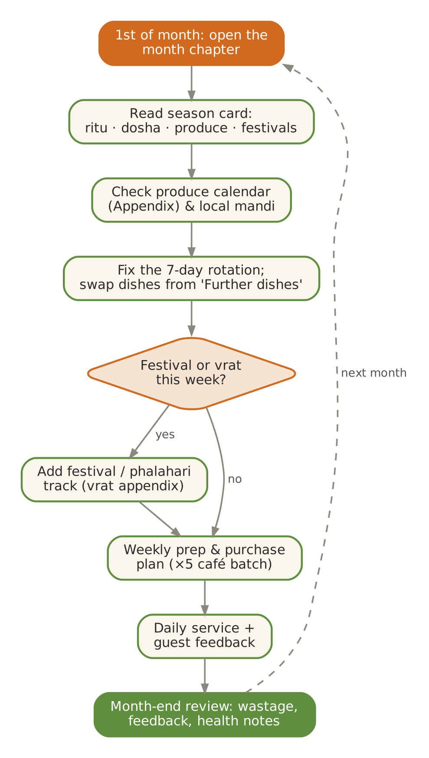  Figure 1. The monthly planning cycle
  Section of each month | What it gives the kitchen
  Season card | Hindu month, Ayurvedic ritu, Haridwar weather, state of agni and doshas, tastes to favour and to limit
  Produce & festivals | What the garden and mandi offer this month; festivals and the food each calls for
  Kitchen guidance | 4–5 rules for the month, plus the morning and bedtime ritual drinks
  Seven-day menu | Breakfast, lunch thali (dal + 2 sabzis + rice/phulka + side), evening, dinner and small sweet for each day
  Nutrition chart | Energy by source and protein per serving for the month's six featured recipes
  Six recipes | Exact grams, household measures, café batch ×5, method, nutrition, 55+ care notes, Ayurvedic note, variations
  Process flowchart | The month's signature technique as a step-and-check flow
  Further dishes & variations | Extra ideas under every category to keep the menu fresh

2. Cooking for the 55+ Guest

What changes after 55
- Muscle loss (sarcopenia) accelerates — protein needs rise even as appetite falls. Spread protein across all three meals.
- Digestive secretions and chewing efficiency decline; dentures are common. Soft, moist textures and smaller, more frequent meals help.
- Thirst sensation weakens; dehydration is a frequent, silent problem in Haridwar's summer and in winter when people simply drink less.
- Bone density falls, especially in women — calcium, vitamin D (sunlight) and protein together protect bones.
- Blood pressure, blood sugar and cholesterol are common concerns — salt, sugar and fat are portioned deliberately.
- Constipation is common — warm water, fibre, ghee and stewed fruit address it; the Vata diet is naturally suited.

Daily planning targets
Nutrient | Indicative daily target | How the menu delivers it
Energy | 1,600 – 2,000 kcal | Lower end for sedentary women; adjust for activity and weight trend
Protein | ≈ 1.0 – 1.2 g per kg body weight (≈ 55 – 70 g) | Higher than younger adults to protect muscle (sarcopenia); spread across 3 meals
Dietary fibre | 25 – 30 g | Whole moong, dalia, vegetables, fruit; with adequate water
Calcium | 1,000 – 1,200 mg | Milk, curd, paneer, ragi, sesame, leafy greens
Vitamin D | 600 – 800 IU | Morning sun 15–20 min; supplements on medical advice
Vitamin B12 | ≈ 2.5 µg | Dairy is the main vegetarian source — milk & curd daily; check levels
Visible fat (ghee + oil) | 20 – 25 g | Of which ghee 10–15 g (2–3 tsp), per the Vata plan
Salt | < 5 g (≈ 1 level tsp) total | House recipes use ¾ tsp per 4 servings; no salt shakers on tables
Added sugar | < 25 g | Dates, jaggery and fruit preferred; sweets at 40–100 g portions
Fluids | 1.5 – 2.0 L | Unless restricted by a doctor; thirst declines with age — offer hourly
Targets are indicative planning figures drawn from ICMR-NIN and international guidance for older adults; individual needs differ and medical advice takes precedence.

The Annapurna thali
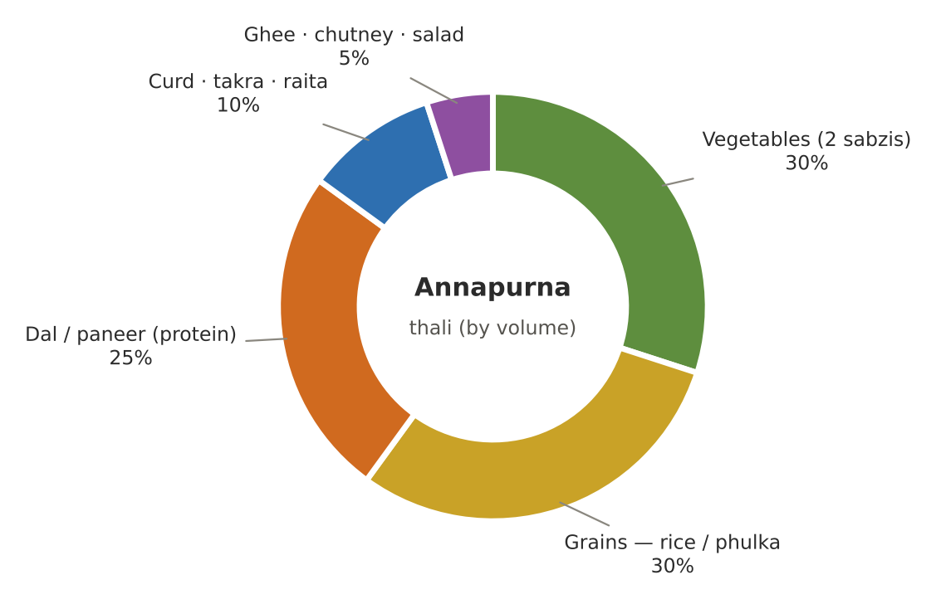
Figure 2. Plate model for lunch — by volume
Item | Standard 55+ portion | Small-appetite portion
Cooked rice / khichdi | 150 g (1 heaped katori) | 100 g
Phulka | 2 (≈60 g atta) | 1–2
Dal / kadhi / sambar | 180 ml (1 katori) | 150 ml
Sabzi (each) | 120 – 150 g | 100 g
Curd / raita | 100 g (lunch only) | 75 g
Soup (dinner) | 250 ml | 200 ml
Sweet | 40 – 100 g | ≈ half
Fruit | 100 – 150 g | 100 g, stewed if raw is unsuitable
Ghee (whole day) | 10 – 15 g | 5 – 10 g

Does the menu meet the targets? A model day, month by month
For each month we added one serving of each of that month's six featured recipes to the daily staples (50 g raw rice, 60 g atta as two phulkas, 100 g curd and the bedtime golden milk). The result is an estimate of what a guest eating the full menu receives.
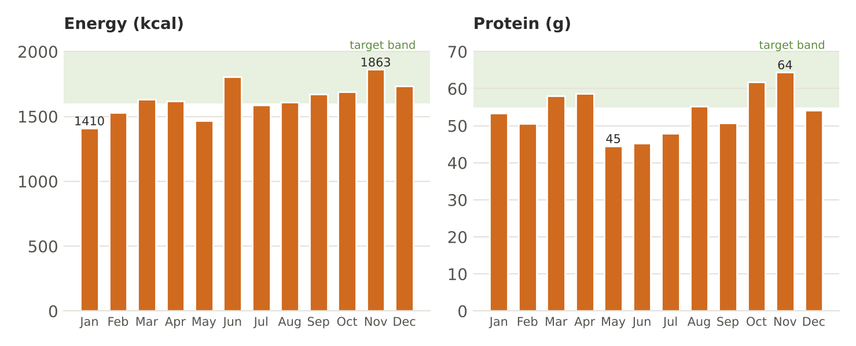
Figure 3. Estimated model-day energy and protein; green band = target range
What the model day tells the kitchen
- Energy sits within or just below the 1,600–2,000 kcal band in most months — appropriate for mostly sedentary guests.
- Protein is the gap: May, June and July fall to about 45 g. In these months add one of: 50 g paneer at lunch, a glass of milk or takra mid-morning, sattu sharbat, or a moong chilla at breakfast.
- Salt stays near 3–4 g from recipes — leaving room within the 5 g limit for curd and bread.
- Fibre reaches 25–32 g except in July (≈ 19 g); add stewed fruit and dalia in the monsoon.

3. Ayurvedic Principles for the Later Years
In Ayurveda, life is divided into three stages: childhood (Kapha), adulthood (Pitta) and the later years (Vata). The source Kerala plan summarises the right diet for this Vata stage in four qualities — and they are the backbone of this book.
Quality | Meaning | In the Annapurna kitchen
Ushna — warm | Warm in temperature and in action | Every dish served warm; drinks at room temperature; ginger, cumin, pepper used gently
Snigdha — unctuous | Moist, oily enough to counter dryness | 2–3 tsp ghee daily; sesame, coconut milk, nuts in measured amounts
Brimhana — grounding | Nourishing, building tissue | Root vegetables, rice, wheat, milk, paneer, dates, moong
Laghu-pachaka — easy to digest | Light enough for weak agni | Khichdi, kanji, yusha, steamed dishes; legumes always paired with hing & ginger

The six seasons at Haridwar
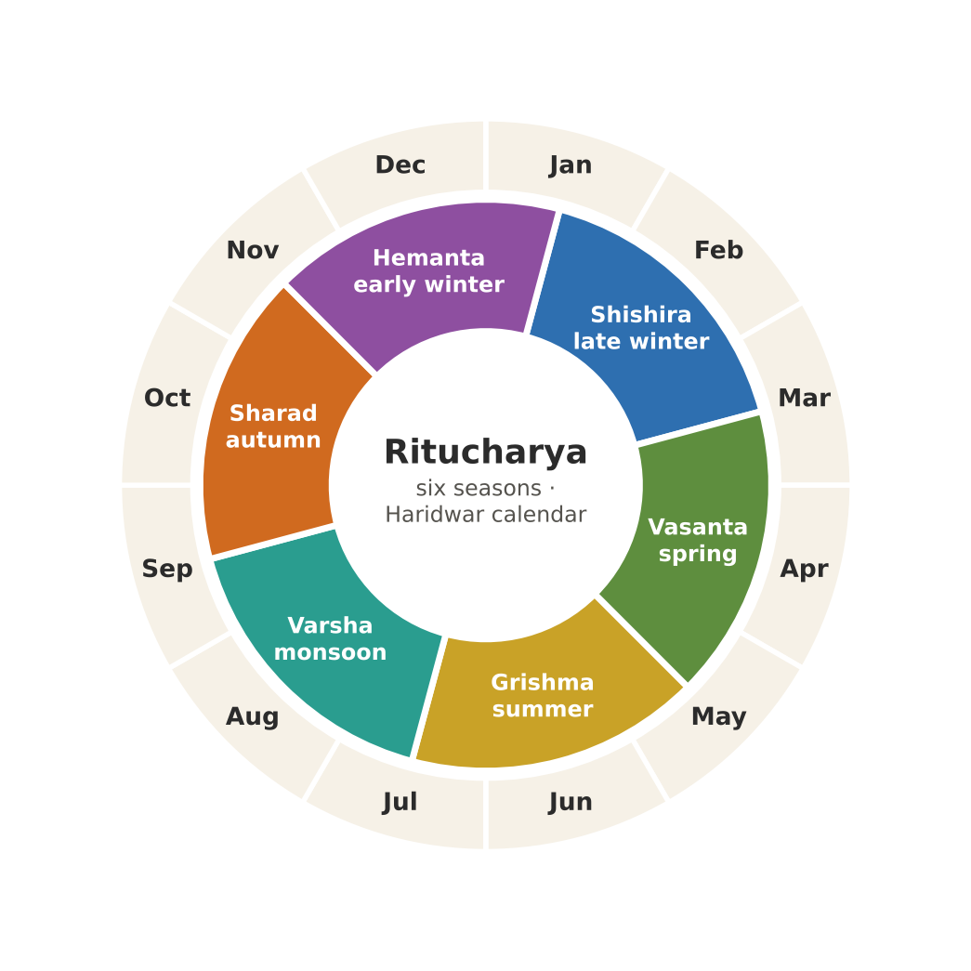
Figure 4. The ritucharya calendar used in this book (seasons begin around mid-month)

How each dosha moves through the year
Ayurveda teaches that each dosha first accumulates, then becomes aggravated, then subsides. Menus anticipate this: for example, Kapha accumulates in late winter, so March menus turn light and bitter before spring congestion peaks.
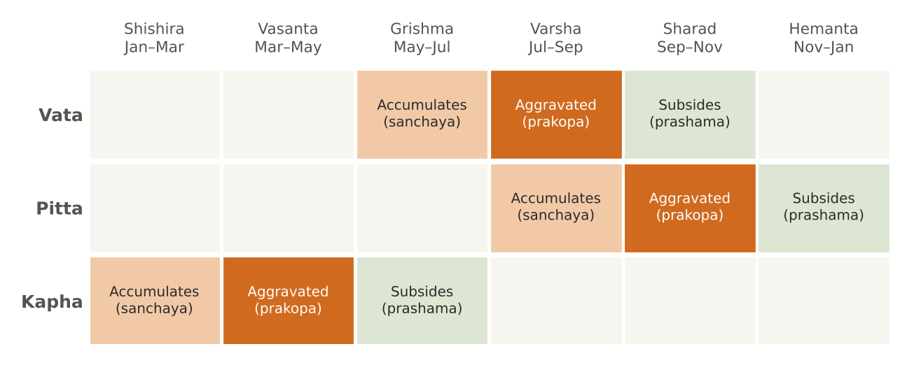
Figure 5. Seasonal cycle of the doshas (classical sanchaya–prakopa–prashama)

Agni through the day
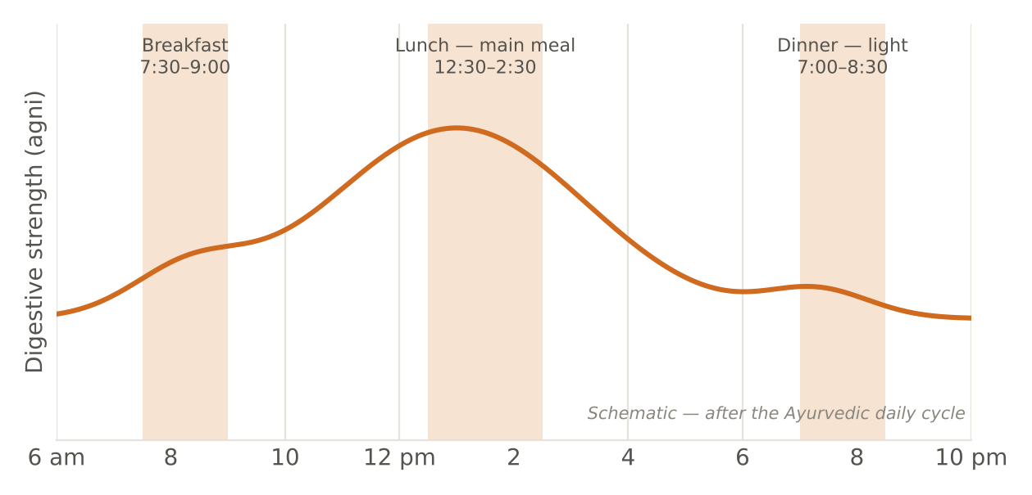
Figure 6. Why lunch is the main meal and dinner stays light
Key Vata dietary rules (from the source Kerala plan)
- Never eat cold or raw: avoid raw salads, ice water, cold smoothies and unheated leftovers — cold immediately agitates Vata. (Raw salads appear only as steamed or cooked versions.)
- Generous ghee: 2–3 teaspoons of pure ghee spread across daily meals to lubricate the intestinal tract and counter Vata dryness.
- Pacing: the largest meal at lunch (12:00–1:30 pm) when agni is strongest; dinner light and early — ideally by 7:00–7:30 pm.

Combinations the kitchen avoids
- Curd at night, curd heated, or curd with fruit; milk with sour fruit or salt-heavy dishes.
- Honey heated or cooked — honey is always added to warm (not hot) drinks.
- Equal quantities of ghee and honey together.
- Very cold drinks with or after meals; fruit (other than stewed) at the end of a heavy meal.

4. The Daily Rhythm
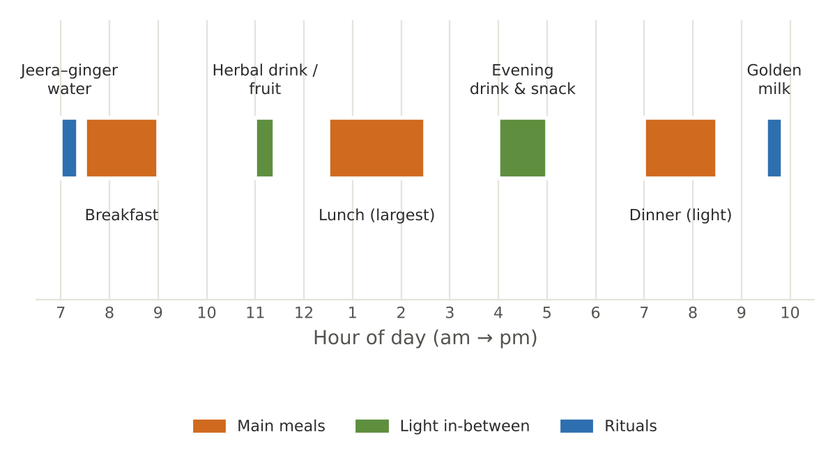
Figure 7. The guest day at the Centre
Time | What is served | Notes
7:00 am | Warm jeera–ginger water (150 ml) | Seasonal swaps: saunf water (summer), dhaniya water (Sharad)
7:30 – 9:00 am | Breakfast (fixed meal) | A warm grain or pulse dish + fruit + tea/milk
11:00 am | Herbal drink / fruit (optional) | CCF tea, takra, coconut water; stewed fruit in winter
12:30 – 2:30 pm | Lunch — the main meal | Rice, dal, phulka, two seasonal vegetables, curd/raita/takra
4:00 – 5:00 pm | Evening drink & light snack | Kadha, sharbat, makhana, stewed fruit
7:00 – 8:30 pm | Dinner — light | Soup/khichdi/kanji, one vegetable, phulka or rice, small sweet; encourage 7:00–7:30
9:30 pm | Golden milk (150 ml) | Turmeric, nutmeg, cardamom, ½ tsp ghee
Meal requests follow the Centre's policy: inform by 6:00 pm on the previous day; on-demand meals subject to availability.

Morning and bedtime rituals

Morning Jeera–Ginger Water
FOUNDATION · Serves 1 · Portion: 150 ml on waking · 8 min
Texture: Thin liquid Dosha: Vata–Kapha
Ingredient | Household measure | Base qty | Café batch ×5
Water | ¾ cup + 1 tbsp | 200 ml | 1,000 ml
Cumin (jeera) | ¼ tsp crushed | 1 g | 5 g
Ginger, fresh | 1 thin slice | 2 g | 10 g
Method
1. Boil water with crushed cumin and ginger 5 minutes.
2. Cool to sip-warm; strain.
3. Serve at 7:00 am as guests wake.

Per serving | Energy  5 kcal | Protein  0.1 g | Fat  0.1 g | Carbs  0.9 g | Fibre  0.3 g | Salt  0.0 g

Care notes for 55+ guests  From the source Kerala ritual. Guests on fluid restriction count it in their daily allowance. | Ayurvedic note  Warm water on waking awakens agni and helps morning bowel movement (a Vata function).
Variations & further ideas: Saunf water (summer) · Dhaniya water (Pitta) · Ajwain water (monsoon) · Lemon–honey water (spring, honey off heat)

Golden Milk (Haldi Doodh) — Bedtime
FOUNDATION · Serves 1 · Portion: 150 ml at 9:30 pm · 8 min
Texture: Liquid Dosha: Vata-pacifying
Ingredient | Household measure | Base qty | Café batch ×5
Cow's milk, whole | ⅔ cup (or almond milk) | 150 ml | 750 ml
Turmeric powder | ⅛ tsp | 0.5 g | 2.5 g
Nutmeg | tiny pinch | 0.1 g | 0.3 g
Green cardamom | 1 pod, crushed | 0.2 g | 1 g
Ghee (cow) | ½ tsp | 2.5 g | 13 g
Black pepper | 1 grain, crushed | 0.1 g | 0.5 g
Method
1. Simmer milk with turmeric, nutmeg and cardamom 3 minutes.
2. Add ghee and a crushed peppercorn.
3. Serve warm.

Per serving | Energy  123 kcal | Protein  4.9 g | Fat  8.3 g | Carbs  7.6 g | Fibre  0.2 g | Salt  0.0 g

Care notes for 55+ guests  The source plan specifies ¼ cup; we standardise to 150 ml so it contributes ≈ 180 mg calcium. Guests with reflux: 100 ml, at least 1 hour after dinner. | Ayurvedic note  Nutmeg is a gentle sleep aid; turmeric with pepper and fat improves absorption.
Variations & further ideas: Saffron milk · Ashwagandha milk (only on physician advice) · Date milk · Almond-milk version

5. Kitchen Standards

Measures and conversions
Measure | Metric | Kitchen note
1 cup (standard) | 240 ml | 1 katori ≈ 150 – 180 ml
1 tablespoon (tbsp) | 15 ml | ≈ 3 tsp
1 teaspoon (tsp) | 5 ml | —
1 pinch | ≈ 0.2 – 0.3 g | Between thumb and forefinger
1 inch ginger | ≈ 8 – 10 g | —
1 medium carrot | ≈ 100 g | —
1 medium tomato | ≈ 100 g | —
1 medium potato | ≈ 150 g | —
1 bunch spinach (cleaned) | ≈ 200 – 250 g | —

Ingredient (1 cup) | Weight | Ingredient (1 cup) | Weight
Rice (basmati, raw) | 190 – 200 g | Moong / masoor dal | 190 – 200 g
Atta (wheat flour) | 120 g | Besan | 90 – 100 g
Suji (semolina) | 160 – 170 g | Dalia (broken wheat) | 160 g
Rolled oats | 90 g | Poha (thick) | 100 g
Ragi flour | 120 – 130 g | Rice flour | 120 g
Jaggery (grated, packed) | 200 g | Mishri / sugar | 200 g
Fresh grated coconut | 80 – 90 g | Sesame seeds | 120 g
Milk / water | 240 g | Ghee (melted) | 220 g

Water-to-grain ratios (by volume)
Dish | Regular | House standard (55+) | Very soft / recovery
Soft white rice | 1 : 2.5 (pressure 3 whistles) | 1 : 4 | 1 : 5 (very soft)
Moong-dal khichdi | 1 : 3 | 1 : 4 (house) | 1 : 5 – 6 (porridge)
Kanji (rice gruel) | — | 1 : 10 | 1 : 12 – 14
Dalia khichdi | 1 : 3 | 1 : 4 | 1 : 5
Upma (suji) | 1 : 2 (by volume) | 1 : 2.5 | 1 : 3 (soft-set)
Dal (split) | 1 : 3 | 1 : 4 | 1 : 5 – 6 (yusha)
Samak rice | 1 : 3 | 1 : 4 | 1 : 5

Texture levels
Level | What it looks like | For whom
Level 1 · Regular-soft | Normal house food, cooked until tender; no hard, crisp or chewy items | Most guests
Level 2 · Soft & bite-sized | Pieces ≤ 1.5 cm, mash with a fork; soft phulka torn small; no whole nuts | Partial dentures, weak grip, fatigue
Level 3 · Minced & moist | Pieces ≤ 4 mm in thick sauce/dal; khichdi porridge; no separate thin liquid | Chewing difficulty, mild swallowing problems (on clinician advice)
Level 4 · Pureed | Smooth, lump-free, holds shape on a spoon (soups thickened, dal blended) | Swallowing difficulty — only with a speech/swallow assessment

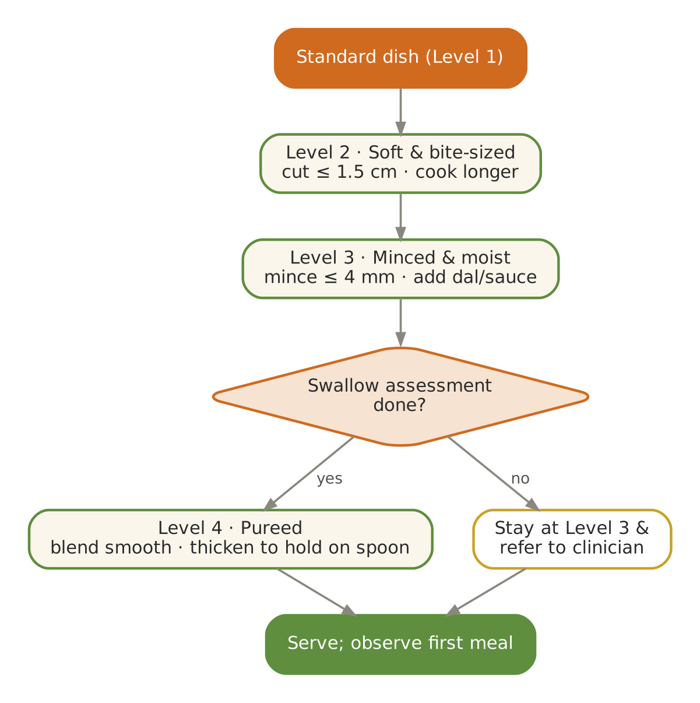  Figure 8. Modifying a dish down the texture levels | The sattvic code of this kitchen  - No onion, garlic, meat, fish, eggs, mushrooms or alcohol. Hing (asafoetida) and ginger provide the depth onion–garlic would give.  - Rock salt (sendha) on fast days; regular iodised salt otherwise (iodine matters for older adults).  - Tomato is optional in every recipe — some guests observe a tomato-free sattvic diet.  - Food is cooked with a calm mind; the cook does not taste from the serving spoon; the first portion is offered (bhog) where the Centre's practice requires.

Therapeutic adaptations
Condition | Favour | Limit / watch
Diabetes / prediabetes | Moong, whole grains (dalia, oats, jowar, samak); vegetables first, then dal, then grain | Sweets ≤ 2 tbsp with meals; dates instead of mishri; no fruit juices; jamun, guava, amla welcome
High blood pressure | Salt ≤ ¾ tsp per 4 servings (house default); lemon, herbs, cumin for flavour | No papad, pickles, namkeen, black salt in excess; potassium-rich vegetables (unless kidney disease)
Chronic kidney disease | Doctor/dietitian prescription governs protein, potassium and fluid | Leach potatoes/greens (soak, boil, discard water); avoid sattu, coconut water, star fruit
Weak digestion / low appetite | Small warm meals; khichdi, kanji, yusha; ginger–rock salt slice before lunch | Calorie-dense additions: ghee, almond paste in milk, paneer
Constipation | Fluids, warm water on waking, ghee, stewed fruit, dalia, bathua, bhindi, papaya | Avoid excess bael, raw banana and dry foods
Acidity / reflux | Cooling Pitta foods: lauki, ash gourd, coconut, milk, rice; dinner 3 h before bed | Avoid sour, chilli, fried food; no lying down after meals
Osteoporosis / joint pain | Calcium: milk, curd, ragi, sesame, paneer; turmeric & ginger in cooking | Morning sunlight; protein at each meal
Anaemia | Moong, masoor, leafy greens with lemon/amla (vitamin C) | Tea/coffee at least 1 h away from meals

New-guest matching and food safety
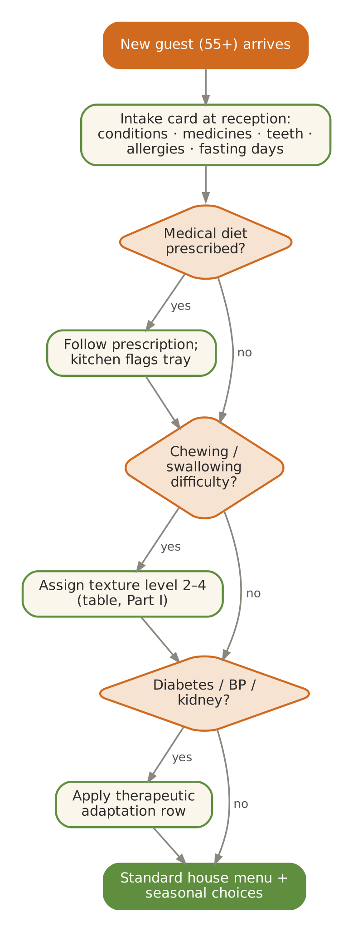  Figure 9. Matching a new guest to the right menu track | 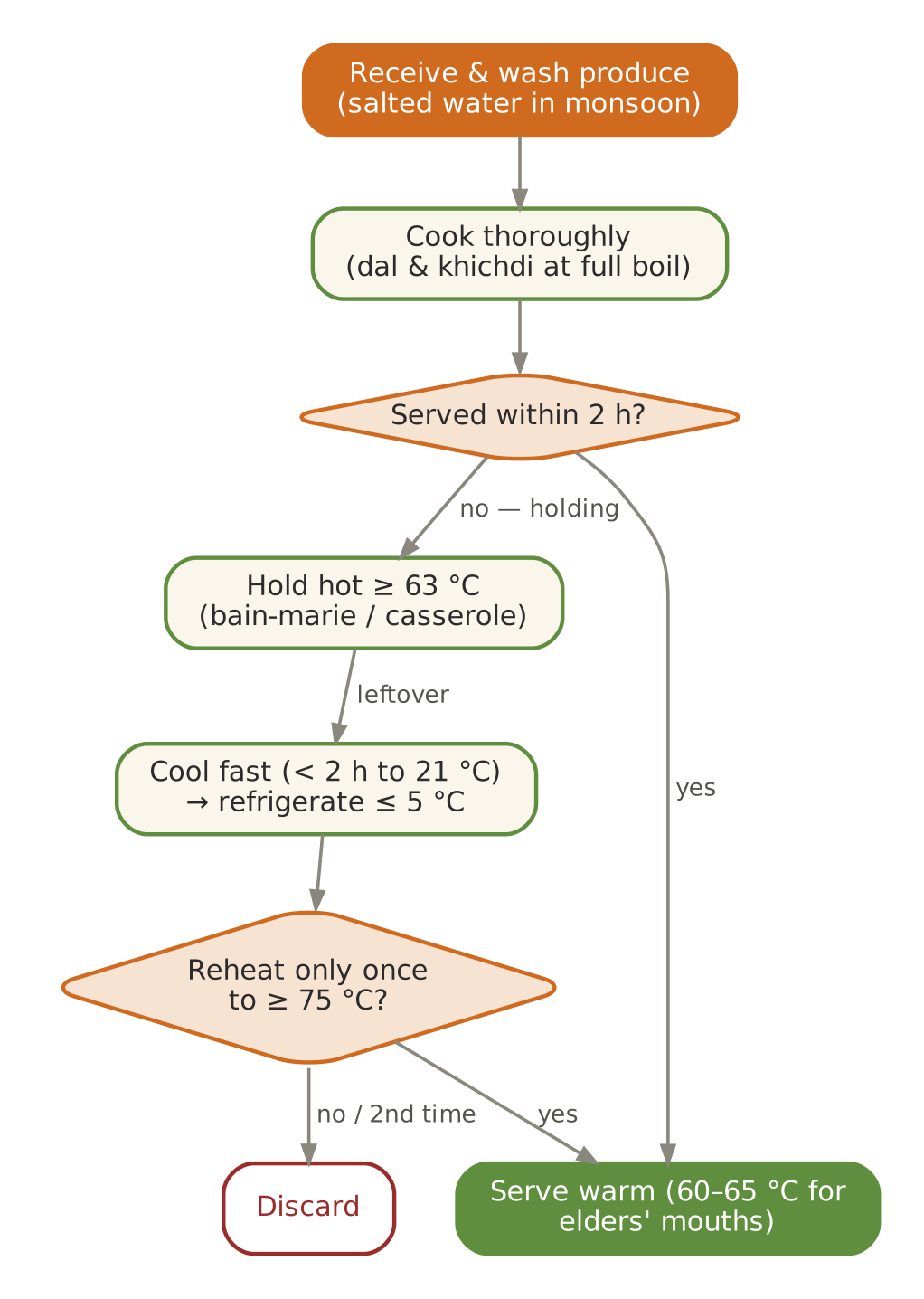  Figure 10. Cook–hold–serve: stricter for older guests

A day and a week in the kitchen
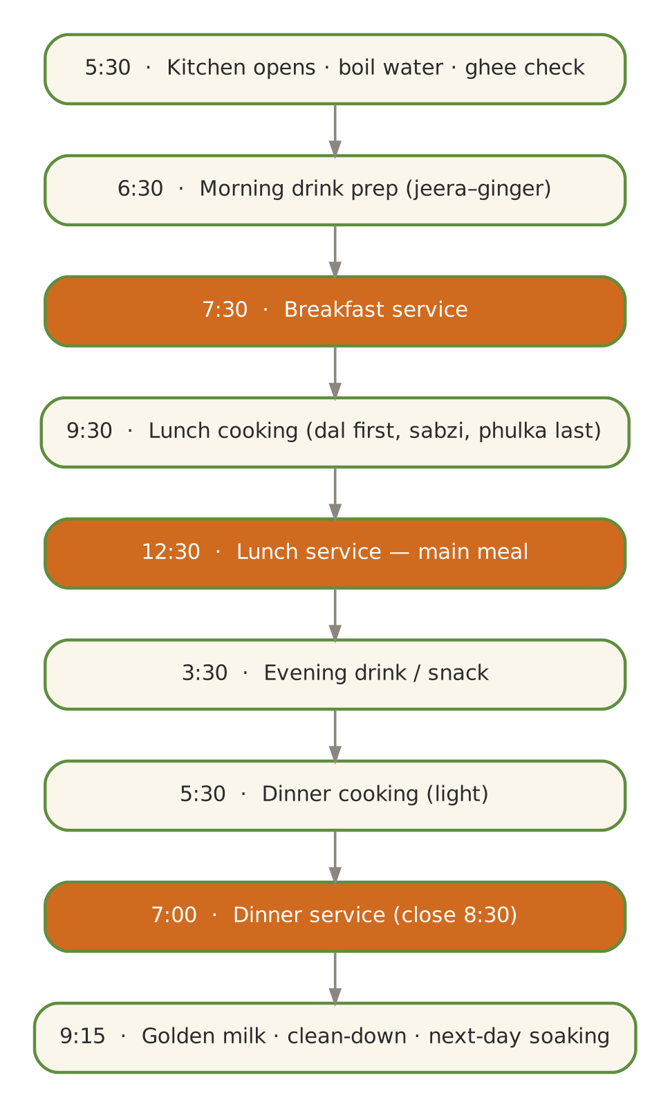  Figure 11. Daily service flow (orange = service) | 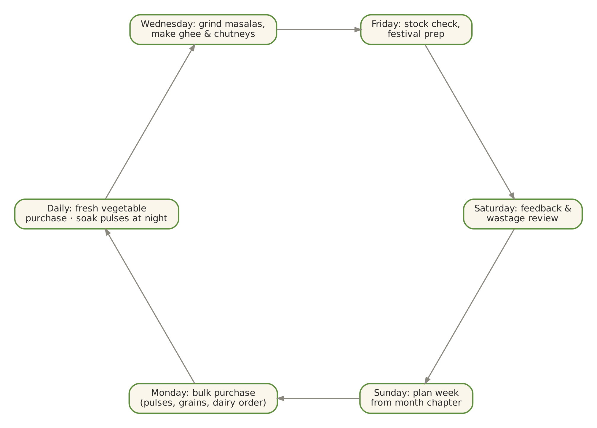  Figure 12. Weekly procurement & prep cycle

6. Foundation Recipes
These preparations are used throughout the twelve months. Make them in-house; they define the flavour and integrity of the kitchen.

Home Ghee from Unsalted White Butter
FOUNDATION · Serves 80 · Portion: 1 tsp (5 g) · 40 min
Texture: — Dosha: Tridoshic; the master Vata medicine
Ingredient | Household measure | Base qty | Café batch ×5
Unsalted white butter | 500 g unsalted white butter (makkhan) | 500 g | 2,500 g
Method
1. Melt butter in a heavy steel pan on low.
2. Simmer gently 25–30 minutes; foam rises, then subsides; milk solids sink and turn light brown.
3. When bubbling becomes quiet and the ghee is clear golden with a nutty aroma, turn off the heat.
4. Cool 10 minutes; strain through fine muslin into a dry glass or steel jar.
5. Yield ≈ 400 g. Store at room temperature; always use a dry spoon.

Per serving | Energy  45 kcal | Protein  0.1 g | Fat  5.1 g | Carbs  0.0 g | Fibre  0.0 g | Salt  0.0 g

Care notes for 55+ guests  Daily house allowance: 2–3 tsp (10–15 g) per guest spread across meals, as the source Vata plan recommends. Guests with high LDL cholesterol: 1–2 tsp. | Ayurvedic note  Ghrita carries herbs into tissues (yogavahi), kindles agni without aggravating Pitta, and lubricates Vata dryness.
Variations & further ideas: Herbal ghee with curry leaves · Ghee from cultured cream (bilona style) · Ginger-infused ghee · Saffron ghee for sweets

Sattvic Garam Masala (No Onion–Garlic)
FOUNDATION · Serves 50 · Portion: ¼ tsp · 20 min
Texture: Powder Dosha: Warming; use sparingly in Pitta months
Ingredient | Household measure | Base qty | Café batch ×5
Coriander seed / powder | 4 tbsp coriander seeds | 40 g | 200 g
Cumin (jeera) | 2 tbsp | 20 g | 100 g
Fennel (saunf) | 1 tbsp | 10 g | 50 g
Green cardamom | 15 pods | 5 g | 25 g
Cinnamon | 2-inch stick | 5 g | 25 g
Clove | 12 | 2 g | 10 g
Black pepper | 1½ tsp | 5 g | 25 g
Bay leaf (tej patta) | 2 leaves | 1 g | 5 g
Dry ginger (saunth) | 2 tsp dry ginger | 5 g | 25 g
Nutmeg | ¼ nutmeg | 1 g | 5 g
Method
1. Dry-roast whole spices on low 4–5 minutes until fragrant; do not darken.
2. Cool completely.
3. Grind fine with dry ginger and nutmeg.
4. Store airtight, away from light; make fresh every 2 months.

Per serving | Energy  6 kcal | Protein  0.2 g | Fat  0.2 g | Carbs  0.9 g | Fibre  0.5 g | Salt  0.0 g

Care notes for 55+ guests  Our blend contains no chilli — heat is added separately and mildly where needed. | Ayurvedic note  Coriander and fennel dominate to keep the blend Pitta-friendly.
Variations & further ideas: Sambar powder (mild) · Rasam powder · Kitchen king without onion–garlic · Chaat masala (house, low-salt)

House Digestive Churna (Hingvashtak-inspired)
FOUNDATION · Serves 60 · Portion: ½ tsp with first morsel of rice + ghee · 15 min
Texture: Powder Dosha: Vata–Kapha; kindles agni
Ingredient | Household measure | Base qty | Café batch ×5
Cumin (jeera) | 3 tbsp, roasted | 30 g | 150 g
Fennel (saunf) | 2 tbsp, roasted | 20 g | 100 g
Carom (ajwain) | 1 tbsp | 10 g | 50 g
Dry ginger (saunth) | 4 tsp dry ginger | 10 g | 50 g
Black pepper | 1½ tsp | 5 g | 25 g
Asafoetida (hing) | ½ tsp | 2 g | 10 g
Rock salt (sendha namak) | 1 tbsp rock salt | 15 g | 75 g
Method
1. Dry-roast cumin, fennel and ajwain separately on low.
2. Cool and grind with dry ginger, pepper and rock salt.
3. Warm hing in a dry pan 10 seconds; mix in.
4. Store airtight; place a small bowl on each lunch table.

Per serving | Energy  4 kcal | Protein  0.1 g | Fat  0.1 g | Carbs  0.6 g | Fibre  0.3 g | Salt  0.3 g

Care notes for 55+ guests  Not a medicine — a culinary digestive. Guests with ulcers or reflux should avoid it. | Ayurvedic note  Modelled on the classical Hingvashtak churna taken with the first morsel of rice and ghee.
Variations & further ideas: Ajwain–saunf mukhwas · Jeera–hing takra masala · Dhaniya–saunf digestive · Ginger–rock-salt slices

CCF Tea (Cumin–Coriander–Fennel)
FOUNDATION · Serves 4 · Portion: 150 ml · 12 min
Texture: Thin liquid Dosha: Tridoshic
Ingredient | Household measure | Base qty | Café batch ×5
Cumin (jeera) | ½ tsp | 2 g | 10 g
Coriander seed / powder | ½ tsp seeds | 2 g | 10 g
Fennel (saunf) | ½ tsp | 2 g | 10 g
Water | 3⅓ cups | 800 ml | 4,000 ml
Method
1. Bring water to a boil.
2. Add the three seeds; simmer 10 minutes.
3. Strain; serve warm through the day.

Per serving | Energy  5 kcal | Protein  0.2 g | Fat  0.1 g | Carbs  0.8 g | Fibre  0.4 g | Salt  0.0 g

Care notes for 55+ guests  Caffeine-free — good for evening and for guests with sleep difficulty. | Ayurvedic note  The best-known Ayurvedic digestive tea; gently diuretic and anti-bloating.
Variations & further ideas: CCF with mint (summer) · CCF with ginger (winter) · CCF with tulsi (monsoon) · CCF with rose (Sharad)

Spiced Takra (Digestive Buttermilk)
FOUNDATION · Serves 4 · Portion: 200 ml · 10 min
Texture: Thin liquid Dosha: Vata–Kapha; Pitta with coriander
Ingredient | Household measure | Base qty | Café batch ×5
Curd (dahi), plain | ¾ cup + 1 tbsp fresh curd | 200 g | 1,000 g
Water | 2½ cups (1 : 3) | 600 ml | 3,000 ml
Cumin (jeera) | ½ tsp roasted, powdered | 2 g | 10 g
Ginger, fresh | 1 tsp grated | 5 g | 25 g
Rock salt (sendha namak) | ⅓ tsp rock salt | 2 g | 10 g
Ghee (cow) | ½ tsp (tempering) | 3 g | 15 g
Asafoetida (hing) | small pinch | 0.2 g | 1 g
Curry leaves | 5 leaves | 1 g | 5 g
Coriander leaves | 1 tbsp | 5 g | 25 g
Method
1. Churn curd and water well (remove any butter that rises).
2. Add roasted cumin, ginger and salt.
3. Temper ghee, hing and curry leaves; pour in.
4. Add coriander; serve at room temperature.

Per serving | Energy  40 kcal | Protein  1.8 g | Fat  2.6 g | Carbs  2.8 g | Fibre  0.2 g | Salt  0.5 g

Care notes for 55+ guests  Takra is the one cultured-milk drink Ayurveda allows after sunset in small amounts — unlike curd. | Ayurvedic note  'Takra is to humans what amrita is to the gods' — an old saying on its digestive value.
Variations & further ideas: Pudina takra · Neer mor (Tamil) · Sambharam (Kerala) · Moru curry (warm)

Soft Phulka (House Standard)
FOUNDATION · Serves 8 · Portion: 1 phulka (≈30 g dough) · Rest 20 min · 15 min
Texture: Soft Dosha: Grounding
Ingredient | Household measure | Base qty | Café batch ×5
Whole-wheat flour (atta) | 1⅓ cups | 160 g | 800 g
Water | ⅓ cup + 1 tbsp, lukewarm | 100 ml | 500 ml
Rock salt (sendha namak) | pinch | 0.5 g | 2.5 g
Ghee (cow) | ¼ tsp per phulka | 10 g | 50 g
Method
1. Knead atta, salt and lukewarm water to a soft, slightly sticky dough (8 minutes).
2. Cover and rest 20 minutes.
3. Divide into 8 balls; roll thin (6 inches) with minimal dry flour.
4. Cook on a hot tawa 20 seconds, flip, 30 seconds; puff on an open flame.
5. Brush ¼ tsp ghee; keep in a cloth-lined casserole.

Per serving | Energy  79 kcal | Protein  2.4 g | Fat  1.6 g | Carbs  12.8 g | Fibre  2.2 g | Salt  0.1 g

Care notes for 55+ guests  Lukewarm water and a long rest keep phulkas soft for hours; offer to tear into small pieces for denture wearers. | Ayurvedic note  Wheat is sweet and grounding — the staple of the North Indian Vata diet.
Variations & further ideas: Jowar–wheat phulka (50:50) · Makki–wheat (25:75) winter roti · Methi phulka · Ragi–wheat phulka

Mint–Coriander Chutney (No Garlic)
FOUNDATION · Serves 10 · Portion: 1 tbsp · 10 min
Texture: Smooth paste Dosha: Cooling; aids digestion
Ingredient | Household measure | Base qty | Café batch ×5
Coriander leaves | 2 cups leaves & tender stems | 60 g | 300 g
Mint leaves | 1 cup leaves | 30 g | 150 g
Ginger, fresh | 1-inch | 10 g | 50 g
Green chilli (optional, deseeded) | ½ (optional) | 2 g | 10 g
Lemon juice | 1 tbsp | 15 ml | 75 ml
Cumin (jeera) | ¼ tsp roasted | 1 g | 5 g
Rock salt (sendha namak) | ⅓ tsp | 2 g | 10 g
Curd (dahi), plain | 2 tbsp (for smoothness) | 30 g | 150 g
Water | 2 tbsp | 30 ml | 150 ml
Method
1. Wash herbs in salted water; drain well.
2. Grind all ingredients smooth.
3. Store refrigerated up to 2 days; bring to room temperature to serve.

Per serving | Energy  6 kcal | Protein  0.4 g | Fat  0.2 g | Carbs  0.9 g | Fibre  0.4 g | Salt  0.2 g

Care notes for 55+ guests  Mild version by default; the curd tames sharpness. | Ayurvedic note  Coriander cools Pitta; mint and ginger aid digestion.
Variations & further ideas: Coconut–coriander chutney · Amla–ginger chutney · Tomato-free curry-leaf chutney · Raw-mango–mint chutney

7. The Kerala Vata Week — Adapted for Annapurna Kitchen
The source plan is an authentic, nutrient-complete Kerala Ayurvedic menu. We kept its structure and almost all of its dishes; the changes below make it fully vegetarian and sattvic for Haridwar, and softer for older guests. Its dishes reappear across the year (December oats, June idiyappam & stew, September kanji, olan and payasam, December carrot–ginger soup).
Day | Source breakfast / item | Annapurna adaptation | Source lunch | Annapurna adaptation
Mon | Njavara/basmati kanji with ghee, cumin, ginger · soaked almonds | Unchanged — kept as is | Basmati rice, moong parippu, sweet potato with coconut, warm beet salad | Warm beet salad served as beet thoran (cooked, warm)
Tue | Rava upma with ghee, mustard, curry leaves, carrots | Unchanged | Mor keerai (spinach in curd–coconut) + soft-boiled eggs or paneer | Eggs → paneer cubes sautéed in ghee (vegetarian, Haridwar)
Wed | Steel-cut oats, almond milk, cardamom, cinnamon, ghee, dates | Unchanged (see December breakfast) | Red matta rice, erissery, ghee | Unchanged — matta double-cooked very soft
Wed dinner | Chicken bone broth (mamsa rasa) or pumpkin–lentil soup | Chicken broth → Moong yusha / pumpkin–lentil soup | — | Classical vegetarian restorative replaces meat broth
Thu | Njavara kanji with hing + 2 soft-boiled eggs | Eggs → 2 tbsp cooked payar (whole moong) or 100 ml warm milk | Basmati rice, olan, snake-gourd thoran | Unchanged
Fri | Idiyappam with cardamom coconut milk | Unchanged (see June dinner) | Kalan (yam/plantain in curd–coconut) + cherupayar | Kalan served at lunch only (curd)
Sat | Puttu with kadala curry | Kadala soaked 8 h and pressure-cooked very soft; small portion | Fish curry or paneer curry, beans–carrots | Fish → paneer or raw-banana curry in the same coconut–turmeric base
Sun | Njavara kanji with milk, cardamom, dates, ghee | Unchanged | Sadhya plate: rice, parippu, aviyal, beet pachadi | Unchanged — see September (Onam)

Why these substitutions work
- Moong yusha (classical pulse soup) is the traditional vegetarian restorative in place of mamsa rasa (meat broth).
- Paneer and well-cooked whole moong replace eggs as protein; milk adds B12, which strict vegetarians often lack.
- Raw-banana or paneer in the same coconut–turmeric gravy keeps the Kerala fish-curry flavour profile.
PART II

The Twelve Months
Season cards · seven-day menus · recipes · flowcharts · further ideas

January — Warmth, Sesame & Winter Greens
Hindu months | Paush – Magh
Ayurvedic season | Hemanta → Shishira (deep winter)
Haridwar weather | ≈ 7 – 19 °C, foggy mornings, dry cold
Agni (digestion) | Strongest of the year — nourishing, unctuous food is digested well
Dosha picture | Vata aggravated by cold and dryness; Kapha begins to accumulate
Favour | Favour sweet, sour and salty; warm, moist, freshly cooked food with ghee and sesame
Limit | Cold drinks, raw salads, dry crackers, stale leftovers, long gaps between meals

In season
Vegetables & greens | Fruit | Pantry & other
Sarson, bathua, methi, palak, carrots, peas, radish, turnip, cauliflower, cabbage, sweet potato, fresh turmeric | Guava, oranges/kinnow, amla, ber, apples (hill), papaya | Fresh jaggery, sesame, peanuts, bajra, makki

Festivals & observances
Occasion | Kitchen response
Lohri (13 Jan) | Til, gur, makhana and roasted peanuts — serve soft til–gud ladoo instead of hard rewri for elders.
Makar Sankranti (14 Jan) | Moong–rice khichdi with ghee, til–gud; Haridwar Ganga snan day — expect visitors.
Basant Panchami (late Jan / Feb, lunar) | Yellow kesari rice, boondi-free besan barfi (soft).

Kitchen guidance for January
- Serve the largest meal at lunch (12:30–1:30 pm); keep dinner light and by 7:30 pm.
- Include 2–3 tsp ghee across the day; use sesame oil for winter abhyanga-linked menus.
- Every dish served hot or warm — re-warm curd-based raitas to room temperature only.
- Leafy saags only well-cooked and blended smooth for guests with dentures.
- Offer a warm kadha at 4 pm to counter Kapha build-up and fog-season coughs.
Daily rituals: on waking — Warm water with crushed cumin and a slice of ginger (150 ml); at bedtime — Golden milk with turmeric, nutmeg, cardamom & ½ tsp ghee.

Seven-day menu — January
Rotate weekly; swap any item for one from 'Further dishes & variations' at the end of this chapter. Lunch always includes rice and phulka; curd/raita is served at lunch only.
Day | Breakfast 7:30–9:00 | Lunch thali 12:30–2:30 | Evening 4:00 | Dinner 7:00–8:30
Monday | Methi–moong dal chilla · mint–curd dip · guava | Sarson–palak–bathua saag · Gajar–matar–shakarkandi · Gobhi–matar adraki · rice & phulka · Bathua raita (room temp.) | Haldi–adrak–gud kadha · roasted makhana | Sankranti moong–rice vegetable khichdi · sweet: Til–gud ladoo (1 mini)
Tuesday | Bajra–moong soft dalia with ghee · stewed apple | Yellow moong dal tadka · Shalgam bharta · Aloo–methi · rice & phulka · Spiced takra | Til–gud ladoo (mini) · CCF tea | Palak–moong soup · soft phulka · sweet: Gajar halwa (40 g)
Wednesday | Gajar–matar upma · amla–ginger tea | Masoor–methi dal · Mooli bhurji with mooli greens · Palak paneer (sattvic) · rice & phulka · Amla–ginger chutney | Stewed guava with cinnamon | Carrot–ginger soup · ghee rice · sweet: Atta panjiri (1 tbsp)
Thursday | Steel-cut oats with dates & sesame · kinnow segments | Whole moong dal (soft) · Matar paneer, light gravy · Beans–carrot thoran · rice & phulka · Steamed carrot–beet salad | Badam–kesar milk | Vegetable dalia khichdi · sweet: Date–walnut barfi (1 pc)
Friday | Paneer–palak soft paratha · fresh curd | Panchmel dal (light) · Kaddu khatta-meetha · Cabbage–peas with ginger · rice & phulka · Mint–coriander chutney | Roasted shakarkandi chaat | Lauki–moong dal · soft phulka · sweet: Sweet-potato kheer (60 ml)
Saturday | Ragi–wheat soft dosa · coconut–coriander chutney | Bathua–moong dal · Gajar–matar–shakarkandi · Gobhi–matar adraki · rice & phulka · Bathua raita (room temp.) | Ginger–cinnamon tea · sesame–walnut mix | Methi–moong khichdi · warm takra · sweet: Sesame-chikki crumble on kheer
Sunday | Sweet-potato–jaggery porridge · 5 soaked almonds | Toor dal with lauki · Shalgam bharta · Aloo–methi · rice & phulka · Spiced takra | Orange–ginger infusion · 2 soaked figs | Mixed vegetable soup · jowar phulka · sweet: Moong dal halwa (30 g)

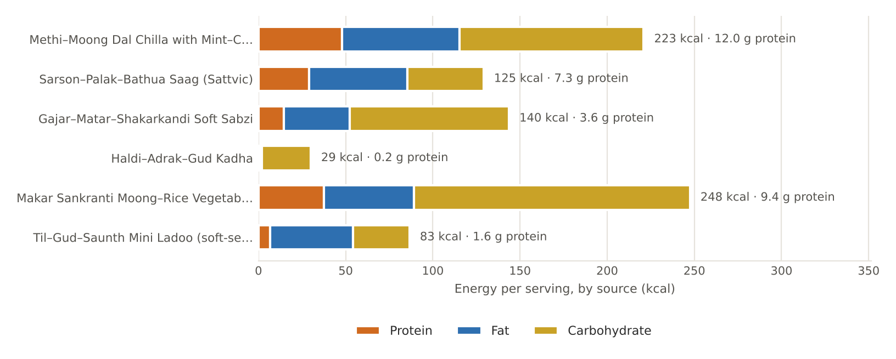
Figure. January's featured recipes — energy per serving by source, with protein

January recipes

Methi–Moong Dal Chilla with Mint–Curd Dip
BREAKFAST · Serves 4 · Portion: 2 chillas (≈120 g) + 2 tbsp dip · Soak 4 h · Cook 25 min
Texture: Soft Dosha: Balances all three; especially Kapha & Vata
Ingredient | Household measure | Base qty | Café batch ×5
Moong dal, yellow split | ¾ cup + 1 tbsp, soaked 4 h | 160 g | 800 g
Fenugreek leaves (methi) | 1 cup, finely chopped | 40 g | 200 g
Ginger, fresh | 1-inch piece, grated | 10 g | 50 g
Cumin (jeera) | ½ tsp | 2 g | 10 g
Asafoetida (hing) | 1 pinch | 0.3 g | 1.5 g
Turmeric powder | ¼ tsp | 1 g | 5 g
Rock salt (sendha namak) | ½ tsp (scant) | 3 g | 15 g
Water | ½ cup, for grinding | 120 ml | 600 ml
Ghee (cow) | 4 tsp (½ tsp per chilla) | 20 g | 100 g
Curd (dahi), plain | ¾ cup + 1 tbsp (dip) | 200 g | 1,000 g
Mint leaves | ¼ cup leaves (dip) | 10 g | 50 g
Cumin (jeera) | ¼ tsp roasted, powdered (dip) | 1 g | 5 g
Method
1. Rinse the moong dal three times and soak for 4 hours; drain.
2. Grind with ginger, cumin and ½ cup water to a smooth, pourable batter (like dosa batter).
3. Stir in methi, turmeric, hing and salt; rest 10 minutes.
4. Heat a tawa on medium, smear ¼ tsp ghee, pour ½ ladle (≈60 ml) and spread into a 6-inch circle, slightly thick.
5. Cook 2 minutes, drizzle ¼ tsp ghee around the edge, flip and cook 1–1½ minutes. Keep soft — do not crisp.
6. Dip: blend mint with 2 tbsp curd; whisk into remaining curd with roasted cumin and a pinch of salt. Serve at room temperature.

Per serving | Energy  223 kcal | Protein  12.0 g | Fat  7.5 g | Carbs  26.4 g | Fibre  4.2 g | Salt  0.8 g

Care notes for 55+ guests  Keep chillas soft and slightly thick for easy chewing; chop methi very fine. Curd always at room temperature, never chilled. A good diabetic-friendly, protein-rich breakfast. | Ayurvedic note  Moong is the lightest of pulses (laghu) and tridoshic; methi and ginger kindle agni on cold, Kapha-heavy mornings.
Variations & further ideas: Palak–moong chilla · Besan–oats chilla with grated lauki · Paneer-stuffed moong chilla · Lauki–moong chilla in summer months

Sarson–Palak–Bathua Saag (Sattvic)
LUNCH · SAAG · Serves 4 · Portion: 1 katori (≈150 g) · Prep 20 min · Cook 50 min
Texture: Pureed / smooth Dosha: Reduces Kapha; ghee keeps Vata settled
Ingredient | Household measure | Base qty | Café batch ×5
Mustard greens (sarson) | 1 large bunch, leaves & tender stems | 400 g | 2,000 g
Spinach (palak) | 1 small bunch | 200 g | 1,000 g
Bathua (chenopodium) leaves | 1 cup, packed | 100 g | 500 g
Fenugreek leaves (methi) | ¾ cup | 30 g | 150 g
Ginger, fresh | 1 tbsp grated | 15 g | 75 g
Green chilli (optional, deseeded) | ½ chilli, deseeded (optional) | 3 g | 15 g
Water | 1¼ cups | 300 ml | 1,500 ml
Rock salt (sendha namak) | ¾ tsp, level | 3.5 g | 18 g
Maize flour (makki atta) | 2 tbsp maize flour | 20 g | 100 g
Water | ½ cup (to whisk makki) | 120 ml | 600 ml
Ghee (cow) | 4 tsp (tempering) | 20 g | 100 g
Cumin (jeera) | ½ tsp | 2 g | 10 g
Asafoetida (hing) | 1 pinch | 0.3 g | 1.5 g
Kashmiri chilli powder (mild) | ¼ tsp Kashmiri chilli | 1 g | 5 g
Method
1. Wash all greens three times in plenty of water; chop roughly.
2. Pressure-cook greens with ginger, chilli, 1¼ cups water and salt — 3 whistles, then 10 minutes on low (or simmer covered 35 minutes).
3. Cool slightly and blend to a smooth purée (coarse for regular diners, smooth for denture wearers).
4. Whisk makki atta into ½ cup water, stir into the saag and simmer 15 minutes, stirring, until glossy.
5. Tempering: heat ghee, add cumin and hing, then Kashmiri chilli off the heat; pour over the saag.
6. Rest 5 minutes; serve hot with ½ tsp ghee on each katori.

Per serving | Energy  125 kcal | Protein  7.3 g | Fat  6.3 g | Carbs  10.9 g | Fibre  4.0 g | Salt  0.9 g

Care notes for 55+ guests  Serve with soft wheat phulka made with 25% makki atta rather than all-makki rotis, which are hard to chew. Add 50 g paneer cubes per serving for protein. | Ayurvedic note  Sarson is heating (ushna) and sharp; ghee and long, slow cooking soften its sharpness, making it a perfect Shishira Kapha-clearer.
Variations & further ideas: Saag paneer · Bathua raita (blanched, room temp.) · Palak–methi–moong saag dal · Chaulai (amaranth) saag in monsoon

Gajar–Matar–Shakarkandi Soft Sabzi
LUNCH · SABZI · Serves 4 · Portion: 1 katori (≈130 g) · Prep 15 min · Cook 25 min
Texture: Soft Dosha: Strongly Vata-pacifying (sweet, grounding)
Ingredient | Household measure | Base qty | Café batch ×5
Carrot | 2 medium, 1-cm dice | 250 g | 1,250 g
Green peas, fresh | 1 cup shelled | 150 g | 750 g
Sweet potato (shakarkandi) | 1 medium, 1-cm dice | 200 g | 1,000 g
Ghee (cow) | 1 tbsp | 15 g | 75 g
Cumin (jeera) | ½ tsp | 2 g | 10 g
Asafoetida (hing) | 1 pinch | 0.3 g | 1.5 g
Ginger, fresh | 2 tsp grated | 10 g | 50 g
Turmeric powder | ¼ tsp | 1 g | 5 g
Coriander seed / powder | 1 tsp coriander powder | 2 g | 10 g
Rock salt (sendha namak) | ½ tsp | 3 g | 15 g
Water | scant ½ cup | 100 ml | 500 ml
Lemon juice | 2 tsp | 10 ml | 50 ml
Coriander leaves | 2 tbsp chopped | 10 g | 50 g
Method
1. Heat ghee; add cumin, let it crackle, then hing and ginger for 30 seconds.
2. Add carrot and peas with turmeric, coriander powder and salt; toss 2 minutes.
3. Add water, cover and cook on low 8 minutes.
4. Add sweet potato, cover and cook 8–10 minutes until every piece is fork-tender.
5. Finish with lemon juice and coriander leaves.

Per serving | Energy  140 kcal | Protein  3.6 g | Fat  4.2 g | Carbs  22.8 g | Fibre  5.6 g | Salt  0.8 g

Care notes for 55+ guests  Dice small and cook covered until a spoon cuts each piece cleanly. Naturally sweet — no added jaggery needed. | Ayurvedic note  Sweet, heavy and grounding (madhura, brimhana) — classic Vata medicine for the 55+ years.
Variations & further ideas: Gajar–matar with paneer · Shakarkandi chaat · Gajar–methi · Beetroot–carrot thoran

Haldi–Adrak–Gud Kadha
EVENING · DRINK · Serves 4 · Portion: 150 ml cup · Cook 15 min
Texture: Thin liquid Dosha: Reduces Kapha & Vata
Ingredient | Household measure | Base qty | Café batch ×5
Water | 3 cups | 700 ml | 3,500 ml
Ginger, fresh | 1-inch piece, crushed | 15 g | 75 g
Turmeric powder | ½ tsp (or 10 g fresh root) | 2 g | 10 g
Black pepper | 4–5 peppercorns, crushed | 0.5 g | 2.5 g
Cinnamon | 1-inch stick | 1 g | 5 g
Tulsi (holy basil) leaves | 8–10 leaves | 3 g | 15 g
Jaggery (gur) | 2 tbsp grated | 24 g | 120 g
Lemon juice | 2 tsp (optional) | 10 ml | 50 ml
Method
1. Boil water with ginger, cinnamon, pepper and turmeric.
2. Simmer 10 minutes until reduced to about 600 ml.
3. Add tulsi leaves; simmer 2 minutes.
4. Turn off heat; stir in jaggery until dissolved.
5. Strain; add lemon only once warm. Serve at 60–65 °C.

Per serving | Energy  29 kcal | Protein  0.2 g | Fat  0.1 g | Carbs  7.0 g | Fibre  0.3 g | Salt  0.0 g

Care notes for 55+ guests  For diabetic guests, omit jaggery and boil in 2 chopped dates or serve unsweetened. | Ayurvedic note  Deepana (agni-kindling) and Kapha-clearing; turmeric with pepper improves absorption of curcumin.
Variations & further ideas: Ajwain–saunf kadha · Tulsi–cinnamon tea · Dalchini–elaichi doodh · Golden milk (bedtime)

Makar Sankranti Moong–Rice Vegetable Khichdi
DINNER · Serves 4 · Portion: 1 bowl (≈300 g) · Soak 20 min · Cook 30 min
Texture: Soft / porridge Dosha: Tridoshic — the house restorative
Ingredient | Household measure | Base qty | Café batch ×5
Rice, white basmati (raw) | ½ cup basmati | 100 g | 500 g
Moong dal, yellow split | ½ cup | 100 g | 500 g
Carrot | 1 small, diced | 80 g | 400 g
Green peas, fresh | ⅓ cup | 60 g | 300 g
Cauliflower | 6–8 small florets | 80 g | 400 g
Ghee (cow) | 4 tsp (2 tadka + 2 serve) | 20 g | 100 g
Cumin (jeera) | ½ tsp | 2 g | 10 g
Bay leaf (tej patta) | 1 leaf | 0.5 g | 2.5 g
Asafoetida (hing) | 1 pinch | 0.3 g | 1.5 g
Ginger, fresh | 2 tsp grated | 10 g | 50 g
Turmeric powder | ¼ tsp | 1 g | 5 g
Black pepper | ¼ tsp crushed | 0.5 g | 2.5 g
Rock salt (sendha namak) | ¾ tsp | 4 g | 20 g
Water | 3⅓ cups (4 : 1 house ratio) | 800 ml | 4,000 ml
Method
1. Wash rice and moong together; soak 20 minutes, drain.
2. In a pressure cooker heat 2 tsp ghee; add cumin, bay leaf, hing and ginger.
3. Add vegetables with turmeric; sauté 2 minutes, then the drained grains for 1 minute.
4. Add water, salt and pepper; pressure-cook 4 whistles and allow natural release (10 minutes).
5. Stir well; loosen with 100–200 ml hot water for a porridge-soft texture.
6. Serve each bowl with ½ tsp ghee on top.

Per serving | Energy  248 kcal | Protein  9.4 g | Fat  5.7 g | Carbs  39.6 g | Fibre  4.6 g | Salt  1.0 g

Care notes for 55+ guests  Porridge-soft, ideal for poor dentition or recovery days. Serve with warm spiced takra rather than cold curd at night. | Ayurvedic note  Khichdi is the classic laghu-pachaka (light, easily digested) meal — nourishing without burdening night-time agni.
Variations & further ideas: Bajra khichdi (lunch only) · Palak khichdi · Dalia khichdi · Samak khichdi on vrat days

Til–Gud–Saunth Mini Ladoo (soft-set)
SWEET · Serves 16 · Portion: 1 mini ladoo (≈15 g) · Cook 20 min
Texture: Soft-chewy Dosha: Vata-pacifying, warming
Ingredient | Household measure | Base qty | Café batch ×5
Sesame seeds (til) | 1 cup white til | 120 g | 600 g
Jaggery (gur) | ½ cup grated, packed | 100 g | 500 g
Almonds | 15 almonds, finely powdered | 20 g | 100 g
Dry ginger (saunth) | 1 tsp dry ginger powder | 2 g | 10 g
Green cardamom | ¼ tsp powder (4 pods) | 1 g | 5 g
Ghee (cow) | 1 tbsp | 15 g | 75 g
Water | 1 tbsp | 15 ml | 75 ml
Method
1. Dry-roast sesame on low 4–5 minutes until it begins to pop and turns pale gold; cool.
2. Coarse-grind half the sesame in a mixer — this makes softer ladoos.
3. Melt ghee, add jaggery and water; stir on low 2–3 minutes until melted and bubbling (a drop in water forms a SOFT ball — do not take to hard crack).
4. Off the heat, mix in all sesame, almond powder, saunth and cardamom.
5. While warm, grease palms with ghee and shape 16 balls of about 15 g.

Per serving | Energy  83 kcal | Protein  1.6 g | Fat  5.3 g | Carbs  8.1 g | Fibre  1.1 g | Salt  0.0 g

Care notes for 55+ guests  Ground sesame and soft-ball syrup keep these chewable — avoid hard chikki for older guests. Diabetic guests: half a ladoo. | Ayurvedic note  Til is ushna and snigdha — a calcium-rich Vata tonic for bones and joints; the Sankranti tradition.
Variations & further ideas: Alsi (flax) ladoo · Methi–gud mini ladoo · Til–gud crumble over kheer · Makhana–til ladoo

Signature process & further dishes — January
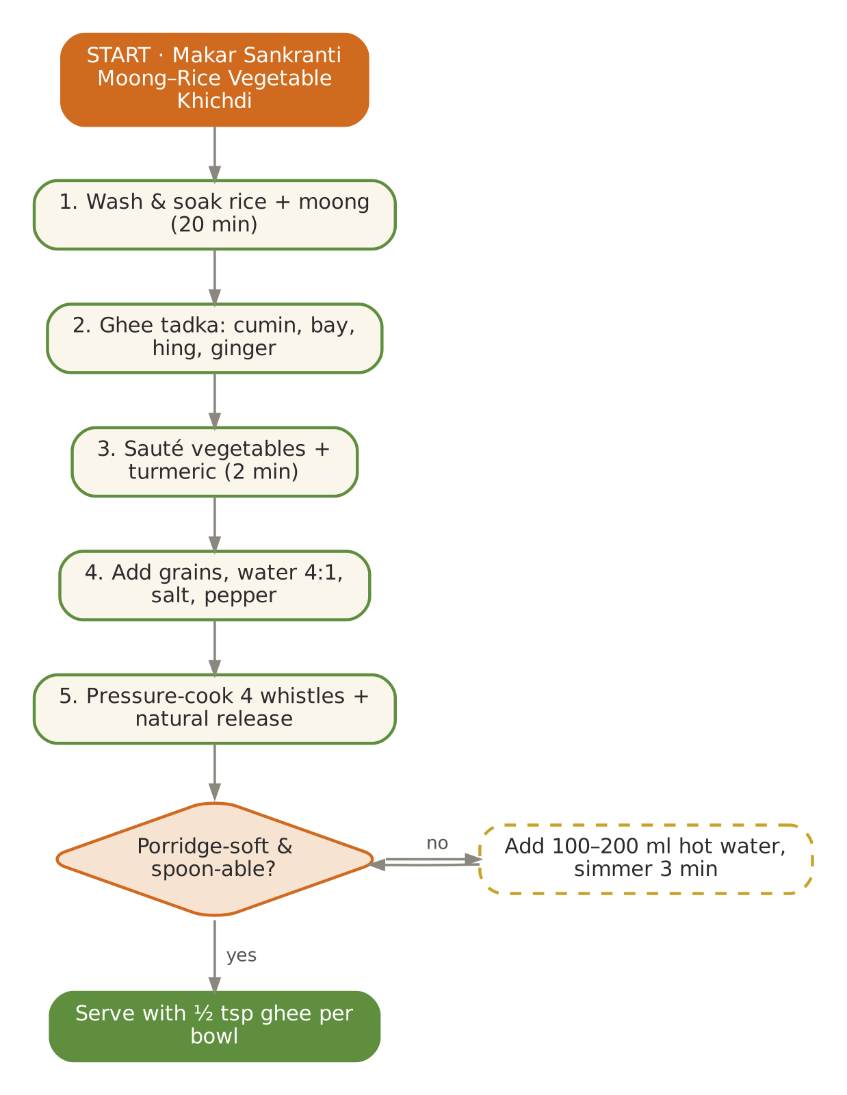  Signature dish: Makar Sankranti Moong–Rice Vegetable Khichdi | Further dishes & variations  Breakfast  Bajra–moong soft dalia · Methi thepla (soft, with curd) · Gajar–dates porridge · Paneer bhurji (no onion) with phulka · Amaranth (rajgira) lapsi  Dals & Saags  Kali urad–chana dal (small portion, lunch only) · Methi dana–moong dal · Mooli patta dal · Palak–chana dal · Sarson-saag with paneer  Sabzis  Gobhi–shalgam mixed · Nimona (green-pea curry, UP) · Methi–aloo · Carrot–beet poriyal · Soft mooli–moong bhurji  Evening  Gajar kanji (served at room temp, small glass) · Til–gud–sonth chai · Roasted makhana with ghee · Soaked anjeer + almonds · Ginger–jaggery barfi (small)  Light Dinners  Nimona with soft rice · Vegetable dalia upma · Palak shorba (no cream) + phulka · Sweet-potato–moong soup  Sweets & Digestives  Gond-free atta ladoo (soft) · Gur-wale chawal · Shakarkandi halwa · Amla candy (post-meal digestive) · Saunf–mishri mukhwas

February — Root Vegetables & the Colour of Basant
Hindu months | Magh – Phalgun
Ayurvedic season | Shishira (late winter)
Haridwar weather | ≈ 9 – 23 °C, cool and dry, warming by month-end
Agni (digestion) | Still strong — continue nourishing meals
Dosha picture | Kapha accumulating; Vata from residual cold winds
Favour | Sweet, sour, salty; warm, moist and well-spiced with ginger
Limit | Heavy fried snacks, chilled desserts, excessive curd at night

In season
Vegetables & greens | Fruit | Pantry & other
Peas, cauliflower, cabbage, carrots, beetroot, radish, spinach, methi, broad beans (sem), turnip | Oranges, kinnow, guava, ber, strawberries, amla | Mustard oil, jaggery, barley flour

Festivals & observances
Occasion | Kitchen response
Basant Panchami (lunar) | Yellow menu: kesari meetha chawal, besan kadhi, yellow moong dal.
Maha Shivratri (Feb/Mar, lunar) | Phalahari thali: sabudana khichdi, kuttu–lauki paratha (soft), singhara halwa, thandai (non-intoxicating).

Kitchen guidance for February
- Begin gently lightening the menu in the last week — add barley and more bitter greens.
- Root vegetables (beet, carrot) are excellent in soups — blend smooth for elders.
- Keep amla daily in some form: tea, chutney, murabba or juice in warm water.
- Spring-cleaning of pantry: discard old flours, re-roast spices, make fresh garam masala.
Daily rituals: on waking — Warm cumin–ginger water; at bedtime — Golden milk with a pinch of nutmeg.

Seven-day menu — February
Rotate weekly; swap any item for one from 'Further dishes & variations' at the end of this chapter. Lunch always includes rice and phulka; curd/raita is served at lunch only.
Day | Breakfast 7:30–9:00 | Lunch thali 12:30–2:30 | Evening 4:00 | Dinner 7:00–8:30
Monday | Matar–gajar vegetable upma · orange | Masoor–palak dal · Gobhi–matar adraki · Beet–carrot poriyal · rice & phulka · Beetroot raita (room temp.) | Amla–ginger–honey warm tea | Beet–carrot–moong soup · soft rice · sweet: Kesari meetha chawal (60 g)
Tuesday | Beetroot–moong chilla · coconut chutney | Yellow moong dal tadka · Cabbage–peas · Palak paneer (sattvic) · rice & phulka · Spiced takra | Roasted makhana | Vegetable khichdi · sweet: Gajar halwa (40 g)
Wednesday | Sweet dalia with jaggery & raisins | Toor dal with methi · Aloo–methi · Mooli bhurji · rice & phulka · Amla chutney | Stewed apple with cinnamon | Palak–moong soup · phulka · sweet: Moong dal halwa (30 g)
Thursday | Methi–paneer soft paratha · curd | Chana dal–lauki · Matar–paneer · Broad-bean (sem) & potato · rice & phulka · Mooli–gajar soft salad | Badam milk | Dalia khichdi · sweet: Atta sheera (50 g)
Friday | Vegetable rava idli · tomato-free coconut chutney | Whole masoor (soft) · Shalgam–gajar · Kaddu khatta-meetha · rice & phulka · Mint–coriander chutney | Sweet-potato chaat | Lauki–chana dal · phulka · sweet: Rice kheer (80 ml)
Saturday | Oats porridge with dates · guava | Moong–palak dal · Gobhi–matar adraki · Beet–carrot poriyal · rice & phulka · Beetroot raita (room temp.) | Til–gud ladoo (mini) | Moong yusha · ghee rice · sweet: Date–nut ladoo
Sunday | Poha with peas & lemon · amla tea | Panchmel dal (light) · Cabbage–peas · Palak paneer (sattvic) · rice & phulka · Spiced takra | CCF tea · soaked walnuts | Mixed-veg soup · phulka · sweet: Amla murabba (½)

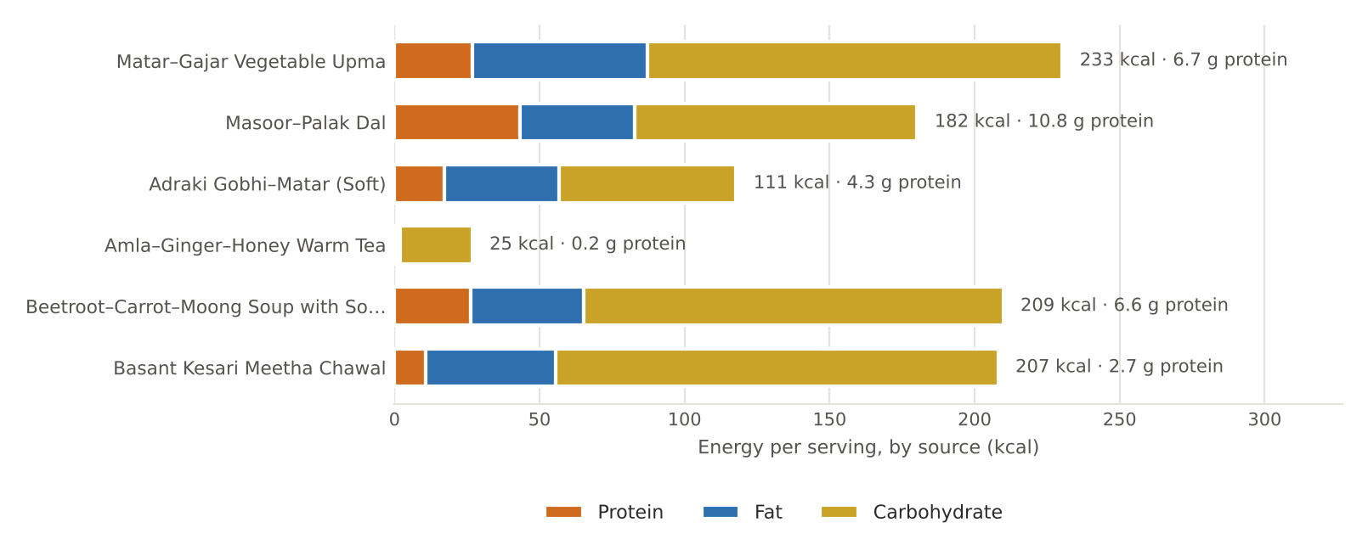
Figure. February's featured recipes — energy per serving by source, with protein

February recipes

Matar–Gajar Vegetable Upma
BREAKFAST · Serves 4 · Portion: 1 plate (≈200 g) · Cook 25 min
Texture: Soft Dosha: Vata-pacifying with ghee
Ingredient | Household measure | Base qty | Café batch ×5
Semolina (suji/rava) | 1 cup | 160 g | 800 g
Ghee (cow) | 4 tsp | 20 g | 100 g
Mustard seeds | ½ tsp | 2 g | 10 g
Urad dal, split | 1 tsp urad dal | 5 g | 25 g
Curry leaves | 10 leaves | 2 g | 10 g
Ginger, fresh | 2 tsp grated | 10 g | 50 g
Green chilli (optional, deseeded) | ½ chilli (optional) | 2 g | 10 g
Carrot | ½ cup fine dice | 80 g | 400 g
Green peas, fresh | ⅓ cup | 60 g | 300 g
Water | 3 cups (soft-set ratio) | 720 ml | 3,600 ml
Rock salt (sendha namak) | ¾ tsp | 3.5 g | 18 g
Cashew nuts | 8 halves (optional) | 10 g | 50 g
Lemon juice | 2 tsp | 10 ml | 50 ml
Coriander leaves | 2 tbsp | 8 g | 40 g
Method
1. Dry-roast suji on low 6–7 minutes until aromatic but not brown; set aside.
2. Heat ghee; add mustard, then urad dal and cashew until golden; add curry leaves, ginger and chilli.
3. Add carrot and peas; sauté 2 minutes.
4. Add water and salt; boil, then simmer covered 4 minutes until vegetables are tender.
5. On low heat, add suji in a thin stream, stirring continuously to avoid lumps.
6. Cover 3 minutes; fluff and finish with lemon and coriander.

Per serving | Energy  233 kcal | Protein  6.7 g | Fat  6.7 g | Carbs  35.8 g | Fibre  3.4 g | Salt  0.9 g

Care notes for 55+ guests  We use 3 cups water per cup suji for a soft set. Upma firms as it cools — serve immediately or loosen with a little hot water. | Ayurvedic note  Wheat and ghee are Vata-grounding; mustard and ginger keep it light for Kapha season.
Variations & further ideas: Dalia upma · Oats upma · Semiya (vermicelli) upma · Rava pongal

Masoor–Palak Dal
LUNCH · DAL · Serves 4 · Portion: 1 katori (≈180 g) · Cook 35 min
Texture: Soft Dosha: Balances Kapha; ghee tadka for Vata
Ingredient | Household measure | Base qty | Café batch ×5
Masoor dal (red lentil) | ¾ cup red lentils | 150 g | 750 g
Water | 3¾ cups | 900 ml | 4,500 ml
Turmeric powder | ¼ tsp | 1 g | 5 g
Spinach (palak) | 1 bunch, chopped | 200 g | 1,000 g
Rock salt (sendha namak) | ¾ tsp | 4 g | 20 g
Ghee (cow) | 1 tbsp | 15 g | 75 g
Cumin (jeera) | ½ tsp | 2 g | 10 g
Asafoetida (hing) | 1 pinch | 0.3 g | 1.5 g
Ginger, fresh | 2 tsp grated | 10 g | 50 g
Tomato | 1 medium, chopped (optional) | 80 g | 400 g
Kashmiri chilli powder (mild) | ¼ tsp Kashmiri | 1 g | 5 g
Lemon juice | 2 tsp | 10 ml | 50 ml
Method
1. Wash masoor and soak 15 minutes.
2. Cook with water and turmeric — 3 whistles, or 25 minutes in an open pot — until fully dissolved.
3. Add chopped palak; simmer 5 minutes, then whisk smooth.
4. Tadka: ghee, cumin, hing, ginger; add tomato and cook 4 minutes until soft; add chilli powder.
5. Pour into dal, add salt, simmer 2 minutes; finish with lemon.

Per serving | Energy  182 kcal | Protein  10.8 g | Fat  4.4 g | Carbs  24.4 g | Fibre  5.4 g | Salt  1.0 g

Care notes for 55+ guests  Masoor cooks fast and mashes completely — an excellent everyday protein. Lemon's vitamin C improves iron absorption from palak. | Ayurvedic note  Masoor is mildly heating and drying; the ghee tadka balances it for Vata constitution.
Variations & further ideas: Dal methi · Moong–palak dal · Lauki–masoor (summer) · Amla-soured dal without tomato

Adraki Gobhi–Matar (Soft)
LUNCH · SABZI · Serves 4 · Portion: 1 katori (≈130 g) · Cook 25 min
Texture: Soft Dosha: Ginger & hing counter Vata of cauliflower
Ingredient | Household measure | Base qty | Café batch ×5
Cauliflower | 1 small head, small florets | 400 g | 2,000 g
Green peas, fresh | ¾ cup | 120 g | 600 g
Potato | 1 small, diced (optional) | 100 g | 500 g
Ghee (cow) | 1 tbsp | 15 g | 75 g
Cumin (jeera) | ½ tsp | 2 g | 10 g
Asafoetida (hing) | 1 pinch | 0.3 g | 1.5 g
Ginger, fresh | 1 tbsp julienne + grated | 15 g | 75 g
Turmeric powder | ¼ tsp | 1 g | 5 g
Coriander seed / powder | 1½ tsp coriander powder | 3 g | 15 g
Sattvic garam masala (no onion-garlic) | ¼ tsp sattvic garam masala | 1 g | 5 g
Rock salt (sendha namak) | ¾ tsp | 3.5 g | 18 g
Water | ⅓ cup | 80 ml | 400 ml
Coriander leaves | 2 tbsp | 10 g | 50 g
Method
1. Blanch florets in hot salted water 3 minutes; drain.
2. Heat ghee; add cumin, hing and ginger.
3. Add turmeric and coriander powder, then cauliflower, peas and potato; toss well.
4. Add water, cover and cook on low 12 minutes until tender.
5. Finish with garam masala and coriander leaves.

Per serving | Energy  111 kcal | Protein  4.3 g | Fat  4.4 g | Carbs  15.3 g | Fibre  4.7 g | Salt  0.9 g

Care notes for 55+ guests  Blanching, hing and ginger reduce bloating — the cabbage family is otherwise Vata-aggravating. | Ayurvedic note  Cauliflower is ruksha (dry); ghee and warm spices make it suitable for older, Vata-prone digestion.
Variations & further ideas: Cabbage–peas · Broccoli–paneer · Aloo–methi · Gobhi–shalgam

Amla–Ginger–Honey Warm Tea
EVENING · DRINK · Serves 4 · Portion: 150 ml cup · Cook 12 min
Texture: Thin liquid Dosha: Tridoshic; amla is the great rasayana
Ingredient | Household measure | Base qty | Café batch ×5
Amla (Indian gooseberry) | 2 medium, grated | 60 g | 300 g
Ginger, fresh | 2 tsp grated | 10 g | 50 g
Cinnamon | 1-inch stick | 1 g | 5 g
Water | 3⅓ cups | 800 ml | 4,000 ml
Honey | 1 tbsp + 1 tsp (added warm) | 20 g | 100 g
Method
1. Boil water with grated amla, ginger and cinnamon; simmer 8 minutes.
2. Strain into a jug.
3. Cool to sip-warm (about 45 °C).
4. Stir in honey just before serving.

Per serving | Energy  25 kcal | Protein  0.2 g | Fat  0.1 g | Carbs  6.2 g | Fibre  0.8 g | Salt  0.0 g

Care notes for 55+ guests  Never add honey to boiling liquid. Diabetic guests: omit honey entirely — amla's taste is pleasant on its own. | Ayurvedic note  Ayurveda holds heated honey to be ama-forming; amla balances all three doshas and supports immunity in seasonal change.
Variations & further ideas: Amla murabba (½ piece) · Warm amla–mint water · Chyawanprash in warm milk · Amla candy as digestive

Beetroot–Carrot–Moong Soup with Soft Rice
DINNER · Serves 4 · Portion: 250 ml soup + 100 g rice · Cook 35 min
Texture: Pureed soup Dosha: Vata-pacifying, warm & sweet
Ingredient | Household measure | Base qty | Café batch ×5
Moong dal, yellow split | ⅓ cup | 60 g | 300 g
Beetroot | 1 medium, cubed | 150 g | 750 g
Carrot | 2 small, cubed | 150 g | 750 g
Ginger, fresh | 1-inch piece | 10 g | 50 g
Water | 4 cups (soup) | 1,000 ml | 5,000 ml
Ghee (cow) | 1 tbsp | 15 g | 75 g
Cumin (jeera) | ½ tsp | 2 g | 10 g
Black pepper | ½ tsp | 1 g | 5 g
Rock salt (sendha namak) | ¾ tsp | 3.5 g | 18 g
Lemon juice | 2 tsp | 10 ml | 50 ml
Coriander leaves | 1 tbsp | 5 g | 25 g
Rice, white basmati (raw) | ½ cup | 100 g | 500 g
Water | 2 cups (rice, 5 : 1 soft) | 500 ml | 2,500 ml
Method
1. Soak moong 20 minutes.
2. Pressure-cook moong, beet, carrot and ginger in 800 ml water — 3 whistles.
3. Cool slightly; blend smooth; thin with remaining 200 ml water and simmer 3 minutes.
4. Temper with ghee and cumin; add pepper and salt; lemon off the heat.
5. Rice: cook rice in 5× water until very soft; serve alongside.

Per serving | Energy  209 kcal | Protein  6.6 g | Fat  4.3 g | Carbs  36.1 g | Fibre  4.1 g | Salt  0.9 g

Care notes for 55+ guests  Smooth soup suits dysphagia-modified diets — adjust thickness on request. | Ayurvedic note  A warm, sweet and slightly unctuous dinner — light enough for evening agni.
Variations & further ideas: Pumpkin–lentil soup · Carrot–ginger soup · Lauki soup · Palak shorba (no cream)

Basant Kesari Meetha Chawal
SWEET · Serves 6 · Portion: ≈70 g · Soak 30 min · Cook 30 min
Texture: Soft grains Dosha: Vata-pacifying; small portion
Ingredient | Household measure | Base qty | Café batch ×5
Rice, white basmati (raw) | ¾ cup basmati, soaked 30 min | 150 g | 750 g
Water | 5 cups (boiling, drained) | 1,200 ml | 6,000 ml
Clove | 3 | 0.5 g | 2.5 g
Ghee (cow) | 4 tsp | 20 g | 100 g
Green cardamom | 4 pods, crushed | 1 g | 5 g
Cinnamon | 1-inch | 1 g | 5 g
Saffron (kesar) | 15–20 strands | 0.1 g | 0.5 g
Cow's milk, whole | 2 tbsp warm (for saffron) | 30 ml | 150 ml
Mishri / sugar | ½ cup less 1 tbsp | 90 g | 450 g
Raisins (kishmish) | 2 tbsp | 20 g | 100 g
Almonds | 10, slivered | 15 g | 75 g
Method
1. Soak saffron in warm milk.
2. Boil rice in plenty of water with cloves until 80% done (8 minutes); drain.
3. Heat ghee; add cardamom, cinnamon, raisins and almonds.
4. Add rice, mishri and saffron milk; fold gently.
5. Cover tightly and cook on lowest heat (dum) 10 minutes until the sugar melts and grains are glossy.

Per serving | Energy  207 kcal | Protein  2.7 g | Fat  5.0 g | Carbs  38.1 g | Fibre  0.9 g | Salt  0.0 g

Care notes for 55+ guests  Serve a small portion (≈70 g); diabetic guests receive a spoonful of plain saffron rice instead. | Ayurvedic note  Saffron is tridoshic and uplifting; yellow food honours Basant.
Variations & further ideas: Zarda · Gur-wale chawal · Kesar phirni · Meethi seviyan

Signature process & further dishes — February
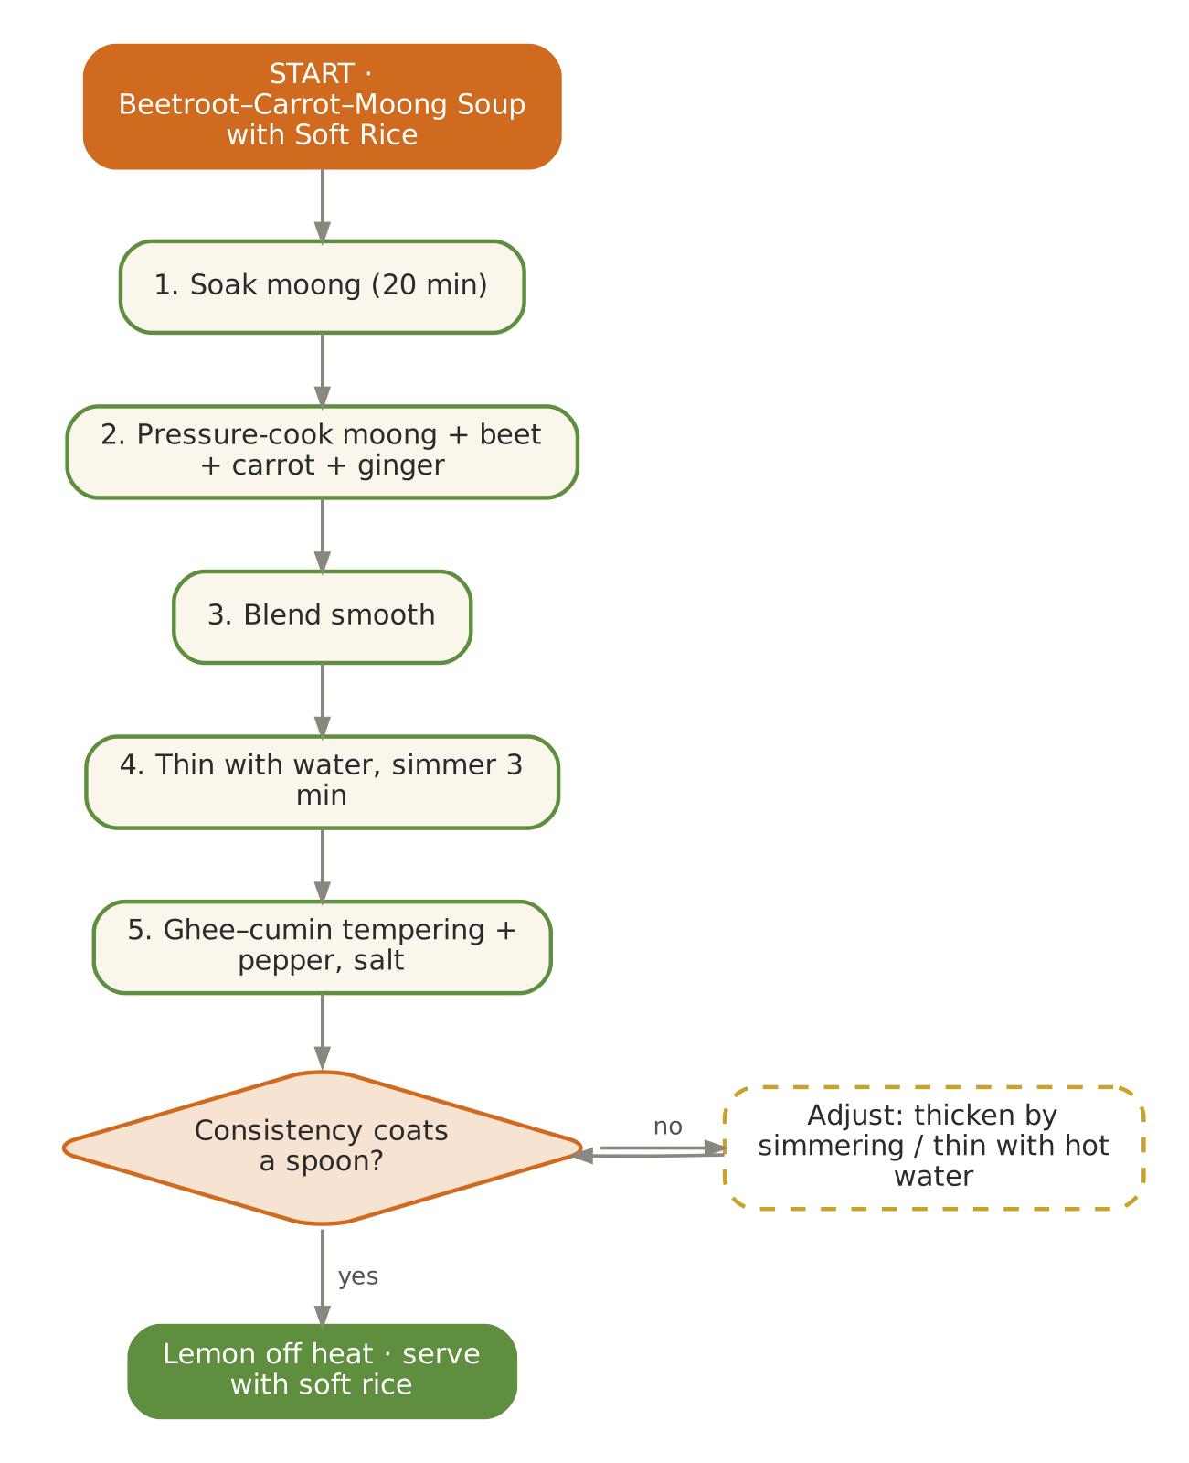  Signature dish: Beetroot–Carrot–Moong Soup with Soft Rice | Further dishes & variations  Breakfast  Beetroot–moong chilla · Methi thepla (soft) · Vegetable dalia (savoury) · Ragi–oats porridge · Moong sprout (cooked) poha  Dals & Saags  Dal methi · Kali masoor (soft, lunch only) · Toor–lauki dal · Moong–methi dana dal · Sarson-saag (early Feb)  Sabzis  Beet thoran · Sem–aloo · Mooli–gajar sabzi · Paneer–matar bhurji · Cabbage kofta (steamed, light gravy)  Evening  Amla murabba · Warm orange juice with ginger (room temp.) · Roasted chana-free makhana mix · Badam–kesar milk · Guava stewed with jaggery  Light Dinners  Beet–moong khichdi · Barley–vegetable soup · Masoor soup with ghee rice · Lauki dalia  Sweets & Digestives  Kesar phirni · Gajar–dates barfi · Ajwain–saunf mukhwas · Ber–jaggery chutney · Atta sheera

March — Lightness, Bitter Greens & Holi Colours
Hindu months | Phalgun – Chaitra
Ayurvedic season | Vasanta (spring)
Haridwar weather | ≈ 13 – 28 °C, pleasant days, cool nights
Agni (digestion) | Weakens as accumulated Kapha melts — lighter food
Dosha picture | Kapha aggravated (spring congestion, sluggish digestion)
Favour | Favour bitter, pungent and astringent; light, dry, warm food; barley, honey, old grains
Limit | Heavy sweets, excess curd, deep-fried snacks, daytime sleep after meals

In season
Vegetables & greens | Fruit | Pantry & other
Last peas, green chickpeas (hara chana), karela, tinda, lauki, early bhindi, drumstick, neem flowers, methi | Strawberries, mulberries, oranges, papaya, early melons | Barley (jau), new wheat, honey

Festivals & observances
Occasion | Kitchen response
Holi (Phalgun Purnima) | Warm thandai (non-intoxicating), soft gujiya (baked), dahi-free kanji; avoid chemical colours near food.
Chaitra Navratri (Mar/Apr, lunar) | Phalahari: makhana kheer, samak khichdi, sabudana-aloo tikki (baked), kuttu cheela.

Kitchen guidance for March
- Introduce barley and old (aged) rice; reduce heavy dairy sweets.
- Bitter vegetables (karela, methi, neem flower) once daily in small portions.
- Use honey — never heated — in place of jaggery where possible.
- Encourage a short walk after lunch; serve lighter dinners by 7 pm.
Daily rituals: on waking — Warm water with ½ tsp honey and lemon (honey added to warm, not hot); at bedtime — Golden milk (smaller, 100 ml) with dry ginger.

Seven-day menu — March
Rotate weekly; swap any item for one from 'Further dishes & variations' at the end of this chapter. Lunch always includes rice and phulka; curd/raita is served at lunch only.
Day | Breakfast 7:30–9:00 | Lunch thali 12:30–2:30 | Evening 4:00 | Dinner 7:00–8:30
Monday | Jau–moong savoury porridge · papaya | Lauki–chana dal · Karela with jaggery & fennel · Tinda masala · rice & phulka · Spiced takra | Holi thandai (warm or room temp.) | Vegetable dalia khichdi · sweet: Makhana kheer (80 ml)
Tuesday | Moong dal chilla · mint chutney | Moong dal with drumstick · Lauki–peas · Hara chana ghugni (soft) · rice & phulka · Mint–coriander chutney | Roasted makhana | Moong yusha · phulka · sweet: Atta sheera (40 g)
Wednesday | Vegetable poha · strawberries | Masoor–lauki dal · Beans–carrot thoran · Bhindi with coconut · rice & phulka · Kheera raita (room temp.) | Ginger–honey tea | Barley–vegetable soup · sweet: Gulkand (1 tsp) with warm milk
Thursday | Barley–oats porridge with honey | Toor dal with methi · Aloo–methi · Drumstick-leaf poriyal · rice & phulka · Neem-flower chutney (small) | Stewed apple | Lauki–moong khichdi · sweet: Date–nut ladoo
Friday | Rava idli · coconut chutney | Whole moong (soft) · Torai–moong · Kaddu khatta-meetha · rice & phulka · Lauki raita | Barley water with lemon | Masoor soup · soft rice · sweet: Baked gujiya (½)
Saturday | Besan–lauki chilla · guava | Moong–palak dal · Karela with jaggery & fennel · Tinda masala · rice & phulka · Spiced takra | CCF tea | Rasam · rice · sweet: Rice kheer (60 ml)
Sunday | Soft upma · mulberries | Light kadhi with methi · Lauki–peas · Hara chana ghugni (soft) · rice & phulka · Mint–coriander chutney | Puffed rice (murmura) chaat | Mixed-veg soup · phulka · sweet: Honey–sesame chikki crumble

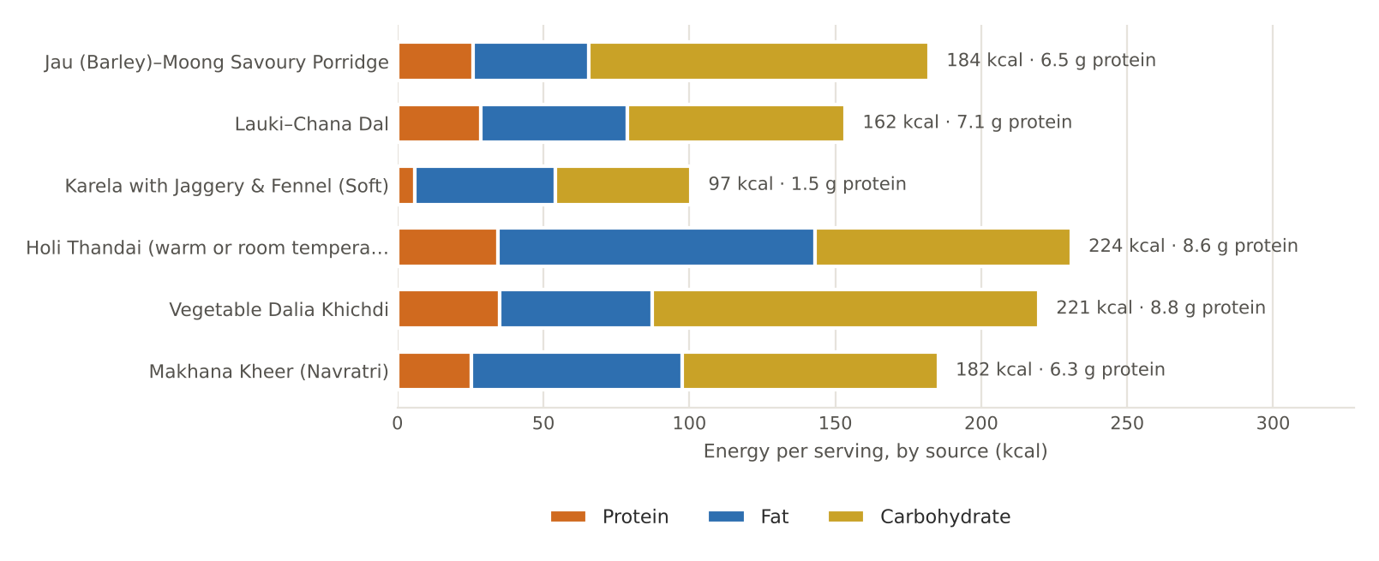
Figure. March's featured recipes — energy per serving by source, with protein

March recipes

Jau (Barley)–Moong Savoury Porridge
BREAKFAST · Serves 4 · Portion: 1 bowl (≈250 g) · Soak overnight · Cook 40 min
Texture: Soft porridge Dosha: Reduces Kapha; ghee for Vata
Ingredient | Household measure | Base qty | Café batch ×5
Barley (jau), pearled | ½ cup pearled barley, soaked overnight | 100 g | 500 g
Moong dal, yellow split | ⅓ cup | 60 g | 300 g
Bottle gourd (lauki) | 1 cup diced | 150 g | 750 g
Ginger, fresh | 2 tsp grated | 10 g | 50 g
Ghee (cow) | 1 tbsp | 15 g | 75 g
Cumin (jeera) | ½ tsp | 2 g | 10 g
Carom (ajwain) | ¼ tsp | 1 g | 5 g
Asafoetida (hing) | 1 pinch | 0.3 g | 1.5 g
Turmeric powder | ¼ tsp | 1 g | 5 g
Black pepper | ¼ tsp | 0.5 g | 2.5 g
Rock salt (sendha namak) | ¾ tsp | 3.5 g | 18 g
Water | 4 cups | 1,000 ml | 5,000 ml
Method
1. Drain the soaked barley; pressure-cook with 600 ml water — 6 whistles.
2. Add moong, lauki, turmeric and 400 ml water; pressure-cook 3 more whistles.
3. Tadka: ghee, cumin, ajwain, hing, ginger; pour into the porridge.
4. Add salt and pepper; simmer 3 minutes to a thick soup-porridge.

Per serving | Energy  184 kcal | Protein  6.5 g | Fat  4.4 g | Carbs  29.2 g | Fibre  5.6 g | Salt  0.9 g

Care notes for 55+ guests  Barley must be fully soft — test a grain between fingers before serving. | Ayurvedic note  Barley (yava) is light and drying — the classical Vasanta grain; ghee balances dryness for Vata-age guests.
Variations & further ideas: Barley sattu drink · Jau–atta roti (30% barley) · Barley–vegetable soup · Sweet jau dalia with dates

Lauki–Chana Dal
LUNCH · DAL · Serves 4 · Portion: 1 katori (≈180 g) · Soak 2 h · Cook 35 min
Texture: Soft Dosha: Lauki lightens chana; hing reduces Vata
Ingredient | Household measure | Base qty | Café batch ×5
Chana dal | ½ cup + 1 tbsp, soaked 2 h | 120 g | 600 g
Bottle gourd (lauki) | 2 cups, 1-cm cubes | 300 g | 1,500 g
Water | 3 cups | 700 ml | 3,500 ml
Turmeric powder | ¼ tsp | 1 g | 5 g
Rock salt (sendha namak) | ¾ tsp | 4 g | 20 g
Ghee (cow) | 1 tbsp | 15 g | 75 g
Cumin (jeera) | ½ tsp | 2 g | 10 g
Asafoetida (hing) | 2 pinches | 0.4 g | 2 g
Ginger, fresh | 2 tsp grated | 10 g | 50 g
Tomato | ½ medium (optional) | 60 g | 300 g
Coriander seed / powder | 1 tsp powder | 2 g | 10 g
Sattvic garam masala (no onion-garlic) | ⅛ tsp | 0.5 g | 2.5 g
Coriander leaves | 2 tbsp | 8 g | 40 g
Method
1. Pressure-cook soaked chana dal with lauki, water and turmeric — 4 whistles, then 5 minutes on low.
2. Check: dal should mash between fingers; cook longer if needed.
3. Tadka: ghee, cumin, hing, ginger, tomato (if using) until soft; add coriander powder.
4. Add to dal with salt; simmer 5 minutes; finish with garam masala and coriander.

Per serving | Energy  162 kcal | Protein  7.1 g | Fat  5.6 g | Carbs  18.6 g | Fibre  5.5 g | Salt  1.0 g

Care notes for 55+ guests  Chana dal is heavier — soaking, hing and a long cook make it digestible. Keep portion to 120–150 g. | Ayurvedic note  Lauki is cooling and light; it tempers the heaviness (guru) of chana.
Variations & further ideas: Lauki–moong dal · Chana dal with tinda · Torai–chana dal · Kaddu–chana dal

Karela with Jaggery & Fennel (Soft)
LUNCH · SABZI · Serves 4 · Portion: ½ katori (≈80 g) · Rest 20 min · Cook 25 min
Texture: Soft Dosha: Reduces Kapha & Pitta
Ingredient | Household measure | Base qty | Café batch ×5
Bitter gourd (karela) | 3 medium, thin slices, seeds removed | 300 g | 1,500 g
Rock salt (sendha namak) | ½ tsp (to degorge + season) | 3 g | 15 g
Mustard oil | 1½ tbsp (or ghee) | 20 g | 100 g
Fennel (saunf) | 1 tsp | 3 g | 15 g
Asafoetida (hing) | 1 pinch | 0.3 g | 1.5 g
Potato | 1 small, thin slices | 100 g | 500 g
Turmeric powder | ¼ tsp | 1 g | 5 g
Coriander seed / powder | 1½ tsp powder | 3 g | 15 g
Water | ¼ cup | 60 ml | 300 ml
Jaggery (gur) | 1 tbsp | 15 g | 75 g
Dry mango powder (amchur) | ½ tsp | 1 g | 5 g
Method
1. Rub karela with salt; rest 20 minutes; squeeze out the bitter juice.
2. Heat oil to smoking, cool slightly; add fennel and hing.
3. Add karela, potato, turmeric and coriander powder; add water, cover and cook on low 12 minutes, stirring, until soft.
4. Add jaggery and amchur; cook open 3 minutes to glaze.

Per serving | Energy  97 kcal | Protein  1.5 g | Fat  5.3 g | Carbs  11.6 g | Fibre  3.2 g | Salt  0.8 g

Care notes for 55+ guests  Slice thinly for chewing. Diabetic guests: reduce jaggery to 1 tsp — karela itself supports blood-sugar control. | Ayurvedic note  Bitter (tikta) rasa melts spring Kapha and purifies rakta (blood).
Variations & further ideas: Steamed bharwan karela · Methi–karela · Neem-begun (bitter starter, Bengal) · Karela–amchur chips (baked)

Holi Thandai (warm or room temperature)
EVENING · DRINK · Serves 4 · Portion: 150 ml · Soak 2 h · Cook 15 min
Texture: Smooth liquid Dosha: Cooling, nourishing; spices keep Kapha in check
Ingredient | Household measure | Base qty | Café batch ×5
Cow's milk, whole | 3⅓ cups | 800 ml | 4,000 ml
Almonds | 18, soaked & peeled | 25 g | 125 g
Pumpkin seeds | 1 tbsp (magaz substitute) | 10 g | 50 g
Fennel (saunf) | 1½ tsp | 4 g | 20 g
Black pepper | 6 peppercorns | 0.5 g | 2.5 g
Green cardamom | 5 pods, seeds only | 1 g | 5 g
Water | scant ½ cup (soaking) | 100 ml | 500 ml
Saffron (kesar) | 10 strands | 0.1 g | 0.5 g
Mishri / sugar | 3 tbsp (or 6 dates) | 40 g | 200 g
Rose water | 1 tsp | 5 ml | 25 ml
Method
1. Soak almonds, pumpkin seeds, fennel, pepper and cardamom in warm water 2 hours.
2. Grind to a very fine paste.
3. Boil milk; add paste and simmer 5 minutes.
4. Add mishri and saffron; strain through a fine sieve for a smooth drink.
5. Add rose water; serve warm or at room temperature — never iced.

Per serving | Energy  224 kcal | Protein  8.6 g | Fat  12.1 g | Carbs  22.0 g | Fibre  1.3 g | Salt  0.0 g

Care notes for 55+ guests  Room temperature only (Vata rule). Strictly non-intoxicating — the house version contains no bhang. | Ayurvedic note  Fennel and rose cool Pitta; pepper and cardamom keep the milk light for spring Kapha.
Variations & further ideas: Badam milk · Kesar–pista doodh · Gulkand milk · Thandai phirni

Vegetable Dalia Khichdi
DINNER · Serves 4 · Portion: 1 bowl (≈300 g) · Cook 30 min
Texture: Soft porridge Dosha: Tridoshic
Ingredient | Household measure | Base qty | Café batch ×5
Broken wheat (dalia) | ½ cup + 2 tbsp broken wheat | 100 g | 500 g
Moong dal, yellow split | ⅓ cup + 1 tbsp | 80 g | 400 g
Bottle gourd (lauki) | ¾ cup diced | 100 g | 500 g
Carrot | ½ small | 60 g | 300 g
Green peas, fresh | ¼ cup | 40 g | 200 g
Ghee (cow) | 4 tsp | 20 g | 100 g
Cumin (jeera) | ½ tsp | 2 g | 10 g
Asafoetida (hing) | 1 pinch | 0.3 g | 1.5 g
Ginger, fresh | 2 tsp grated | 10 g | 50 g
Turmeric powder | ¼ tsp | 1 g | 5 g
Black pepper | ¼ tsp | 0.5 g | 2.5 g
Rock salt (sendha namak) | ¾ tsp | 4 g | 20 g
Water | 3¾ cups | 900 ml | 4,500 ml
Method
1. Roast dalia in 1 tsp ghee for 3 minutes; wash moong.
2. In the cooker heat remaining ghee; add cumin, hing and ginger, then vegetables for 2 minutes.
3. Add dalia, moong, water, turmeric, salt and pepper.
4. Pressure-cook 4 whistles, then 5 minutes on low; rest 10 minutes.
5. Stir and loosen with hot water to porridge consistency.

Per serving | Energy  221 kcal | Protein  8.8 g | Fat  5.8 g | Carbs  33.1 g | Fibre  6.1 g | Salt  1.0 g

Care notes for 55+ guests  Higher-fibre than rice khichdi — helpful for constipation, common after 55. | Ayurvedic note  Wheat is grounding; moong keeps it light; vegetables add sweetness.
Variations & further ideas: Oats khichdi · Masala dalia · Sweet dalia with jaggery · Bajra–moong khichdi (winter)

Makhana Kheer (Navratri)
SWEET · Serves 6 · Portion: 120 ml · Cook 35 min
Texture: Soft, creamy Dosha: Vata & Pitta pacifying
Ingredient | Household measure | Base qty | Café batch ×5
Fox nut (makhana) | 1½ cups | 40 g | 200 g
Ghee (cow) | 1 tsp | 5 g | 25 g
Cow's milk, whole | 4 cups | 1,000 ml | 5,000 ml
Mishri / sugar | ¼ cup (or 6 dates) | 50 g | 250 g
Green cardamom | ¼ tsp powder | 1 g | 5 g
Saffron (kesar) | 6–8 strands | 0.1 g | 0.3 g
Almonds | 8, slivered | 10 g | 50 g
Method
1. Roast makhana in ghee on low 5 minutes until crisp; crush half coarsely.
2. Boil milk and simmer 15 minutes to reduce to about 750 ml.
3. Add makhana (crushed and whole); cook 10 minutes until soft.
4. Add mishri, cardamom and saffron; garnish with almonds.

Per serving | Energy  182 kcal | Protein  6.3 g | Fat  8.0 g | Carbs  21.9 g | Fibre  0.5 g | Salt  0.0 g

Care notes for 55+ guests  Crush all makhana for denture wearers; diabetic guests — sweeten with 2 dates only. | Ayurvedic note  Makhana is cooling, nourishing (vrishya) and light — ideal for fasting days.
Variations & further ideas: Sabudana kheer · Samak kheer · Lauki kheer · Singhara halwa

Signature process & further dishes — March
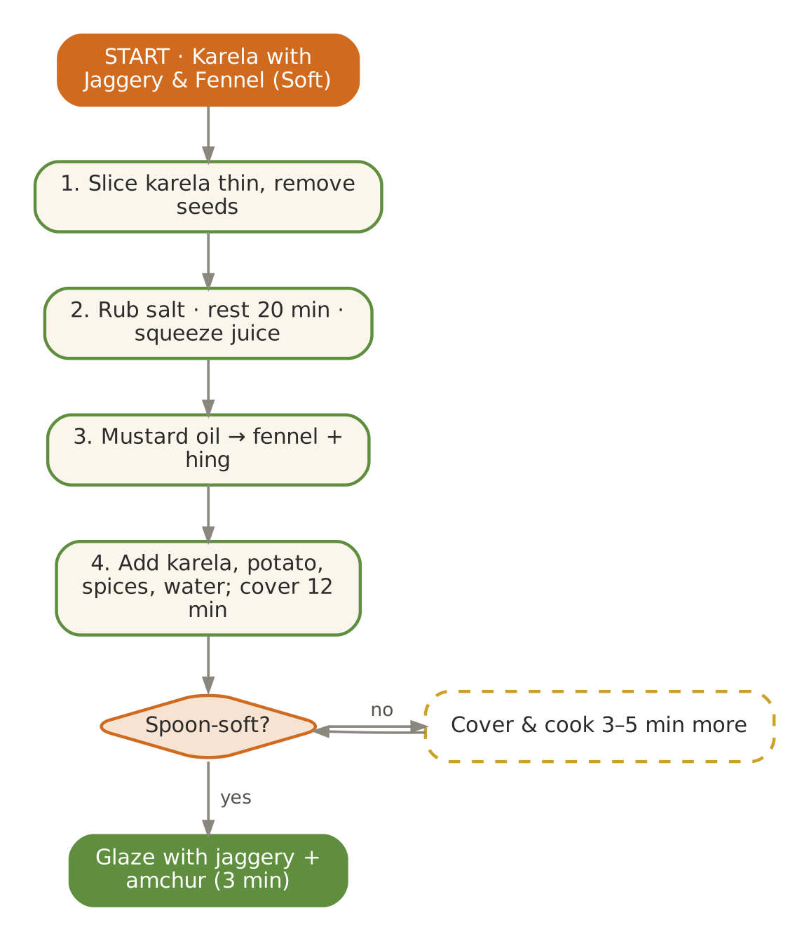  Signature dish: Karela with Jaggery & Fennel (Soft) | Further dishes & variations  Breakfast  Barley chilla · Neem-flower (sparing) rice · Hara chana (cooked) poha · Moong sprouts (steamed) with lemon · Murmura upma  Dals & Saags  Drumstick–moong dal · Methi kadhi (light) · Moong dal with neem flowers · Masoor–lauki · Toor dal with raw mango (end of month)  Sabzis  Hara chana–paneer · Tinda bharwa (steamed) · Bhindi–tomato (light) · Lauki kofta (steamed, light gravy) · Karela–aloo  Evening  Barley water · Mulberry stew · Ginger–honey tea · Strawberry–mint warm infusion · Roasted murmura with ghee  Light Dinners  Barley soup · Moong yusha · Lauki–moong khichdi · Rasam with rice · Vegetable dalia upma  Sweets & Digestives  Baked gujiya with dates · Honey–til ladoo · Gulkand · Saunf–mishri · Kheer in small kulhads

April — Gentle Cooling & the New Wheat
Hindu months | Chaitra – Vaishakh
Ayurvedic season | Vasanta → Grishma (spring to early summer)
Haridwar weather | ≈ 18 – 34 °C, warm dry days, hot afternoons
Agni (digestion) | Moderate, starting to dip with heat
Dosha picture | Kapha settling; Pitta and Vata (dryness) begin to rise
Favour | Sweet, bitter, astringent; light, slightly cooling, freshly cooked
Limit | Very spicy, sour or salty food, fermented items in excess, heavy fried snacks

In season
Vegetables & greens | Fruit | Pantry & other
Lauki, tinda, torai, early bhindi, cucumber, raw mango, drumstick, mint, green coriander | Watermelon (late), muskmelon, papaya, banana, last oranges, mulberry | New-crop wheat, sattu, jau

Festivals & observances
Occasion | Kitchen response
Baisakhi (13–14 Apr) | New-wheat celebration: soft atta phulka, kadhi–chawal, sweet meethe chawal; Haridwar Ganga snan.
Ram Navami (Chaitra Navratri, lunar) | Panakam (jaggery–ginger–cardamom water), kosambari (soaked moong salad — serve lightly steamed), neer mor.
Hanuman Jayanti (lunar) | Boondi-free besan ladoo (soft), banana, prasad halwa.

Kitchen guidance for April
- Shift from warming to neutral foods: moong, lauki, tinda, rice.
- Introduce cooling drinks at room temperature: sattu sharbat, panakam, takra.
- Fluid target 1.5–2 L/day for most guests — elders lose thirst sensation; offer drinks proactively.
- Keep salt modest but replace electrolytes with buttermilk and lemon water.
Daily rituals: on waking — Room-temperature water with a few soaked coriander seeds (dhaniya water); at bedtime — Warm milk with a pinch of cardamom (100–150 ml).

Seven-day menu — April
Rotate weekly; swap any item for one from 'Further dishes & variations' at the end of this chapter. Lunch always includes rice and phulka; curd/raita is served at lunch only.
Day | Breakfast 7:30–9:00 | Lunch thali 12:30–2:30 | Evening 4:00 | Dinner 7:00–8:30
Monday | Lemon–peas poha · papaya | Lauki–moong dal · Tinda masala · Lauki–chana · rice & phulka · Kheera raita (room temp.) | Sattu sharbat (salted) | Moong yusha · soft phulka · sweet: Gulkand–rose phirni (80 ml)
Tuesday | Moong dal chilla · mint chutney | Yellow moong tadka · Torai–moong · Bhindi with coconut · rice & phulka · Pudina takra | Panakam | Lauki–moong khichdi · sweet: Rice kheer (60 ml)
Wednesday | Rava idli · coconut chutney | Toor dal (mild) · Kaddu khatta-meetha · Parwal sabzi · rice & phulka · Raw-mango chutney (small) | Roasted makhana | Namkeen dalia · sweet: Atta sheera (40 g)
Thursday | Sweet dalia with dates · banana | Kadhi (no pakora) · Aloo–jeera (light) · Raw-mango–kaddu · rice & phulka · Lauki raita | Stewed apple | Rasam · soft rice · sweet: Coconut ladoo (1 small)
Friday | Vegetable upma · muskmelon | Masoor–lauki dal · Beans–carrot thoran · Kundru (soft) · rice & phulka · Coriander chutney | Coconut water with lime | Vegetable soup · phulka · sweet: Banana–date mash
Saturday | Ragi porridge with jaggery | Moong with drumstick · Tinda masala · Lauki–chana · rice & phulka · Kheera raita (room temp.) | CCF tea | Moong dal · ghee rice · sweet: Mango phirni (end Apr)
Sunday | Soft besan–lauki chilla · curd | Whole moong (soft) · Torai–moong · Bhindi with coconut · rice & phulka · Pudina takra | Muskmelon cubes | Torai–dal · phulka · sweet: Gulkand (1 tsp)

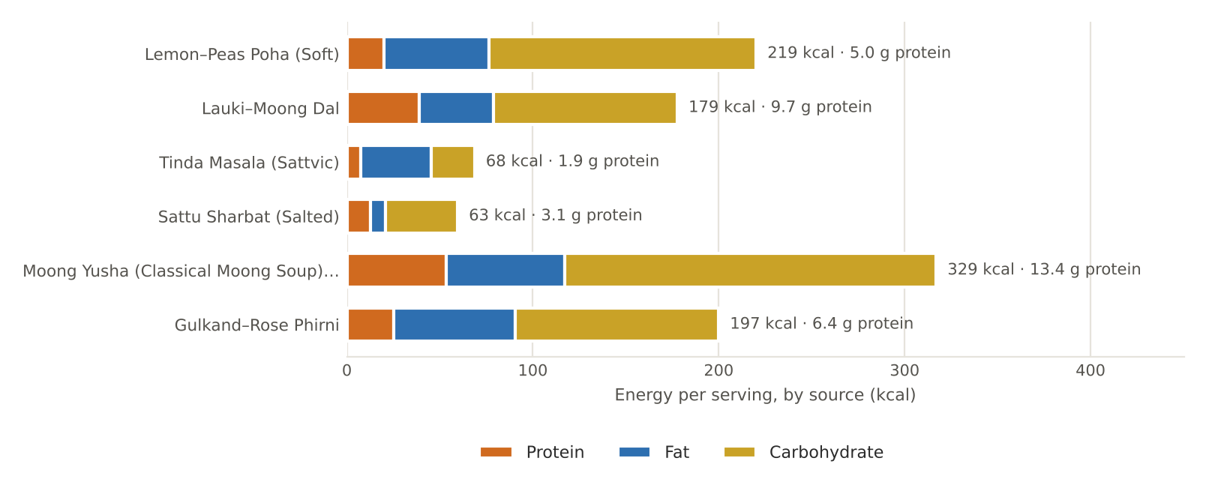
Figure. April's featured recipes — energy per serving by source, with protein

April recipes

Lemon–Peas Poha (Soft)
BREAKFAST · Serves 4 · Portion: 1 plate (≈180 g) · Cook 20 min
Texture: Soft Dosha: Light; balances Pitta & Kapha
Ingredient | Household measure | Base qty | Café batch ×5
Poha (flattened rice) | 1½ cups thick poha | 150 g | 750 g
Green peas, fresh | ½ cup | 80 g | 400 g
Carrot | ⅓ cup fine dice | 50 g | 250 g
Ghee (cow) | 1 tbsp | 15 g | 75 g
Mustard seeds | ½ tsp | 2 g | 10 g
Cumin (jeera) | ¼ tsp | 1 g | 5 g
Curry leaves | 10 leaves | 2 g | 10 g
Asafoetida (hing) | 1 small pinch | 0.2 g | 1 g
Ginger, fresh | 1½ tsp grated | 8 g | 40 g
Turmeric powder | ¼ tsp | 1 g | 5 g
Rock salt (sendha namak) | ½ tsp | 3 g | 15 g
Mishri / sugar | 1 tsp | 5 g | 25 g
Water | 2 tbsp (to steam veg) | 30 ml | 150 ml
Lemon juice | 1 tbsp | 15 ml | 75 ml
Coriander leaves | 2 tbsp | 8 g | 40 g
Pumpkin seeds | 1 tbsp roasted (in place of peanuts) | 15 g | 75 g
Method
1. Rinse poha twice in a colander; drain and rest 5 minutes — it should be soft, not mushy. Mix in turmeric, salt and mishri.
2. Heat ghee; add mustard, cumin, curry leaves, hing and ginger.
3. Add peas, carrot and 2 tbsp water; cover 4 minutes until tender.
4. Add poha; toss gently on low 2 minutes; cover 2 minutes to steam.
5. Finish with lemon, coriander and roasted seeds.

Per serving | Energy  219 kcal | Protein  5.0 g | Fat  6.3 g | Carbs  35.9 g | Fibre  2.9 g | Salt  0.8 g

Care notes for 55+ guests  Pumpkin seeds replace whole peanuts (hard to chew, choking risk). Sprinkle seeds only for those with good dentition. | Ayurvedic note  Rice flakes are light and cooling; lemon added at the end preserves vitamin C and freshness.
Variations & further ideas: Dadpe poha (Maharashtra) · Indori poha without onion · Poha upma · Aval payasam (sweet poha)

Lauki–Moong Dal
LUNCH · DAL · Serves 4 · Portion: 1 katori (≈180 g) · Cook 30 min
Texture: Soft Dosha: Cooling, tridoshic
Ingredient | Household measure | Base qty | Café batch ×5
Moong dal, yellow split | ¾ cup | 150 g | 750 g
Bottle gourd (lauki) | 2 cups, 1-cm cubes | 300 g | 1,500 g
Water | 3⅓ cups | 800 ml | 4,000 ml
Turmeric powder | ¼ tsp | 1 g | 5 g
Rock salt (sendha namak) | ¾ tsp | 4 g | 20 g
Ghee (cow) | 1 tbsp | 15 g | 75 g
Cumin (jeera) | ½ tsp | 2 g | 10 g
Asafoetida (hing) | 1 pinch | 0.3 g | 1.5 g
Ginger, fresh | 2 tsp grated | 10 g | 50 g
Coriander seed / powder | 1 tsp powder | 2 g | 10 g
Coriander leaves | 2 tbsp | 8 g | 40 g
Lemon juice | 2 tsp | 10 ml | 50 ml
Method
1. Wash moong; soak 15 minutes.
2. Pressure-cook moong, lauki, water and turmeric — 3 whistles.
3. Whisk lightly so lauki blends into the dal.
4. Tadka: ghee, cumin, hing, ginger, coriander powder; pour in, add salt, simmer 3 minutes.
5. Finish with coriander and lemon.

Per serving | Energy  179 kcal | Protein  9.7 g | Fat  4.4 g | Carbs  24.8 g | Fibre  4.2 g | Salt  1.0 g

Care notes for 55+ guests  Lauki is over 90% water — excellent for hydration and gentle on the kidneys and gut. | Ayurvedic note  Lauki (alabu) is cooling and heart-friendly; moong keeps the dal light — an everyday summer staple.
Variations & further ideas: Torai–moong dal · Lauki–chana dal · Lauki kadhi · Lauki raita

Tinda Masala (Sattvic)
LUNCH · SABZI · Serves 4 · Portion: 1 katori (≈130 g) · Cook 30 min
Texture: Soft Dosha: Cooling, light
Ingredient | Household measure | Base qty | Café batch ×5
Round gourd (tinda) | 6–7 young, peeled & quartered | 400 g | 2,000 g
Tomato | 1 large, puréed (optional) | 100 g | 500 g
Ghee (cow) | 1 tbsp | 15 g | 75 g
Cumin (jeera) | ½ tsp | 2 g | 10 g
Asafoetida (hing) | 1 pinch | 0.3 g | 1.5 g
Ginger, fresh | 2 tsp grated | 10 g | 50 g
Turmeric powder | ¼ tsp | 1 g | 5 g
Coriander seed / powder | 1½ tsp | 3 g | 15 g
Kashmiri chilli powder (mild) | ¼ tsp Kashmiri | 1 g | 5 g
Rock salt (sendha namak) | ½ tsp | 3 g | 15 g
Water | ½ cup | 120 ml | 600 ml
Sattvic garam masala (no onion-garlic) | ⅛ tsp | 0.5 g | 2.5 g
Coriander leaves | 2 tbsp | 8 g | 40 g
Method
1. Peel the tinda and quarter.
2. Heat ghee; add cumin, hing and ginger; add tomato purée and cook 4 minutes.
3. Add turmeric, coriander powder, chilli and salt; then tinda.
4. Add water; cover and cook on low 15 minutes until tinda turns translucent and spoon-soft.
5. Finish with garam masala and coriander.

Per serving | Energy  68 kcal | Protein  1.9 g | Fat  4.2 g | Carbs  5.9 g | Fibre  1.9 g | Salt  0.8 g

Care notes for 55+ guests  Choose young tinda (seeds soft). Mature tinda: scoop out seeds. | Ayurvedic note  Tinda is light, cooling and diuretic — good for summer Pitta and fluid balance.
Variations & further ideas: Bharwa tinda (steamed) · Tinda–moong dal · Lauki–tinda · Parwal masala

Sattu Sharbat (Salted)
EVENING · DRINK · Serves 4 · Portion: 200 ml · 5 min
Texture: Thin liquid Dosha: Cooling; reduces Pitta
Ingredient | Household measure | Base qty | Café batch ×5
Roasted gram flour (sattu) | 6 tbsp (≈½ cup) | 60 g | 300 g
Water | 3⅓ cups | 800 ml | 4,000 ml
Lemon juice | 4 tsp | 20 ml | 100 ml
Cumin (jeera) | ½ tsp roasted, powdered | 2 g | 10 g
Rock salt (sendha namak) | ½ tsp black/rock salt | 3 g | 15 g
Mint leaves | 10 leaves, crushed | 8 g | 40 g
Method
1. Whisk sattu with 200 ml water to a lump-free paste.
2. Add the remaining water, lemon, roasted cumin, salt and crushed mint.
3. Stir well; serve at room temperature. Stir before each sip — sattu settles.

Per serving | Energy  63 kcal | Protein  3.1 g | Fat  0.9 g | Carbs  9.8 g | Fibre  2.1 g | Salt  0.8 g

Care notes for 55+ guests  Good protein and fibre. Guests on potassium or fluid restriction (kidney disease) should check with their doctor. | Ayurvedic note  Roasted gram (sattu) is cooling and strengthening — Bihar's summer drink.
Variations & further ideas: Sweet sattu with jaggery & cardamom · Sattu-stuffed soft paratha · Sattu ladoo · Jau–chana sattu

Moong Yusha (Classical Moong Soup) with Soft Phulka
DINNER · Serves 4 · Portion: 250 ml soup + 2 phulkas · Cook 40 min
Texture: Thin soup + soft bread Dosha: Tridoshic; classical convalescent food
Ingredient | Household measure | Base qty | Café batch ×5
Moong dal, yellow split | ½ cup + 2 tbsp | 120 g | 600 g
Water | 5 cups (soup) | 1,200 ml | 6,000 ml
Turmeric powder | ¼ tsp | 1 g | 5 g
Ghee (cow) | 1 tbsp (tadka) | 15 g | 75 g
Cumin (jeera) | ½ tsp | 2 g | 10 g
Asafoetida (hing) | 1 pinch | 0.3 g | 1.5 g
Ginger, fresh | 2 tsp grated | 10 g | 50 g
Black pepper | ¼ tsp | 0.5 g | 2.5 g
Rock salt (sendha namak) | ¾ tsp | 3.5 g | 18 g
Coriander leaves | 1 tbsp | 5 g | 25 g
Lemon juice | 2 tsp | 10 ml | 50 ml
Whole-wheat flour (atta) | 1⅔ cups (phulka) | 200 g | 1,000 g
Water | ½ cup + 1 tsp (dough) | 125 ml | 625 ml
Ghee (cow) | ½ tsp per phulka | 8 g | 40 g
Method
1. Cook moong with 6× water and turmeric until fully dissolved (4 whistles or 30 minutes open pot).
2. Whisk well; strain if a clear yusha is wanted.
3. Tempering: ghee, cumin, hing, ginger; add pepper and salt; simmer 3 minutes; finish with coriander and lemon.
4. Phulka: knead a soft dough, rest 20 minutes, roll 8 thin 6-inch discs, cook on a tawa and puff on the flame; brush ½ tsp ghee each.

Per serving | Energy  329 kcal | Protein  13.4 g | Fat  7.1 g | Carbs  49.9 g | Fibre  8.5 g | Salt  0.9 g

Care notes for 55+ guests  The vegetarian substitute for the meat broth (mamsa rasa) in the source Kerala plan — equally restorative. | Ayurvedic note  Mudga yusha is prescribed in classical texts for recovery and weak agni.
Variations & further ideas: Moong–lauki yusha · Kulthi (horse gram) yusha — winter · Moong–masoor soup · Moong soup with rice (kanji style)

Gulkand–Rose Phirni
SWEET · Serves 6 · Portion: 100 ml kulhad · Soak 30 min · Cook 25 min
Texture: Smooth, set Dosha: Cooling; Pitta-pacifying
Ingredient | Household measure | Base qty | Café batch ×5
Rice, white basmati (raw) | ¼ cup, soaked 30 min | 50 g | 250 g
Cow's milk, whole | 4 cups | 1,000 ml | 5,000 ml
Mishri / sugar | ¼ cup | 50 g | 250 g
Green cardamom | ¼ tsp | 1 g | 5 g
Gulkand (rose-petal preserve) | 2 tbsp | 30 g | 150 g
Rose water | 1 tsp | 5 ml | 25 ml
Almonds | 8, slivered | 10 g | 50 g
Method
1. Grind soaked rice with 4 tbsp milk to a coarse, semolina-like paste.
2. Boil remaining milk; add rice paste stirring constantly 12–15 minutes until thick.
3. Add mishri and cardamom; cook 2 minutes.
4. Cool to room temperature; stir in gulkand and rose water.
5. Set in earthen kulhads; serve at room temperature, not chilled.

Per serving | Energy  197 kcal | Protein  6.4 g | Fat  7.2 g | Carbs  27.4 g | Fibre  0.4 g | Salt  0.0 g

Care notes for 55+ guests  Smooth texture — safe for all chewing abilities. Diabetic portion: 50 ml, no mishri, 1 tsp gulkand. | Ayurvedic note  Rose and gulkand calm Pitta and heat; rice and milk nourish.
Variations & further ideas: Kesar phirni · Mango phirni · Sitaphal phirni (autumn) · Rose–coconut ladoo

Signature process & further dishes — April
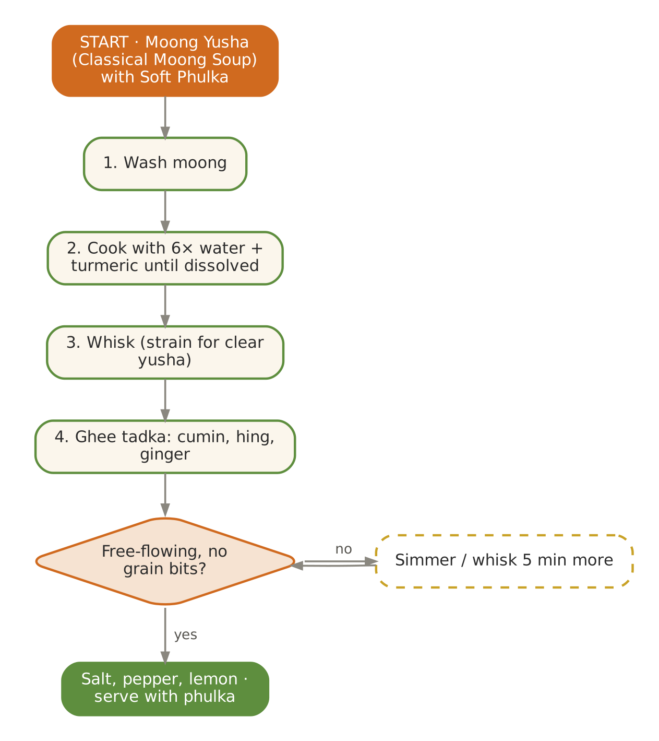  Signature dish: Moong Yusha (Classical Moong Soup) with Soft Phulka | Further dishes & variations  Breakfast  Sattu paratha (soft) · Lauki thepla · Rice–moong idli · Kosambari (steamed moong salad) · Dalia with banana  Dals & Saags  Neer mor (thin spiced buttermilk) · Toor dal with raw mango (small) · Moong with mint tempering · Lauki chana dal · Drumstick-leaf dal  Sabzis  Kundru with coconut · Raw-mango kaddu · Torai–chana dal · Bhindi kadhi · Aloo–tinda  Evening  Panakam · Coconut water with lime · Bel sharbat (late Apr) · Mint–jeera takra · Muskmelon with cardamom  Light Dinners  Lauki–moong soup · Lauki soup · Namkeen dalia · Moong dal khichdi · Jowar phulka with dal  Sweets & Digestives  Coconut–rose ladoo · Banana sheera · Dhaniya–mishri digestive · Saunf–mishri · Phirni

May — Hydration, Mango & Cooling Kitchen
Hindu months | Vaishakh – Jyeshtha
Ayurvedic season | Grishma (summer)
Haridwar weather | ≈ 22 – 38 °C, hot dry winds (loo)
Agni (digestion) | Low — the body conserves energy in heat
Dosha picture | Vata accumulates (dryness); Pitta rising with heat
Favour | Sweet, cool, liquid, slightly unctuous; rice, milk, ghee, melons
Limit | Pungent, sour and salty excess; heavy, oily and fried food; exertion at midday

In season
Vegetables & greens | Fruit | Pantry & other
Lauki, torai, parwal, bhindi, kundru, cucumber, tinda, drumstick, raw mango, mint | Mango (early), muskmelon, watermelon, bael, falsa, litchi (late), jamun (late) | Khus, rose, sattu, coconut water

Festivals & observances
Occasion | Kitchen response
Akshaya Tritiya (lunar) | Sattu, kheer, panakam offered; start of mango season.
Buddha Purnima (lunar) | Simple kheer and sattvic thali.
Nirjala Ekadashi (May/Jun) | For non-fasting elderly guests serve light phalahari; fasting elders: monitor hydration closely.

Kitchen guidance for May
- Serve drinks at room temperature from earthen matkas — no ice for 55+ guests.
- Watch for dehydration and heat exhaustion: offer 150 ml fluid every hour 10 am–6 pm.
- Make the evening snack a drink; keep dinner liquid-rich (soups, dal, khichdi).
- Mangoes: soak 1 hour in water before cutting (traditional — reduces 'heat'); serve at lunch.
Daily rituals: on waking — Room-temperature water from a copper or earthen pot; at bedtime — Warm (not hot) milk with a pinch of cardamom and ½ tsp ghee.

Seven-day menu — May
Rotate weekly; swap any item for one from 'Further dishes & variations' at the end of this chapter. Lunch always includes rice and phulka; curd/raita is served at lunch only.
Day | Breakfast 7:30–9:00 | Lunch thali 12:30–2:30 | Evening 4:00 | Dinner 7:00–8:30
Monday | Vegetable rava idli · coconut chutney | Lauki kadhi (no pakora) · Parwal sabzi · Tinda masala · rice & phulka · Pudina takra | Aam panna | Namkeen dalia with summer gourds · sweet: Aamras (lunch, 100 g)
Tuesday | Ragi malt · banana | Lauki–moong dal · Torai–moong · Bhindi with coconut · rice & phulka · Kheera raita (room temp.) | Bel sharbat | Lauki soup · phulka · sweet: Rose phirni (60 ml)
Wednesday | Poha with lemon · muskmelon | Moong with drumstick · Kundru thoran · Lauki–peas · rice & phulka · Raw-mango chutney (small) | Sattu sharbat | Moong khichdi · sweet: Rice kheer (60 ml)
Thursday | Moong chilla · mint chutney | Toor dal (mild) · Ash-gourd (petha) sabzi · Raw-mango–kaddu · rice & phulka · Lauki raita | Coconut water | Rasam · soft rice · sweet: Coconut ladoo
Friday | Sweet dalia · mango slices | Masoor–lauki · Aloo–jeera light · Cucumber kootu · rice & phulka · Coconut chutney | Khus sharbat (light) | Moong yusha · phulka · sweet: Banana–date mash
Saturday | Oats porridge (almond milk) · papaya | Moong–masoor dal · Parwal sabzi · Tinda masala · rice & phulka · Pudina takra | Rose–fennel cooler | Vegetable stew · idiyappam · sweet: Gulkand (1 tsp)
Sunday | Soft upma · watermelon | Thin moong dal with mint · Torai–moong · Bhindi with coconut · rice & phulka · Kheera raita (room temp.) | Muskmelon with mint | Torai dal · rice · sweet: Sabudana kheer (60 ml)

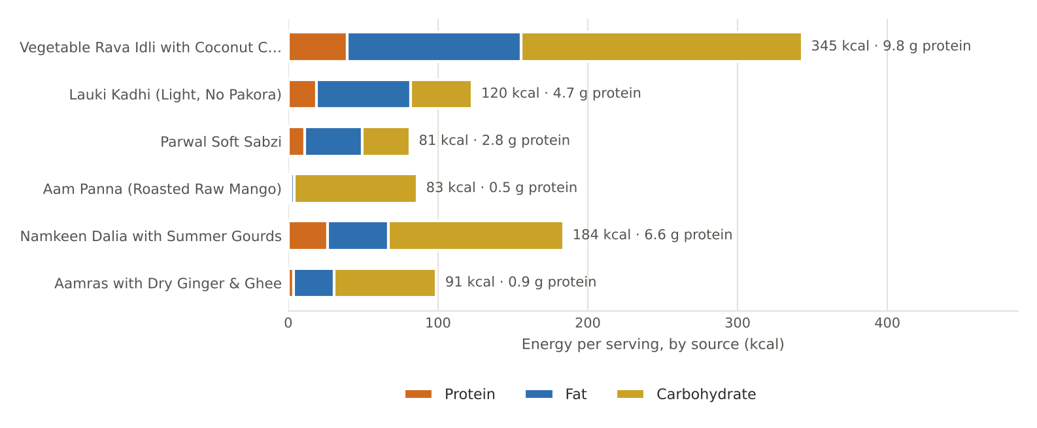
Figure. May's featured recipes — energy per serving by source, with protein

May recipes

Vegetable Rava Idli with Coconut Chutney
BREAKFAST · Serves 4 · Portion: 3 idlis + 3 tbsp chutney · Rest 20 min · Steam 12 min
Texture: Soft, spongy Dosha: Light; balances Pitta
Ingredient | Household measure | Base qty | Café batch ×5
Semolina (suji/rava) | 1 cup + 2 tbsp | 200 g | 1,000 g
Ghee (cow) | 2 tsp | 10 g | 50 g
Mustard seeds | ½ tsp | 2 g | 10 g
Curry leaves | 8 leaves | 1 g | 5 g
Ginger, fresh | 1½ tsp grated | 8 g | 40 g
Curd (dahi), plain | ¾ cup + 1 tbsp | 200 g | 1,000 g
Water | ⅓ cup | 80 ml | 400 ml
Carrot | ⅓ cup grated | 50 g | 250 g
Green peas, fresh | 3 tbsp | 30 g | 150 g
Rock salt (sendha namak) | ½ tsp | 3 g | 15 g
Fruit salt (Eno) / leavening | 1 tsp fruit salt (Eno) | 4 g | 20 g
Coconut, fresh grated | 1 cup fresh grated (chutney) | 80 g | 400 g
Chana dal | 1 tbsp roasted (chutney) | 15 g | 75 g
Ginger, fresh | 1 tsp (chutney) | 5 g | 25 g
Water | ⅓ cup (chutney) | 80 ml | 400 ml
Rock salt (sendha namak) | pinch (chutney) | 1 g | 5 g
Coconut oil | 1 tsp (chutney tempering) | 5 g | 25 g
Mustard seeds | ¼ tsp (tempering) | 1 g | 5 g
Method
1. Heat ghee; add mustard, curry leaves and ginger; add suji and roast 4 minutes; cool.
2. Mix in curd, water, carrot, peas and salt to an idli-batter consistency; rest 20 minutes.
3. Grease idli moulds. Just before steaming add fruit salt and 1 tbsp water; mix gently.
4. Fill moulds; steam 12 minutes; rest 5 minutes before unmoulding.
5. Chutney: grind coconut, roasted chana dal, ginger, salt and water smooth; temper with coconut oil and mustard.

Per serving | Energy  345 kcal | Protein  9.8 g | Fat  12.9 g | Carbs  46.8 g | Fibre  5.4 g | Salt  1.0 g

Care notes for 55+ guests  Steamed, soft and easy to swallow. Serve warm — not straight from the steamer. | Ayurvedic note  Steaming keeps food light (laghu); coconut cools summer Pitta.
Variations & further ideas: Rice idli · Ragi idli · Oats idli · Moong dal idli

Lauki Kadhi (Light, No Pakora)
LUNCH · KADHI · Serves 4 · Portion: 1 katori (≈200 g) · Cook 35 min
Texture: Smooth with soft pieces Dosha: Takra-based; good for Vata & Kapha, mild for Pitta
Ingredient | Household measure | Base qty | Café batch ×5
Curd (dahi), plain | 1¼ cups, slightly sour | 300 g | 1,500 g
Gram flour (besan) | 3 tbsp | 30 g | 150 g
Turmeric powder | ¼ tsp | 1 g | 5 g
Water | 3 cups | 700 ml | 3,500 ml
Bottle gourd (lauki) | 1½ cups small cubes | 200 g | 1,000 g
Ghee (cow) | 1 tbsp | 15 g | 75 g
Fenugreek seeds | ¼ tsp | 0.5 g | 2.5 g
Cumin (jeera) | ½ tsp | 2 g | 10 g
Asafoetida (hing) | 1 pinch | 0.3 g | 1.5 g
Curry leaves | 8 leaves | 1 g | 5 g
Ginger, fresh | 1½ tsp grated | 8 g | 40 g
Rock salt (sendha namak) | ¾ tsp | 3.5 g | 18 g
Kashmiri chilli powder (mild) | pinch (optional) | 0.5 g | 2.5 g
Coriander leaves | 1 tbsp | 5 g | 25 g
Method
1. Whisk curd, besan, turmeric and water until lump-free.
2. Boil lauki in 150 ml of the water 6 minutes until just soft.
3. Tadka in a deep pan: ghee, methi seeds, cumin, hing, curry leaves, ginger.
4. Add the kadhi mixture; bring to a boil, stirring constantly (prevents splitting).
5. Add lauki; simmer on low 20 minutes, stirring occasionally. Add salt at the end; garnish with coriander.

Per serving | Energy  120 kcal | Protein  4.7 g | Fat  7.0 g | Carbs  10.3 g | Fibre  1.4 g | Salt  0.9 g

Care notes for 55+ guests  Salt is added last so the kadhi doesn't split. Keep it mildly sour in summer. | Ayurvedic note  Cooked takra is a digestive; lauki cools — a summer-safe kadhi.
Variations & further ideas: Gujarati kadhi (sweet-sour) · Majjige huli (Karnataka) · Bhindi kadhi · Moringa kadhi

Parwal Soft Sabzi
LUNCH · SABZI · Serves 4 · Portion: 1 katori (≈120 g) · Cook 25 min
Texture: Soft Dosha: Light, Pitta-pacifying
Ingredient | Household measure | Base qty | Café batch ×5
Pointed gourd (parwal) | 12–14, scraped & quartered | 400 g | 2,000 g
Potato | 1 small, diced | 100 g | 500 g
Ghee (cow) | 1 tbsp | 15 g | 75 g
Cumin (jeera) | ½ tsp | 2 g | 10 g
Asafoetida (hing) | 1 pinch | 0.3 g | 1.5 g
Ginger, fresh | 1½ tsp grated | 8 g | 40 g
Turmeric powder | ¼ tsp | 1 g | 5 g
Coriander seed / powder | 1½ tsp powder | 3 g | 15 g
Fennel (saunf) | 1 tsp powder | 2 g | 10 g
Rock salt (sendha namak) | ½ tsp | 3 g | 15 g
Water | scant ½ cup | 100 ml | 500 ml
Coriander leaves | 2 tbsp | 8 g | 40 g
Method
1. Scrape parwal lightly, trim ends, quarter; remove mature seeds.
2. Heat ghee; add cumin, hing, ginger.
3. Add parwal, potato, turmeric, coriander and fennel powders, salt; toss 2 minutes.
4. Add water; cover and cook on low 15 minutes until soft.
5. Garnish with coriander.

Per serving | Energy  81 kcal | Protein  2.8 g | Fat  4.3 g | Carbs  7.9 g | Fibre  4.2 g | Salt  0.8 g

Care notes for 55+ guests  Remove hard seeds of mature parwal; cook covered for softness. | Ayurvedic note  Patola (parwal) is praised in Ayurveda as light, Pitta-pacifying and supportive of digestion.
Variations & further ideas: Parwal–aloo rasa · Stuffed parwal (steamed) · Parwal kheer (Bengal sweet) · Parwal–moong dal

Aam Panna (Roasted Raw Mango)
EVENING · DRINK · Serves 6 · Portion: 150 ml · Cook 20 min
Texture: Thin liquid Dosha: Cooling; protects against heat-stroke
Ingredient | Household measure | Base qty | Café batch ×5
Raw mango | 2 medium | 300 g | 1,500 g
Jaggery (gur) | ½ cup grated, loosely packed | 80 g | 400 g
Cumin (jeera) | 1 tsp roasted, powdered | 3 g | 15 g
Rock salt (sendha namak) | ½ tsp black salt | 3 g | 15 g
Mint leaves | 10 leaves | 8 g | 40 g
Water | 3⅓ cups (to dilute) | 800 ml | 4,000 ml
Method
1. Roast mangoes on an open flame (smoky) or pressure-cook 2 whistles.
2. Cool, peel and scrape out the pulp (≈180 g).
3. Blend pulp with jaggery, roasted cumin, salt and mint.
4. Dilute with water (about 1 : 4); serve at room temperature or cool — never iced.

Per serving | Energy  83 kcal | Protein  0.5 g | Fat  0.2 g | Carbs  20.5 g | Fibre  1.0 g | Salt  0.5 g

Care notes for 55+ guests  Diabetic guests: halve the jaggery and serve 100 ml. | Ayurvedic note  Traditional remedy for 'loo' (heat exhaustion); restores electrolytes.
Variations & further ideas: Kairi jaljeera · Pudina–kairi takra · Kokum sharbat · Jaljeera (mild, room temp.)

Namkeen Dalia with Summer Gourds
DINNER · Serves 4 · Portion: 1 bowl (≈280 g) · Cook 30 min
Texture: Soft porridge Dosha: Light, cooling
Ingredient | Household measure | Base qty | Café batch ×5
Broken wheat (dalia) | ¾ cup | 120 g | 600 g
Moong dal, yellow split | 3 tbsp | 40 g | 200 g
Bottle gourd (lauki) | ¾ cup diced | 100 g | 500 g
Ridge gourd (torai) | ¾ cup diced | 100 g | 500 g
Ghee (cow) | 1 tbsp | 15 g | 75 g
Cumin (jeera) | ½ tsp | 2 g | 10 g
Asafoetida (hing) | 1 pinch | 0.3 g | 1.5 g
Ginger, fresh | 1½ tsp | 8 g | 40 g
Turmeric powder | ¼ tsp | 1 g | 5 g
Rock salt (sendha namak) | ¾ tsp | 3.5 g | 18 g
Water | 3⅓ cups | 800 ml | 4,000 ml
Coriander leaves | 2 tbsp | 8 g | 40 g
Lemon juice | 2 tsp | 10 ml | 50 ml
Method
1. Roast dalia in 1 tsp ghee 3 minutes.
2. Heat remaining ghee; cumin, hing, ginger; add gourds 2 minutes.
3. Add dalia, moong, turmeric, salt and water; pressure-cook 4 whistles.
4. Rest, stir and loosen; finish with coriander and lemon.

Per serving | Energy  184 kcal | Protein  6.6 g | Fat  4.5 g | Carbs  29.2 g | Fibre  5.2 g | Salt  0.9 g

Care notes for 55+ guests  Torai and lauki melt into the dalia — very easy to eat. | Ayurvedic note  Gourds are cooling and diuretic; ideal summer dinner.
Variations & further ideas: Lauki khichdi · Dalia pulao (soft) · Sweet dalia with banana · Oats–torai khichdi

Aamras with Dry Ginger & Ghee
SWEET · Serves 4 · Portion: ≈100 g (serve at lunch) · Soak 1 h · 10 min
Texture: Smooth purée Dosha: Nourishing; dry ginger aids digestion
Ingredient | Household measure | Base qty | Café batch ×5
Mango, ripe | pulp of 3 medium ripe mangoes | 450 g | 2,250 g
Water | 3 tbsp (to loosen) | 40 ml | 200 ml
Dry ginger (saunth) | ½ tsp dry ginger powder | 1 g | 5 g
Ghee (cow) | 2 tsp | 10 g | 50 g
Green cardamom | ⅛ tsp | 0.5 g | 2.5 g
Saffron (kesar) | 5 strands (optional) | 0.1 g | 0.3 g
Method
1. Soak whole mangoes in water for 1 hour.
2. Peel and pulp; blend smooth with water.
3. Stir in dry ginger, ghee and cardamom (and saffron).
4. Serve at lunch with soft phulka — not at dinner.

Per serving | Energy  91 kcal | Protein  0.9 g | Fat  3.0 g | Carbs  17.1 g | Fibre  1.9 g | Salt  0.0 g

Care notes for 55+ guests  Diabetic guests: 2 tbsp only, with the meal (never alone). | Ayurvedic note  Ghee and dry ginger make ripe mango easier to digest and less heating.
Variations & further ideas: Mango phirni · Mango–coconut ladoo · Aam ki launji (sweet-sour relish) · Mango lassi — room temp., lunch only

Signature process & further dishes — May
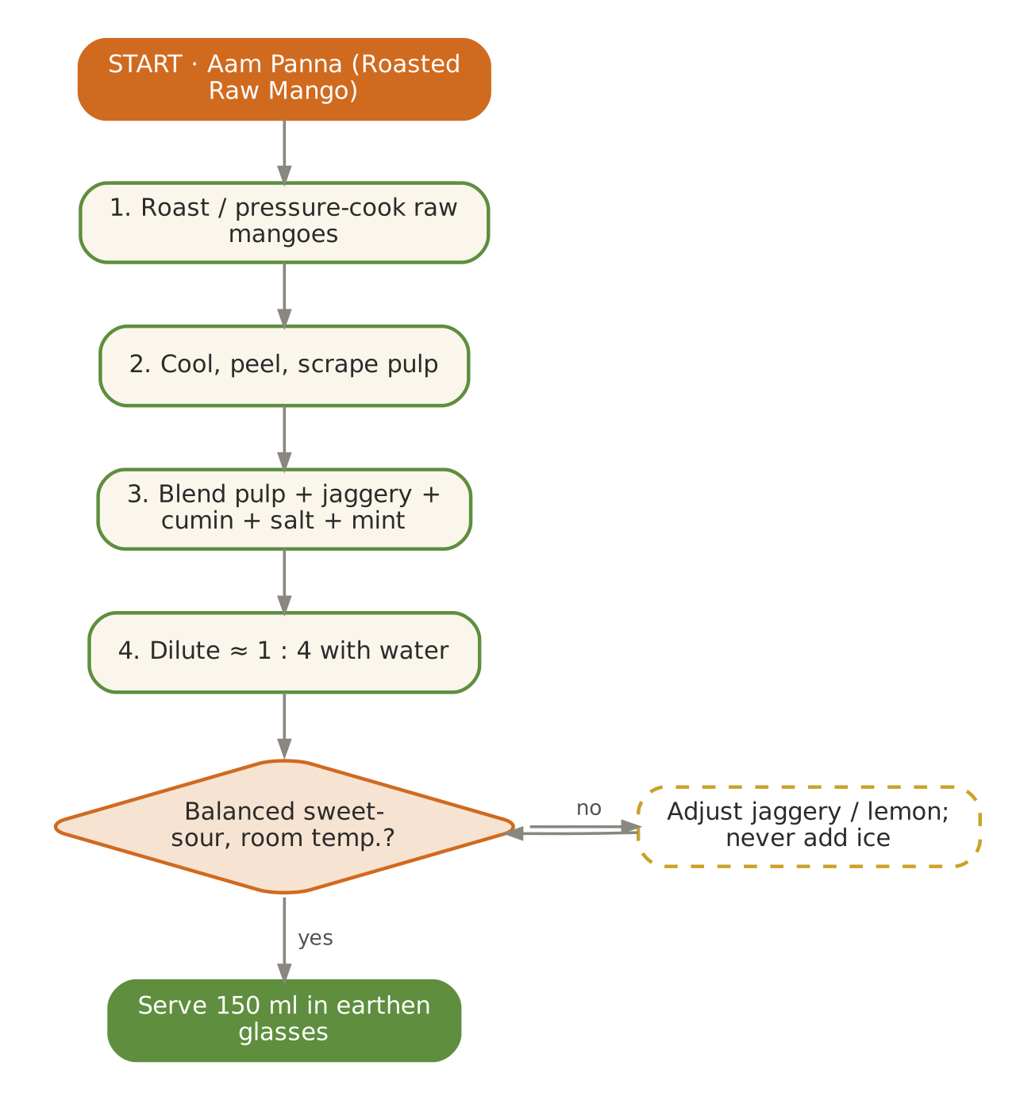  Signature dish: Aam Panna (Roasted Raw Mango) | Further dishes & variations  Breakfast  Neer dosa with coconut chutney · Ragi idli · Moong sprout (steamed) usal · Sabudana upma · Mango–oats porridge  Dals & Saags  Majjige huli · Mor kuzhambu · Moong dal with mint · Toor dal with drumstick · Lauki kofta kadhi (steamed kofta)  Sabzis  Ash-gourd kootu · Kundru with coconut · Torai–chana dal · Bhindi–kadhi · Cucumber pachadi (room temp.)  Evening  Bel sharbat · Khus sharbat · Falsa juice (diluted) · Coconut water with tulsi · Neer mor  Light Dinners  Lauki soup with phulka · Moong–rice khichdi · Rasam rice · Vegetable stew with appam  Sweets & Digestives  Mango phirni · Rose–coconut ladoo · Gulkand · Saunf–mishri · Sabudana kheer

June — Cool, Nourish & Ganga Dussehra
Hindu months | Jyeshtha – Ashadha
Ayurvedic season | Grishma (high summer) → pre-monsoon
Haridwar weather | ≈ 25 – 38 °C, humid by month-end; monsoon arrives late June
Agni (digestion) | Lowest of the summer
Dosha picture | Vata accumulating, Pitta high; humidity begins Kapha
Favour | Sweet and cool; unctuous and liquid; a little sour only with rains
Limit | Heavy, spicy, sour food; cold-from-fridge drinks; leftovers (spoil fast in heat)

In season
Vegetables & greens | Fruit | Pantry & other
Lauki, kaddu, bhindi, kundru, torai, parwal, cucumber, drumstick, early corn | Mango (dasheri, langra), jamun, litchi, bael, falsa, plum, muskmelon | Coconut, kokum (stored), sattu

Festivals & observances
Occasion | Kitchen response
Ganga Dussehra (Jyeshtha Shukla Dashami) | Haridwar's great festival — sharbat seva (bael, rose), sattu, kheer; very large crowds.
Nirjala Ekadashi | Distribution of sharbat and water; fasting elders need careful hydration afterwards.
Rath Yatra (late Jun/Jul) | Sweet pongal, khichdi bhog.

Kitchen guidance for June
- Food safety is critical: cook in small batches; nothing cooked sits above 2 hours at room temperature.
- Earthen-pot drinks; offer coconut water and buttermilk generously.
- From the first rains, shift gently to more cooked, warm food and digestive spices.
- Jamun season: small portions with rock salt — helpful for diabetic guests.
Daily rituals: on waking — Room-temperature water with soaked fennel (saunf water); at bedtime — Warm milk with cardamom (avoid if humid-night indigestion).

Seven-day menu — June
Rotate weekly; swap any item for one from 'Further dishes & variations' at the end of this chapter. Lunch always includes rice and phulka; curd/raita is served at lunch only.
Day | Breakfast 7:30–9:00 | Lunch thali 12:30–2:30 | Evening 4:00 | Dinner 7:00–8:30
Monday | Ragi malt porridge · banana | Kaddu–toor dal sambar (mild) · Bhindi with coconut · Kundru thoran · rice & phulka · Pudina takra | Bael sharbat | Vegetable stew · idiyappam · sweet: Rice–coconut-milk payasam (80 ml)
Tuesday | Idiyappam with coconut milk · papaya | Lauki–moong dal · Torai–moong · Kaddu khatta-meetha · rice & phulka · Cucumber pachadi (room temp.) | Coconut water | Moong khichdi · sweet: Aamras (lunch)
Wednesday | Moong dal chilla · mint chutney | Lauki kadhi · Parwal sabzi · Lauki–peas · rice & phulka · Coconut chutney | Rose–fennel cooler | Lauki soup · phulka · sweet: Rose phirni
Thursday | Vegetable poha · jamun (6) | Moong with drumstick · Ash-gourd olan · Beans–carrot thoran · rice & phulka · Lauki raita | Aam panna | Rasam · soft rice · sweet: Coconut ladoo
Friday | Rice idli · coconut chutney | Thin moong dal · Tinda masala · Raw-banana poriyal · rice & phulka · Neer mor | Sattu sharbat | Namkeen dalia · sweet: Banana sheera (40 g)
Saturday | Sweet dalia · mango | Masoor–lauki · Bhindi with coconut · Kundru thoran · rice & phulka · Pudina takra | Stewed plum | Moong yusha · rice · sweet: Gulkand (1 tsp)
Sunday | Soft upma · muskmelon | Parippu (Kerala moong) · Torai–moong · Kaddu khatta-meetha · rice & phulka · Cucumber pachadi (room temp.) | Makhana with ghee | Torai dal · phulka · sweet: Sabudana kheer

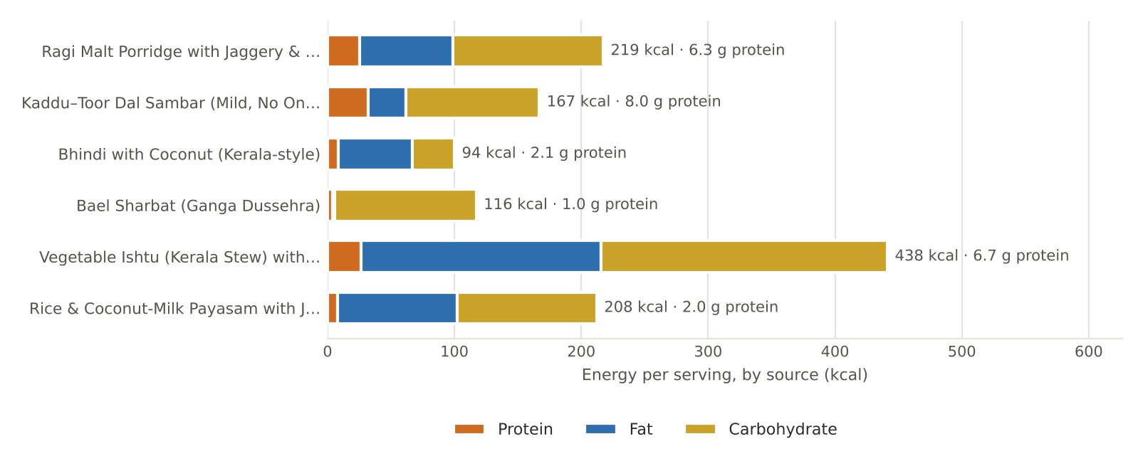
Figure. June's featured recipes — energy per serving by source, with protein

June recipes

Ragi Malt Porridge with Jaggery & Cardamom
BREAKFAST · Serves 4 · Portion: 200 ml bowl · Cook 15 min
Texture: Smooth porridge Dosha: Cooling, nourishing
Ingredient | Household measure | Base qty | Café batch ×5
Finger millet (ragi) flour | ½ cup + 2 tbsp ragi flour | 80 g | 400 g
Water | 1¼ cups | 300 ml | 1,500 ml
Cow's milk, whole | 2 cups | 500 ml | 2,500 ml
Jaggery (gur) | 3 tbsp grated (added off heat) | 40 g | 200 g
Green cardamom | ⅛ tsp | 0.5 g | 2.5 g
Ghee (cow) | 1 tsp | 5 g | 25 g
Almonds | 10, soaked & chopped | 15 g | 75 g
Method
1. Whisk ragi flour into cold water until lump-free.
2. Cook on low, stirring, 8 minutes until glossy and thick.
3. Add milk and simmer 5 minutes.
4. Turn off the heat; cool 2 minutes, then stir in jaggery (prevents curdling).
5. Add cardamom and ghee; top with chopped almonds.

Per serving | Energy  219 kcal | Protein  6.3 g | Fat  8.2 g | Carbs  29.6 g | Fibre  2.7 g | Salt  0.0 g

Care notes for 55+ guests  Ragi is among the richest plant sources of calcium — valuable for bone health after 55. | Ayurvedic note  Ragi is cooling and strengthening; jaggery added off heat keeps milk from splitting.
Variations & further ideas: Savoury ragi ambli with buttermilk · Ragi idli · Ragi dosa · Ragi halwa

Kaddu–Toor Dal Sambar (Mild, No Onion)
LUNCH · DAL · Serves 4 · Portion: 1 katori (≈200 g) · Cook 40 min
Texture: Soft Dosha: Balancing; mild for Pitta
Ingredient | Household measure | Base qty | Café batch ×5
Toor / arhar dal | ½ cup + 2 tbsp | 120 g | 600 g
Water | 3¾ cups | 900 ml | 4,500 ml
Turmeric powder | ¼ tsp | 1 g | 5 g
Pumpkin (kaddu) | 1½ cups cubes | 200 g | 1,000 g
Drumstick pods (sahjan) | 1 pod, 3-inch pieces | 100 g | 500 g
Tamarind pulp | small lime-sized ball, soaked | 10 g | 50 g
Coriander seed / powder | 2 tsp coriander powder | 4 g | 20 g
Kashmiri chilli powder (mild) | ¼ tsp Kashmiri | 1 g | 5 g
Fenugreek seeds | ¼ tsp roasted, powdered | 0.5 g | 2.5 g
Cumin (jeera) | ¼ tsp powdered | 1 g | 5 g
Jaggery (gur) | 1 tsp | 5 g | 25 g
Rock salt (sendha namak) | ¾ tsp | 4 g | 20 g
Ghee (cow) | 2 tsp | 10 g | 50 g
Mustard seeds | ½ tsp | 2 g | 10 g
Curry leaves | 10 leaves | 2 g | 10 g
Asafoetida (hing) | 1 pinch | 0.3 g | 1.5 g
Coriander leaves | 1 tbsp | 5 g | 25 g
Method
1. Pressure-cook toor dal with 600 ml water and turmeric — 4 whistles; mash.
2. Boil pumpkin and drumstick in tamarind water (300 ml) with salt for 10 minutes.
3. Add dal, spice powders and jaggery; simmer 8 minutes.
4. Temper with ghee, mustard, curry leaves and hing; garnish with coriander.

Per serving | Energy  167 kcal | Protein  8.0 g | Fat  3.3 g | Carbs  26.3 g | Fibre  4.6 g | Salt  1.0 g

Care notes for 55+ guests  Drumstick: chew the pulp, discard fibres — scrape pulp out for denture wearers. | Ayurvedic note  Drumstick (shigru) clears Kapha; pumpkin sweetens and cools.
Variations & further ideas: Moringa-leaf sambar · Lauki sambar · Arachuvitta sambar · Pepper rasam

Bhindi with Coconut (Kerala-style)
LUNCH · SABZI · Serves 4 · Portion: 1 katori (≈100 g) · Cook 25 min
Texture: Soft Dosha: Lubricating; good for Vata dryness
Ingredient | Household measure | Base qty | Café batch ×5
Okra (bhindi) | 1-cm rounds | 350 g | 1,750 g
Coconut oil | 1 tbsp | 15 g | 75 g
Mustard seeds | ½ tsp | 2 g | 10 g
Curry leaves | 8 leaves | 1 g | 5 g
Ginger, fresh | 1 tsp grated | 5 g | 25 g
Turmeric powder | ¼ tsp | 1 g | 5 g
Coriander seed / powder | 1 tsp | 2 g | 10 g
Coconut, fresh grated | 3 tbsp grated | 30 g | 150 g
Rock salt (sendha namak) | ½ tsp | 3 g | 15 g
Lemon juice | 1 tsp | 5 ml | 25 ml
Method
1. Wash bhindi and dry completely before cutting.
2. Heat oil; add mustard, curry leaves, ginger.
3. Add bhindi and turmeric; spread out and cook open on low-medium 12 minutes, stirring gently.
4. Cover for the last 3 minutes to soften.
5. Add coconut and coriander powder; cook 2 minutes; salt at the end; finish with lemon.

Per serving | Energy  94 kcal | Protein  2.1 g | Fat  6.5 g | Carbs  8.2 g | Fibre  3.8 g | Salt  0.8 g

Care notes for 55+ guests  Covering at the end keeps bhindi soft rather than crisp. | Ayurvedic note  Bhindi's slipperiness (picchila guna) eases Vata dryness and constipation.
Variations & further ideas: Bhindi kadhi · Bharwa bhindi (soft) · Bhindi–tomato (light) · Bhindi pachadi

Bael Sharbat (Ganga Dussehra)
EVENING · DRINK · Serves 4 · Portion: 200 ml · Soak 30 min · 15 min
Texture: Pulpy liquid Dosha: Cooling; soothes the gut
Ingredient | Household measure | Base qty | Café batch ×5
Bael (wood apple) pulp | pulp of 1 medium fruit | 200 g | 1,000 g
Water | 3⅓ cups | 800 ml | 4,000 ml
Jaggery (gur) | ⅓ cup grated | 50 g | 250 g
Green cardamom | ⅛ tsp | 0.5 g | 2.5 g
Rock salt (sendha namak) | pinch black salt | 0.5 g | 2.5 g
Method
1. Crack the bael and scoop out the pulp.
2. Soak in 400 ml water for 30 minutes; mash with clean hands.
3. Strain through a coarse sieve, pressing well; discard seeds and fibre.
4. Add remaining water, jaggery, cardamom and black salt; serve at room temperature.

Per serving | Energy  116 kcal | Protein  1.0 g | Fat  0.2 g | Carbs  27.9 g | Fibre  1.5 g | Salt  0.1 g

Care notes for 55+ guests  Ripe bael is binding (grahi) — excellent for loose motions; avoid for chronically constipated guests. | Ayurvedic note  Bael cools Pitta and calms the intestines — the summer gut tonic.
Variations & further ideas: Bael murabba · Bael–mint cooler · Bael candy · Rose sharbat

Vegetable Ishtu (Kerala Stew) with Idiyappam
DINNER · Serves 4 · Portion: 1 bowl stew + 3 idiyappam · Cook 45 min
Texture: Soft Dosha: Mild, cooling, Vata-friendly
Ingredient | Household measure | Base qty | Café batch ×5
Coconut oil | 1 tbsp | 15 g | 75 g
Cinnamon | 1-inch | 1 g | 5 g
Clove | 3 | 0.5 g | 2.5 g
Green cardamom | 2 pods | 0.5 g | 2.5 g
Curry leaves | 10 leaves | 2 g | 10 g
Ginger, fresh | 2 tsp julienne | 10 g | 50 g
Green chilli (optional, deseeded) | ½ slit (optional) | 2 g | 10 g
Potato | 1 medium, cubed | 150 g | 750 g
Carrot | 1 medium, cubed | 100 g | 500 g
French beans | 10, cut | 80 g | 400 g
Green peas, fresh | ⅓ cup | 50 g | 250 g
Coconut milk, thin | 2 cups (1½ thin + ½ thick) | 500 ml | 2,500 ml
Black pepper | ½ tsp crushed | 1 g | 5 g
Rock salt (sendha namak) | ¾ tsp | 3.5 g | 18 g
Rice flour | 1⅔ cups roasted rice flour (idiyappam) | 200 g | 1,000 g
Water | 1 cup + 1 tbsp, boiling | 260 ml | 1,300 ml
Coconut oil | 1 tsp (dough) | 5 g | 25 g
Rock salt (sendha namak) | pinch (dough) | 1 g | 5 g
Method
1. Idiyappam: boil water with salt and oil; pour over rice flour, mix with a spoon, then knead to a warm, soft dough.
2. Press through a sevai mould onto greased idli plates; steam 8 minutes.
3. Stew: heat oil; add whole spices, curry leaves, ginger and chilli.
4. Add vegetables and thin coconut milk; simmer covered 12 minutes until soft.
5. Add pepper and salt; pour in thick coconut milk and heat 2 minutes — do not boil.

Per serving | Energy  438 kcal | Protein  6.7 g | Fat  21.0 g | Carbs  56.5 g | Fibre  4.9 g | Salt  1.1 g

Care notes for 55+ guests  Adapted from the Kerala Vata menu (idiyappam with coconut milk). Very soft and mild. | Ayurvedic note  Coconut milk is cooling and unctuous — soothes summer Pitta and Vata alike.
Variations & further ideas: Appam with stew · Rice-flour puttu · Vegetable stew with soft rice · Idiyappam with sweet cardamom coconut milk

Rice & Coconut-Milk Payasam with Jaggery
SWEET · Serves 6 · Portion: 100 ml · Cook 35 min
Texture: Soft, creamy Dosha: Cooling, nourishing
Ingredient | Household measure | Base qty | Café batch ×5
Rice, white basmati (raw) | ⅓ cup broken rice | 60 g | 300 g
Water | 1⅔ cups | 400 ml | 2,000 ml
Jaggery (gur) | ½ cup grated | 100 g | 500 g
Coconut milk, thin | 1⅔ cups (thin + thick) | 400 ml | 2,000 ml
Green cardamom | ¼ tsp | 1 g | 5 g
Ghee (cow) | 2 tsp | 10 g | 50 g
Cashew nuts | 8 | 10 g | 50 g
Raisins (kishmish) | 1 tbsp | 10 g | 50 g
Method
1. Cook rice in 340 ml water 20 minutes until very soft and mushy.
2. Melt jaggery in 60 ml water; strain out impurities.
3. Add jaggery to the rice; simmer 5 minutes.
4. Add thin coconut milk and simmer 5 minutes on low; add thick milk and heat through.
5. Off heat add cardamom; top with ghee-fried cashews and raisins.

Per serving | Energy  208 kcal | Protein  2.0 g | Fat  10.5 g | Carbs  27.4 g | Fibre  0.6 g | Salt  0.0 g

Care notes for 55+ guests  Diabetic guests: 50 ml portion. | Ayurvedic note  Jaggery with coconut milk avoids the milk–jaggery curdling issue.
Variations & further ideas: Palada pradhaman (light) · Semiya payasam · Sabudana payasam · Jackfruit payasam (seasonal)

Signature process & further dishes — June
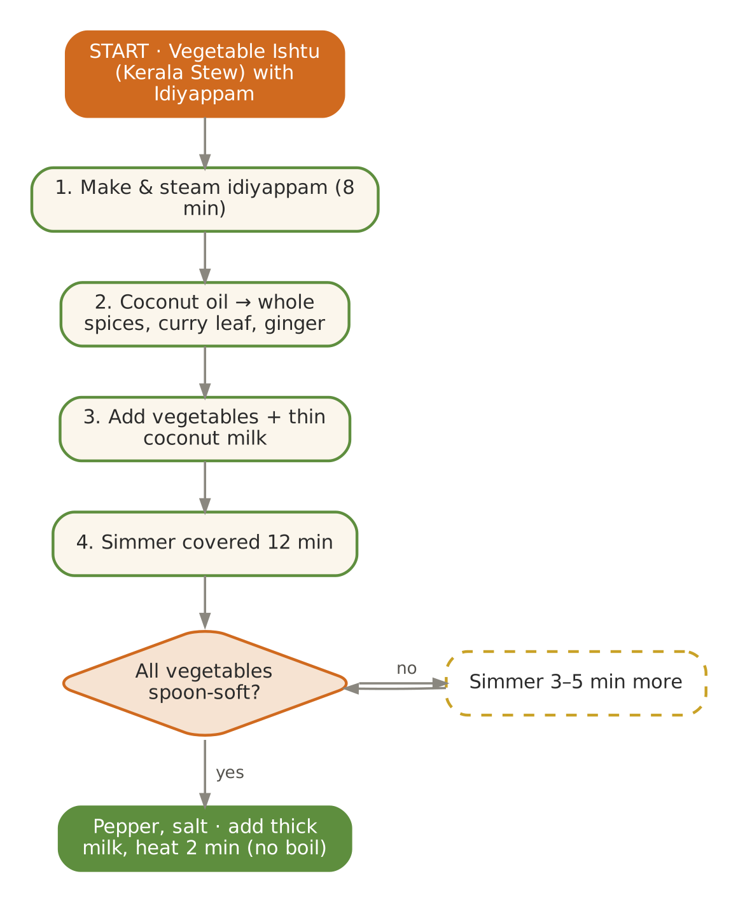  Signature dish: Vegetable Ishtu (Kerala Stew) with Idiyappam | Further dishes & variations  Breakfast  Appam with stew · Ragi idli · Puttu with banana · Sabudana khichdi (soft) · Ambli (savoury ragi drink)  Dals & Saags  Mor kuzhambu · Moringa sambar · Majjige huli · Moong–lauki dal · Parippu with ghee  Sabzis  Raw-banana poriyal · Kundru with coconut · Ash-gourd kootu · Lauki–peas · Kaddu khatta-meetha  Evening  Rose sharbat · Jamun with rock salt (small) · Coconut water · Litchi (4–5) · Sattu sharbat  Light Dinners  Moong khichdi · Lauki soup · Rasam rice · Kanji with ghee  Sweets & Digestives  Semiya payasam · Coconut barfi (soft) · Gulkand · Saunf water · Aamras

July — Kindle the Fire — Shravan & the Kanwar Season
Hindu months | Ashadha – Shravan
Ayurvedic season | Varsha (monsoon)
Haridwar weather | ≈ 25 – 33 °C, heavy rain, very humid
Agni (digestion) | Weakest of the year — food must be light, warm and well-spiced
Dosha picture | Vata aggravated; Pitta accumulating; Kapha from dampness
Favour | Sour, salty and a little unctuous; warm, freshly cooked, with ginger, pepper and hing
Limit | Raw salads, raw sprouts, leafy greens (uncooked), curd at night, river water, street food, day-old food

In season
Vegetables & greens | Fruit | Pantry & other
Kaddu, arbi, karela, kundru, parwal, lauki, torai, sweet corn, ginger, fresh turmeric | Jamun, pear, plum, peach (hill), early guava, litchi (end) | Old rice, old wheat, honey, rock salt

Festivals & observances
Occasion | Kitchen response
Guru Purnima (Ashadha Purnima) | Sooji sheera and panchamrit prasad; ashram bhandaras — plan for larger numbers.
Shravan month & Kanwar Yatra | Haridwar receives very large numbers of pilgrims; Monday fasts — phalahari options daily.
Hariyali Teej (late Jul/Aug) | Ghevar (small piece), kheer, malpua — offer baked/light alternatives.

Kitchen guidance for July
- Boil all drinking water; serve only freshly cooked, hot food.
- Avoid uncooked greens and salads — wash vegetables in salted water; cook leafy greens thoroughly.
- Add ginger, pepper, ajwain, hing and rock salt generously but not fiery.
- Serve buttermilk (spiced, at room temperature) instead of curd; no curd after sunset.
- Fasting (Shravan Mondays): for 55+ guests ensure fluids, phal and makhana; no prolonged dry fasts.
Daily rituals: on waking — Warm water with a pinch of dry ginger; at bedtime — Golden milk with a pinch of dry ginger and nutmeg.

Seven-day menu — July
Rotate weekly; swap any item for one from 'Further dishes & variations' at the end of this chapter. Lunch always includes rice and phulka; curd/raita is served at lunch only.
Day | Breakfast 7:30–9:00 | Lunch thali 12:30–2:30 | Evening 4:00 | Dinner 7:00–8:30
Monday | Ven pongal · pear | Adraki moong dal with saunth · Khatta-meetha kaddu (Haridwar style) · Arbi ajwaini · rice & phulka · Spiced takra (room temp.) | Ghee–pepper makhana · tulsi tea | Pepper–jeera rasam · soft rice · sweet: Sooji sheera (40 g)
Tuesday | Moong dal chilla · ginger chutney | Toor dal with drumstick · Karela–aloo · Kundru thoran · rice & phulka · Ginger–lemon pickle (fresh) | Tulsi–ginger kadha | Moong khichdi · sweet: Rice kheer (60 ml)
Wednesday | Dalia upma · stewed apple | Masoor–lauki · Parwal sabzi · Lauki–peas · rice & phulka · Coriander–mint chutney | Corn soup | Vegetable soup · phulka · sweet: Panchamrit (2 tbsp)
Thursday | Ragi porridge | Panchmel (light) · Torai–moong · Corn–pumpkin sabzi · rice & phulka · Amla chutney | Stewed pear | Moong yusha · ghee rice · sweet: Dhaniya panjiri (1 tbsp)
Friday | Rice idli · tomato-free coconut chutney | Kadhi with ajwain · Beans–carrot thoran · Raw-banana poriyal · rice & phulka · Jeera takra | Roasted bhutta (soft, kernels) | Namkeen dalia · sweet: Banana sheera
Saturday | Vegetable poha · papaya | Moong–masoor · Khatta-meetha kaddu (Haridwar style) · Arbi ajwaini · rice & phulka · Spiced takra (room temp.) | CCF tea | Lauki–moong soup · sweet: Ghevar (small piece)
Sunday | Oats–moong porridge | Whole moong (soft) · Karela–aloo · Kundru thoran · rice & phulka · Ginger–lemon pickle (fresh) | Plum compote | Kanji with ghee · sweet: Malpua (baked, small)

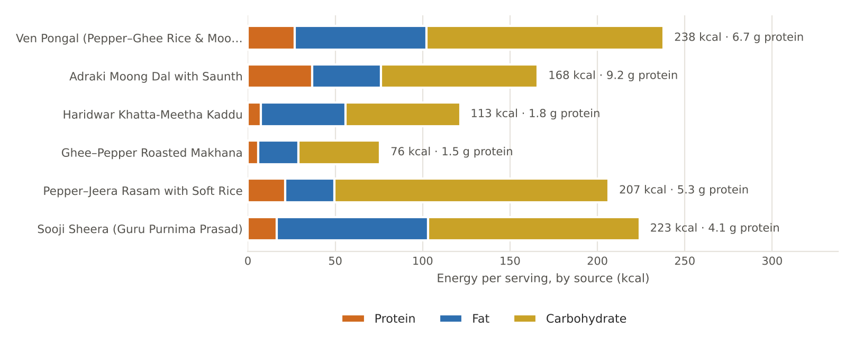
Figure. July's featured recipes — energy per serving by source, with protein

July recipes

Ven Pongal (Pepper–Ghee Rice & Moong)
BREAKFAST · Serves 4 · Portion: 1 bowl (≈250 g) · Cook 30 min
Texture: Soft, creamy Dosha: Kindles agni; Vata-pacifying
Ingredient | Household measure | Base qty | Café batch ×5
Rice, white basmati (raw) | ½ cup + 2 tbsp | 120 g | 600 g
Moong dal, yellow split | ⅓ cup, dry-roasted | 60 g | 300 g
Water | 3¾ cups (5 : 1 soft) | 900 ml | 4,500 ml
Ghee (cow) | 5 tsp | 25 g | 125 g
Black pepper | 1 tsp whole, crushed | 2 g | 10 g
Cumin (jeera) | ½ tsp | 2 g | 10 g
Ginger, fresh | 2 tsp grated | 10 g | 50 g
Curry leaves | 8 leaves | 1 g | 5 g
Asafoetida (hing) | 1 pinch | 0.3 g | 1.5 g
Cashew nuts | 10, halved | 15 g | 75 g
Rock salt (sendha namak) | ¾ tsp | 4 g | 20 g
Method
1. Dry-roast moong dal 3 minutes until aromatic.
2. Wash rice and moong; pressure-cook with water — 5 whistles.
3. Mash well while hot.
4. Tadka: ghee, crushed pepper, cumin, ginger, curry leaves, hing and cashews.
5. Mix the tadka and salt into the pongal; loosen with hot water for a creamy texture.

Per serving | Energy  238 kcal | Protein  6.7 g | Fat  8.4 g | Carbs  34.0 g | Fibre  2.2 g | Salt  1.0 g

Care notes for 55+ guests  Remove cashews for those with chewing difficulty; pepper crushed (not whole) avoids biting into it. | Ayurvedic note  Pepper and ginger are deepana (fire-kindling) — exactly what weak monsoon agni needs.
Variations & further ideas: Sakkarai (sweet) pongal · Millet pongal · Oats pongal · Dalia pongal

Adraki Moong Dal with Saunth
LUNCH · DAL · Serves 4 · Portion: 1 katori (≈180 g) · Cook 30 min
Texture: Soft Dosha: Tridoshic; digestive
Ingredient | Household measure | Base qty | Café batch ×5
Moong dal, yellow split | ¾ cup | 150 g | 750 g
Water | 3⅓ cups | 800 ml | 4,000 ml
Turmeric powder | ¼ tsp | 1 g | 5 g
Rock salt (sendha namak) | ¾ tsp | 4 g | 20 g
Ghee (cow) | 1 tbsp | 15 g | 75 g
Cumin (jeera) | ½ tsp | 2 g | 10 g
Asafoetida (hing) | 2 pinches | 0.4 g | 2 g
Ginger, fresh | 1 tbsp grated | 15 g | 75 g
Dry ginger (saunth) | ½ tsp dry ginger | 1 g | 5 g
Black pepper | ¼ tsp | 0.5 g | 2.5 g
Lemon juice | 2 tsp | 10 ml | 50 ml
Method
1. Pressure-cook moong with water and turmeric — 3 whistles; whisk.
2. Tadka: ghee, cumin, hing, fresh ginger; off heat add saunth and pepper.
3. Pour into dal; add salt; simmer 3 minutes.
4. Finish with lemon.

Per serving | Energy  168 kcal | Protein  9.2 g | Fat  4.4 g | Carbs  22.5 g | Fibre  3.8 g | Salt  1.0 g

Care notes for 55+ guests  Fresh and dry ginger together — the classic monsoon pairing for weak digestion. | Ayurvedic note  Sunthi (dry ginger) is called 'vishwabheshaj' — the universal medicine.
Variations & further ideas: Moong with ajwain · Moong–lauki dal · Hing–jeera dal · Moong soup with ghee

Haridwar Khatta-Meetha Kaddu
LUNCH · SABZI · Serves 4 · Portion: 1 katori (≈150 g) · Cook 30 min
Texture: Soft, half-mashed Dosha: Vata-pacifying, sweet
Ingredient | Household measure | Base qty | Café batch ×5
Pumpkin (kaddu) | 2-cm cubes, with skin | 600 g | 3,000 g
Mustard oil | 1½ tbsp (or ghee) | 20 g | 100 g
Fenugreek seeds | ½ tsp | 1 g | 5 g
Fennel (saunf) | 1 tsp | 2 g | 10 g
Cumin (jeera) | ¼ tsp | 1 g | 5 g
Asafoetida (hing) | 1 pinch | 0.3 g | 1.5 g
Ginger, fresh | 2 tsp grated | 10 g | 50 g
Turmeric powder | ¼ tsp | 1 g | 5 g
Rock salt (sendha namak) | ¾ tsp | 3.5 g | 18 g
Water | ¼ cup | 60 ml | 300 ml
Coriander seed / powder | 1½ tsp | 3 g | 15 g
Kashmiri chilli powder (mild) | ¼ tsp | 1 g | 5 g
Dry mango powder (amchur) | 1 tsp | 2 g | 10 g
Jaggery (gur) | 1½ tbsp | 20 g | 100 g
Method
1. Heat mustard oil to smoking; cool slightly.
2. Add methi seeds, fennel, cumin, hing and ginger.
3. Add pumpkin, turmeric and salt; add water, cover and cook on low 12–15 minutes.
4. Mash half the pumpkin with the spatula.
5. Add coriander powder, chilli, amchur and jaggery; cook open 3 minutes.

Per serving | Energy  113 kcal | Protein  1.8 g | Fat  5.4 g | Carbs  16.4 g | Fibre  1.5 g | Salt  0.9 g

Care notes for 55+ guests  Haridwar's famous puri–kaddu prasad — serve with soft phulka instead of fried puri. Skin softens fully; peel for guests who prefer. | Ayurvedic note  Sweet and sour together stimulate appetite gently during monsoon.
Variations & further ideas: Kaddu–aloo rasa · Pumpkin halwa · Kaddu with coconut (Kerala erissery) · Pumpkin–moong soup

Ghee–Pepper Roasted Makhana
EVENING · SNACK · Serves 4 · Portion: ≈15 g (1 small bowl) · 12 min
Texture: Crisp-melting Dosha: Light; Vata & Pitta pacifying
Ingredient | Household measure | Base qty | Café batch ×5
Fox nut (makhana) | 2½ cups | 60 g | 300 g
Ghee (cow) | 2 tsp | 10 g | 50 g
Black pepper | ½ tsp | 1 g | 5 g
Turmeric powder | pinch | 0.3 g | 1.5 g
Rock salt (sendha namak) | ¼ tsp | 1.5 g | 7.5 g
Method
1. Heat ghee on low; add makhana.
2. Roast 8–10 minutes, stirring, until one crushes crisply between fingers.
3. Sprinkle pepper, turmeric and salt; toss.
4. Cool; store airtight up to 1 week.

Per serving | Energy  76 kcal | Protein  1.5 g | Fat  2.5 g | Carbs  11.7 g | Fibre  0.7 g | Salt  0.4 g

Care notes for 55+ guests  Makhana melts in the mouth; for denture wearers soak briefly in warm milk. | Ayurvedic note  Makhana is light, cooling and nourishing — the ideal monsoon snack instead of fried pakoras.
Variations & further ideas: Makhana kheer · Makhana–peanut chaat (powdered nuts) · Makhana raita (lunch) · Masala makhana with chaat masala

Pepper–Jeera Rasam with Soft Rice
DINNER · Serves 4 · Portion: 200 ml rasam + 150 g rice · Cook 30 min
Texture: Thin soup + soft rice Dosha: Kindles agni; reduces Kapha & Vata
Ingredient | Household measure | Base qty | Café batch ×5
Toor / arhar dal | 2 tbsp (cooked, for body) | 30 g | 150 g
Tomato | 2 medium, crushed | 150 g | 750 g
Tamarind pulp | small marble-sized | 5 g | 25 g
Black pepper | 1½ tsp | 3 g | 15 g
Cumin (jeera) | 1½ tsp | 3 g | 15 g
Ginger, fresh | 2 tsp crushed | 10 g | 50 g
Turmeric powder | ⅛ tsp | 0.5 g | 2.5 g
Rock salt (sendha namak) | ¾ tsp | 3.5 g | 18 g
Water | 3⅓ cups | 800 ml | 4,000 ml
Ghee (cow) | 2 tsp | 10 g | 50 g
Mustard seeds | ¼ tsp | 1 g | 5 g
Asafoetida (hing) | 1 pinch | 0.3 g | 1.5 g
Curry leaves | 10 leaves | 2 g | 10 g
Coriander leaves | 2 tbsp | 8 g | 40 g
Rice, white basmati (raw) | ¾ cup + 1 tbsp | 160 g | 800 g
Water | 2⅔ cups (rice, 4 : 1) | 640 ml | 3,200 ml
Method
1. Coarsely grind pepper and cumin.
2. Boil tomato, tamarind water, ginger, turmeric and salt in 600 ml water for 8 minutes.
3. Add cooked mashed toor and 200 ml water; add pepper–cumin powder.
4. When it froths, turn off — do not boil hard.
5. Temper with ghee, mustard, hing and curry leaves; add coriander.
6. Rice: cook in 4× water until soft.

Per serving | Energy  207 kcal | Protein  5.3 g | Fat  3.1 g | Carbs  39.2 g | Fibre  2.3 g | Salt  0.9 g

Care notes for 55+ guests  Mild pepper level for 55+ — increase only on request. Rasam can be sipped from a cup. | Ayurvedic note  A deepana–pachana soup: the South Indian remedy for monsoon colds and sluggish digestion.
Variations & further ideas: Lemon rasam · Tomato-free jeera rasam · Moong-dal rasam · Mysore rasam

Sooji Sheera (Guru Purnima Prasad)
SWEET · Serves 6 · Portion: ≈80 g · Cook 20 min
Texture: Soft, moist Dosha: Vata-pacifying
Ingredient | Household measure | Base qty | Café batch ×5
Semolina (suji/rava) | ½ cup + 2 tbsp | 100 g | 500 g
Ghee (cow) | 3 tbsp | 40 g | 200 g
Cow's milk, whole | 1¼ cups | 300 ml | 1,500 ml
Water | ¾ cup + 1 tbsp | 200 ml | 1,000 ml
Mishri / sugar | ⅓ cup | 70 g | 350 g
Banana, ripe | ½ ripe, sliced | 60 g | 300 g
Green cardamom | ¼ tsp | 1 g | 5 g
Almonds | 8 slivered | 10 g | 50 g
Raisins (kishmish) | 1 tbsp | 10 g | 50 g
Method
1. Roast suji in ghee on low 8–10 minutes until golden and fragrant.
2. Meanwhile heat milk and water together.
3. Pour hot liquid carefully into suji (it splutters), stirring.
4. Cook 3 minutes until absorbed; add mishri and banana; cook 2 minutes until it leaves the sides.
5. Add cardamom, almonds and raisins.

Per serving | Energy  223 kcal | Protein  4.1 g | Fat  9.6 g | Carbs  30.3 g | Fibre  1.2 g | Salt  0.0 g

Care notes for 55+ guests  The milk–water mix keeps it soft and moist; reduced ghee from the traditional 1 : 1 ratio. | Ayurvedic note  Satyanarayan-style sheera — sweet, unctuous and grounding for Vata.
Variations & further ideas: Atta sheera · Moong dal halwa · Banana sheera · Rava kesari

Signature process & further dishes — July
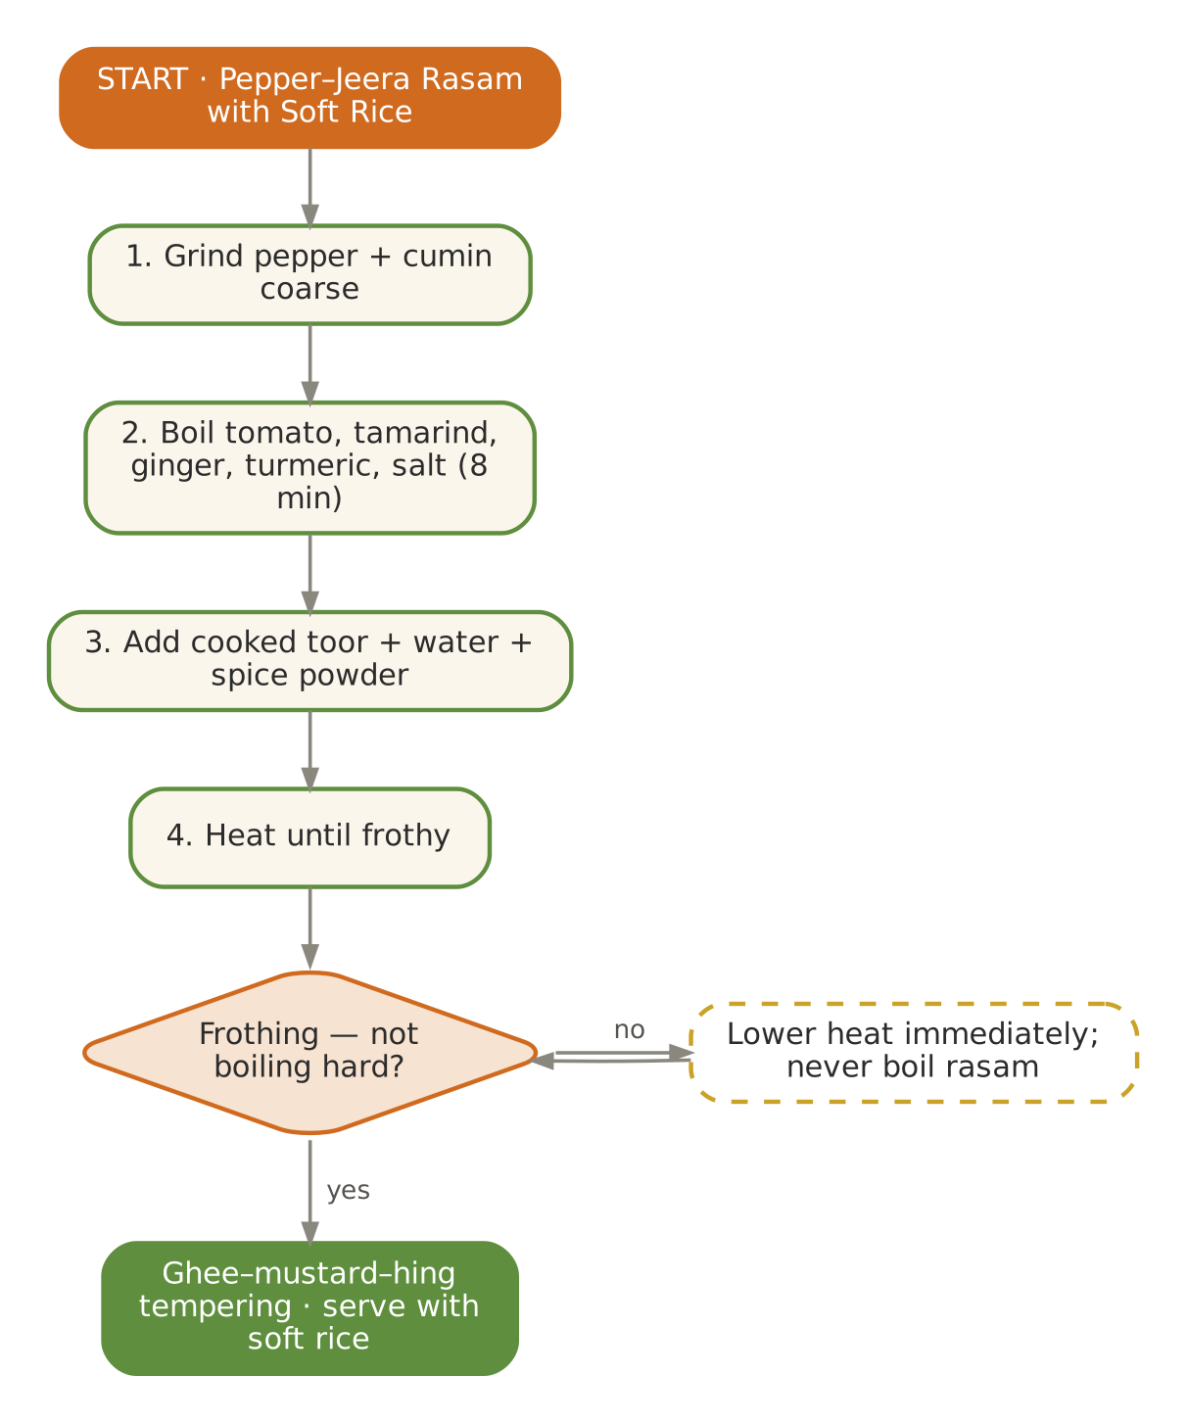  Signature dish: Pepper–Jeera Rasam with Soft Rice | Further dishes & variations  Breakfast  Ragi dosa · Millet pongal · Hot sweet-corn upma · Moong-dal dosa (pesarattu, no onion) · Dalia khichdi  Dals & Saags  Kulthi (horse gram) rasam · Ajwain kadhi · Moong with fresh turmeric · Panchmel dal · Toor–drumstick dal  Sabzis  Arbi patra (steamed) · Karela with jaggery · Kundru–aloo · Corn–kaddu · Raw-banana kofta (steamed)  Evening  Sweet-corn soup (blended) · Tulsi kadha · Hot ginger–lemon water · Plum compote · Masala makhana  Light Dinners  Rasam rice · Kanji with pickle-free ginger · Moong khichdi · Vegetable dalia  Sweets & Digestives  Panchamrit · Ghevar (small) · Dhaniya panjiri · Ajwain–saunf mukhwas · Rice kheer

August — Light, Warm & Immunity — Janmashtami Month
Hindu months | Shravan – Bhadrapad
Ayurvedic season | Varsha (peak monsoon)
Haridwar weather | ≈ 25 – 32 °C, continuous rain, very humid
Agni (digestion) | Weak — keep meals small and warm
Dosha picture | Vata at its peak; Pitta accumulating
Favour | Sour, salty, sweet in moderation; warm, freshly cooked, mildly spiced
Limit | Curd at night, uncooked greens, heavy fried snacks, cold drinks, day-old food

In season
Vegetables & greens | Fruit | Pantry & other
Lauki, torai, arbi, kakdi, kundru, karela, ginger, fresh turmeric, corn, bhindi | Guava, pear, plum, apple (early), banana, papaya | Coriander seeds, ajwain, tulsi

Festivals & observances
Occasion | Kitchen response
Raksha Bandhan (Shravan Purnima) | Soft mithai: date–nut ladoo, kesar peda (small).
Janmashtami (Bhadrapad Krishna Ashtami) | Dhaniya panjiri, makhan–mishri, panchamrit; midnight prasad — keep portions tiny for elders.
Hariyali / Kajari Teej | Light ghevar piece; sattvic thali.

Kitchen guidance for August
- Small, frequent warm meals; never reheat food more than once.
- Cook leafy greens thoroughly or avoid; prefer gourds, roots and pulses.
- Every lunch includes a digestive: ginger slices with rock salt and lemon before the meal.
- Watch for joint stiffness and low mood in elders — warm oil massage days, warm food, sunlight when available.
Daily rituals: on waking — Warm water with a pinch of ajwain or dry ginger; at bedtime — Golden milk with dry ginger.

Seven-day menu — August
Rotate weekly; swap any item for one from 'Further dishes & variations' at the end of this chapter. Lunch always includes rice and phulka; curd/raita is served at lunch only.
Day | Breakfast 7:30–9:00 | Lunch thali 12:30–2:30 | Evening 4:00 | Dinner 7:00–8:30
Monday | Moong dal dhokla · mint chutney | Moong–masoor with fresh turmeric · Arbi ajwaini · Lauki–peas · rice & phulka · Jeera takra | Dhaniya panjiri · tulsi tea | Monsoon clear vegetable soup · ghee rice · sweet: Seviyan kheer with dates (60 ml)
Tuesday | Ven pongal | Adraki moong dal · Torai–moong · Kundru thoran · rice & phulka · Ginger–lemon slices | Roasted makhana | Moong khichdi · sweet: Panchamrit
Wednesday | Vegetable dalia upma · pear | Ajwain kadhi · Karela with jaggery · Bhindi with coconut · rice & phulka · Coriander chutney | Corn soup | Rasam · rice · sweet: Makhan–mishri (1 tsp)
Thursday | Ragi porridge · banana | Toor dal (mild) · Kaddu khatta-meetha · Corn–capsicum (soft) · rice & phulka · Amla chutney | Stewed pear | Lauki–moong soup · phulka · sweet: Date–nut ladoo
Friday | Rice idli · coconut chutney | Moong–lauki dal · Parwal sabzi · Raw-banana poriyal · rice & phulka · Guava chutney | Ginger–honey tea | Namkeen dalia · sweet: Sooji sheera (40 g)
Saturday | Oats–moong porridge | Whole moong (soft) · Arbi ajwaini · Lauki–peas · rice & phulka · Jeera takra | Steamed corn kernels with ghee & lemon | Moong yusha · sweet: Kesar peda (½)
Sunday | Soft besan chilla · guava | Panchmel (light) · Torai–moong · Kundru thoran · rice & phulka · Ginger–lemon slices | CCF tea | Kanji with payar · sweet: Rice kheer

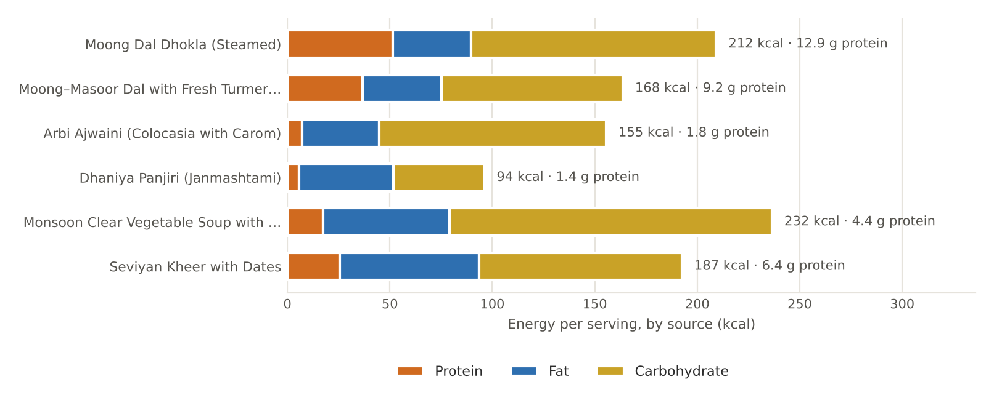
Figure. August's featured recipes — energy per serving by source, with protein

August recipes

Moong Dal Dhokla (Steamed)
BREAKFAST · Serves 4 · Portion: 4 pieces (≈150 g) · Soak 4 h · Steam 15 min
Texture: Soft, spongy Dosha: Light; Kapha- and Pitta-friendly
Ingredient | Household measure | Base qty | Café batch ×5
Moong dal, yellow split | 1 cup, soaked 4 h | 200 g | 1,000 g
Ginger, fresh | 2 tsp | 10 g | 50 g
Green chilli (optional, deseeded) | ½ (optional) | 2 g | 10 g
Water | ½ cup (grinding) | 120 ml | 600 ml
Curd (dahi), plain | ¼ cup | 60 g | 300 g
Rock salt (sendha namak) | ¾ tsp | 3.5 g | 18 g
Turmeric powder | ⅛ tsp | 0.5 g | 2.5 g
Asafoetida (hing) | small pinch | 0.2 g | 1 g
Fruit salt (Eno) / leavening | 1 tsp fruit salt | 4 g | 20 g
Ghee (cow) | 2 tsp (tempering) | 10 g | 50 g
Mustard seeds | ½ tsp | 2 g | 10 g
Sesame seeds (til) | 1 tsp | 4 g | 20 g
Curry leaves | 8 leaves | 1 g | 5 g
Coriander leaves | 2 tbsp | 8 g | 40 g
Method
1. Grind soaked moong with ginger, chilli and minimal water to a thick batter.
2. Mix in curd, salt, turmeric and hing; rest 30 minutes.
3. Grease a thali; heat the steamer. Add fruit salt and 1 tbsp water to the batter; whisk briefly.
4. Pour into the thali; steam 15 minutes; check with a toothpick.
5. Cool 5 minutes; cut. Temper ghee, mustard, sesame and curry leaves with 3 tbsp water; drizzle to keep moist.

Per serving | Energy  212 kcal | Protein  12.9 g | Fat  4.3 g | Carbs  29.9 g | Fibre  4.9 g | Salt  0.9 g

Care notes for 55+ guests  The water in the tempering keeps dhokla moist for easy swallowing. | Ayurvedic note  Steamed moong is light (laghu) — a protein breakfast that respects weak monsoon agni.
Variations & further ideas: Besan khaman · Rava dhokla · Lauki–moong dhokla · Khatta dhokla (rice–urad)

Moong–Masoor Dal with Fresh Turmeric & Ginger
LUNCH · DAL · Serves 4 · Portion: 1 katori (≈180 g) · Cook 30 min
Texture: Soft Dosha: Tridoshic; anti-inflammatory spices
Ingredient | Household measure | Base qty | Café batch ×5
Moong dal, yellow split | ⅓ cup + 1 tbsp | 80 g | 400 g
Masoor dal (red lentil) | ⅓ cup | 70 g | 350 g
Water | 3½ cups | 850 ml | 4,250 ml
Fresh turmeric root | 2 tsp grated fresh root | 10 g | 50 g
Ginger, fresh | 2 tsp grated | 10 g | 50 g
Rock salt (sendha namak) | ¾ tsp | 4 g | 20 g
Ghee (cow) | 1 tbsp | 15 g | 75 g
Cumin (jeera) | ½ tsp | 2 g | 10 g
Asafoetida (hing) | 1 pinch | 0.3 g | 1.5 g
Kashmiri chilli powder (mild) | pinch | 0.5 g | 2.5 g
Coriander leaves | 2 tbsp | 8 g | 40 g
Method
1. Pressure-cook dals with water and half the fresh turmeric — 3 whistles; whisk.
2. Tadka: ghee, cumin, hing, remaining turmeric and ginger; sauté 1 minute.
3. Add chilli off heat; pour into dal; add salt; simmer 3 minutes.
4. Garnish with coriander.

Per serving | Energy  168 kcal | Protein  9.2 g | Fat  4.2 g | Carbs  22.1 g | Fibre  3.9 g | Salt  1.0 g

Care notes for 55+ guests  Fresh turmeric is milder and more aromatic than powder; it stains — use a steel spoon. | Ayurvedic note  Haridra (turmeric) supports joints and immunity — useful for monsoon aches common after 55.
Variations & further ideas: Turmeric pickle (fresh, small) · Turmeric–ginger milk · Moong with ajwain · Masoor–lauki dal

Arbi Ajwaini (Colocasia with Carom)
LUNCH · SABZI · Serves 4 · Portion: ½ katori (≈90 g) · Cook 30 min
Texture: Soft inside Dosha: Ajwain & hing counter arbi's heaviness
Ingredient | Household measure | Base qty | Café batch ×5
Colocasia (arbi) | ≈8 medium | 400 g | 2,000 g
Mustard oil | 1 tbsp | 15 g | 75 g
Carom (ajwain) | ¾ tsp | 2 g | 10 g
Asafoetida (hing) | 1 pinch | 0.3 g | 1.5 g
Ginger, fresh | 2 tsp grated | 10 g | 50 g
Turmeric powder | ¼ tsp | 1 g | 5 g
Coriander seed / powder | 1½ tsp | 3 g | 15 g
Kashmiri chilli powder (mild) | ¼ tsp | 1 g | 5 g
Dry mango powder (amchur) | 1 tsp | 2 g | 10 g
Rock salt (sendha namak) | ¾ tsp | 3.5 g | 18 g
Coriander leaves | 2 tbsp | 8 g | 40 g
Method
1. Pressure-cook arbi in its skin — 2 whistles (don't overcook).
2. Cool, peel and flatten each lightly between palms.
3. Heat oil; add ajwain, hing, ginger.
4. Add arbi with turmeric, coriander powder, chilli and salt; pan-roast on low 8–10 minutes until edges turn golden.
5. Sprinkle amchur and coriander.

Per serving | Energy  155 kcal | Protein  1.8 g | Fat  4.2 g | Carbs  27.7 g | Fibre  4.8 g | Salt  0.9 g

Care notes for 55+ guests  Keep portions small (≈90 g) — arbi is heavy. Wear gloves when peeling raw arbi (itchy). | Ayurvedic note  Arbi is guru and Vata-provoking (gas); ajwain is its classical antidote.
Variations & further ideas: Arbi patra (steamed leaf rolls) · Arbi in curd gravy (lunch) · Arbi–kadhi · Arbi chips (baked)

Dhaniya Panjiri (Janmashtami)
EVENING · PRASAD · Serves 10 · Portion: 1 tbsp heap (≈22 g) · 20 min
Texture: Powdery Dosha: Cooling, digestive
Ingredient | Household measure | Base qty | Café batch ×5
Coriander seed / powder | ½ cup coriander powder | 60 g | 300 g
Ghee (cow) | 2 tbsp | 30 g | 150 g
Fox nut (makhana) | 1 cup, roasted & crushed | 30 g | 150 g
Almonds | 15, chopped | 20 g | 100 g
Coconut, fresh grated | 3 tbsp dry grated | 20 g | 100 g
Mishri / sugar | ¼ cup powdered | 50 g | 250 g
Green cardamom | ⅛ tsp | 0.5 g | 2.5 g
Method
1. Heat 3 tsp ghee; roast coriander powder on low 4–5 minutes until the aroma changes — do not burn.
2. Roast makhana in the remaining ghee; crush coarsely.
3. Dry-roast almonds and coconut.
4. Cool everything; mix with powdered mishri and cardamom.
5. Store airtight up to 2 weeks.

Per serving | Energy  94 kcal | Protein  1.4 g | Fat  5.1 g | Carbs  11.1 g | Fibre  2.1 g | Salt  0.0 g

Care notes for 55+ guests  Powdered texture — easy for all. Serve with a sip of water to avoid coughing on dry powder. | Ayurvedic note  Dhanyaka (coriander) is deepana–pachana and cooling — the ideal monsoon prasad.
Variations & further ideas: Atta panjiri · Makhana panjiri · Gond-free dry-fruit panjiri · Dhaniya–saunf digestive

Monsoon Clear Vegetable Soup with Ghee Rice
DINNER · Serves 4 · Portion: 250 ml soup + 150 g rice · Cook 30 min
Texture: Soft vegetables in broth Dosha: Light, warming
Ingredient | Household measure | Base qty | Café batch ×5
Ghee (cow) | 1 tbsp | 15 g | 75 g
Ginger, fresh | 1 tbsp grated | 15 g | 75 g
Cumin (jeera) | ¼ tsp | 1 g | 5 g
Carrot | 1 small, fine dice | 80 g | 400 g
French beans | 8, fine | 60 g | 300 g
Cabbage | ½ cup shredded | 60 g | 300 g
Sweet corn kernels | ⅓ cup kernels | 50 g | 250 g
Bottle gourd (lauki) | ¾ cup diced | 100 g | 500 g
Water | 4 cups | 1,000 ml | 5,000 ml
Black pepper | ½ tsp | 1 g | 5 g
Rock salt (sendha namak) | ¾ tsp | 3.5 g | 18 g
Lemon juice | 2 tsp | 10 ml | 50 ml
Coriander leaves | 1 tbsp | 5 g | 25 g
Rice, white basmati (raw) | ¾ cup + 1 tbsp | 160 g | 800 g
Water | 2⅔ cups (rice) | 640 ml | 3,200 ml
Ghee (cow) | 2 tsp (rice) | 10 g | 50 g
Method
1. Heat ghee; add ginger and cumin for 30 seconds.
2. Add finely chopped vegetables; sauté 3 minutes.
3. Add water; simmer 15 minutes until soft.
4. Season with pepper and salt; lemon off the heat.
5. Rice: cook soft; stir in ghee.

Per serving | Energy  232 kcal | Protein  4.4 g | Fat  6.8 g | Carbs  39.4 g | Fibre  2.7 g | Salt  0.9 g

Care notes for 55+ guests  Corn kernels can be pulsed briefly for those who cannot chew skins. | Ayurvedic note  Warm, light and freshly made — perfect for weak monsoon digestion.
Variations & further ideas: Sweet-corn soup · Lauki–ginger soup · Moong–vegetable soup · Tulsi–vegetable broth

Seviyan Kheer with Dates
SWEET · Serves 6 · Portion: 100 ml · Cook 25 min
Texture: Soft Dosha: Vata-pacifying
Ingredient | Household measure | Base qty | Café batch ×5
Wheat vermicelli (seviyan) | ¾ cup broken vermicelli | 60 g | 300 g
Ghee (cow) | 1 tsp | 5 g | 25 g
Cow's milk, whole | 3¾ cups | 900 ml | 4,500 ml
Dates, seedless | 6–7 seedless, pureed | 50 g | 250 g
Mishri / sugar | 1½ tbsp | 20 g | 100 g
Green cardamom | ¼ tsp | 1 g | 5 g
Almonds | 8, slivered | 10 g | 50 g
Method
1. Roast seviyan in ghee 3 minutes until golden.
2. Boil milk and reduce 10 minutes.
3. Add seviyan; cook 8 minutes until soft.
4. Blend dates with 2 tbsp milk; stir in with mishri; simmer 2 minutes.
5. Add cardamom and almonds.

Per serving | Energy  187 kcal | Protein  6.4 g | Fat  7.5 g | Carbs  24.7 g | Fibre  1.1 g | Salt  0.0 g

Care notes for 55+ guests  Dates replace most of the sugar; diabetic portion 50 ml. | Ayurvedic note  Dates (kharjura) with milk is a classical strengthening combination.
Variations & further ideas: Sheer khurma (light) · Semiya payasam · Rice kheer · Lauki kheer

Signature process & further dishes — August
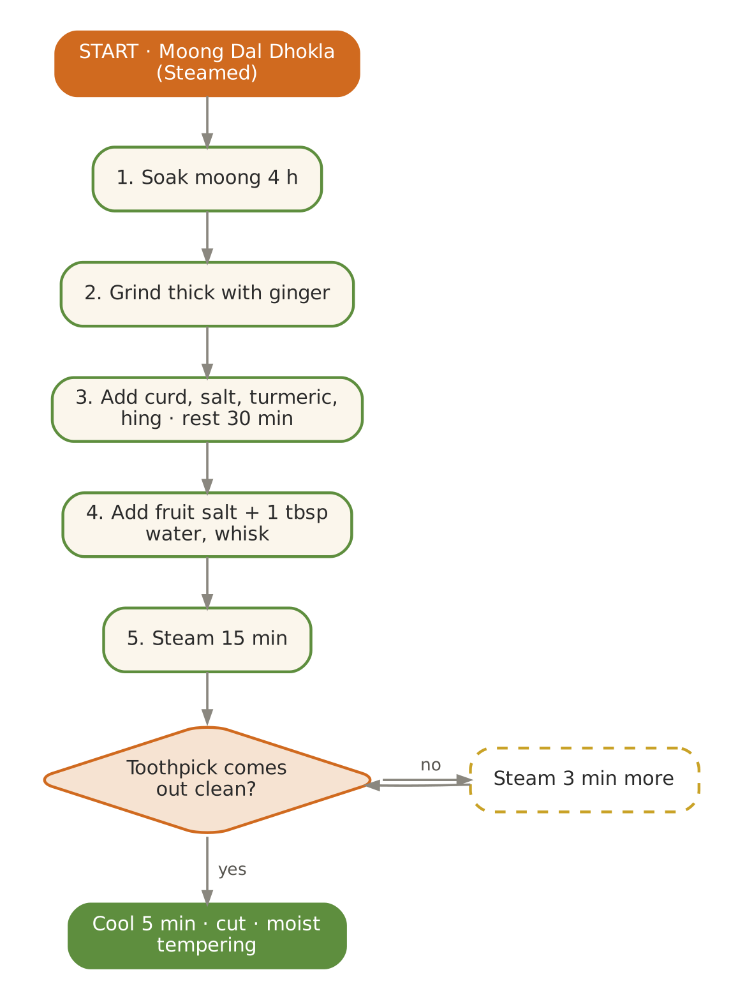  Signature dish: Moong Dal Dhokla (Steamed) | Further dishes & variations  Breakfast  Rava dhokla · Lauki thepla (soft) · Moong dal idli · Sabudana khichdi (Shravan Monday) · Kuttu cheela (vrat)  Dals & Saags  Ajwain kadhi · Kulthi dal · Moong with fresh turmeric · Lauki–chana dal · Toor dal with kokum  Sabzis  Arbi in curd gravy (lunch) · Kakdi (cooked cucumber) sabzi · Bhindi–kadhi · Corn–capsicum · Karela–aloo  Evening  Corn soup · Hot tulsi water · Guava stewed · Makhana chaat · Ginger tea  Light Dinners  Kanji with payar · Rasam rice · Moong khichdi · Vegetable dalia  Sweets & Digestives  Makhan–mishri · Kesar peda (small) · Panchamrit · Coconut barfi · Ajwain–saunf mukhwas

September — Kerala Onam & the Pitta Turn
Hindu months | Bhadrapad – Ashwin
Ayurvedic season | Varsha → Sharad (late monsoon to autumn)
Haridwar weather | ≈ 23 – 32 °C, rains easing, sunny humid days
Agni (digestion) | Recovering — moderate
Dosha picture | Pitta aggravated (sudden sun after rains); Vata settling
Favour | Sweet, bitter, astringent; cooling, mildly unctuous; ghee preferred to oil
Limit | Sour, salty, pungent excess; curd; fried and fermented foods; excessive sun

In season
Vegetables & greens | Fruit | Pantry & other
Lauki, kaddu, arbi, bhindi, torai, ash gourd, raw banana, yam (suran), beans | Guava, pomegranate, pear, apple, custard apple (late), banana | Coconut, singhara (late), old rice

Festivals & observances
Occasion | Kitchen response
Onam (Kerala, Aug/Sep) | A Sadhya-style Vata–Pitta plate: parippu with ghee, olan, avial, erissery, pachadi, payasam.
Ganesh Chaturthi (Bhadrapad) | Steamed ukadiche modak (small), sundal (soft-cooked).
Pitru Paksha (Bhadrapad Purnima – Amavasya) | Simple sattvic shraddh food: kheer, kaddu, arbi, puri (offer phulka to elders).

Kitchen guidance for September
- Pitta season begins: reduce chilli, sour and salt; increase ghee, milk, rice, coconut.
- Coconut-based Kerala dishes suit both Vata elders and Pitta season.
- Bitter vegetables (karela, neem-free methi) twice a week.
- Shraddh fortnight: keep a simple sattvic thali available for guests performing rites.
Daily rituals: on waking — Room-temperature water with soaked coriander seeds; at bedtime — Warm milk with a pinch of cardamom and mishri.

Seven-day menu — September
Rotate weekly; swap any item for one from 'Further dishes & variations' at the end of this chapter. Lunch always includes rice and phulka; curd/raita is served at lunch only.
Day | Breakfast 7:30–9:00 | Lunch thali 12:30–2:30 | Evening 4:00 | Dinner 7:00–8:30
Monday | Oats–moong savoury porridge · pomegranate | Kerala parippu (moong with coconut) · Olan (ash gourd & cowpea) · Avial (mixed vegetables, coconut–curd) · rice & phulka · Beetroot pachadi (warm) | Stewed pear with cinnamon & clove | Rice kanji with ghee, cumin & ginger · payar · sweet: Parippu payasam (80 ml)
Tuesday | Idiyappam with sweet coconut milk | Lauki–moong dal · Beans thoran · Raw-banana poriyal · rice & phulka · Spiced takra | Coconut water | Moong khichdi · sweet: Rice kheer
Wednesday | Puttu (rice flour) with banana | Erissery (pumpkin–lobia) · Kaddu khatta-meetha · Bhindi with coconut · rice & phulka · Coconut chutney | Roasted makhana | Lauki soup · phulka · sweet: Ukadiche modak (1)
Thursday | Rice kanji with ghee | Moong yusha · Arbi ajwaini · Lauki–peas · rice & phulka · Inji (ginger) chutney (small) | Pomegranate (½ cup) | Vegetable stew · idiyappam · sweet: Coconut ladoo
Friday | Moong dal chilla · coconut chutney | Toor dal (mild) · Carrot–beet thoran · Torai–moong · rice & phulka · Cucumber kichadi | CCF tea | Moong yusha · rice · sweet: Banana–jaggery halwa
Saturday | Ragi porridge · guava | Moong–masoor · Olan (ash gourd & cowpea) · Avial (mixed vegetables, coconut–curd) · rice & phulka · Beetroot pachadi (warm) | Banana with cardamom & ghee | Namkeen dalia · sweet: Palada (light, 60 ml)
Sunday | Soft upma · pear | Kalan (yam in curd–coconut, lunch) · Beans thoran · Raw-banana poriyal · rice & phulka · Spiced takra | Sweet-potato chaat | Pumpkin–lentil soup · rice · sweet: Sooji kesari (40 g)

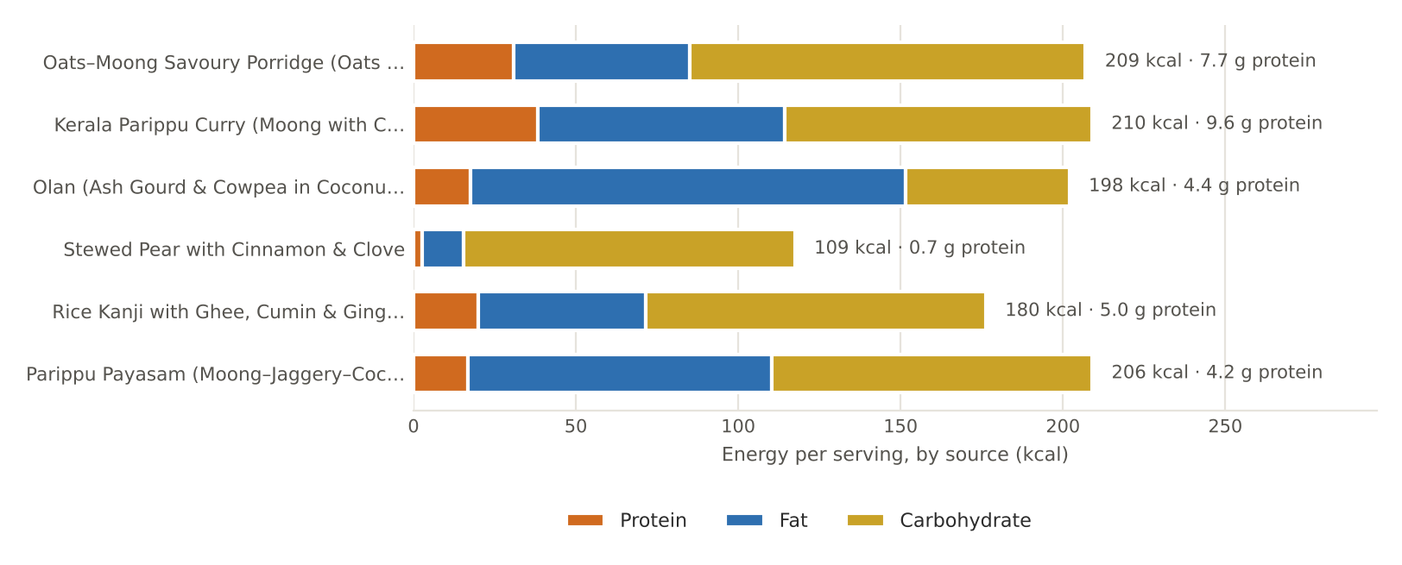
Figure. September's featured recipes — energy per serving by source, with protein

September recipes

Oats–Moong Savoury Porridge (Oats Khichdi)
BREAKFAST · Serves 4 · Portion: 1 bowl (≈250 g) · Cook 25 min
Texture: Soft porridge Dosha: Balancing; heart-friendly
Ingredient | Household measure | Base qty | Café batch ×5
Moong dal, yellow split | ¼ cup | 50 g | 250 g
Water | 3¾ cups | 900 ml | 4,500 ml
Oats, rolled / steel-cut | 1⅓ cups rolled | 120 g | 600 g
Carrot | ⅓ cup diced | 50 g | 250 g
Green peas, fresh | ¼ cup | 40 g | 200 g
Ghee (cow) | 1 tbsp | 15 g | 75 g
Cumin (jeera) | ½ tsp | 2 g | 10 g
Asafoetida (hing) | 1 pinch | 0.3 g | 1.5 g
Ginger, fresh | 1½ tsp | 8 g | 40 g
Turmeric powder | ¼ tsp | 1 g | 5 g
Rock salt (sendha namak) | ¾ tsp | 3.5 g | 18 g
Coriander leaves | 2 tbsp | 8 g | 40 g
Lemon juice | 2 tsp | 10 ml | 50 ml
Method
1. Pressure-cook moong in 400 ml water — 2 whistles.
2. Heat ghee; cumin, hing, ginger; add vegetables and turmeric, sauté 2 minutes.
3. Add oats and roast 2 minutes.
4. Add cooked moong and 500 ml water; simmer 5–6 minutes, stirring, to a porridge.
5. Salt, coriander and lemon to finish.

Per serving | Energy  209 kcal | Protein  7.7 g | Fat  6.0 g | Carbs  30.5 g | Fibre  5.3 g | Salt  0.9 g

Care notes for 55+ guests  Oats' soluble fibre (beta-glucan) supports healthy cholesterol — useful for many 55+ guests. | Ayurvedic note  Light and warm, with moong for protein; suitable through the season change.
Variations & further ideas: Masala oats (no onion) · Oats idli · Sweet oats with dates · Oats–vegetable soup

Kerala Parippu Curry (Moong with Coconut)
LUNCH · DAL · Serves 4 · Portion: 1 katori (≈170 g) · Cook 30 min
Texture: Soft, smooth Dosha: Pitta & Vata pacifying
Ingredient | Household measure | Base qty | Café batch ×5
Moong dal, yellow split | ¾ cup, lightly roasted | 150 g | 750 g
Water | 3 cups | 700 ml | 3,500 ml
Turmeric powder | ¼ tsp | 1 g | 5 g
Coconut, fresh grated | ½ cup grated | 50 g | 250 g
Cumin (jeera) | ½ tsp (ground with coconut) | 2 g | 10 g
Green chilli (optional, deseeded) | ½ (optional) | 2 g | 10 g
Water | ¼ cup (grinding) | 60 ml | 300 ml
Rock salt (sendha namak) | ¾ tsp | 4 g | 20 g
Ghee (cow) | 1 tbsp | 15 g | 75 g
Mustard seeds | ½ tsp | 2 g | 10 g
Curry leaves | 8 leaves | 1 g | 5 g
Asafoetida (hing) | small pinch | 0.2 g | 1 g
Method
1. Roast moong lightly 3 minutes; pressure-cook with water and turmeric — 4 whistles; mash smooth.
2. Grind coconut, cumin and chilli with water to a fine paste.
3. Add paste to the dal; simmer gently 5 minutes (do not boil hard); add salt.
4. Temper with ghee, mustard, curry leaves and hing.
5. Serve as the Sadhya first course: over rice with a spoon of ghee.

Per serving | Energy  210 kcal | Protein  9.6 g | Fat  8.5 g | Carbs  23.6 g | Fibre  4.8 g | Salt  1.0 g

Care notes for 55+ guests  Smooth and mild — one of the gentlest dals in the book. | Ayurvedic note  Coconut and ghee cool Pitta; moong is light — perfect for the Varsha-to-Sharad transition.
Variations & further ideas: Parippu with spinach · Cherupayar (whole moong) curry · Moong–coconut kootu · Dal with coconut milk

Olan (Ash Gourd & Cowpea in Coconut Milk)
LUNCH · SABZI · Serves 4 · Portion: 1 katori (≈170 g) · Soak overnight · Cook 35 min
Texture: Very soft Dosha: Cooling; Pitta-pacifying
Ingredient | Household measure | Base qty | Café batch ×5
Cowpea (lobia), dry | ¼ cup, soaked overnight | 50 g | 250 g
Ash gourd (petha) | thin 3-cm squares | 400 g | 2,000 g
Coconut milk, thin | 1⅔ cups (300 thin + 100 thick) | 400 ml | 2,000 ml
Green chilli (optional, deseeded) | ½, slit (optional) | 2 g | 10 g
Ginger, fresh | 1 tsp julienne | 5 g | 25 g
Rock salt (sendha namak) | ½ tsp | 3 g | 15 g
Coconut oil | 2 tsp (raw, to finish) | 10 g | 50 g
Curry leaves | 8 leaves | 1 g | 5 g
Method
1. Pressure-cook soaked lobia 5 whistles until completely soft.
2. Simmer ash gourd in thin coconut milk with chilli, ginger and salt 10–12 minutes until translucent.
3. Add lobia; stir gently.
4. Pour in thick coconut milk and warm through — do not boil.
5. Finish with raw coconut oil and curry leaves.

Per serving | Energy  198 kcal | Protein  4.4 g | Fat  14.9 g | Carbs  12.6 g | Fibre  4.8 g | Salt  0.8 g

Care notes for 55+ guests  No spice powders at all — the mildest dish in the book; ideal for sensitive stomachs. | Ayurvedic note  Ash gourd (kushmanda) is cooling and nourishing — celebrated in Ayurveda for calming Pitta and the mind.
Variations & further ideas: Pumpkin olan · Lauki in coconut milk · Erissery · Kootu with ash gourd

Stewed Pear with Cinnamon & Clove
EVENING · SNACK · Serves 4 · Portion: ≈130 g · Cook 20 min
Texture: Spoon-soft Dosha: Vata-pacifying when stewed
Ingredient | Household measure | Base qty | Café batch ×5
Pear | 4 medium, peeled & cored | 500 g | 2,500 g
Water | ¾ cup + 1 tbsp | 200 ml | 1,000 ml
Cinnamon | 1-inch stick | 1 g | 5 g
Clove | 2 | 0.3 g | 1.5 g
Green cardamom | 1 pod | 0.3 g | 1.5 g
Raisins (kishmish) | 1 tbsp | 15 g | 75 g
Jaggery (gur) | 1 tbsp (optional) | 15 g | 75 g
Ghee (cow) | 1 tsp | 5 g | 25 g
Method
1. Cut pears into 2-cm pieces.
2. Simmer with water, spices and raisins covered 12–15 minutes until spoon-soft.
3. Stir in jaggery (optional) and ghee.
4. Remove whole spices; serve warm.

Per serving | Energy  109 kcal | Protein  0.7 g | Fat  1.4 g | Carbs  25.5 g | Fibre  4.1 g | Salt  0.0 g

Care notes for 55+ guests  From the source Kerala plan. Stewing makes raw fruit (Vata-aggravating) gentle; good for constipation. | Ayurvedic note  Cooked fruit with warming spices is far easier on aged digestion than raw fruit.
Variations & further ideas: Stewed apple · Stewed guava · Baked apple with dates · Pear–ginger compote

Rice Kanji with Ghee, Cumin & Ginger · Payar
DINNER · Serves 4 · Portion: 300 ml kanji + 2 tbsp payar · Cook 45 min
Texture: Thin porridge Dosha: Tridoshic; restorative
Ingredient | Household measure | Base qty | Café batch ×5
Rice, Kerala red matta (raw) | ½ cup red matta (or njavara/basmati) | 100 g | 500 g
Water | 5 cups | 1,200 ml | 6,000 ml
Rock salt (sendha namak) | ½ tsp | 3 g | 15 g
Ghee (cow) | 1 tbsp | 15 g | 75 g
Cumin (jeera) | ½ tsp | 2 g | 10 g
Ginger, fresh | 2 tsp grated | 10 g | 50 g
Moong, whole green | ¼ cup whole moong (payar), soaked | 50 g | 250 g
Coconut, fresh grated | 1½ tbsp grated | 15 g | 75 g
Mustard seeds | ¼ tsp | 1 g | 5 g
Curry leaves | 5 leaves | 1 g | 5 g
Method
1. Wash rice; boil in 1200 ml water, open pot, 35–40 minutes (or 5 whistles) until grains burst and the liquid is starchy.
2. Add salt; temper with ghee, cumin and ginger.
3. Payar: pressure-cook soaked whole moong 5 whistles until soft.
4. Temper payar with a few drops of ghee, mustard and curry leaves; stir in coconut.
5. Serve kanji in a bowl with payar alongside.

Per serving | Energy  180 kcal | Protein  5.0 g | Fat  5.7 g | Carbs  26.2 g | Fibre  3.5 g | Salt  0.8 g

Care notes for 55+ guests  Red matta must be double-cooked until very soft. Kanji is the classic Kerala sick-room and elder food. | Ayurvedic note  Peya/yavagu (thin rice gruel) is the first food after fasting or illness in Ayurveda.
Variations & further ideas: Njavara milk kanji (sweet, with dates) · Jeera kanji · Moong kanji · Ragi kanji

Parippu Payasam (Moong–Jaggery–Coconut Milk)
SWEET · Serves 8 · Portion: 80 ml · Cook 40 min
Texture: Thick, smooth Dosha: Nourishing, Vata-pacifying
Ingredient | Household measure | Base qty | Café batch ×5
Moong dal, yellow split | ½ cup | 100 g | 500 g
Ghee (cow) | 1 tbsp | 15 g | 75 g
Water | 1⅔ cups | 400 ml | 2,000 ml
Jaggery (gur) | ⅔ cup grated | 120 g | 600 g
Coconut milk, thin | 2 cups (350 thin + 150 thick) | 500 ml | 2,500 ml
Green cardamom | ¼ tsp | 1 g | 5 g
Dry ginger (saunth) | ¼ tsp dry ginger | 0.5 g | 2.5 g
Cashew nuts | 10 | 15 g | 75 g
Raisins (kishmish) | 1 tbsp | 10 g | 50 g
Method
1. Roast moong in 1 tsp ghee 4 minutes; pressure-cook with 300 ml water — 3 whistles; mash.
2. Melt jaggery in 100 ml water; strain.
3. Add jaggery to dal; cook 8 minutes to thicken.
4. Add thin coconut milk; simmer 8 minutes; add thick milk and heat through.
5. Off heat add cardamom and dry ginger; top with ghee-fried cashews and raisins.

Per serving | Energy  206 kcal | Protein  4.2 g | Fat  10.4 g | Carbs  24.6 g | Fibre  1.6 g | Salt  0.0 g

Care notes for 55+ guests  Rich — serve 80 ml. Diabetic guests: 2 tbsp only. | Ayurvedic note  Dry ginger in payasam aids digestion of the heavy jaggery and coconut — a Kerala wisdom.
Variations & further ideas: Ada pradhaman (light) · Pal payasam · Semiya payasam · Chana dal payasam

Signature process & further dishes — September
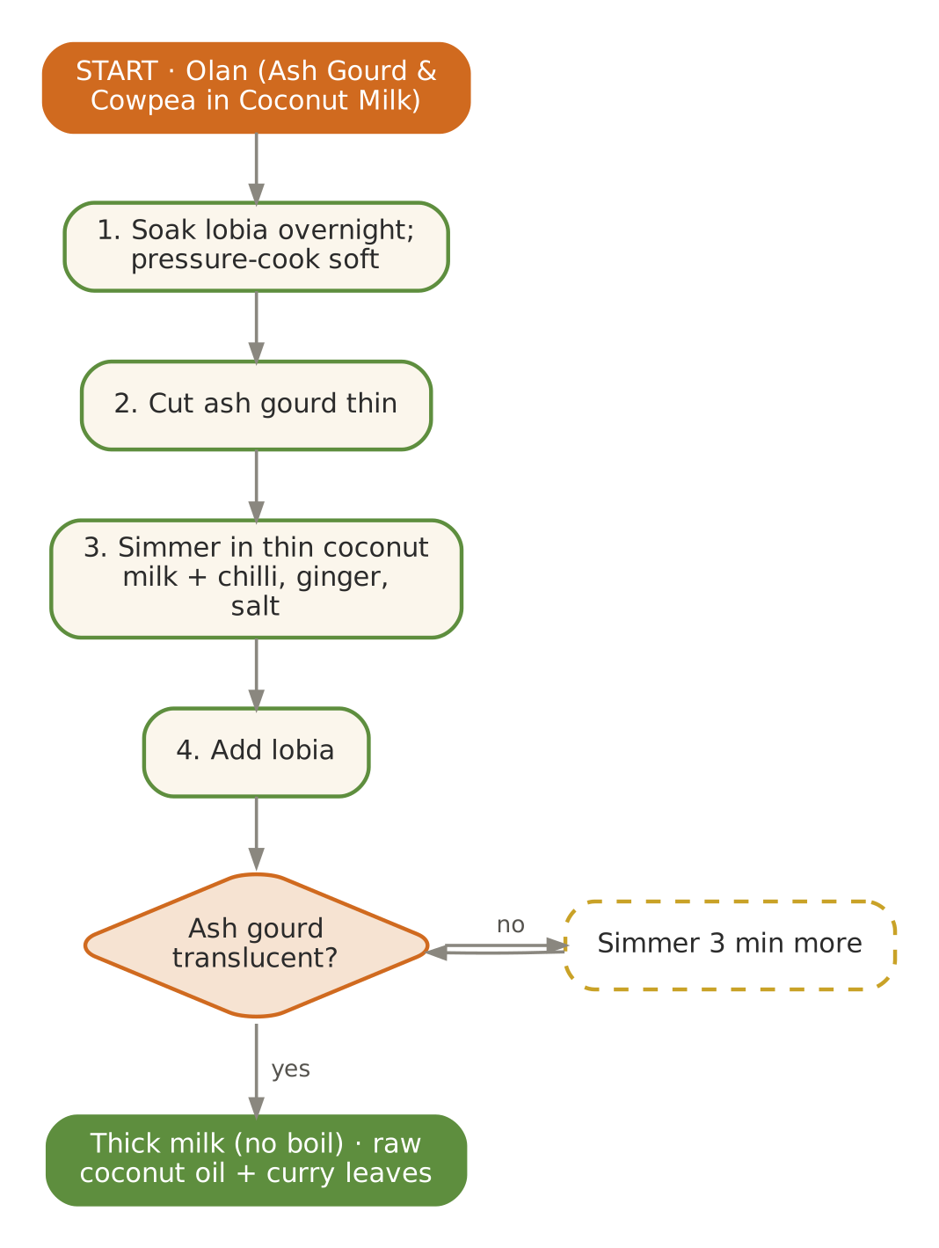  Signature dish: Olan (Ash Gourd & Cowpea in Coconut Milk) | Further dishes & variations  Breakfast  Puttu with kadala (soft-cooked) · Neer dosa · Appam with stew · Kozhukattai (steamed rice dumplings) · Oats idli  Dals & Saags  Erissery · Kalan (lunch) · Moru curry (spiced buttermilk) · Cherupayar curry · Moong–spinach kootu  Sabzis  Avial · Kootu · Raw-banana thoran · Yam erissery · Beans–coconut thoran  Evening  Banana with ghee & cardamom · Coconut water · Stewed apple · Pomegranate · Sukku (dry-ginger) tea  Light Dinners  Kanji · Pumpkin–lentil soup · Idiyappam with stew · Moong khichdi  Sweets & Digestives  Ukadiche modak · Palada · Coconut ladoo · Pal payasam · Saunf–mishri

October — Cooling Sweetness — Navratri & Sharad Purnima
Hindu months | Ashwin – Kartik
Ayurvedic season | Sharad (autumn)
Haridwar weather | ≈ 18 – 30 °C, clear skies, warm days, cool nights
Agni (digestion) | Improving steadily
Dosha picture | Pitta at its peak (the 'October heat' after rains)
Favour | Sweet, bitter, astringent; ghee, milk, rice, moong, amla; mildly cooling
Limit | Chilli, sour pickles, excess salt, fermented food, curd at night, sun exposure at midday

In season
Vegetables & greens | Fruit | Pantry & other
Lauki, kaddu, sweet potato, singhara, arbi, early spinach & methi, beans, raw banana | Pomegranate, guava, custard apple (sitaphal), apple, early amla, banana | Samak rice, kuttu, rajgira, makhana (Navratri)

Festivals & observances
Occasion | Kitchen response
Sharad Navratri (Ashwin Shukla) | Nine-day phalahari menu: samak khichdi, rajgira porridge, kuttu cheela, sabudana khichdi, makhana kheer, aloo–dahi (lunch).
Dussehra | Jalebi substitute: soft kesari; festive sattvic thali.
Sharad Purnima | Rice kheer kept briefly under moonlight — a Pitta-cooling tradition.
Karva Chauth / Diwali preparations | Soft mithai planning — see November.

Kitchen guidance for October
- Ghee is the Sharad medicine — ½ tsp on rice and dal; reduce oil.
- Navratri: keep a full phalahari track daily; ensure protein (milk, paneer, makhana, rajgira).
- Bitter and astringent: pomegranate, amla, karela, lauki daily.
- Avoid fasting elders skipping fluids; offer coconut water and takra.
Daily rituals: on waking — Room-temperature water with soaked raisins (8–10) eaten; at bedtime — Warm milk with ghee and a pinch of cardamom.

Seven-day menu — October
Rotate weekly; swap any item for one from 'Further dishes & variations' at the end of this chapter. Lunch always includes rice and phulka; curd/raita is served at lunch only.
Day | Breakfast 7:30–9:00 | Lunch thali 12:30–2:30 | Evening 4:00 | Dinner 7:00–8:30
Monday | Rajgira–milk porridge with dates | Whole green moong dal · Sattvic palak paneer · Kaddu khatta-meetha · rice & phulka · Lauki raita (lunch) | Roasted shakarkandi chaat | Samak rice khichdi · sweet: Sharad Purnima kheer (80 ml)
Tuesday | Samak upma · pomegranate | Lauki–moong dal · Arbi ajwaini · Lauki–peas · rice & phulka · Pomegranate raita | Coconut water | Moong khichdi · sweet: Makhana kheer
Wednesday | Kuttu–lauki chilla (vrat) · curd | Kerala parippu · Shakarkandi–singhara sabzi · Raw-banana poriyal · rice & phulka · Coconut chutney | Roasted makhana | Lauki soup · phulka · sweet: Singhara halwa (40 g)
Thursday | Sabudana khichdi (soft) · banana | Moong yusha · Beans thoran · Bhindi with coconut · rice & phulka · Mint–coriander chutney | Pomegranate juice (fresh, room temp.) | Kanji with ghee · sweet: Coconut ladoo
Friday | Moong dal chilla · coconut chutney | Masoor–lauki · Paneer–capsicum (light) · Karela with jaggery · rice & phulka · Spiced takra | Badam milk | Pumpkin soup · rice · sweet: Rajgira ladoo (soft)
Saturday | Rice idli · coconut chutney | Toor dal (mild) · Sattvic palak paneer · Kaddu khatta-meetha · rice & phulka · Lauki raita (lunch) | Banana–cardamom | Moong yusha · ghee rice · sweet: Sitaphal rabdi (light)
Sunday | Oats porridge · guava | Aloo–dahi curry (vrat, lunch) · Arbi ajwaini · Lauki–peas · rice & phulka · Pomegranate raita | CCF tea | Namkeen dalia · sweet: Kesari (40 g)

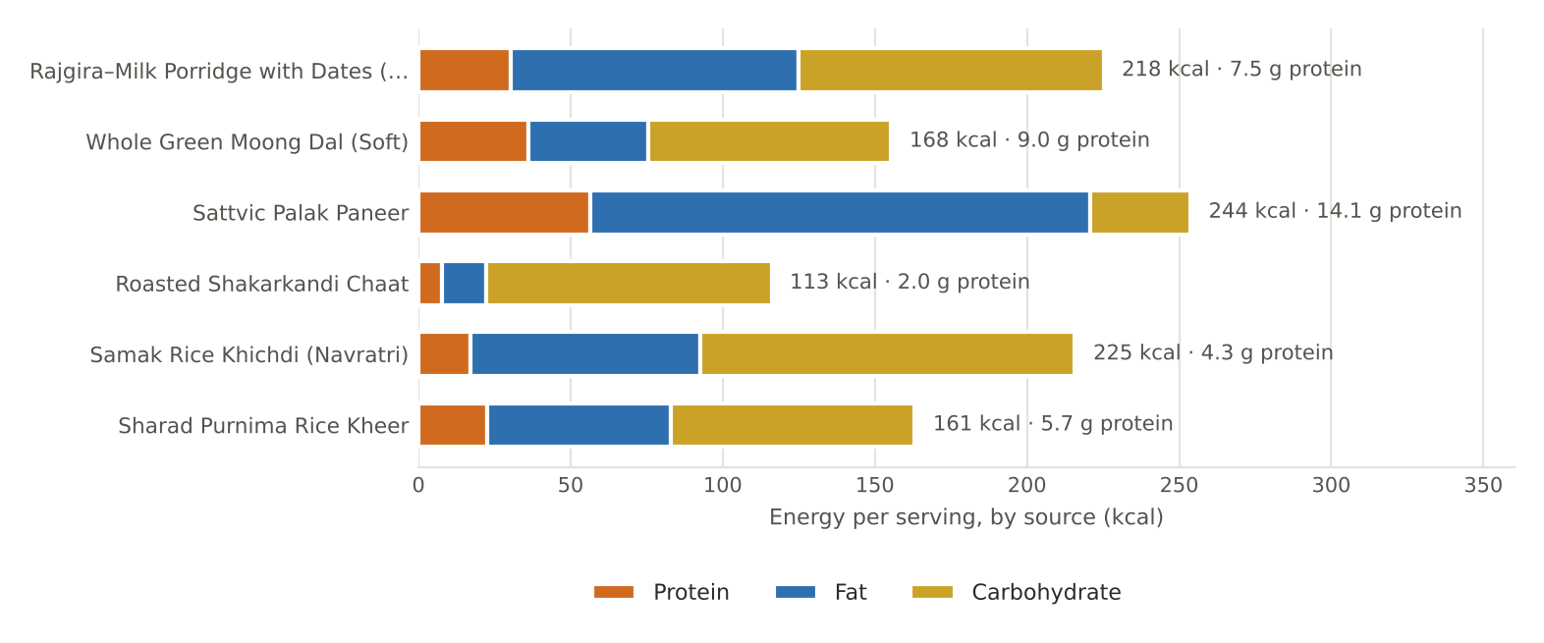
Figure. October's featured recipes — energy per serving by source, with protein

October recipes

Rajgira–Milk Porridge with Dates (Navratri)
BREAKFAST · Serves 4 · Portion: 200 ml bowl · Cook 15 min
Texture: Smooth porridge Dosha: Nourishing; Pitta & Vata pacifying
Ingredient | Household measure | Base qty | Café batch ×5
Amaranth (rajgira) flour | ½ cup amaranth flour | 60 g | 300 g
Ghee (cow) | 2 tsp | 10 g | 50 g
Cow's milk, whole | 2½ cups, warm | 600 ml | 3,000 ml
Dates, seedless | 5 seedless, chopped | 40 g | 200 g
Green cardamom | ⅛ tsp | 0.5 g | 2.5 g
Almonds | 8, slivered | 10 g | 50 g
Method
1. Roast rajgira flour in ghee on low 5 minutes until nutty.
2. Add warm milk gradually, whisking to avoid lumps.
3. Cook 6 minutes, stirring, until creamy.
4. Add dates and cardamom; simmer 1 minute.
5. Top with almonds.

Per serving | Energy  218 kcal | Protein  7.5 g | Fat  10.5 g | Carbs  25.1 g | Fibre  2.1 g | Salt  0.0 g

Care notes for 55+ guests  Amaranth is a complete-protein pseudo-grain, permitted on fasts — a valuable Navratri protein. | Ayurvedic note  Light yet nourishing; dates and milk cool Sharad Pitta.
Variations & further ideas: Rajgira ladoo (soft) · Rajgira thepla (vrat) · Rajgira kheer · Popped amaranth with milk

Whole Green Moong Dal (Soft)
LUNCH · DAL · Serves 4 · Portion: 1 katori (≈180 g) · Soak 6 h · Cook 40 min
Texture: Soft Dosha: Tridoshic; cooling
Ingredient | Household measure | Base qty | Café batch ×5
Moong, whole green | ¾ cup, soaked 6 h | 150 g | 750 g
Water | 3¾ cups | 900 ml | 4,500 ml
Turmeric powder | ¼ tsp | 1 g | 5 g
Rock salt (sendha namak) | ¾ tsp | 4 g | 20 g
Ghee (cow) | 1 tbsp | 15 g | 75 g
Cumin (jeera) | ½ tsp | 2 g | 10 g
Asafoetida (hing) | 1 pinch | 0.3 g | 1.5 g
Ginger, fresh | 2 tsp grated | 10 g | 50 g
Tomato | ½ medium (optional) | 60 g | 300 g
Coriander seed / powder | 1 tsp | 2 g | 10 g
Sattvic garam masala (no onion-garlic) | ⅛ tsp | 0.5 g | 2.5 g
Coriander leaves | 2 tbsp | 8 g | 40 g
Lemon juice | 2 tsp | 10 ml | 50 ml
Method
1. Pressure-cook soaked moong with water and turmeric — 6 whistles until grains burst.
2. Mash about a third against the pot for body.
3. Tadka: ghee, cumin, hing, ginger, tomato until soft; coriander powder.
4. Pour in, add salt; simmer 5 minutes.
5. Finish with garam masala, coriander and lemon.

Per serving | Energy  168 kcal | Protein  9.0 g | Fat  4.4 g | Carbs  20.0 g | Fibre  6.7 g | Salt  1.0 g

Care notes for 55+ guests  Soaking and long cooking make whole moong as digestible as split; the skins give extra fibre. | Ayurvedic note  Mudga is the most praised pulse in Ayurveda — light, cooling and tridoshic.
Variations & further ideas: Moong usal (soft) · Moong–spinach · Sabut moong khichdi · Moong soup

Sattvic Palak Paneer
LUNCH · SABZI · Serves 4 · Portion: 1 katori (≈160 g) · Cook 30 min
Texture: Smooth gravy, soft paneer Dosha: Balancing; protein-rich
Ingredient | Household measure | Base qty | Café batch ×5
Spinach (palak) | 2 bunches | 500 g | 2,500 g
Paneer (cow's milk) | 1-inch cubes | 200 g | 1,000 g
Ghee (cow) | 4 tsp | 20 g | 100 g
Cumin (jeera) | ½ tsp | 2 g | 10 g
Asafoetida (hing) | 1 pinch | 0.3 g | 1.5 g
Ginger, fresh | 1 tbsp | 15 g | 75 g
Green chilli (optional, deseeded) | ½ (optional) | 2 g | 10 g
Cashew nuts | 10, soaked | 15 g | 75 g
Coriander seed / powder | 1 tsp | 2 g | 10 g
Sattvic garam masala (no onion-garlic) | ⅛ tsp | 0.5 g | 2.5 g
Water | scant ½ cup | 100 ml | 500 ml
Cow's milk, whole | ¼ cup (in place of cream) | 60 ml | 300 ml
Rock salt (sendha namak) | ¾ tsp | 3.5 g | 18 g
Method
1. Blanch palak 2 minutes; drain and cool in plain water.
2. Blend palak with ginger, chilli and soaked cashews to a smooth purée.
3. Soak paneer cubes in warm water 10 minutes (keeps them soft).
4. Heat ghee; cumin and hing; add purée and water; simmer 5 minutes.
5. Add coriander powder, salt and paneer; add milk; simmer 3 minutes; finish with garam masala.

Per serving | Energy  244 kcal | Protein  14.1 g | Fat  18.2 g | Carbs  8.3 g | Fibre  3.3 g | Salt  0.9 g

Care notes for 55+ guests  Each serving gives roughly a third of the day's protein need for many older adults; paneer soaked in warm water stays tender. | Ayurvedic note  Cooked palak with ghee is far gentler than raw; paneer is nourishing (brimhana).
Variations & further ideas: Palak–makhana · Methi–malai paneer (light) · Paneer bhurji (no onion) · Matar paneer

Roasted Shakarkandi Chaat
EVENING · SNACK · Serves 4 · Portion: ≈110 g · Cook 30 min
Texture: Soft Dosha: Vata-pacifying, sweet
Ingredient | Household measure | Base qty | Café batch ×5
Sweet potato (shakarkandi) | 2 medium | 400 g | 2,000 g
Ghee (cow) | 1 tsp | 5 g | 25 g
Cumin (jeera) | ½ tsp roasted, powdered | 2 g | 10 g
Black pepper | ¼ tsp | 0.5 g | 2.5 g
Rock salt (sendha namak) | ⅓ tsp rock salt | 2 g | 10 g
Lemon juice | 1 tbsp | 15 ml | 75 ml
Pomegranate arils | ½ cup arils | 60 g | 300 g
Coriander leaves | 1 tbsp | 5 g | 25 g
Method
1. Steam or roast sweet potatoes 25 minutes until fully soft.
2. Peel and cut into cubes.
3. Toss with ghee, roasted cumin, pepper, rock salt and lemon.
4. Top with pomegranate and coriander; serve warm.

Per serving | Energy  113 kcal | Protein  2.0 g | Fat  1.6 g | Carbs  23.5 g | Fibre  3.8 g | Salt  0.5 g

Care notes for 55+ guests  Steaming gives the softest result. A fibre- and beta-carotene-rich snack. | Ayurvedic note  Sweet potato is sweet and grounding; pomegranate balances Pitta.
Variations & further ideas: Shakarkandi kheer · Sweet-potato tikki (baked) · Shakarkandi halwa · Sweet-potato soup

Samak Rice Khichdi (Navratri)
DINNER · Serves 4 · Portion: 1 bowl (≈250 g) · Soak 20 min · Cook 25 min
Texture: Soft Dosha: Light; vrat-friendly
Ingredient | Household measure | Base qty | Café batch ×5
Barnyard millet (samak rice) | ¾ cup barnyard millet | 150 g | 750 g
Ghee (cow) | 4 tsp | 20 g | 100 g
Cumin (jeera) | ½ tsp | 2 g | 10 g
Ginger, fresh | 2 tsp grated | 10 g | 50 g
Green chilli (optional, deseeded) | ½ (optional) | 2 g | 10 g
Potato | 1 small, diced | 100 g | 500 g
Water | 2½ cups (4 : 1) | 600 ml | 3,000 ml
Rock salt (sendha namak) | ¾ tsp rock salt (sendha) only | 3.5 g | 18 g
Peanuts | 2 tbsp roasted, powdered | 20 g | 100 g
Black pepper | ¼ tsp | 0.5 g | 2.5 g
Lemon juice | 2 tsp | 10 ml | 50 ml
Coriander leaves | 1 tbsp | 5 g | 25 g
Method
1. Wash samak and soak 20 minutes; drain.
2. Heat ghee; cumin, ginger and chilli; add potato and sauté 3 minutes.
3. Add samak, water and rock salt; cover and simmer 12–15 minutes until soft.
4. Stir in powdered peanuts, pepper and lemon; loosen with hot water if needed.
5. Garnish with coriander.

Per serving | Energy  225 kcal | Protein  4.3 g | Fat  8.4 g | Carbs  30.8 g | Fibre  4.9 g | Salt  0.9 g

Care notes for 55+ guests  Peanuts are powdered (never whole) for safe swallowing. Serve with curd only at lunch. | Ayurvedic note  Barnyard millet is light, quick to digest and permitted on fasts.
Variations & further ideas: Samak pulao · Samak kheer · Samak dosa (vrat) · Samak upma

Sharad Purnima Rice Kheer
SWEET · Serves 8 · Portion: 100 ml · Cook 55 min
Texture: Creamy Dosha: Cooling; Pitta-pacifying
Ingredient | Household measure | Base qty | Café batch ×5
Cow's milk, whole | 5 cups | 1,200 ml | 6,000 ml
Rice, white basmati (raw) | ¼ cup, soaked 20 min | 50 g | 250 g
Mishri / sugar | ⅓ cup | 60 g | 300 g
Green cardamom | ¼ tsp | 1 g | 5 g
Saffron (kesar) | 10–12 strands | 0.1 g | 0.5 g
Almonds | 10, slivered | 15 g | 75 g
Method
1. Simmer milk 10 minutes.
2. Add rice; cook on low 40 minutes, stirring often, until the rice dissolves and milk reduces by about half.
3. Add mishri; cook 3 minutes.
4. Add saffron and cardamom; garnish with almonds.
5. Tradition: keep covered with muslin in moonlight up to 2 hours, then refrigerate; bring to room temperature to serve next morning.

Per serving | Energy  161 kcal | Protein  5.7 g | Fat  6.7 g | Carbs  20.1 g | Fibre  0.4 g | Salt  0.0 g

Care notes for 55+ guests  Food safety first: never leave milk dishes out overnight. Diabetic portion 50 ml. | Ayurvedic note  Moonlight, milk and rice — the classic Sharad remedy for accumulated Pitta.
Variations & further ideas: Chawal ki kheer with jaggery (winter) · Makhana kheer · Sabudana kheer · Lauki kheer

Signature process & further dishes — October
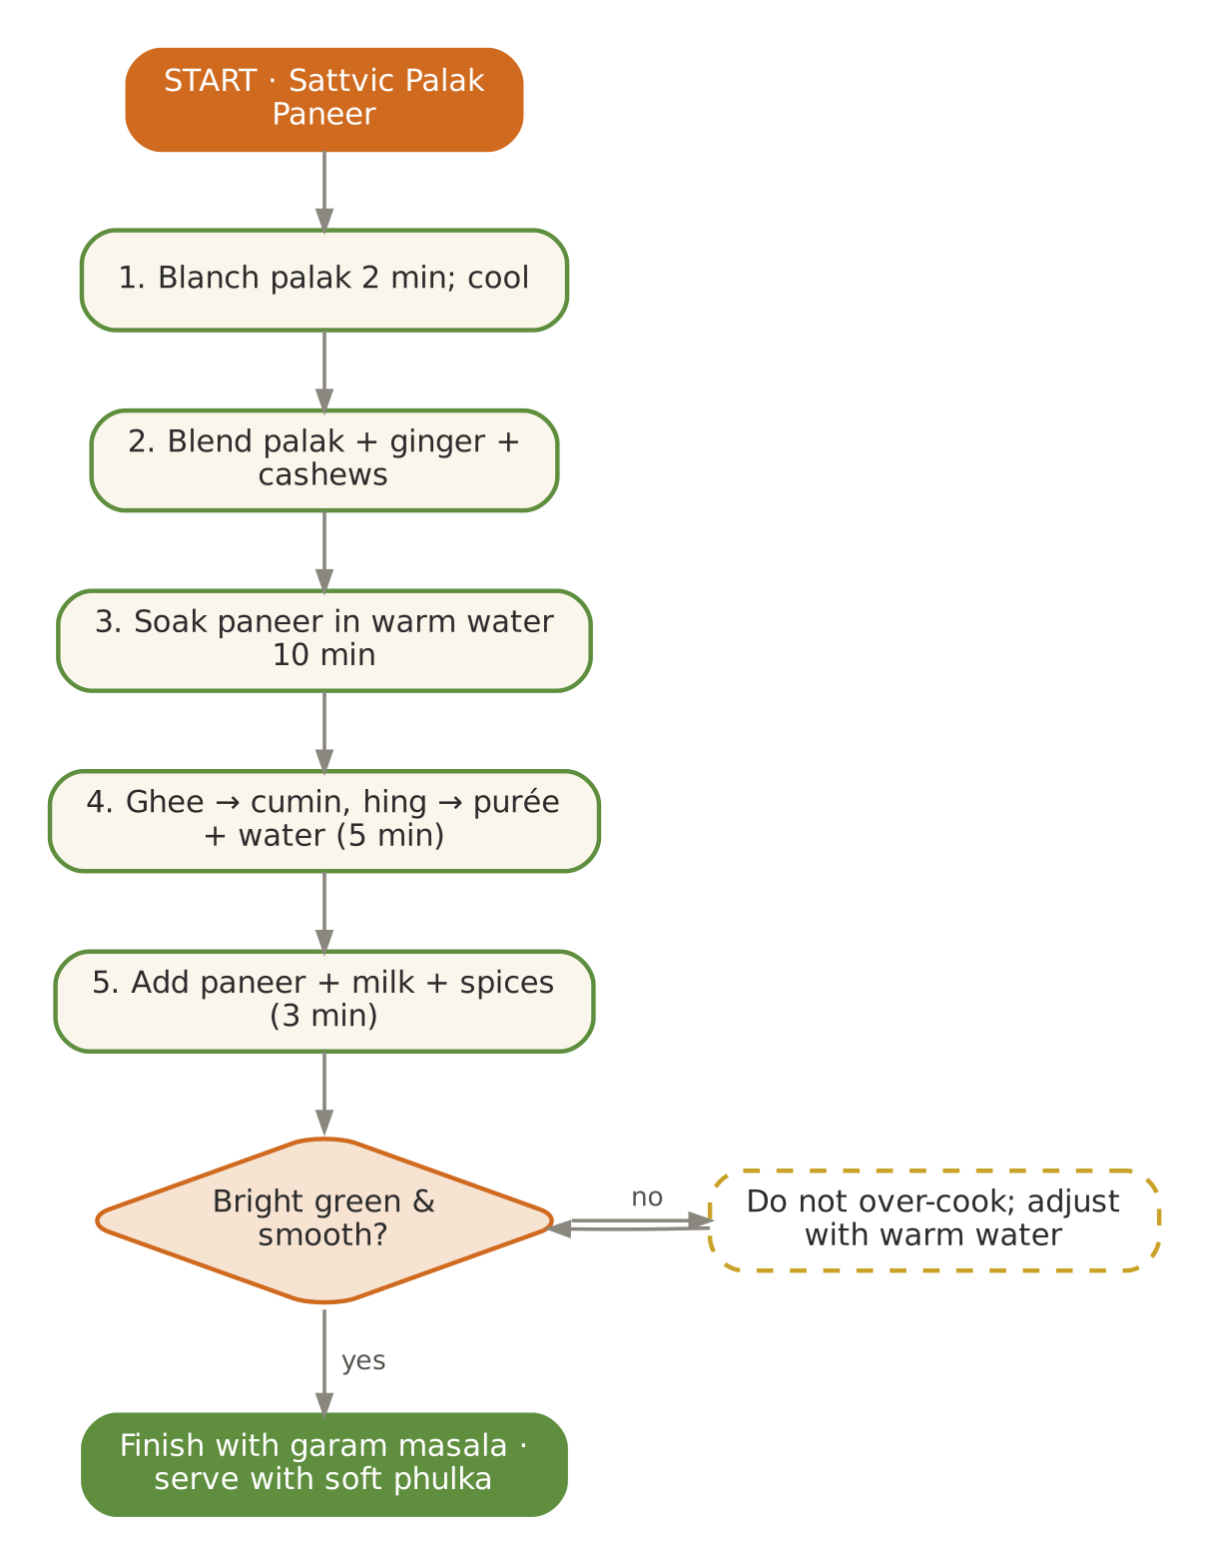  Signature dish: Sattvic Palak Paneer | Further dishes & variations  Breakfast  Kuttu cheela with lauki (vrat) · Sabudana–makhana khichdi · Singhara-atta porridge · Samak dosa · Poha with pomegranate  Dals & Saags  Aloo–dahi curry (vrat, lunch) · Moong usal · Lauki–moong · Moong–spinach · Parippu  Sabzis  Shakarkandi–singhara · Vrat aloo jeera (rock salt) · Paneer–capsicum · Kaddu ki sabzi (vrat) · Arbi (vrat)  Evening  Sitaphal (custard apple) pulp with milk · Makhana chaat · Coconut water · Pomegranate · Singhara (boiled) chaat  Light Dinners  Sabudana khichdi (soft) · Samak pulao · Lauki soup · Kanji  Sweets & Digestives  Singhara halwa · Rajgira ladoo · Coconut barfi · Sitaphal rabdi (light) · Saunf–mishri

November — Nourish & Build — Diwali, Annakut & Kartik Snan
Hindu months | Kartik – Margashirsha
Ayurvedic season | Sharad → Hemanta (early winter)
Haridwar weather | ≈ 12 – 26 °C, crisp mornings, dry air
Agni (digestion) | Strong — the 'building' season begins
Dosha picture | Pitta settling; Vata rising with dryness and cold
Favour | Sweet, sour, salty; unctuous, warm, nourishing; ghee, sesame, milk, jaggery
Limit | Dry, cold, light-only food; skipping breakfast; cold drinks

In season
Vegetables & greens | Fruit | Pantry & other
Amla, methi, palak, peas, cauliflower, carrots, radish, sweet potato, singhara, beans, cabbage | Guava, oranges, amla, apple, pomegranate, sitaphal (early) | Fresh jaggery (end), sesame, nuts

Festivals & observances
Occasion | Kitchen response
Diwali (Kartik Amavasya) | Soft mithai: moong dal halwa (small), kaju–date roll, besan ladoo (soft); a 'sugar-smart' sweet box for diabetic guests.
Govardhan Puja / Annakut | 56-dish spirit in a single mixed-vegetable Annakut sabzi with kadhi and rice.
Kartik Purnima / Dev Deepawali | Ganga snan in Haridwar; light satvik thali, kheer.
Gita Jayanti (late Nov/Dec) | Simple prasad: panchamrit, sheera.

Kitchen guidance for November
- Increase portion size slightly and reintroduce parathas, nuts and sesame.
- Amla every day — November is peak amla; make murabba and chutney for the season.
- Begin weekly 'oil-massage day' menus with warm soups and khichdi.
- Diwali: offer small portions of sweets with the meal, never on an empty stomach.
Daily rituals: on waking — Warm cumin–ginger water; at bedtime — Golden milk with nutmeg and ½ tsp ghee.

Seven-day menu — November
Rotate weekly; swap any item for one from 'Further dishes & variations' at the end of this chapter. Lunch always includes rice and phulka; curd/raita is served at lunch only.
Day | Breakfast 7:30–9:00 | Lunch thali 12:30–2:30 | Evening 4:00 | Dinner 7:00–8:30
Monday | Paneer–methi paratha (soft) · curd | Panchmel dal (light) · Annakut mixed vegetable · Gobhi–matar adraki · rice & phulka · Amla–ginger chutney | Badam–kesar milk | Shakarkandi–gajar–ginger soup · phulka · sweet: Amla murabba (1)
Tuesday | Vegetable upma · guava | Masoor–palak · Palak paneer · Gajar–matar–shakarkandi · rice & phulka · Beetroot raita (room temp.) | Amla–ginger tea | Moong khichdi · sweet: Moong dal halwa (30 g)
Wednesday | Moong chilla · amla chutney | Methi–moong dal · Aloo–methi · Kaddu khatta-meetha · rice & phulka · Spiced takra | Roasted makhana | Palak–moong soup · phulka · sweet: Gajar halwa (40 g)
Thursday | Ragi porridge · dates | Whole moong · Beans thoran · Matar paneer (light) · rice & phulka · Mint–coriander chutney | Stewed guava | Vegetable dalia · sweet: Kaju–date roll
Friday | Rice idli · coconut chutney | Toor dal with lauki · Mooli bhurji · Cabbage–peas · rice & phulka · Carrot–amla pickle (fresh) | Sweet-potato chaat | Methi–moong khichdi · sweet: Besan ladoo (soft, small)
Saturday | Oats with dates & walnuts · orange | Chana dal–lauki · Annakut mixed vegetable · Gobhi–matar adraki · rice & phulka · Amla–ginger chutney | Til–gud ladoo (mini) | Carrot–ginger soup · rice · sweet: Rice kheer
Sunday | Sweet-potato–jaggery porridge | Kadhi (no pakora) · Palak paneer · Gajar–matar–shakarkandi · rice & phulka · Beetroot raita (room temp.) | CCF tea | Lauki–moong dal · phulka · sweet: Sheera (40 g)

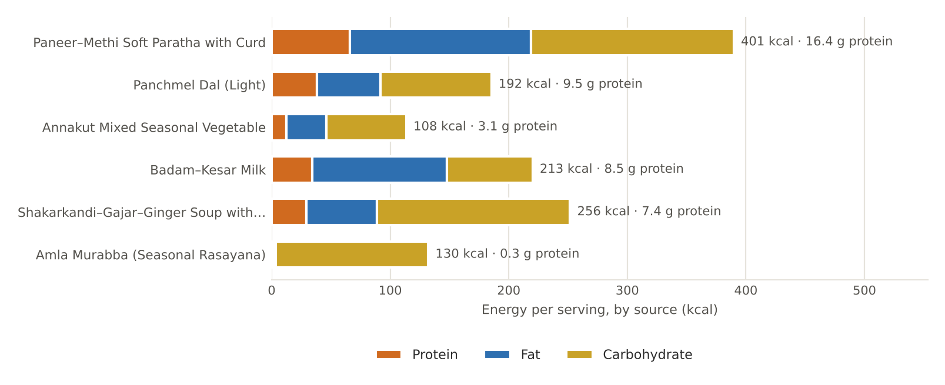
Figure. November's featured recipes — energy per serving by source, with protein

November recipes

Paneer–Methi Soft Paratha with Curd
BREAKFAST · Serves 4 · Portion: 2 parathas + 50 g curd · Rest 20 min · Cook 30 min
Texture: Soft Dosha: Nourishing; Vata-pacifying
Ingredient | Household measure | Base qty | Café batch ×5
Whole-wheat flour (atta) | 2 cups | 240 g | 1,200 g
Water | ½ cup + 1 tbsp | 140 ml | 700 ml
Rock salt (sendha namak) | pinch (dough) | 1 g | 5 g
Paneer (cow's milk) | grated | 150 g | 750 g
Fenugreek leaves (methi) | 1 cup, finely chopped | 50 g | 250 g
Ginger, fresh | 2 tsp grated | 10 g | 50 g
Cumin (jeera) | ¼ tsp | 1 g | 5 g
Carom (ajwain) | pinch | 0.5 g | 2.5 g
Coriander seed / powder | 1 tsp | 2 g | 10 g
Rock salt (sendha namak) | ½ tsp (filling) | 2.5 g | 13 g
Ghee (cow) | 5 tsp (cooking) | 25 g | 125 g
Curd (dahi), plain | ¾ cup + 1 tbsp (to serve) | 200 g | 1,000 g
Method
1. Knead a soft dough with atta, salt and water; rest 20 minutes.
2. Mix paneer, methi, ginger, spices and salt for the filling.
3. Divide dough and filling into 8; stuff each ball, seal and roll gently to 6 inches.
4. Cook on a medium tawa with ½ tsp ghee per side until golden-spotted.
5. Stack in a cloth to keep soft; serve with room-temperature curd.

Per serving | Energy  401 kcal | Protein  16.4 g | Fat  17.0 g | Carbs  42.7 g | Fibre  7.0 g | Salt  0.9 g

Care notes for 55+ guests  Roll slightly thick and cook on medium (not high) so parathas stay soft, not crisp. | Ayurvedic note  Hemanta's strong agni can digest a heavier breakfast; methi keeps it balanced.
Variations & further ideas: Gobhi paratha (soft) · Mooli paratha · Matar paratha · Missi roti (soft, small)

Panchmel Dal (Light)
LUNCH · DAL · Serves 4 · Portion: 1 katori (≈180 g) · Soak 1 h · Cook 40 min
Texture: Soft Dosha: Nourishing; hing for Vata
Ingredient | Household measure | Base qty | Café batch ×5
Toor / arhar dal | 3 tbsp | 40 g | 200 g
Chana dal | 2 tbsp | 30 g | 150 g
Moong dal, yellow split | 3 tbsp | 40 g | 200 g
Masoor dal (red lentil) | 2 tbsp | 30 g | 150 g
Urad dal, split | 1½ tbsp | 20 g | 100 g
Water | 3¾ cups | 900 ml | 4,500 ml
Turmeric powder | ¼ tsp | 1 g | 5 g
Rock salt (sendha namak) | ¾ tsp | 4 g | 20 g
Ghee (cow) | 4 tsp | 20 g | 100 g
Cumin (jeera) | ½ tsp | 2 g | 10 g
Asafoetida (hing) | 2 pinches | 0.4 g | 2 g
Ginger, fresh | 2 tsp | 10 g | 50 g
Clove | 2 | 0.3 g | 1.5 g
Cinnamon | ½-inch | 0.5 g | 2.5 g
Bay leaf (tej patta) | 1 | 0.5 g | 2.5 g
Kashmiri chilli powder (mild) | ¼ tsp | 1 g | 5 g
Tomato | ½ medium (optional) | 60 g | 300 g
Coriander leaves | 2 tbsp | 8 g | 40 g
Method
1. Wash the five dals; soak 1 hour.
2. Pressure-cook with water and turmeric — 5 whistles, then 5 minutes on low.
3. Mash partly.
4. Tadka: ghee, whole spices, cumin, hing, ginger, tomato; chilli off heat.
5. Pour in; add salt; simmer 5 minutes; garnish.

Per serving | Energy  192 kcal | Protein  9.5 g | Fat  6.0 g | Carbs  23.3 g | Fibre  4.9 g | Salt  1.0 g

Care notes for 55+ guests  Five dals give a broader amino-acid profile; urad and chana make it heavier, so keep to lunch. | Ayurvedic note  Rajasthani panchratna made light — Hemanta can digest it.
Variations & further ideas: Dal makhani (light, no cream, lunch) · Dal tadka · Mixed dal khichdi · Panchmel with lauki

Annakut Mixed Seasonal Vegetable
LUNCH · SABZI · Serves 6 · Portion: 1 katori (≈150 g) · Cook 35 min
Texture: Soft Dosha: Balancing; sweet-sour
Ingredient | Household measure | Base qty | Café batch ×5
Potato | 1 small | 100 g | 500 g
Sweet potato (shakarkandi) | ½ medium | 100 g | 500 g
Carrot | 1 medium | 100 g | 500 g
French beans | 10 | 80 g | 400 g
Cauliflower | 8 florets | 150 g | 750 g
Pumpkin (kaddu) | 1 cup | 150 g | 750 g
Green peas, fresh | ½ cup | 80 g | 400 g
Spinach (palak) | 1 cup chopped | 80 g | 400 g
Ghee (cow) | 4 tsp | 20 g | 100 g
Cumin (jeera) | ½ tsp | 2 g | 10 g
Asafoetida (hing) | 1 pinch | 0.3 g | 1.5 g
Ginger, fresh | 1 tbsp | 15 g | 75 g
Turmeric powder | ¼ tsp | 1 g | 5 g
Coriander seed / powder | 2 tsp | 4 g | 20 g
Rock salt (sendha namak) | 1 tsp | 5 g | 25 g
Water | ⅔ cup | 150 ml | 750 ml
Jaggery (gur) | 2 tsp | 10 g | 50 g
Dry mango powder (amchur) | ½ tsp | 1 g | 5 g
Sattvic garam masala (no onion-garlic) | ¼ tsp | 1 g | 5 g
Coriander leaves | 2 tbsp | 8 g | 40 g
Method
1. Cut all vegetables into 2-cm pieces.
2. Heat ghee; cumin, hing, ginger; add potato, sweet potato, carrot and beans with turmeric, coriander and salt; add water, cover 8 minutes.
3. Add cauliflower, pumpkin and peas; cover 8–10 minutes.
4. Add spinach; cook 3 minutes.
5. Finish with jaggery, amchur, garam masala and coriander.

Per serving | Energy  108 kcal | Protein  3.1 g | Fat  3.8 g | Carbs  16.8 g | Fibre  3.9 g | Salt  0.8 g

Care notes for 55+ guests  Staggered cooking keeps every vegetable equally soft. | Ayurvedic note  Annakut — 'mountain of food' — offered at Govardhan Puja; diversity of vegetables nourishes all tissues.
Variations & further ideas: Undhiyu (steamed, light) · Mixed-vegetable kootu · Avial · Shukto (Bengali bitter-sweet)

Badam–Kesar Milk
EVENING · DRINK · Serves 4 · Portion: 200 ml · Soak overnight · 15 min
Texture: Smooth Dosha: Vata-pacifying, nourishing
Ingredient | Household measure | Base qty | Café batch ×5
Almonds | 30, soaked overnight & peeled | 40 g | 200 g
Cow's milk, whole | 3⅓ cups | 800 ml | 4,000 ml
Saffron (kesar) | 10 strands | 0.1 g | 0.5 g
Green cardamom | ⅛ tsp | 0.5 g | 2.5 g
Nutmeg | tiny pinch | 0.1 g | 0.5 g
Mishri / sugar | 2 tbsp (or 3 dates) | 25 g | 125 g
Method
1. Grind almonds with 100 ml milk to a fine paste.
2. Boil the remaining milk; add paste; simmer 6 minutes.
3. Add saffron, cardamom, nutmeg and mishri.
4. Serve warm.

Per serving | Energy  213 kcal | Protein  8.5 g | Fat  12.6 g | Carbs  18.1 g | Fibre  1.3 g | Salt  0.0 g

Care notes for 55+ guests  Fine grinding means no grit — strain if necessary. | Ayurvedic note  Badam with milk is a medhya (brain) and Vata tonic for the elderly.
Variations & further ideas: Kesar–pista milk · Dates milk · Golden milk · Almond–rice kheer

Shakarkandi–Gajar–Ginger Soup with Soft Phulka
DINNER · Serves 4 · Portion: 250 ml soup + 1 phulka · Cook 35 min
Texture: Pureed soup Dosha: Vata-pacifying, warming
Ingredient | Household measure | Base qty | Café batch ×5
Sweet potato (shakarkandi) | 1 medium | 200 g | 1,000 g
Carrot | 2 medium | 200 g | 1,000 g
Moong dal, yellow split | 3 tbsp | 40 g | 200 g
Ginger, fresh | 1 tbsp | 15 g | 75 g
Water | 4 cups | 1,000 ml | 5,000 ml
Ghee (cow) | 1 tbsp | 15 g | 75 g
Cumin (jeera) | ¼ tsp | 1 g | 5 g
Black pepper | ½ tsp | 1 g | 5 g
Rock salt (sendha namak) | ¾ tsp | 3.5 g | 18 g
Lemon juice | 2 tsp | 10 ml | 50 ml
Whole-wheat flour (atta) | 1 cup (4 phulkas) | 120 g | 600 g
Water | 5 tbsp (dough) | 75 ml | 375 ml
Ghee (cow) | ½ tsp per phulka | 8 g | 40 g
Method
1. Pressure-cook sweet potato, carrot, moong and ginger with 800 ml water — 3 whistles.
2. Blend smooth; thin with remaining water; simmer 3 minutes.
3. Temper with ghee and cumin; add pepper and salt; lemon off heat.
4. Make 4 soft phulkas; brush with ghee.

Per serving | Energy  256 kcal | Protein  7.4 g | Fat  6.6 g | Carbs  40.7 g | Fibre  7.3 g | Salt  0.9 g

Care notes for 55+ guests  Velvety texture; naturally sweet — no sugar needed. | Ayurvedic note  Sweet, warm and unctuous: the three qualities that pacify Vata.
Variations & further ideas: Carrot–ginger soup · Pumpkin–lentil soup · Beet–carrot soup · Sweet-potato–moong khichdi

Amla Murabba (Seasonal Rasayana)
SWEET · Serves 14 · Portion: 1 amla with 1 tsp syrup · Soak overnight · 2 days
Texture: Soft Dosha: Tridoshic rasayana
Ingredient | Household measure | Base qty | Café batch ×5
Amla (Indian gooseberry) | 12–14 large | 500 g | 2,500 g
Mishri / sugar | 2 cups | 400 g | 2,000 g
Water | ⅔ cup | 150 ml | 750 ml
Green cardamom | ¼ tsp | 1 g | 5 g
Black pepper | ¼ tsp crushed | 0.5 g | 2.5 g
Saffron (kesar) | 5 strands (optional) | 0.1 g | 0.3 g
Method
1. Wash amla and prick all over with a fork; soak in water overnight.
2. Steam or boil 6–8 minutes until slightly soft but whole; drain.
3. Make syrup with mishri and water; add amla and simmer 15 minutes; rest overnight.
4. Next day boil 10 minutes until the syrup reaches one-string consistency.
5. Add cardamom, pepper and saffron; cool and store in a sterilised glass jar; mature 1 week.

Per serving | Energy  130 kcal | Protein  0.3 g | Fat  0.2 g | Carbs  32.2 g | Fibre  1.6 g | Salt  0.0 g

Care notes for 55+ guests  One amla a day after breakfast. Diabetic guests: plain steamed amla with rock salt instead. | Ayurvedic note  Amalaki is the foremost rasayana (rejuvenative) in Ayurveda — rich in vitamin C.
Variations & further ideas: Amla candy · Amla chutney with jaggery · Amla–ginger juice · Amla pickle (oil-light)

Signature process & further dishes — November
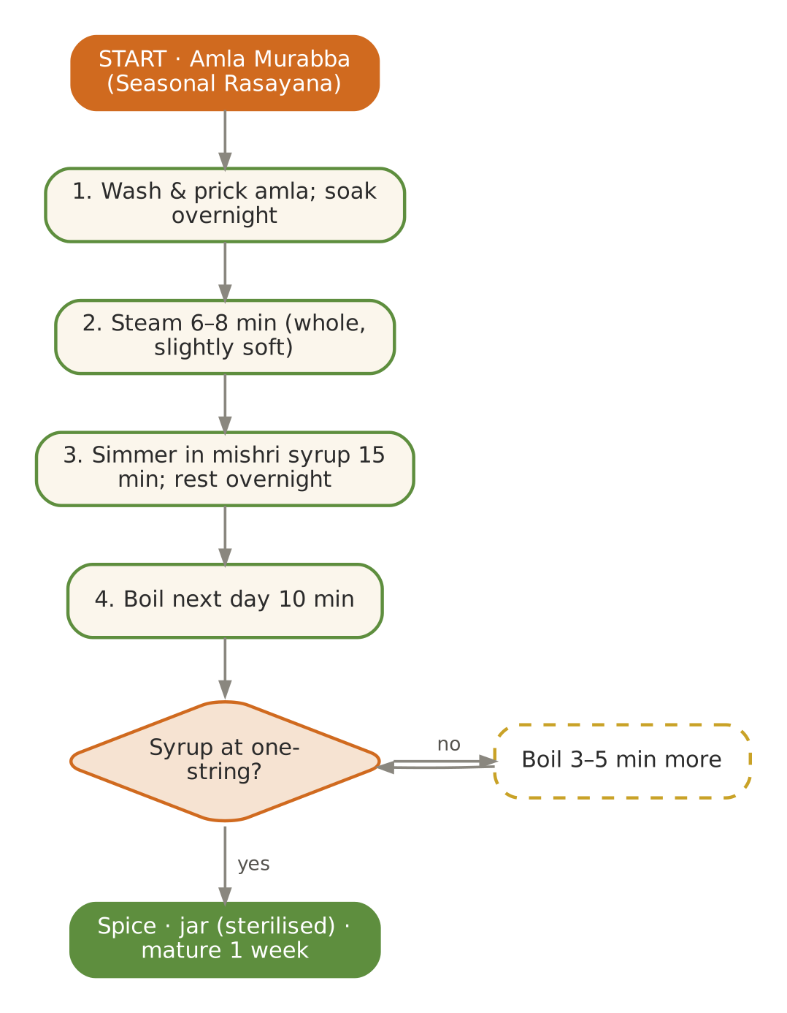  Signature dish: Amla Murabba (Seasonal Rasayana) | Further dishes & variations  Breakfast  Gobhi paratha (soft) · Matar kachori — baked version · Sooji–vegetable cheela · Bajra raab (savoury drink) · Amla–oats porridge  Dals & Saags  Dal makhani (light, lunch) · Methi–moong · Palak–chana dal · Kadhi with methi · Mooli dal  Sabzis  Undhiyu (steamed, light) · Gobhi–aloo · Methi–malai paneer (light) · Singhara–shakarkandi · Shukto  Evening  Amla–ginger tea · Dry-fruit milk · Guava stewed · Til–gud ladoo · Hot jaggery–ginger water  Light Dinners  Palak–moong soup · Methi khichdi · Vegetable dalia · Carrot–ginger soup  Sweets & Digestives  Moong dal halwa · Kaju–date roll · Soft besan ladoo · Amla candy · Saunf–ajwain mukhwas

December — Deep Nourishment & Winter Greens
Hindu months | Margashirsha – Paush
Ayurvedic season | Hemanta (early winter)
Haridwar weather | ≈ 8 – 21 °C, cold nights, dry
Agni (digestion) | Very strong — nourishing food is essential
Dosha picture | Vata rising with cold and dryness; Kapha begins to gather
Favour | Sweet, sour, salty; warm, heavy (in measure), unctuous; ghee, sesame, jaggery, nuts
Limit | Cold, dry, light-only meals; long fasts; cold water; raw salads

In season
Vegetables & greens | Fruit | Pantry & other
Sarson, bathua, methi, palak, peas, carrots, turnip, radish, cauliflower, sweet potato, fresh turmeric | Oranges, kinnow, guava, amla, apples, pomegranate | Fresh jaggery, sesame, peanuts, walnuts

Festivals & observances
Occasion | Kitchen response
Gita Jayanti (Margashirsha Shukla Ekadashi) | Panchamrit, sheera; ashram satsang prasad.
Datta Jayanti / Margashirsha Purnima | Kheer and sattvic thali.
Christmas & New Year guests | Warm baked apple with dates, ginger–jaggery cookies (soft), eggless whole-wheat fruit-and-nut loaf.

Kitchen guidance for December
- Full Vata protocol from the source Kerala plan: warm, unctuous, grounding, easily digestible.
- Ghee 2–3 tsp daily across meals; sesame in sweets; warm water all day.
- Lunch is the main meal; dinner light and by 7:30 pm (cold nights + heavy dinner = poor sleep).
- Watch elderly guests for chilblains, joint stiffness and dehydration (people drink less in cold).
Daily rituals: on waking — Warm cumin–ginger water; at bedtime — Golden milk with turmeric, nutmeg, cardamom & ½ tsp ghee.

Seven-day menu — December
Rotate weekly; swap any item for one from 'Further dishes & variations' at the end of this chapter. Lunch always includes rice and phulka; curd/raita is served at lunch only.
Day | Breakfast 7:30–9:00 | Lunch thali 12:30–2:30 | Evening 4:00 | Dinner 7:00–8:30
Monday | Spiced steel-cut oats with dates & ghee | Bathua–moong dal · Shalgam (turnip) bharta · Gajar–matar–shakarkandi · rice & phulka · Bathua raita (room temp.) | Herbal spice tea · sesame–walnut mix | Carrot–ginger soup · ghee rice · sweet: Gajar halwa with dates (40 g)
Tuesday | Methi–moong chilla · mint–curd dip | Sarson–palak saag · Gobhi–matar adraki · Aloo–methi · rice & phulka · Amla chutney | Badam milk | Moong khichdi · sweet: Til–gud ladoo
Wednesday | Gajar–matar upma · orange | Masoor–methi · Palak paneer · Mooli bhurji · rice & phulka · Spiced takra | Haldi–adrak kadha | Palak–moong soup · phulka · sweet: Atta panjiri
Thursday | Ragi porridge · walnuts | Panchmel (light) · Matar paneer · Beans–carrot thoran · rice & phulka · Mint–coriander chutney | Roasted makhana | Vegetable dalia khichdi · sweet: Moong dal halwa
Friday | Paneer–palak paratha (soft) · curd | Whole moong · Kaddu khatta-meetha · Cabbage–peas · rice & phulka · Steamed carrot–beet salad | Stewed apple | Methi khichdi · sweet: Date–walnut barfi
Saturday | Rice kanji with ghee · 5 almonds | Toor–lauki · Shalgam (turnip) bharta · Gajar–matar–shakarkandi · rice & phulka · Bathua raita (room temp.) | Til–gud ladoo | Moong yusha · phulka · sweet: Gur rice kheer
Sunday | Sweet-potato porridge | Chana dal–lauki · Gobhi–matar adraki · Aloo–methi · rice & phulka · Amla chutney | Roasted shakarkandi | Bathua–moong dal · rice · sweet: Sweet-potato halwa

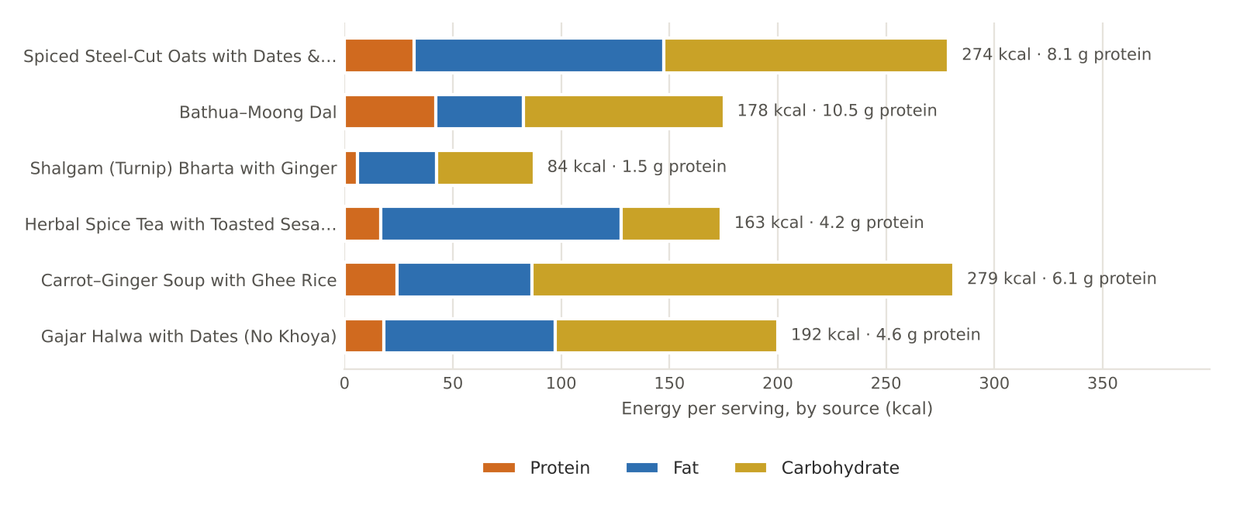
Figure. December's featured recipes — energy per serving by source, with protein

December recipes

Spiced Steel-Cut Oats with Dates & Ghee
BREAKFAST · Serves 4 · Portion: 1 bowl (≈220 g) · Soak overnight · Cook 25 min
Texture: Soft porridge Dosha: Vata-pacifying
Ingredient | Household measure | Base qty | Café batch ×5
Oats, rolled / steel-cut | ¾ cup steel-cut (or 1⅓ cups rolled) | 120 g | 600 g
Water | 1⅔ cups | 400 ml | 2,000 ml
Cow's milk, whole | 1⅔ cups (or almond milk) | 400 ml | 2,000 ml
Dates, seedless | 5 seedless, chopped | 40 g | 200 g
Green cardamom | ⅛ tsp | 0.5 g | 2.5 g
Cinnamon | ¼ tsp powder | 0.5 g | 2.5 g
Rock salt (sendha namak) | pinch | 0.5 g | 2.5 g
Ghee (cow) | 1 tsp per bowl (≈4 tsp) | 15 g | 75 g
Walnuts | 5 halves, chopped | 20 g | 100 g
Method
1. Soak steel-cut oats overnight; drain.
2. Simmer in water 15 minutes.
3. Add milk; simmer 10 minutes, stirring, until creamy.
4. Add dates, cardamom, cinnamon and a pinch of salt.
5. Serve with 1 tsp ghee per bowl and chopped walnuts.

Per serving | Energy  274 kcal | Protein  8.1 g | Fat  12.8 g | Carbs  32.9 g | Fibre  4.1 g | Salt  0.1 g

Care notes for 55+ guests  From the source Kerala Vata plan (Wednesday). Rolled oats cook in 6 minutes for a quicker, softer option. | Ayurvedic note  Warm, sweet and unctuous; walnuts add omega-3 for brain and joints.
Variations & further ideas: Oats kheer · Savoury oats khichdi · Oats–ragi porridge · Apple–cinnamon oats

Bathua–Moong Dal
LUNCH · DAL · Serves 4 · Portion: 1 katori (≈180 g) · Cook 30 min
Texture: Soft Dosha: Balancing; gently laxative
Ingredient | Household measure | Base qty | Café batch ×5
Moong dal, yellow split | ¾ cup | 150 g | 750 g
Bathua (chenopodium) leaves | 1½ cups packed, chopped | 150 g | 750 g
Water | 3½ cups | 850 ml | 4,250 ml
Turmeric powder | ¼ tsp | 1 g | 5 g
Rock salt (sendha namak) | ¾ tsp | 4 g | 20 g
Ghee (cow) | 1 tbsp | 15 g | 75 g
Cumin (jeera) | ½ tsp | 2 g | 10 g
Asafoetida (hing) | 1 pinch | 0.3 g | 1.5 g
Ginger, fresh | 2 tsp | 10 g | 50 g
Kashmiri chilli powder (mild) | pinch | 0.5 g | 2.5 g
Lemon juice | 2 tsp | 10 ml | 50 ml
Method
1. Pressure-cook moong, chopped bathua, water and turmeric — 3 whistles.
2. Whisk smooth.
3. Tadka: ghee, cumin, hing, ginger; chilli off heat.
4. Pour in; add salt; simmer 3 minutes; lemon to finish.

Per serving | Energy  178 kcal | Protein  10.5 g | Fat  4.5 g | Carbs  23.2 g | Fibre  4.0 g | Salt  1.0 g

Care notes for 55+ guests  Bathua is mildly laxative — helpful for winter constipation. | Ayurvedic note  Vastuka (bathua) is light and digestive; a winter 'cleansing green'.
Variations & further ideas: Bathua raita · Bathua paratha (soft) · Bathua saag · Bathua kadhi

Shalgam (Turnip) Bharta with Ginger
LUNCH · SABZI · Serves 4 · Portion: ½ katori (≈110 g) · Cook 25 min
Texture: Mashed Dosha: Vata-pacifying with ghee
Ingredient | Household measure | Base qty | Café batch ×5
Turnip (shalgam) | 4 medium, cubed | 500 g | 2,500 g
Ghee (cow) | 1 tbsp | 15 g | 75 g
Cumin (jeera) | ½ tsp | 2 g | 10 g
Asafoetida (hing) | 1 pinch | 0.3 g | 1.5 g
Ginger, fresh | 1 tbsp grated | 15 g | 75 g
Tomato | ½ medium (optional) | 60 g | 300 g
Coriander seed / powder | 1½ tsp | 3 g | 15 g
Sattvic garam masala (no onion-garlic) | ⅛ tsp | 0.5 g | 2.5 g
Jaggery (gur) | 1 tsp | 5 g | 25 g
Rock salt (sendha namak) | ¾ tsp | 3.5 g | 18 g
Water | ¼ cup | 60 ml | 300 ml
Coriander leaves | 2 tbsp | 8 g | 40 g
Method
1. Pressure-cook turnip with water — 2 whistles; mash.
2. Heat ghee; cumin, hing, ginger; add tomato until soft.
3. Add coriander powder, mashed turnip and salt; cook 6 minutes until thick.
4. Add jaggery (balances turnip's bitterness) and garam masala; garnish.

Per serving | Energy  84 kcal | Protein  1.5 g | Fat  4.1 g | Carbs  11.2 g | Fibre  2.9 g | Salt  0.9 g

Care notes for 55+ guests  Mashed texture suits all chewing abilities. | Ayurvedic note  Shalgam is warming in winter; ghee and jaggery round off its pungency.
Variations & further ideas: Shalgam–gajar sabzi · Shalgam ki kadhi (Kashmiri-style, light) · Turnip–moong dal · Sweet-sour shalgam

Herbal Spice Tea with Toasted Sesame–Walnut Mix
EVENING · DRINK & SNACK · Serves 4 · Portion: 150 ml tea + 20 g mix · 15 min
Texture: Liquid + small crunchy mix Dosha: Vata-pacifying, warming
Ingredient | Household measure | Base qty | Café batch ×5
Water | 3⅓ cups (tea) | 800 ml | 4,000 ml
Cinnamon | 1½-inch stick | 1.5 g | 7.5 g
Green cardamom | 4 pods | 1 g | 5 g
Ginger, fresh | 1½ tsp sliced | 8 g | 40 g
Fennel (saunf) | 1 tsp | 2 g | 10 g
Jaggery (gur) | 1 tbsp (optional) | 15 g | 75 g
Sesame seeds (til) | 2 tbsp | 20 g | 100 g
Walnuts | 10 halves | 40 g | 200 g
Pumpkin seeds | 2 tbsp | 20 g | 100 g
Raisins (kishmish) | 2 tbsp | 20 g | 100 g
Ghee (cow) | ½ tsp | 3 g | 15 g
Rock salt (sendha namak) | pinch | 0.3 g | 1.5 g
Method
1. Tea: simmer water with cinnamon, cardamom, ginger and fennel 10 minutes; strain; add jaggery if wished.
2. Mix: toast sesame on low 3 minutes; set aside.
3. Warm ghee; toast walnuts and pumpkin seeds 3 minutes.
4. Combine with sesame, raisins and a pinch of salt; cool.

Per serving | Energy  163 kcal | Protein  4.2 g | Fat  12.3 g | Carbs  11.6 g | Fibre  2.1 g | Salt  0.1 g

Care notes for 55+ guests  Chop walnuts finely for guests with weak teeth, or offer the tea with soaked walnuts. | Ayurvedic note  From the source Kerala Vata plan; sesame and walnuts are snigdha (unctuous) Vata-foods.
Variations & further ideas: CCF tea · Ginger–lemon–honey tea · Til–gud ladoo · Soaked almonds & figs

Carrot–Ginger Soup with Ghee Rice
DINNER · Serves 4 · Portion: 250 ml soup + 150 g rice · Cook 35 min
Texture: Pureed soup + soft rice Dosha: Vata-pacifying
Ingredient | Household measure | Base qty | Café batch ×5
Carrot | 5 medium | 500 g | 2,500 g
Ginger, fresh | 1½ tbsp | 20 g | 100 g
Moong dal, yellow split | 2 tbsp (for body) | 30 g | 150 g
Water | 3¾ cups | 900 ml | 4,500 ml
Ghee (cow) | 1 tbsp | 15 g | 75 g
Cumin (jeera) | ¼ tsp | 1 g | 5 g
Black pepper | ½ tsp | 1 g | 5 g
Rock salt (sendha namak) | ¾ tsp | 3.5 g | 18 g
Lemon juice | 2 tsp | 10 ml | 50 ml
Rice, white basmati (raw) | ¾ cup + 1 tbsp | 160 g | 800 g
Water | 2⅔ cups (rice) | 640 ml | 3,200 ml
Ghee (cow) | 2 tsp (rice) | 10 g | 50 g
Method
1. Pressure-cook carrot, ginger and moong with 700 ml water — 3 whistles.
2. Blend smooth; thin with 200 ml water; simmer 3 minutes.
3. Temper with ghee and cumin; add pepper, salt; lemon off heat.
4. Rice: cook soft; stir in ghee.

Per serving | Energy  279 kcal | Protein  6.1 g | Fat  6.9 g | Carbs  48.7 g | Fibre  4.9 g | Salt  0.9 g

Care notes for 55+ guests  From the source Kerala plan (Saturday dinner). Excellent beta-carotene source. | Ayurvedic note  Sweet carrot and pungent ginger: grounding yet light.
Variations & further ideas: Carrot–beet soup · Carrot–coconut soup · Carrot–lentil soup · Carrot–tomato shorba (light)

Gajar Halwa with Dates (No Khoya)
SWEET · Serves 8 · Portion: ≈90 g · Cook 60 min
Texture: Soft Dosha: Vata-pacifying, nourishing
Ingredient | Household measure | Base qty | Café batch ×5
Carrot | 6 medium, grated | 750 g | 3,750 g
Ghee (cow) | 2 tbsp | 30 g | 150 g
Cow's milk, whole | 3 cups | 750 ml | 3,750 ml
Dates, seedless | 8 seedless, pureed | 60 g | 300 g
Mishri / sugar | 3 tbsp | 40 g | 200 g
Green cardamom | ¼ tsp | 1 g | 5 g
Almonds | 15, slivered | 20 g | 100 g
Raisins (kishmish) | 1 tbsp | 10 g | 50 g
Method
1. Cook grated carrot in ghee 8 minutes.
2. Add milk; cook, stirring, 35–40 minutes until fully absorbed.
3. Add date purée and mishri; cook 8 minutes until glossy.
4. Add cardamom, almonds and raisins.

Per serving | Energy  193 kcal | Protein  4.6 g | Fat  8.8 g | Carbs  25.7 g | Fibre  3.5 g | Salt  0.0 g

Care notes for 55+ guests  Dates halve the added sugar; milk-reduction instead of khoya keeps it lighter. Diabetic portion 30 g. | Ayurvedic note  Carrot, milk and ghee — the winter sweet that genuinely nourishes.
Variations & further ideas: Beetroot halwa · Lauki halwa · Shakarkandi halwa · Gajar kheer

Signature process & further dishes — December
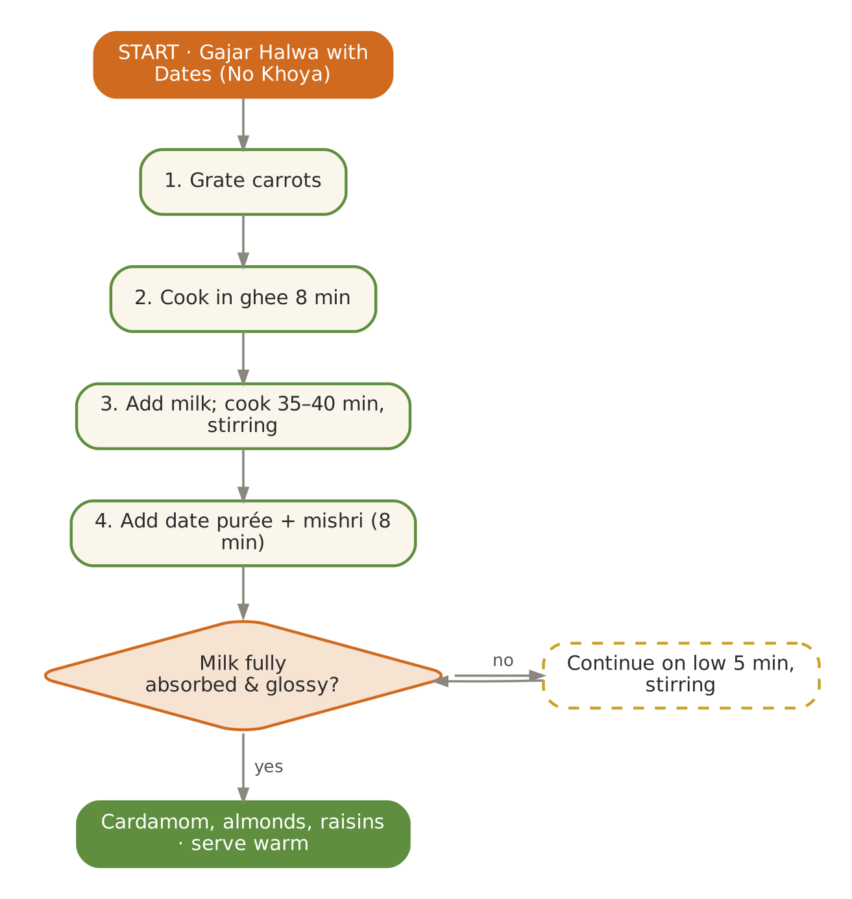  Signature dish: Gajar Halwa with Dates (No Khoya) | Further dishes & variations  Breakfast  Bajra raab · Makki–wheat soft roti with saag · Gajar–oats porridge · Methi thepla (soft) · Sooji–beet cheela  Dals & Saags  Sarson saag · Kali masoor (lunch) · Mooli dal · Methi–chana dal · Palak–moong  Sabzis  Nimona (green-pea curry) · Gobhi–shalgam · Gajar–methi · Sem–aloo · Mooli–gajar  Evening  Gajar kanji (small, room temp.) · Dry-fruit milk · Baked apple with dates · Til–gud chai · Soaked figs  Light Dinners  Sweet-potato–moong soup · Methi khichdi · Palak shorba · Nimona with soft rice  Sweets & Digestives  Date–walnut barfi · Gond-free atta ladoo · Gur rice · Amla candy · Saunf–mishri
PART III

Appendices
Calendars · vrat recipes · nutrition tables · idea bank · planners · glossary

A. Annual Produce Calendar — Haridwar
Indicative availability for the Gangetic plains and Shivalik foothills; stored produce (potato, pumpkin, sweet potato) extends beyond the shaded months. Use with the Annamaya garden harvest log.
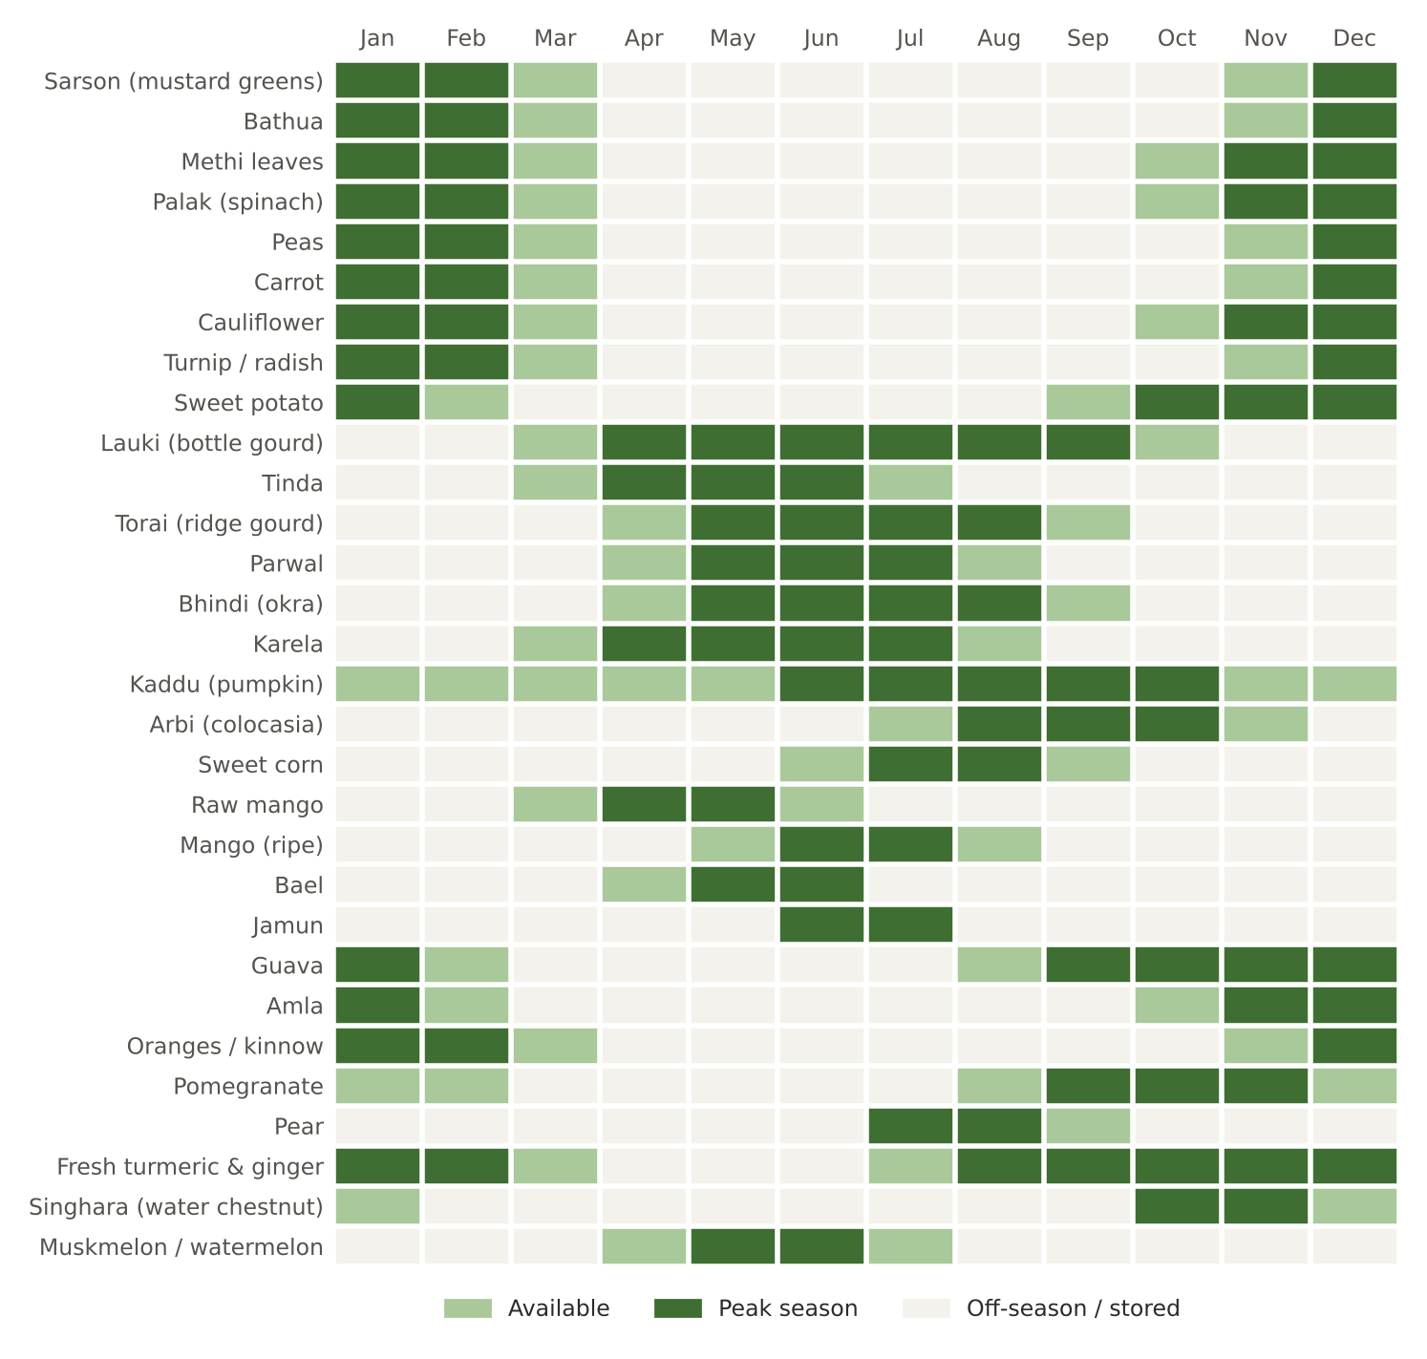
Figure. Month-by-month availability of 30 key ingredients

B. Vrat, Ekadashi & Festival Kitchen
Many guests fast on Ekadashi, Navratri, Shravan Mondays and festival days. For those over 55, the kitchen offers a phalahari track that keeps fluids, protein and energy adequate.
Permitted on most fasts | Avoided on most fasts | Care for elderly fasters
Samak, kuttu, rajgira, singhara, sabudana; potato, sweet potato, pumpkin, lauki, arbi; milk, curd, paneer; fruit, nuts, makhana; rock salt, cumin, pepper, ginger, green chilli | Rice, wheat, pulses, regular salt, turmeric (in some traditions), hing, mustard seeds, most ground spices | No prolonged dry fasts; offer coconut water, takra, milk; check medicines that need food (diabetes, BP); break fast with something warm and light

Soft Sabudana–Makhana Khichdi
VRAT · EKADASHI · Serves 4 · Portion: 1 plate (≈180 g) · Soak 5 h · Cook 15 min
Texture: Soft Dosha: Light; Pitta-pacifying
Ingredient | Household measure | Base qty | Café batch ×5
Sago (sabudana) | 1 cup, soaked 5 h | 160 g | 800 g
Potato | 1 small, boiled & cubed | 100 g | 500 g
Fox nut (makhana) | ¾ cup, roasted & crushed | 20 g | 100 g
Peanuts | 3 tbsp roasted, powdered | 30 g | 150 g
Ghee (cow) | 4 tsp | 20 g | 100 g
Cumin (jeera) | ½ tsp | 2 g | 10 g
Ginger, fresh | 1½ tsp | 8 g | 40 g
Green chilli (optional, deseeded) | ½ (optional) | 2 g | 10 g
Rock salt (sendha namak) | ½ tsp rock salt | 3 g | 15 g
Lemon juice | 2 tsp | 10 ml | 50 ml
Coriander leaves | 1 tbsp | 5 g | 25 g
Method
1. Rinse sabudana until water runs clear; soak with water just covering it for 5 hours; pearls should press flat easily.
2. Mix in powdered peanuts and rock salt.
3. Heat ghee; cumin, ginger, chilli; add potato for 2 minutes.
4. Add sabudana; cook on low 4–6 minutes, stirring gently, until pearls turn translucent.
5. Fold in makhana, lemon and coriander.

Per serving | Energy  269 kcal | Protein  3.1 g | Fat  8.8 g | Carbs  45.0 g | Fibre  2.0 g | Salt  0.8 g

Care notes for 55+ guests  Sabudana can clump and stick — serve warm and loose; offer water alongside. Diabetic guests: prefer samak khichdi (lower glycaemic load). | Ayurvedic note  Sabudana is cooling and easy to digest — a traditional fast food.
Variations & further ideas: Sabudana kheer · Sabudana thalipeeth (soft) · Sabudana vada — baked · Sabudana upma

Singhara Atta Halwa
VRAT · NAVRATRI · Serves 6 · Portion: ≈60 g · Cook 20 min
Texture: Soft Dosha: Cooling, nourishing
Ingredient | Household measure | Base qty | Café batch ×5
Water-chestnut (singhara) flour | ¾ cup water-chestnut flour | 100 g | 500 g
Ghee (cow) | 3 tbsp | 40 g | 200 g
Cow's milk, whole | 1 cup | 250 ml | 1,250 ml
Water | ¾ cup + 1 tbsp | 200 ml | 1,000 ml
Mishri / sugar | ⅓ cup | 60 g | 300 g
Green cardamom | ¼ tsp | 1 g | 5 g
Almonds | 8, slivered | 10 g | 50 g
Method
1. Roast singhara flour in ghee on low 8 minutes until it darkens slightly and smells nutty.
2. Heat milk and water together.
3. Add the hot liquid gradually, stirring constantly (it thickens fast).
4. Add mishri; cook until it leaves the sides (3–4 minutes).
5. Add cardamom and almonds.

Per serving | Energy  192 kcal | Protein  2.5 g | Fat  9.2 g | Carbs  24.5 g | Fibre  0.9 g | Salt  0.0 g

Care notes for 55+ guests  Soft, smooth and filling on fast days. | Ayurvedic note  Shringataka (water chestnut) is cooling and strengthening — prized during fasts.
Variations & further ideas: Kuttu halwa · Rajgira sheera · Singhara–lauki cheela · Singhara ladoo

C. Nutrition Summary of All Recipes
Estimated per serving from raw ingredient weights using standard food-composition tables (IFCT 2017 / USDA). Actual values vary with produce, cooking losses and portioning; use for planning, not clinical prescription.
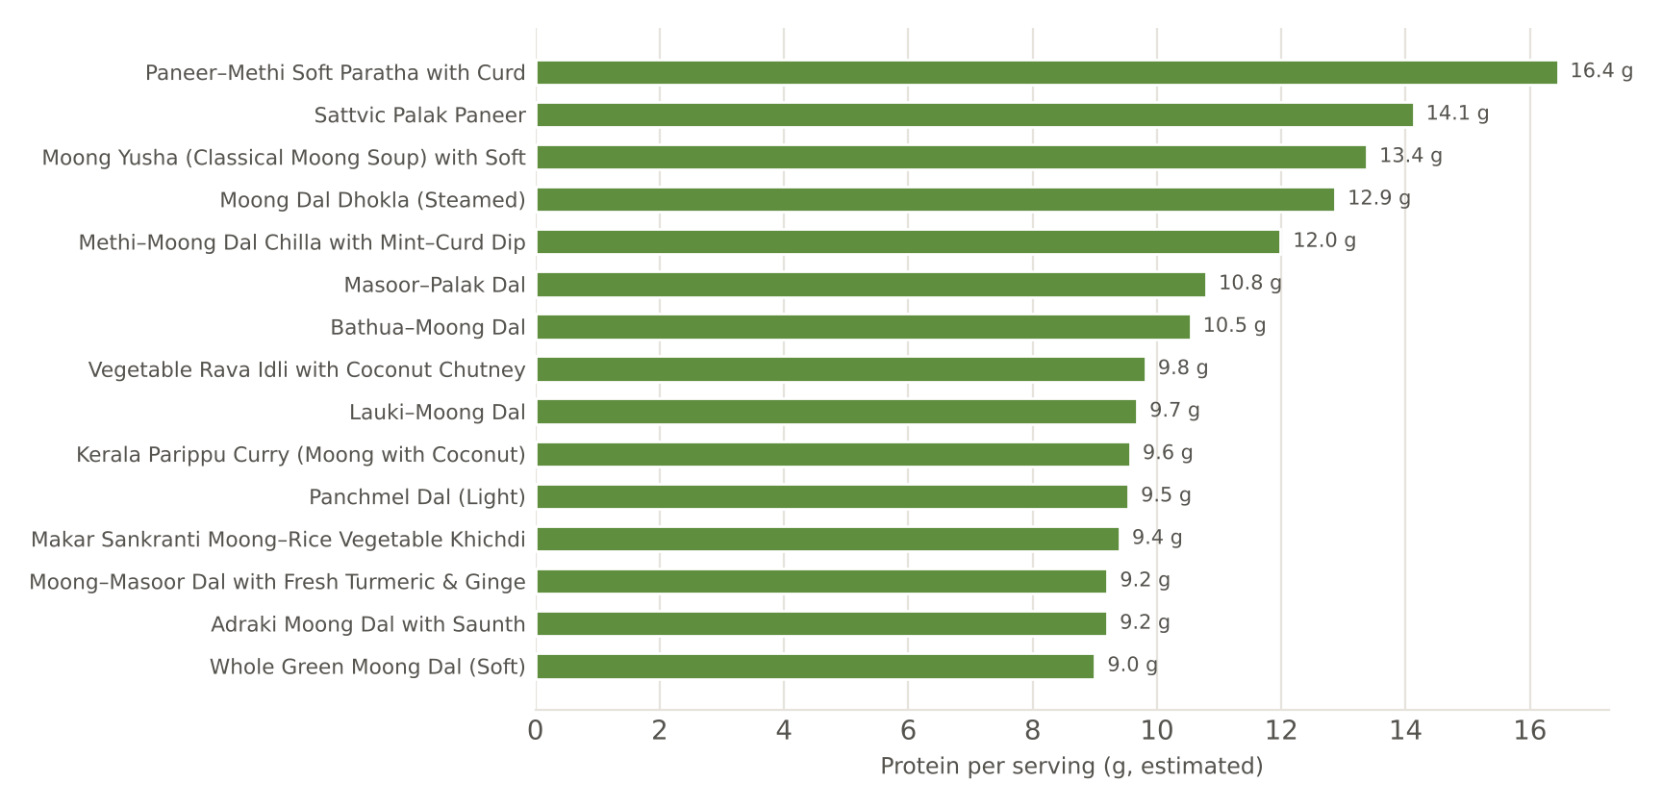
Figure. The 15 most protein-rich recipes per serving
Recipe | Category | kcal | Protein g | Fat g | Carbs g | Fibre g | Salt g
Methi–Moong Dal Chilla with Mint–Curd Dip | Breakfast | 223 | 12.0 | 7.5 | 26.4 | 4.2 | 0.8
Sarson–Palak–Bathua Saag (Sattvic) | Lunch · Saag | 125 | 7.3 | 6.3 | 10.9 | 4.0 | 0.9
Gajar–Matar–Shakarkandi Soft Sabzi | Lunch · Sabzi | 140 | 3.6 | 4.2 | 22.8 | 5.6 | 0.8
Haldi–Adrak–Gud Kadha | Evening · Drink | 29 | 0.2 | 0.1 | 7.0 | 0.3 | 0.0
Makar Sankranti Moong–Rice Vegetable Khichdi | Dinner | 248 | 9.4 | 5.7 | 39.6 | 4.6 | 1.0
Til–Gud–Saunth Mini Ladoo (soft-set) | Sweet | 83 | 1.6 | 5.3 | 8.1 | 1.1 | 0.0
Matar–Gajar Vegetable Upma | Breakfast | 233 | 6.7 | 6.7 | 35.8 | 3.4 | 0.9
Masoor–Palak Dal | Lunch · Dal | 182 | 10.8 | 4.4 | 24.4 | 5.4 | 1.0
Adraki Gobhi–Matar (Soft) | Lunch · Sabzi | 111 | 4.3 | 4.4 | 15.3 | 4.7 | 0.9
Amla–Ginger–Honey Warm Tea | Evening · Drink | 25 | 0.2 | 0.1 | 6.2 | 0.8 | 0.0
Beetroot–Carrot–Moong Soup with Soft Rice | Dinner | 209 | 6.6 | 4.3 | 36.1 | 4.1 | 0.9
Basant Kesari Meetha Chawal | Sweet | 207 | 2.7 | 5.0 | 38.1 | 0.9 | 0.0
Jau (Barley)–Moong Savoury Porridge | Breakfast | 184 | 6.5 | 4.4 | 29.2 | 5.6 | 0.9
Lauki–Chana Dal | Lunch · Dal | 162 | 7.1 | 5.6 | 18.6 | 5.5 | 1.0
Karela with Jaggery & Fennel (Soft) | Lunch · Sabzi | 97 | 1.5 | 5.3 | 11.6 | 3.2 | 0.8
Holi Thandai (warm or room temperature) | Evening · Drink | 224 | 8.6 | 12.1 | 22.0 | 1.3 | 0.0
Vegetable Dalia Khichdi | Dinner | 221 | 8.8 | 5.8 | 33.1 | 6.1 | 1.0
Makhana Kheer (Navratri) | Sweet | 182 | 6.3 | 8.0 | 21.9 | 0.5 | 0.0
Lemon–Peas Poha (Soft) | Breakfast | 219 | 5.0 | 6.3 | 35.9 | 2.9 | 0.8
Lauki–Moong Dal | Lunch · Dal | 179 | 9.7 | 4.4 | 24.8 | 4.2 | 1.0
Tinda Masala (Sattvic) | Lunch · Sabzi | 68 | 1.9 | 4.2 | 5.9 | 1.9 | 0.8
Sattu Sharbat (Salted) | Evening · Drink | 63 | 3.1 | 0.9 | 9.8 | 2.1 | 0.8
Moong Yusha (Classical Moong Soup) with Soft Phulka | Dinner | 329 | 13.4 | 7.1 | 49.9 | 8.5 | 0.9
Gulkand–Rose Phirni | Sweet | 197 | 6.4 | 7.2 | 27.4 | 0.4 | 0.0
Vegetable Rava Idli with Coconut Chutney | Breakfast | 345 | 9.8 | 12.9 | 46.8 | 5.4 | 1.0
Lauki Kadhi (Light, No Pakora) | Lunch · Kadhi | 120 | 4.7 | 7.0 | 10.3 | 1.4 | 0.9
Parwal Soft Sabzi | Lunch · Sabzi | 81 | 2.8 | 4.3 | 7.9 | 4.2 | 0.8
Aam Panna (Roasted Raw Mango) | Evening · Drink | 83 | 0.5 | 0.2 | 20.5 | 1.0 | 0.5
Namkeen Dalia with Summer Gourds | Dinner | 184 | 6.6 | 4.5 | 29.2 | 5.2 | 0.9
Aamras with Dry Ginger & Ghee | Sweet | 91 | 0.9 | 3.0 | 17.1 | 1.9 | 0.0
Ragi Malt Porridge with Jaggery & Cardamom | Breakfast | 219 | 6.3 | 8.2 | 29.6 | 2.7 | 0.0
Kaddu–Toor Dal Sambar (Mild, No Onion) | Lunch · Dal | 167 | 8.0 | 3.3 | 26.3 | 4.6 | 1.0
Bhindi with Coconut (Kerala-style) | Lunch · Sabzi | 94 | 2.1 | 6.5 | 8.2 | 3.8 | 0.8
Bael Sharbat (Ganga Dussehra) | Evening · Drink | 116 | 1.0 | 0.2 | 27.9 | 1.5 | 0.1
Vegetable Ishtu (Kerala Stew) with Idiyappam | Dinner | 438 | 6.7 | 21.0 | 56.5 | 4.9 | 1.1
Rice & Coconut-Milk Payasam with Jaggery | Sweet | 208 | 2.0 | 10.5 | 27.4 | 0.6 | 0.0
Ven Pongal (Pepper–Ghee Rice & Moong) | Breakfast | 238 | 6.7 | 8.4 | 34.0 | 2.2 | 1.0
Adraki Moong Dal with Saunth | Lunch · Dal | 168 | 9.2 | 4.4 | 22.5 | 3.8 | 1.0
Haridwar Khatta-Meetha Kaddu | Lunch · Sabzi | 113 | 1.8 | 5.4 | 16.4 | 1.5 | 0.9
Ghee–Pepper Roasted Makhana | Evening · Snack | 76 | 1.5 | 2.5 | 11.7 | 0.7 | 0.4
Pepper–Jeera Rasam with Soft Rice | Dinner | 207 | 5.3 | 3.1 | 39.2 | 2.3 | 0.9
Sooji Sheera (Guru Purnima Prasad) | Sweet | 223 | 4.1 | 9.6 | 30.3 | 1.2 | 0.0
Moong Dal Dhokla (Steamed) | Breakfast | 212 | 12.9 | 4.3 | 29.9 | 4.9 | 0.9
Moong–Masoor Dal with Fresh Turmeric & Ginger | Lunch · Dal | 168 | 9.2 | 4.2 | 22.1 | 3.9 | 1.0
Arbi Ajwaini (Colocasia with Carom) | Lunch · Sabzi | 155 | 1.8 | 4.2 | 27.7 | 4.8 | 0.9
Dhaniya Panjiri (Janmashtami) | Evening · Prasad | 94 | 1.4 | 5.1 | 11.1 | 2.1 | 0.0
Monsoon Clear Vegetable Soup with Ghee Rice | Dinner | 232 | 4.4 | 6.8 | 39.4 | 2.7 | 0.9
Seviyan Kheer with Dates | Sweet | 187 | 6.4 | 7.5 | 24.7 | 1.1 | 0.0
Oats–Moong Savoury Porridge (Oats Khichdi) | Breakfast | 209 | 7.7 | 6.0 | 30.5 | 5.3 | 0.9
Kerala Parippu Curry (Moong with Coconut) | Lunch · Dal | 210 | 9.6 | 8.5 | 23.6 | 4.8 | 1.0
Olan (Ash Gourd & Cowpea in Coconut Milk) | Lunch · Sabzi | 198 | 4.4 | 14.9 | 12.6 | 4.8 | 0.8
Stewed Pear with Cinnamon & Clove | Evening · Snack | 109 | 0.7 | 1.4 | 25.5 | 4.1 | 0.0
Rice Kanji with Ghee, Cumin & Ginger · Payar | Dinner | 180 | 5.0 | 5.7 | 26.2 | 3.5 | 0.8
Parippu Payasam (Moong–Jaggery–Coconut Milk) | Sweet | 206 | 4.2 | 10.4 | 24.6 | 1.6 | 0.0
Rajgira–Milk Porridge with Dates (Navratri) | Breakfast | 218 | 7.5 | 10.5 | 25.1 | 2.1 | 0.0
Whole Green Moong Dal (Soft) | Lunch · Dal | 168 | 9.0 | 4.4 | 20.0 | 6.7 | 1.0
Sattvic Palak Paneer | Lunch · Sabzi | 244 | 14.1 | 18.2 | 8.3 | 3.3 | 0.9
Roasted Shakarkandi Chaat | Evening · Snack | 113 | 2.0 | 1.6 | 23.5 | 3.8 | 0.5
Samak Rice Khichdi (Navratri) | Dinner | 225 | 4.3 | 8.4 | 30.8 | 4.9 | 0.9
Sharad Purnima Rice Kheer | Sweet | 161 | 5.7 | 6.7 | 20.1 | 0.4 | 0.0
Paneer–Methi Soft Paratha with Curd | Breakfast | 401 | 16.4 | 17.0 | 42.7 | 7.0 | 0.9
Panchmel Dal (Light) | Lunch · Dal | 192 | 9.5 | 6.0 | 23.3 | 4.9 | 1.0
Annakut Mixed Seasonal Vegetable | Lunch · Sabzi | 108 | 3.1 | 3.8 | 16.8 | 3.9 | 0.8
Badam–Kesar Milk | Evening · Drink | 213 | 8.5 | 12.6 | 18.1 | 1.3 | 0.0
Shakarkandi–Gajar–Ginger Soup with Soft Phulka | Dinner | 256 | 7.4 | 6.6 | 40.7 | 7.3 | 0.9
Amla Murabba (Seasonal Rasayana) | Sweet | 130 | 0.3 | 0.2 | 32.2 | 1.6 | 0.0
Spiced Steel-Cut Oats with Dates & Ghee | Breakfast | 274 | 8.1 | 12.8 | 32.9 | 4.1 | 0.1
Bathua–Moong Dal | Lunch · Dal | 178 | 10.5 | 4.5 | 23.2 | 4.0 | 1.0
Shalgam (Turnip) Bharta with Ginger | Lunch · Sabzi | 84 | 1.5 | 4.1 | 11.2 | 2.9 | 0.9
Herbal Spice Tea with Toasted Sesame–Walnut Mix | Evening · Drink & Snack | 163 | 4.2 | 12.3 | 11.6 | 2.1 | 0.1
Carrot–Ginger Soup with Ghee Rice | Dinner | 279 | 6.1 | 6.9 | 48.7 | 4.9 | 0.9
Gajar Halwa with Dates (No Khoya) | Sweet | 193 | 4.6 | 8.8 | 25.7 | 3.5 | 0.0
Home Ghee from Unsalted White Butter | Foundation | 45 | 0.1 | 5.1 | 0.0 | 0.0 | 0.0
Sattvic Garam Masala (No Onion–Garlic) | Foundation | 6 | 0.2 | 0.2 | 0.9 | 0.5 | 0.0
House Digestive Churna (Hingvashtak-inspired) | Foundation | 4 | 0.1 | 0.1 | 0.6 | 0.3 | 0.3
CCF Tea (Cumin–Coriander–Fennel) | Foundation | 5 | 0.2 | 0.1 | 0.8 | 0.4 | 0.0
Spiced Takra (Digestive Buttermilk) | Foundation | 40 | 1.8 | 2.6 | 2.8 | 0.2 | 0.5
Morning Jeera–Ginger Water | Foundation | 5 | 0.1 | 0.1 | 0.9 | 0.3 | 0.0
Golden Milk (Haldi Doodh) — Bedtime | Foundation | 123 | 4.9 | 8.3 | 7.6 | 0.2 | 0.0
Soft Phulka (House Standard) | Foundation | 79 | 2.4 | 1.6 | 12.8 | 2.2 | 0.1
Mint–Coriander Chutney (No Garlic) | Foundation | 6 | 0.4 | 0.2 | 0.9 | 0.4 | 0.2
Soft Sabudana–Makhana Khichdi | Vrat · Ekadashi | 269 | 3.1 | 8.8 | 45.0 | 2.0 | 0.8
Singhara Atta Halwa | Vrat · Navratri | 192 | 2.5 | 9.2 | 24.5 | 0.9 | 0.0

D. Master Idea Bank — Every Category, Every Season
All dishes named in the twelve weekly rotations, gathered by category, so the kitchen can build new weeks quickly. Seasonal fit is shown by the month chapter where each first appears.

Breakfasts
Months | Ideas
Jan – Feb – Mar | Methi–moong dal chilla · Bajra–moong soft dalia with ghee · Gajar–matar upma · Steel-cut oats with dates & sesame · Paneer–palak soft paratha · Ragi–wheat soft dosa · Sweet-potato–jaggery porridge · Matar–gajar vegetable upma · Beetroot–moong chilla · Sweet dalia with jaggery & raisins · Methi–paneer soft paratha · Vegetable rava idli · Oats porridge with dates · Poha with peas & lemon · Jau–moong savoury porridge · Moong dal chilla · Vegetable poha · Barley–oats porridge with honey · Rava idli · Besan–lauki chilla · Soft upma
Apr – May – Jun | Lemon–peas poha · Moong dal chilla · Rava idli · Sweet dalia with dates · Vegetable upma · Ragi porridge with jaggery · Soft besan–lauki chilla · Vegetable rava idli · Ragi malt · Poha with lemon · Moong chilla · Sweet dalia · Oats porridge (almond milk) · Soft upma · Ragi malt porridge · Idiyappam with coconut milk · Vegetable poha · Rice idli
Jul – Aug – Sep | Ven pongal · Moong dal chilla · Dalia upma · Ragi porridge · Rice idli · Vegetable poha · Oats–moong porridge · Moong dal dhokla · Vegetable dalia upma · Soft besan chilla · Oats–moong savoury porridge · Idiyappam with sweet coconut milk · Puttu (rice flour) with banana · Rice kanji with ghee · Soft upma
Oct – Nov – Dec | Rajgira–milk porridge with dates · Samak upma · Kuttu–lauki chilla (vrat) · Sabudana khichdi (soft) · Moong dal chilla · Rice idli · Oats porridge · Paneer–methi paratha (soft) · Vegetable upma · Moong chilla · Ragi porridge · Oats with dates & walnuts · Sweet-potato–jaggery porridge · Spiced steel-cut oats with dates & ghee · Methi–moong chilla · Gajar–matar upma · Paneer–palak paratha (soft) · Rice kanji with ghee · Sweet-potato porridge

Dals, kadhis & saags
Months | Ideas
Jan – Feb – Mar | Sarson–palak–bathua saag · Yellow moong dal tadka · Masoor–methi dal · Whole moong dal (soft) · Panchmel dal (light) · Bathua–moong dal · Toor dal with lauki · Masoor–palak dal · Toor dal with methi · Chana dal–lauki · Whole masoor (soft) · Moong–palak dal · Lauki–chana dal · Moong dal with drumstick · Masoor–lauki dal · Whole moong (soft) · Light kadhi with methi
Apr – May – Jun | Lauki–moong dal · Yellow moong tadka · Toor dal (mild) · Kadhi (no pakora) · Masoor–lauki dal · Moong with drumstick · Whole moong (soft) · Lauki kadhi (no pakora) · Masoor–lauki · Moong–masoor dal · Thin moong dal with mint · Kaddu–toor dal sambar (mild) · Lauki kadhi · Thin moong dal · Parippu (Kerala moong)
Jul – Aug – Sep | Adraki moong dal with saunth · Toor dal with drumstick · Masoor–lauki · Panchmel (light) · Kadhi with ajwain · Moong–masoor · Whole moong (soft) · Moong–masoor with fresh turmeric · Adraki moong dal · Ajwain kadhi · Toor dal (mild) · Moong–lauki dal · Kerala parippu (moong with coconut) · Lauki–moong dal · Erissery (pumpkin–lobia) · Moong yusha · Kalan (yam in curd–coconut, lunch)
Oct – Nov – Dec | Whole green moong dal · Lauki–moong dal · Kerala parippu · Moong yusha · Masoor–lauki · Toor dal (mild) · Aloo–dahi curry (vrat, lunch) · Panchmel dal (light) · Masoor–palak · Methi–moong dal · Whole moong · Toor dal with lauki · Chana dal–lauki · Kadhi (no pakora) · Bathua–moong dal · Sarson–palak saag · Masoor–methi · Panchmel (light) · Toor–lauki

Sabzis
Months | Ideas
Jan – Feb – Mar | Gajar–matar–shakarkandi · Gobhi–matar adraki · Shalgam bharta · Aloo–methi · Mooli bhurji with mooli greens · Palak paneer (sattvic) · Matar paneer, light gravy · Beans–carrot thoran · Kaddu khatta-meetha · Cabbage–peas with ginger · Beet–carrot poriyal · Cabbage–peas · Mooli bhurji · Matar–paneer · Broad-bean (sem) & potato · Shalgam–gajar · Karela with jaggery & fennel · Tinda masala · Lauki–peas · Hara chana ghugni (soft) · Bhindi with coconut · Drumstick-leaf poriyal · Torai–moong
Apr – May – Jun | Tinda masala · Lauki–chana · Torai–moong · Bhindi with coconut · Kaddu khatta-meetha · Parwal sabzi · Aloo–jeera (light) · Raw-mango–kaddu · Beans–carrot thoran · Kundru (soft) · Kundru thoran · Lauki–peas · Ash-gourd (petha) sabzi · Aloo–jeera light · Cucumber kootu · Ash-gourd olan · Raw-banana poriyal
Jul – Aug – Sep | Khatta-meetha kaddu (Haridwar style) · Arbi ajwaini · Karela–aloo · Kundru thoran · Parwal sabzi · Lauki–peas · Torai–moong · Corn–pumpkin sabzi · Beans–carrot thoran · Raw-banana poriyal · Karela with jaggery · Bhindi with coconut · Kaddu khatta-meetha · Corn–capsicum (soft) · Olan (ash gourd & cowpea) · Avial (mixed vegetables, coconut–curd) · Beans thoran · Carrot–beet thoran
Oct – Nov – Dec | Sattvic palak paneer · Kaddu khatta-meetha · Arbi ajwaini · Lauki–peas · Shakarkandi–singhara sabzi · Raw-banana poriyal · Beans thoran · Bhindi with coconut · Paneer–capsicum (light) · Karela with jaggery · Annakut mixed vegetable · Gobhi–matar adraki · Palak paneer · Gajar–matar–shakarkandi · Aloo–methi · Matar paneer (light) · Mooli bhurji · Cabbage–peas · Shalgam (turnip) bharta · Matar paneer · Beans–carrot thoran

Lunch sides
Months | Ideas
Jan – Feb – Mar | Bathua raita (room temp.) · Spiced takra · Amla–ginger chutney · Steamed carrot–beet salad · Mint–coriander chutney · Beetroot raita (room temp.) · Amla chutney · Mooli–gajar soft salad · Kheera raita (room temp.) · Neem-flower chutney (small) · Lauki raita
Apr – May – Jun | Kheera raita (room temp.) · Pudina takra · Raw-mango chutney (small) · Lauki raita · Coriander chutney · Coconut chutney · Cucumber pachadi (room temp.) · Neer mor
Jul – Aug – Sep | Spiced takra (room temp.) · Ginger–lemon pickle (fresh) · Coriander–mint chutney · Amla chutney · Jeera takra · Ginger–lemon slices · Coriander chutney · Guava chutney · Beetroot pachadi (warm) · Spiced takra · Coconut chutney · Inji (ginger) chutney (small) · Cucumber kichadi
Oct – Nov – Dec | Lauki raita (lunch) · Pomegranate raita · Coconut chutney · Mint–coriander chutney · Spiced takra · Amla–ginger chutney · Beetroot raita (room temp.) · Carrot–amla pickle (fresh) · Bathua raita (room temp.) · Amla chutney · Steamed carrot–beet salad

Evening drinks & snacks
Months | Ideas
Jan – Feb – Mar | Haldi–adrak–gud kadha · Til–gud ladoo (mini) · Stewed guava with cinnamon · Badam–kesar milk · Roasted shakarkandi chaat · Ginger–cinnamon tea · Orange–ginger infusion · Amla–ginger–honey warm tea · Roasted makhana · Stewed apple with cinnamon · Badam milk · Sweet-potato chaat · CCF tea · Holi thandai (warm or room temp.) · Ginger–honey tea · Stewed apple · Barley water with lemon · Puffed rice (murmura) chaat
Apr – May – Jun | Sattu sharbat (salted) · Panakam · Roasted makhana · Stewed apple · Coconut water with lime · CCF tea · Muskmelon cubes · Aam panna · Bel sharbat · Sattu sharbat · Coconut water · Khus sharbat (light) · Rose–fennel cooler · Muskmelon with mint · Bael sharbat · Stewed plum · Makhana with ghee
Jul – Aug – Sep | Ghee–pepper makhana · Tulsi–ginger kadha · Corn soup · Stewed pear · Roasted bhutta (soft, kernels) · CCF tea · Plum compote · Dhaniya panjiri · Roasted makhana · Ginger–honey tea · Steamed corn kernels with ghee & lemon · Stewed pear with cinnamon & clove · Coconut water · Pomegranate (½ cup) · Banana with cardamom & ghee · Sweet-potato chaat
Oct – Nov – Dec | Roasted shakarkandi chaat · Coconut water · Roasted makhana · Pomegranate juice (fresh, room temp.) · Badam milk · Banana–cardamom · CCF tea · Badam–kesar milk · Amla–ginger tea · Stewed guava · Sweet-potato chaat · Til–gud ladoo (mini) · Herbal spice tea · Haldi–adrak kadha · Stewed apple · Til–gud ladoo · Roasted shakarkandi

Light dinners
Months | Ideas
Jan – Feb – Mar | Sankranti moong–rice vegetable khichdi · Palak–moong soup · Carrot–ginger soup · Vegetable dalia khichdi · Lauki–moong dal · Methi–moong khichdi · Mixed vegetable soup · Beet–carrot–moong soup · Vegetable khichdi · Dalia khichdi · Lauki–chana dal · Moong yusha · Mixed-veg soup · Barley–vegetable soup · Lauki–moong khichdi · Masoor soup · Rasam
Apr – May – Jun | Moong yusha · Lauki–moong khichdi · Namkeen dalia · Rasam · Vegetable soup · Moong dal · Torai–dal · Namkeen dalia with summer gourds · Lauki soup · Moong khichdi · Vegetable stew · Torai dal
Jul – Aug – Sep | Pepper–jeera rasam · Moong khichdi · Vegetable soup · Moong yusha · Namkeen dalia · Lauki–moong soup · Kanji with ghee · Monsoon clear vegetable soup · Rasam · Kanji with payar · Rice kanji with ghee, cumin & ginger · Lauki soup · Vegetable stew · Pumpkin–lentil soup
Oct – Nov – Dec | Samak rice khichdi · Moong khichdi · Lauki soup · Kanji with ghee · Pumpkin soup · Moong yusha · Namkeen dalia · Shakarkandi–gajar–ginger soup · Palak–moong soup · Vegetable dalia · Methi–moong khichdi · Carrot–ginger soup · Lauki–moong dal · Vegetable dalia khichdi · Methi khichdi · Bathua–moong dal

Small sweets
Months | Ideas
Jan – Feb – Mar | Til–gud ladoo (1 mini) · Gajar halwa (40 g) · Atta panjiri (1 tbsp) · Date–walnut barfi (1 pc) · Sweet-potato kheer (60 ml) · Sesame-chikki crumble on kheer · Moong dal halwa (30 g) · Kesari meetha chawal (60 g) · Atta sheera (50 g) · Rice kheer (80 ml) · Date–nut ladoo · Amla murabba (½) · Makhana kheer (80 ml) · Atta sheera (40 g) · Gulkand (1 tsp) with warm milk · Baked gujiya (½) · Rice kheer (60 ml) · Honey–sesame chikki crumble
Apr – May – Jun | Gulkand–rose phirni (80 ml) · Rice kheer (60 ml) · Atta sheera (40 g) · Coconut ladoo (1 small) · Banana–date mash · Mango phirni (end Apr) · Gulkand (1 tsp) · Aamras (lunch, 100 g) · Rose phirni (60 ml) · Coconut ladoo · Sabudana kheer (60 ml) · Rice–coconut-milk payasam (80 ml) · Aamras (lunch) · Rose phirni · Banana sheera (40 g) · Sabudana kheer
Jul – Aug – Sep | Sooji sheera (40 g) · Rice kheer (60 ml) · Panchamrit (2 tbsp) · Dhaniya panjiri (1 tbsp) · Banana sheera · Ghevar (small piece) · Malpua (baked, small) · Seviyan kheer with dates (60 ml) · Panchamrit · Makhan–mishri (1 tsp) · Date–nut ladoo · Kesar peda (½) · Rice kheer · Parippu payasam (80 ml) · Ukadiche modak (1) · Coconut ladoo · Banana–jaggery halwa · Palada (light, 60 ml) · Sooji kesari (40 g)
Oct – Nov – Dec | Sharad Purnima kheer (80 ml) · Makhana kheer · Singhara halwa (40 g) · Coconut ladoo · Rajgira ladoo (soft) · Sitaphal rabdi (light) · Kesari (40 g) · Amla murabba (1) · Moong dal halwa (30 g) · Gajar halwa (40 g) · Kaju–date roll · Besan ladoo (soft, small) · Rice kheer · Sheera (40 g) · Gajar halwa with dates (40 g) · Til–gud ladoo · Atta panjiri · Moong dal halwa · Date–walnut barfi · Gur rice kheer · Sweet-potato halwa

E. Planners & Checklists

Weekly menu planner
Day | Breakfast | Lunch dal | Lunch sabzis | Evening | Dinner | Sweet
Monday
Tuesday
Wednesday
Thursday
Friday
Saturday
Sunday

Weekly procurement (for 20 guests)
Item | Typical weekly qty | Ordered | Received | Notes
Rice (basmati / matta) | 12 – 14 kg
Atta | 10 – 12 kg
Moong dal (split + whole) | 6 – 7 kg
Other dals (masoor, toor, chana) | 3 – 4 kg
Milk | 45 – 55 L
Curd (or milk to set) | 15 – 18 kg
Paneer | 3 – 4 kg
Ghee | 2 – 2.5 kg
Seasonal vegetables | 60 – 75 kg
Fruit | 25 – 30 kg
Jaggery / mishri / dates | 2 – 3 kg
Spices, herbs, ginger | as per stock check
Quantities are planning estimates for 20 full-board guests derived from the portion standards in Chapter 2; adjust to occupancy and wastage records.

Daily kitchen checklist
- ☐ Drinking water boiled and cooled in clean matkas/steel containers
- ☐ Pulses for tomorrow soaked; dough rested 20 minutes before rolling
- ☐ Special-diet trays labelled (texture level, diabetic, low-salt, vrat)
- ☐ All hot food held ≥ 63 °C or served within 2 hours
- ☐ Leftovers cooled, covered, labelled with time; nothing reheated twice
- ☐ Feedback card read; wastage weighed and noted

F. Glossary
Term | Meaning
Agni | Digestive fire; strength of digestion and metabolism
Ama | Undigested residue; heaviness, coated tongue
Brimhana | Nourishing, building
Deepana | Kindles appetite and agni
Dosha | Vata, Pitta, Kapha — the three functional principles
Guru / Laghu | Heavy / light to digest
Pachana | Digests ama
Rasayana | Rejuvenative (e.g., amla)
Ritu / Ritucharya | Season / seasonal regimen
Snigdha / Ruksha | Unctuous / dry
Takra | Thin churned buttermilk
Ushna / Shita | Heating / cooling in potency
Yusha | Thin pulse soup
Phalahari | Fasting-permitted food
Tadka / Tempering | Spices bloomed in hot ghee or oil and poured over a dish
Katori | Small steel bowl (150–180 ml)
Sendha namak | Rock salt (used on fasts)
Mishri | Crystallised sugar candy
Sattvic | Pure, fresh, calming food — no onion, garlic, meat, eggs, alcohol
Kanji | Thin rice gruel
Thoran / Poriyal | South Indian dry vegetable with coconut
Sadhya | Kerala feast served on a banana leaf

G. Method, Sources & Disclaimer
- Recipes are written for 4 servings unless stated; the café batch column multiplies the base by 5 (≈ 20 servings). For batches above ×5, increase spices and salt by ×4 first, then adjust to taste — they do not scale linearly.
- Nutrition figures are estimates computed from ingredient weights and standard composition tables (IFCT 2017, USDA FoodData Central). They exclude cooking losses and are rounded.
- Nutrient targets follow ICMR-NIN (2020) reference values and international guidance for older adults on protein (≈ 1.0–1.2 g/kg) and salt (< 5 g/day, WHO).
- Ayurvedic content follows the classical ritucharya and dinacharya framework (Charaka & Ashtanga Hridaya traditions) and the source Kerala Vata plan supplied to the panel.
- This book is a kitchen and menu guide. It is not medical advice. Guests with medical conditions, swallowing difficulty, kidney disease or on medication should follow their doctor's and dietitian's instructions, which always override this book.

॥ सर्वे भवन्तु सुखिनः ॥
May all be happy; may all be free from illness.
Annapurna Kitchen
Shree Shree Ma Anandamayee International Centre
Daksh Mandir Road, Kankhal, Dist. Haridwar – 249408 (U.K.), India · www.ssmaic.org

