॥ शरीरमाद्यं खलु धर्मसाधनम् ॥
The body is the first instrument of dharma
ANNAPURNA KITCHEN · VOLUME III
The Ayurvedic Kitchen
& Lifestyle Companion
Cooking wisdom, eating rules and daily living for the second half of life
Foundations: elements, doshas, prakriti, gunas, tastes, agni, the seven tissues
The kitchen: spice pharmacy, tadka science, grains, pulses, dairy, water, food combining, 50 cooking tips
Eating and living: rules of the meal, dinacharya, abhyanga, movement, breath, sleep, seasons, sadhana
The Annapurna lifestyle programme at Shree Shree Ma Anandamayee International Centre

Shree Shree Ma Anandamayee International Centre
Daksh Mandir Road, Kankhal, Dist. Haridwar – 249408 (U.K.), India · www.ssmaic.org
Kitchen edition · 2026–27

Contents

If page numbers do not show, right-click the contents and choose 'Update field'.
PART I

Foundations of Ayurvedic Living
Elements, doshas, constitution, qualities, tastes and digestion — the grammar behind every recipe

1. Ayurveda in One Page
Ayurveda — literally the knowledge (veda) of life (ayus) — is India's classical science of health. Its first aim, stated in the Charaka Samhita, is to protect the health of the healthy (swasthasya swasthya rakshanam); only its second is to relieve the disease of the sick. Food (ahara), daily and seasonal routine (vihara) and the state of the mind are its three main tools for the first aim. This volume is about those tools as they are lived out in a kitchen and a household — especially for people in the second half of life.
Sushruta describes a healthy person (swastha) as one whose doshas are in balance, whose digestive fire is even, whose tissues and wastes function properly, and whose senses, mind and spirit are content (prasanna). Notice that health here is not only the absence of disease: it includes good appetite and digestion, regular elimination, sound sleep, clarity and cheerfulness. Each of these is something a kitchen and a daily routine can support.
Pillar | Sanskrit | What it means in daily life | Where in this volume
Food | Ahara | What, how much, when and how we eat | Parts II and III
Sleep | Nidra | Enough, at the right time, restful | Chapter 37
Regulated living | Brahmacharya / sadvritta | Moderation of the senses and right conduct | Chapters 39–40
Routine | Dinacharya, ritucharya | Living in rhythm with the day and the season | Chapters 33, 38
Mind and spirit | Sattva, sadhana | Contentment, prayer, meditation, service | Chapters 31, 36, 42

How to use this volume
- Part I gives the vocabulary — elements, doshas, qualities, tastes, digestion. Every later chapter uses it.
- Part II is the kitchen craft: ingredients, spices, techniques, combinations, cooking for each dosha, and a home-remedy pantry.
- Part III is the art of eating: the classical rules of eating, portions, timing and mindful meals.
- Part IV is lifestyle: daily and seasonal routines, oil massage, movement, breath, sleep and sadhana after 55.
- Part IV-B takes each of the six seasons in depth, then answers guests' common questions and kitchen myths.
- Part V turns it into the Annapurna Kitchen guest programme at the Centre in Kankhal.
- Volumes I and II hold the menus and 252 recipes; this volume explains the why and the how around them.

Important — this is lifestyle guidance, not medical treatment
- Ayurvedic dietary and lifestyle advice supports health; it does not replace diagnosis or treatment by a doctor.
- Guests with diabetes, heart, kidney or liver disease, on blood thinners, pregnant, or with swallowing difficulty should check changes with their physician.
- Therapies such as nasya, panchakarma and medicinal herbs are given only by a qualified Ayurvedic physician (vaidya).

2. The Five Elements and the Three Doshas

The five great elements (pancha mahabhuta)
Ayurveda sees everything — the body, food, the seasons — as composed of five elements. They are not chemical elements but five states or principles of matter. Understanding them makes the rest of Ayurveda intuitive: a food that is mostly earth and water (rice, milk) will feel heavy, moist and grounding; a food that is mostly air and fire (chilli, dry crackers) will feel light, dry and stimulating.
Element | Sanskrit | Qualities | In the body | In the kitchen
Space / ether | Akasha | Subtle, light, clear, expansive | Hollow spaces: mouth, gut, ears, joints | Puffed rice, fasting, light soups
Air | Vayu | Light, dry, mobile, cool, rough | Movement: breath, circulation, nerve impulses, peristalsis | Raw salads, dry crackers, beans, cold drinks
Fire | Agni / tejas | Hot, sharp, light, penetrating | Digestion, metabolism, body heat, vision | Chilli, ginger, pepper, sour, fermented foods
Water | Jala / ap | Cool, liquid, soft, smooth, cohesive | Plasma, saliva, lymph, mucus | Milk, coconut water, juicy fruit, soups
Earth | Prithvi | Heavy, stable, dense, hard, gross | Bones, muscles, teeth, nails | Root vegetables, grains, nuts, pulses

The three doshas
The five elements combine into three functional principles, the doshas, which govern all activity in the body and mind. Every person has all three; their proportion at birth is one's constitution (prakriti), and their current state is one's condition (vikriti).
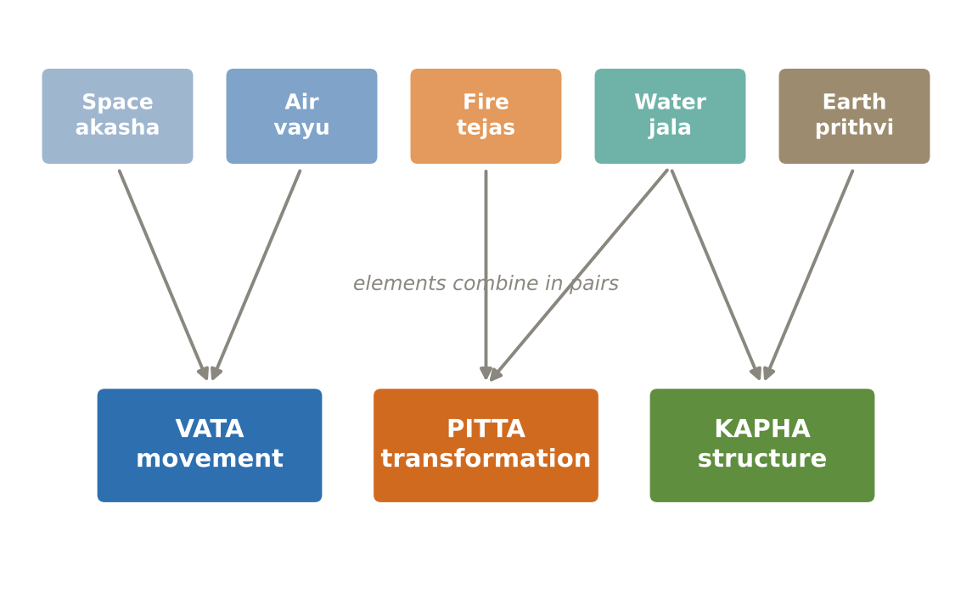
Figure. How the five elements combine to form the three doshas
Dosha | Elements | Qualities | Main function | Main seats | Balanced, it gives | Aggravated, it causes
Vata | Space + air | Dry, light, cold, rough, subtle, mobile | Movement of every kind | Colon, pelvis, bones, joints, ears, skin, nervous system | Enthusiasm, quick mind, good circulation and elimination | Dryness, constipation, gas, joint pain, insomnia, anxiety, tremor, weight loss
Pitta | Fire + water | Hot, sharp, light, slightly oily, liquid, spreading | Transformation: digestion, metabolism, perception | Small intestine, stomach, liver, blood, eyes, skin | Strong digestion, warmth, courage, intelligence, lustrous skin | Acidity, heartburn, inflammation, rashes, loose stools, irritability, excess hunger or thirst
Kapha | Water + earth | Heavy, slow, cool, oily, smooth, dense, stable | Structure, lubrication, cohesion, immunity | Chest, lungs, stomach, head, joints, plasma | Strength, stamina, stable joints, calm, patience, immunity | Heaviness, sluggish digestion, congestion, weight gain, lethargy, attachment

The fifteen sub-doshas
Each dosha has five functional divisions. A cook does not need to memorise them, but they explain why, for example, Ayurveda links digestion (pachaka pitta), the heart and emotion (sadhaka pitta) and taste perception (bodhaka kapha).
Dosha | Sub-dosha | Seat | Function relevant to food and lifestyle
Vata | Prana | Head, chest | Breathing, swallowing, sensory intake, will
Vata | Udana | Throat, chest | Speech, exhalation, effort, memory
Vata | Samana | Stomach, small intestine | Moves food through digestion; fans the digestive fire
Vata | Vyana | Heart, whole body | Circulation, movement of limbs
Vata | Apana | Colon, pelvis | Elimination of stool, urine, menstruation
Pitta | Pachaka | Stomach, small intestine | Digests food; separates nutrients from waste
Pitta | Ranjaka | Liver, spleen | Gives colour to blood
Pitta | Sadhaka | Heart | Emotions, intelligence, devotion
Pitta | Alochaka | Eyes | Vision
Pitta | Bhrajaka | Skin | Complexion, warmth of skin, absorbs oil massage
Kapha | Kledaka | Stomach | Moistens and softens food at the start of digestion
Kapha | Avalambaka | Chest, heart, lungs | Supports chest and heart; strength
Kapha | Bodhaka | Tongue | Perception of taste; first stage of digestion
Kapha | Tarpaka | Head, brain | Nourishes the senses and brain; contentment
Kapha | Shleshaka | Joints | Lubricates joints

The doshas through the day and through life
Each dosha predominates at certain times of the day and in a certain stage of life. This is the basis of Ayurveda's daily timetable: rise in the Vata hours before dawn, eat the main meal in the Pitta hours around noon, and sleep before the Vata hours of late night. And it explains why the later years — the Vata stage of life — call for warm, moist, grounding food and a steady routine.
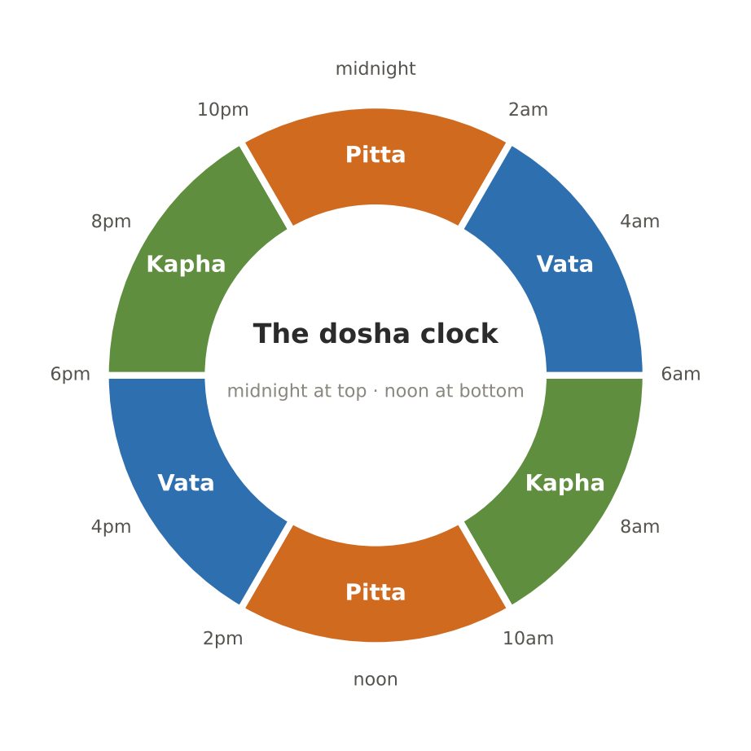
Figure. The dosha clock — each dosha governs two four-hour periods of the day
Period | Dosha | What the body is doing | What to do
6–10 am | Kapha | Heaviness after sleep; slow digestion | Wake before 6, move the body, light breakfast
10 am–2 pm | Pitta | Digestive fire at its strongest | Main meal 12:00–1:30; focused work
2–6 pm | Vata | Lightness, mental activity; dryness rises | Warm drink and light snack; walks, study, creative work
6–10 pm | Kapha | Body slows and grows heavy | Light early dinner; unwind; sleep by 10
10 pm–2 am | Pitta | Internal digestion and repair of tissues | Be asleep — late meals and screens disturb this
2–6 am | Vata | Lightness, alertness, dreaming | The best time for waking, prayer and meditation (brahma muhurta)

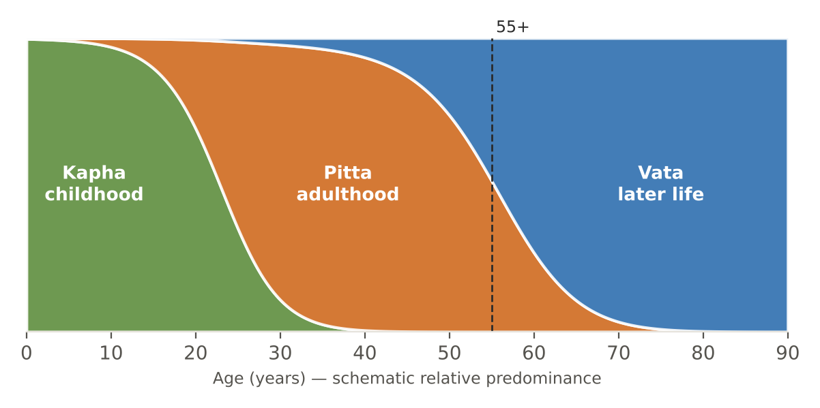
Figure. The doshas across the lifespan — later life is the Vata stage

Why the 55+ kitchen is a Vata kitchen
- Vata's qualities — dry, light, cold, rough, mobile — increase naturally with age: drier skin and joints, lighter sleep, irregular appetite, constipation, a more restless mind.
- The antidote is the opposite set of qualities: warm, moist (unctuous), heavy enough, smooth, stable and regular.
- In practice: warm freshly-cooked meals at regular times, ghee and sesame in measured amounts, soft textures, soups and porridges, warm water, oil massage, early sleep and a calm routine.
- Pitta and Kapha still matter — a guest with acidity or with excess weight needs those adjusted too — but the Vata principles are the default for everyone over 55.

3. Prakriti — Knowing Your Constitution
Prakriti is the unique proportion of the three doshas fixed at conception. It does not change over a lifetime; what changes is the current state (vikriti). Most people are a combination — Vata–Pitta, Pitta–Kapha and so on — and a few are balanced in all three. Knowing one's prakriti explains why the same meal suits one person and disagrees with another.
The questionnaire below is a self-reflection tool, not a diagnosis. Answer for how you have been for most of your life, not how you are this week. Tick one column per row and count the ticks.
Feature | Vata | Pitta | Kapha
Body frame | Thin, light, prominent joints | Medium, muscular | Broad, solid, heavy
Weight | Hard to gain | Gains and loses easily | Gains easily, hard to lose
Skin | Dry, rough, cool | Warm, oily, freckles, prone to rashes | Thick, smooth, moist, cool
Hair | Dry, frizzy, thin | Fine, early greying or thinning | Thick, wavy, lustrous
Eyes | Small, active, dry | Sharp, penetrating, sensitive to light | Large, calm, moist
Appetite | Irregular — sometimes hungry, sometimes not | Strong; irritable if a meal is missed | Steady but can skip meals easily
Digestion | Gas, bloating, constipation tendency | Fast; acidity, loose stools tendency | Slow; heaviness after meals
Thirst | Variable | High | Low
Preferred climate | Warmth; dislikes cold and wind | Coolness; dislikes heat | Warm and dry; dislikes damp cold
Sleep | Light, interrupted, 5–6 h | Moderate, sound, 6–8 h | Deep, long, hard to wake
Energy | Bursts, then fatigue | Purposeful, intense | Steady, enduring, slow to start
Speech | Fast, talkative | Sharp, precise, persuasive | Slow, calm, melodious
Mind | Quick, creative, restless | Focused, analytical, critical | Calm, methodical, steady
Memory | Learns fast, forgets fast | Sharp, clear | Slow to learn, never forgets
Under stress | Anxious, worried | Irritable, angry | Withdrawn, stubborn
Walking | Fast, light steps | Purposeful, medium | Slow, steady
Spending | Impulsive | Planned, on quality | Saves
Joints | Crack, stiffen in cold | Loose, sometimes inflamed | Large, well-lubricated
Bowel habit | Dry, hard, irregular | Soft, frequent, loose | Regular, heavy, well-formed
Weather illnesses | Dryness, aches, insomnia in autumn–winter | Heat, rashes, acidity in summer–autumn | Colds, congestion in late winter–spring

Reading your score
- If one column has clearly the most ticks (for example 12 of 20), that dosha is your dominant one.
- If two columns are close (for example Vata 9, Pitta 8), you are dual-doshic — read both sets of guidance and favour foods that suit both.
- If all three are close, you are tridoshic (sama prakriti) — follow the seasonal guidance in Volume I.
- After 55, nearly everyone shows some Vata signs regardless of prakriti; that is vikriti (current state), and it is addressed by the Vata principles of this book.
- A vaidya assesses prakriti properly through pulse (nadi), observation and history — the questionnaire is a starting point only.

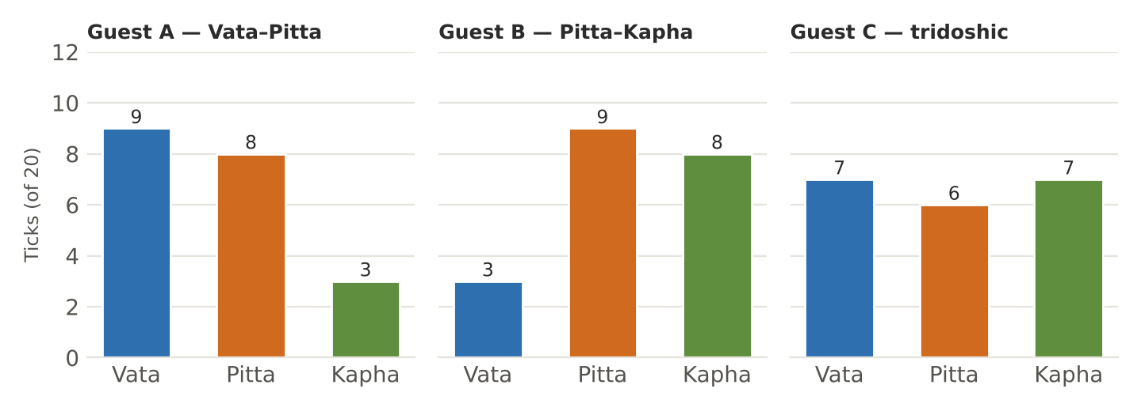
Figure. Example scoring of three guests: a Vata–Pitta, a Pitta–Kapha and a tridoshic profile

4. The Twenty Qualities (Gurvadi Gunas)
Ayurveda describes every substance and every state of the body by ten pairs of opposite qualities. This is its most practical tool: like increases like, and opposites balance. If a guest is dry, constipated and cold (Vata qualities), the kitchen adds their opposites — moist, smooth and warm — through ghee, soups and warm spices.
Quality | Opposite | Increases | Food examples (first quality) | Food examples (opposite)
Heavy (guru) | Light (laghu) | Kapha / Vata | Urad, paneer, sweets, cheese, wheat | Moong, puffed rice, barley, steamed vegetables
Slow (manda) | Sharp (tikshna) | Kapha / Pitta | Milk, rice, banana | Chilli, mustard, garlic, ginger
Cold (shita) | Hot (ushna) | Vata–Kapha / Pitta | Cold water, cucumber, ice cream | Ginger, pepper, sesame, hot soup
Unctuous (snigdha) | Dry (ruksha) | Kapha–Pitta / Vata | Ghee, sesame oil, avocado, coconut | Barley, millets, crackers, popcorn, beans
Smooth (shlakshna) | Rough (khara) | Kapha / Vata | Ghee, milk, okra | Raw vegetables, bran, dry leafy greens
Dense (sandra) | Liquid (drava) | Kapha / Pitta–Kapha | Cheese, nuts, khoya | Soups, juices, buttermilk
Soft (mridu) | Hard (kathina) | Kapha–Pitta / Vata | Khichdi, ripe banana, kheer | Raw nuts, hard rotis, dry toast
Stable (sthira) | Mobile (chala) | Kapha / Vata | Root vegetables, grains | Caffeine, sprouts, raw salads
Subtle (sukshma) | Gross (sthula) | Vata–Pitta / Kapha | Spices, hing, herbal teas | Heavy fried foods, cheese
Clear (vishada) | Slimy (picchila) | Vata–Pitta / Kapha | Water, light vegetables | Okra, curd, urad, taro

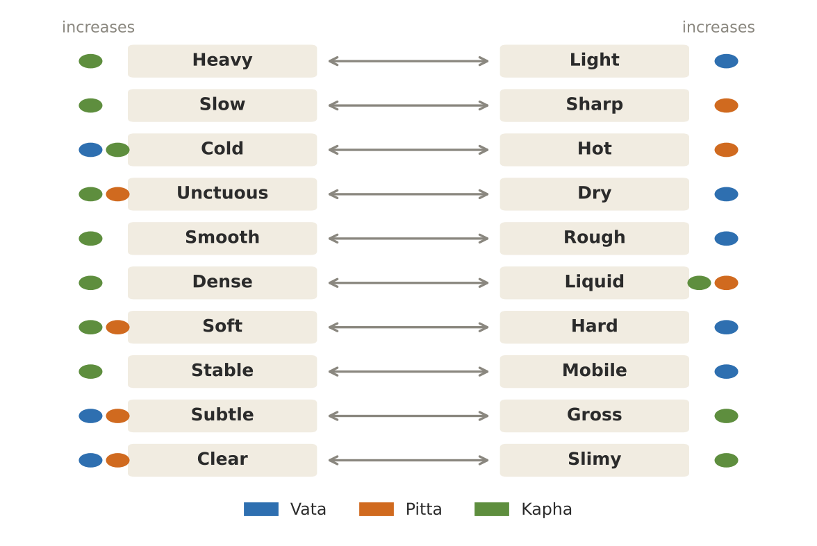
Figure. The ten pairs of qualities, and which dosha each side increases

5. The Six Tastes (Shad Rasa)
Taste (rasa) is the most immediate guide to a food's effect. Each of the six tastes is made of two elements and therefore pacifies some doshas and aggravates others. A balanced meal includes all six tastes, with the season and the person deciding which dominate. The Indian thali — rice and sweets (sweet), lemon and curd (sour), pickle and salt (salty), ginger and spices (pungent), methi and karela (bitter), dal and greens (astringent) — is the six tastes on one plate.
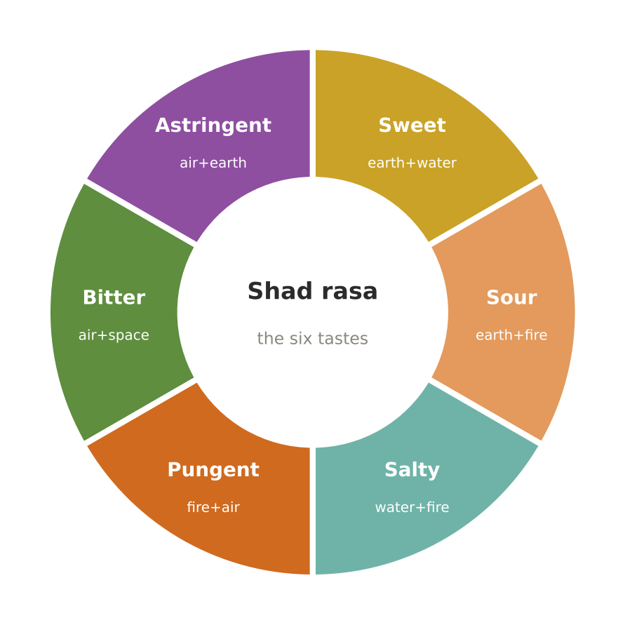
Figure. The six tastes, their elements and their effect on the doshas
Taste | Elements | Effect on doshas | Actions in the body | Kitchen sources | In excess
Sweet (madhura) | Earth + water | Pacifies Vata and Pitta; increases Kapha | Builds tissues, strength, satisfaction; soothing | Rice, wheat, milk, ghee, dates, sweet fruits, root vegetables, moong | Heaviness, weight gain, congestion, sluggish digestion
Sour (amla) | Earth + fire | Pacifies Vata; increases Pitta and Kapha | Stimulates appetite and saliva; aids digestion | Lemon, amla, curd, tamarind, kokum, tomato, fermented foods | Acidity, inflammation, loose teeth, thirst
Salty (lavana) | Water + fire | Pacifies Vata; increases Pitta and Kapha | Moistens, softens, aids digestion and taste | Rock salt, sea salt, black salt | Water retention, high blood pressure, thirst, skin problems
Pungent (katu) | Fire + air | Pacifies Kapha; increases Vata and Pitta | Kindles agni, clears channels, reduces fat | Ginger, pepper, chilli, mustard, cloves, hing | Burning, dryness, dizziness, insomnia
Bitter (tikta) | Air + space | Pacifies Pitta and Kapha; increases Vata | Detoxifying, cooling, reduces fever and craving | Methi, karela, neem, turmeric, leafy greens | Dryness, emaciation, constipation, anxiety
Astringent (kashaya) | Air + earth | Pacifies Pitta and Kapha; increases Vata | Tightening, drying, stops discharges, heals | Moong, masoor, pomegranate, unripe banana, green tea, turmeric | Dryness, constipation, gas, stiffness

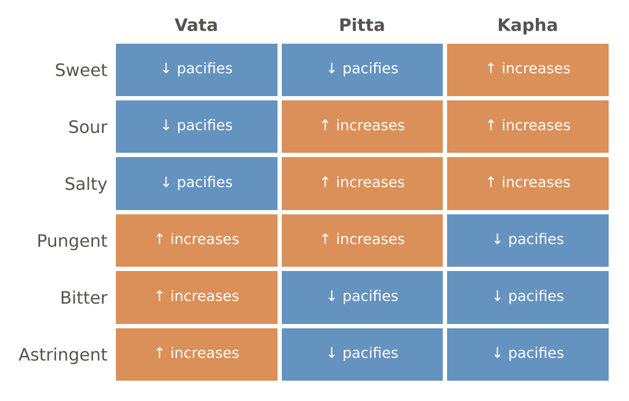
Figure. Taste–dosha effects at a glance (↓ pacifies, ↑ increases)

Six tastes for the 55+ plate
- Lead with sweet, sour and salty in gentle measure — they pacify Vata (but keep salt to the house limit and sour mild for acidity-prone guests).
- Keep pungent mild: ginger, cumin, pepper and hing rather than chilli.
- Include a little bitter (methi, karela, turmeric) and astringent (moong, pomegranate) daily for balance, especially for guests with diabetes or excess weight.
- Order within a meal: classical texts suggest starting with sweet, moving to sour and salty, and finishing with pungent, bitter and astringent.

6. Potency, Post-Digestive Effect and Special Action
Taste is only the first layer. Ayurveda describes three more properties that explain exceptions — why honey is sweet yet reduces Kapha, or why ginger is pungent yet does not aggravate Pitta as much as chilli.
Property | Meaning | Types | Examples
Virya (potency) | The heating or cooling energy a food releases | Ushna (heating), shita (cooling) | Heating: ginger, sesame, mustard, curd, jaggery. Cooling: milk, ghee, coconut, fennel, coriander
Vipaka (post-digestive effect) | The effect after digestion, mainly on elimination and tissues | Madhura (from sweet and salty), amla (from sour), katu (from pungent, bitter, astringent) | Ginger: pungent taste but sweet vipaka — gentler than chilli. Rice: sweet vipaka — nourishing
Prabhava (special action) | An effect that cannot be explained by the other properties | Unique to the substance | Honey reduces Kapha despite its sweet taste; ghee cools yet kindles agni

Food | Rasa | Virya | Vipaka | Net effect
Ghee | Sweet | Cooling | Sweet | Pacifies Vata and Pitta; kindles agni (prabhava)
Honey | Sweet, astringent | Cooling | Pungent | Reduces Kapha; never heated
Curd | Sour | Heating | Sour | Pacifies Vata; aggravates Pitta and Kapha
Buttermilk | Astringent, sour | Heating (mild) | Sweet | Digestive; balances Kapha and Vata
Fresh ginger | Pungent | Heating | Sweet | Kindles agni; pacifies Vata and Kapha
Turmeric | Bitter, pungent | Heating | Pungent | Balances all three in culinary amounts
Amla | Five tastes (mainly sour) | Cooling | Sweet | Pacifies all three — the great rasayana
Moong | Sweet, astringent | Cooling | Pungent | Light; balances all three when cooked with ghee
Jaggery (old) | Sweet | Heating | Sweet | Warming sweetness for winter
Rock salt | Salty | Cooling (mild) | Sweet | The best salt in Ayurveda; less heating than sea salt

7. Agni, Ama and the Journey of Food

Agni — the digestive fire
If one idea sums up Ayurvedic nutrition, it is this: we are not what we eat but what we digest. Agni, the transforming fire, decides whether a meal becomes nourishment or residue. Ayurveda counts thirteen agnis — the central digestive fire (jatharagni), five elemental fires (bhutagni) in the liver, and seven tissue fires (dhatvagni) — but in the kitchen the central fire is what matters.
State of agni | Linked dosha | Signs | Kitchen response
Sama agni (balanced) | All in balance | Regular appetite, comfortable digestion, regular stools, steady energy | Keep doing what you are doing; follow the season
Vishama agni (irregular) | Vata | Hunger comes and goes; gas, bloating, constipation, cravings | Regular meal times; warm, moist, cooked food; ginger, cumin, hing, ghee
Tikshna agni (sharp) | Pitta | Intense hunger, irritability if meals are late, acidity, loose stools | Do not skip meals; cooling foods: rice, milk, ghee, coconut, fennel; less chilli and sour
Manda agni (dull) | Kapha | Little appetite, heaviness, sleepiness after meals, slow digestion | Light warm meals; pungent and bitter spices; no snacking; dinner very light

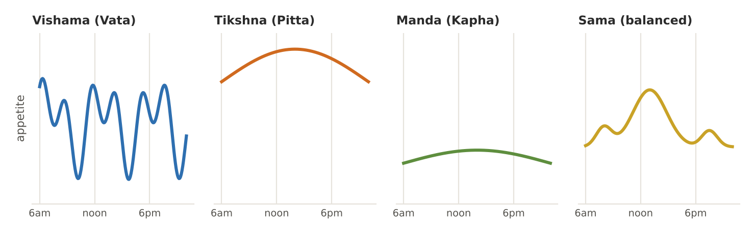
Figure. Four states of agni — irregular, sharp, dull and balanced

Ama — the residue of incomplete digestion
When food is not fully digested it leaves ama: a heavy, sticky, cold residue that Ayurveda considers the root of many disorders. Recognising ama is a daily skill for a cook who serves the same guests for weeks.
Sign of ama | What the guest notices
Coated tongue | Thick white or yellow coating, especially on waking
Heaviness and fatigue | Tired even after sleep; heavy after meals
Loss of appetite and taste | Food does not appeal; dull taste in the mouth
Bad breath, foul stools | Sticky stools that sink; strong odour
Stiffness and aches | Generalised body ache, worse in the morning
Mental fog | Dullness, low motivation

Clearing ama in the kitchen — gentle steps
- Lighter meals for a day or two: moong yusha, peya, khichdi (Volume II, Section 1).
- Sip warm water or ginger–coriander water through the day; avoid cold drinks.
- Dry ginger, black pepper, cumin, ajwain and hing in cooking; a slice of fresh ginger with rock salt and lemon 15 minutes before lunch.
- No eating between meals; dinner small and early; no curd, fried food, cheese or heavy sweets until appetite returns.
- If symptoms persist beyond a few days, or with fever, pain, weight loss or blood in stool, the guest should see a doctor.

From food to tissue — the seven dhatus
Ayurveda describes digested food nourishing seven tissues in sequence, each refined from the one before. The final essence of all tissues is ojas — the substance of immunity, vitality and contentment. This sequence is why Ayurveda says that good nutrition takes time to show: changes in diet are felt in digestion within days, but in bones and deeper tissues only over weeks and months.
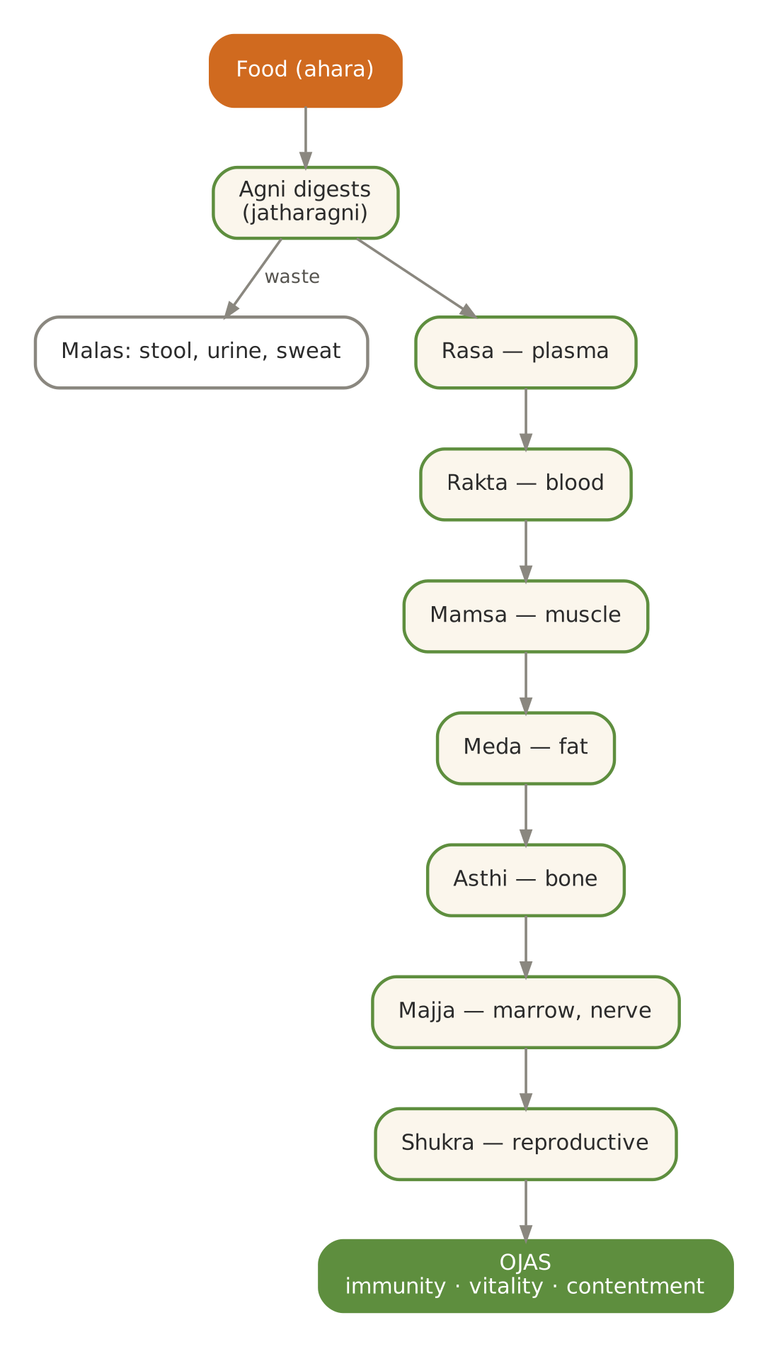
Figure. The journey of food — from digestion through the seven tissues to ojas
Dhatu | Tissue | Nourished especially by | Signs of good nourishment
Rasa | Plasma, lymph | Water, milk, juicy fruit, soups | Hydrated, clear skin; contentment
Rakta | Blood | Pomegranate, beet, leafy greens with amla, jaggery | Good colour, warmth, vitality
Mamsa | Muscle | Moong, urad, paneer, milk, wheat | Strength, firm muscles
Meda | Fat | Ghee, sesame, nuts | Lubricated joints, supple skin
Asthi | Bone, teeth | Milk, sesame, ragi, amla | Strong bones, teeth, nails, hair
Majja | Marrow, nerves | Ghee, milk, almonds, walnuts | Clear mind, steady nerves, good sleep
Shukra / artava | Reproductive essence | Milk, ghee, dates, almonds, saffron | Vitality, creativity
Ojas | Essence of all | All of the above; also contentment and love | Immunity, radiance, calm

8. Sattva, Rajas, Tamas — Food and the Mind
Beside the three doshas of the body, Ayurveda and yoga describe three qualities of the mind (maha gunas). Sattva is clarity, balance and peace; rajas is activity, passion and restlessness; tamas is inertia, heaviness and dullness. Food influences all three — which is why a guesthouse devoted to sadhana serves a sattvic kitchen. The Bhagavad Gita (chapter 17) classifies food in exactly these terms.
Quality | Nature | Foods | Preparation and eating | Effect
Sattvic | Pure, fresh, light, nourishing | Fresh fruits and vegetables, whole grains, moong, milk, ghee, honey, nuts, mild spices | Freshly cooked with love, eaten calmly at regular times, in moderation | Clarity, contentment, steady energy, compassion
Rajasic | Stimulating, spicy, sharp | Onion, garlic, chilli, excess salt and sour, coffee, strong tea, fried snacks | Eaten in a hurry, while working or arguing; too much variety | Restlessness, irritability, desire, poor sleep
Tamasic | Stale, heavy, dull | Leftovers, reheated many times, meat, eggs, alcohol, processed and deep-fried foods, overripe food | Overeating, eating late at night, eating without hunger | Lethargy, dullness, heaviness, confusion

The sattvic kitchen at Annapurna
- No onion, garlic, meat, fish, eggs, mushrooms or alcohol; hing and ginger give the depth.
- Food is cooked fresh for each meal; nothing is held more than two hours; nothing is reheated twice.
- The cook works in a calm state; the kitchen is clean; prayer or a mantra may begin the cooking.
- Meals are eaten in a peaceful setting, at fixed times, with gratitude.

PART II

The Ayurvedic Kitchen
Space, spices, technique, ingredients, combinations — the craft behind the recipes

9. Setting Up a Sattvic Kitchen
The classical texts call the kitchen the mahanasa — the great hall of food — and describe it as clean, well-lit, airy and tended by trusted, calm cooks. For a guesthouse serving sadhakas and older guests, the kitchen is both a workplace and a place of offering. Its order, cleanliness and mood reach the guest through the food.
Aspect | Classical guidance | Annapurna Kitchen practice
Location and light | Clean, spacious, well-ventilated, bright | Natural light and cross-ventilation; exhaust hood over the line
Cleanliness | Pure (shuchi) vessels, water and hands | Hand-wash station at the entry; colour-coded boards and cloths; daily deep clean
The cook | Trusted, healthy, clean, calm, affectionate | Annual medical fitness; FoSTaC-trained supervisor; no cooking when unwell; a quiet, unhurried kitchen
Fire and water | Fuel and water should be wholesome | Clean gas or induction; RO + UV purified water; boiled water for drinking
Vessels | Of suitable metals for each purpose | Steel default; iron for sabzi and roti; kalai brass for kheer; earthenware for curd and water (Volume II, D4)
Order | Food prepared with attention, not hurry | Prep lists by 6 am; mise en place before the flame is lit
Offering | Food offered before it is eaten | First portion offered at the kitchen shrine (bhog) where the Centre's practice requires

The cook's state of mind
Ayurveda and Indian tradition hold that the cook's mind enters the food. A cook who is angry, rushed or distracted makes food that is, in a subtle sense, rajasic. Practical steps help: begin the shift with washing hands and face and a minute of silence; keep conversation calm and low; play soft devotional music if the team likes it; never taste from the serving spoon; and remember that each plate goes to someone's healing.

Prayers that may open the cooking
- Annapurne sadapurne, shankara prana vallabhe; jnana vairagya siddhyartham, bhiksham dehi cha parvati — an invocation to Annapurna, the goddess of food, after whom the kitchen is named.
- Brahmarpanam brahma havir brahmagnau brahmana hutam; brahmaiva tena gantavyam brahma karma samadhina (Bhagavad Gita 4.24) — the offering, the food, the fire and the one who offers are all Brahman.
- A simple silent intention — "May this food nourish and heal those who eat it" — is equally valid.

Daily kitchen rhythm
Time | Task | Ayurvedic point
5:30 am | Open, wash, light the lamp; boil drinking water | Begin in Vata time with calm and cleanliness
6:00 am | Jeera–ginger water for guests; breakfast prep | Warm water first — awakens agni
7:30–9:00 am | Breakfast service | Light, warm, Kapha time
9:30 am | Lunch cooking: dal first, then sabzis, rice; phulka last | Everything fresh for the strongest agni of the day
12:30–2:30 pm | Lunch service | Main meal in Pitta time
3:30 pm | Evening drink and snack | Warm, light, Vata time
5:30 pm | Dinner cooking — lighter dishes | Smaller batch; no holding of lunch food
7:00–8:30 pm | Dinner service | Light and early
9:00 pm | Golden milk; clean-down; soak pulses; set curd | Prepare tomorrow; rest

10. The Spice Pharmacy
In an Ayurvedic kitchen the spice box is a small pharmacy. Spices kindle agni, help digest heavy foods, reduce gas from pulses, preserve, and balance the doshas — in pinch quantities. They are most effective when whole spices are freshly roasted and ground, and when they are bloomed in ghee or oil, which carries their aromatic compounds into the food.
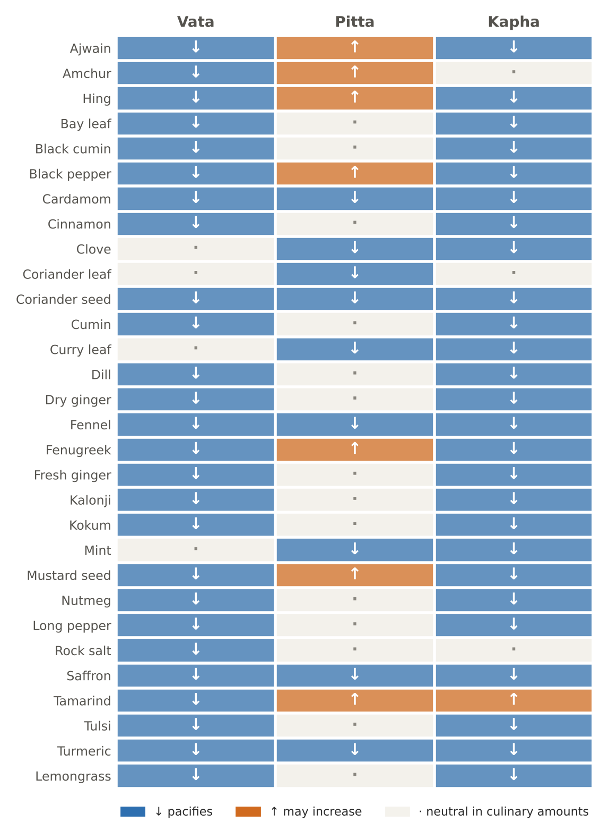
Figure. Thirty kitchen spices and herbs — warming or cooling, and their effect on each dosha
Spice / herb | Sanskrit | Taste | Potency | Dosha effect | Best culinary use | Notes for 55+ guests
Ajwain (carom) | Yavani | Pungent, bitter | Heating | ↓V ↓K ↑P | Arbi, beans, parathas, monsoon dals | Strong digestive for gas; small amounts
Amchur (dry mango) | Amra churna | Sour | Heating | ↓V ↑P | Khatta-meetha sabzis, chaat | Avoid in acidity; skip in Pitta season
Asafoetida | Hingu | Pungent | Heating | ↓V ↓K ↑P | Every pulse dish; replaces onion–garlic | A pinch fried 5 seconds in ghee; never raw
Bay leaf | Tamalapatra | Sweet, pungent | Heating | ↓V ↓K | Pulao, dal, kheer | Remove before serving texture-modified food
Black cumin | Krishna jiraka | Pungent | Heating | ↓V ↓K | Pulao, light gravies | Use sparingly
Black pepper | Maricha | Pungent | Heating | ↓V ↓K ↑P | Rasam, pongal, golden milk | Crushed, not whole, for elders; mild amounts
Cardamom | Ela | Sweet, pungent | Cooling | Tridoshic | Milk, sweets, tea, rice | Neutralises heaviness of milk and sweets
Cinnamon | Tvak | Sweet, pungent, bitter | Heating | ↓V ↓K | Kadha, stews, oats, kheer | True (Ceylon) cinnamon preferred for daily use
Clove | Lavanga | Pungent, bitter | Cooling (by tradition) | ↓K ↓P | Whole-spice tempering, kadha | 1–2 per dish
Coriander leaf | Dhanyaka patra | Pungent, bitter | Cooling | ↓P | Garnish, chutneys | Wash well in salted water
Coriander seed | Dhanyaka | Astringent, bitter, sweet | Cooling (mild) | Tridoshic | Masalas, CCF tea, dhaniya water | A Pitta-friendly base for most masalas
Cumin | Jiraka | Pungent | Cooling (by tradition) / mild | ↓V ↓K | Tempering, raita, takra | The most used digestive spice
Curry leaf | Kaidarya / surabhinimba | Bitter, pungent | Cooling | ↓P ↓K | Tempering, chutney, buttermilk | Grow in the garden; use fresh
Dill | Shatapushpa | Pungent, bitter | Heating | ↓V ↓K | Dal, sabzi | Traditionally used for gas and menstrual comfort
Dry ginger | Shunthi | Pungent | Heating | ↓V ↓K | Kadha, sweets, panjiri | Gentler on the gut than fresh ginger; 'universal medicine'
Fennel | Mishreya | Sweet, pungent | Cooling | Tridoshic | Mukhwas, coolers, khatta-meetha | Best digestive for Pitta; after meals
Fenugreek seed | Methika | Bitter | Heating | ↓V ↓K ↑P | Kadhi, sambar powder, pickles | Bitter: tiny amounts; supports blood-sugar control
Fresh ginger | Ardraka | Pungent | Heating | ↓V ↓K | Every dal, kadha, pre-meal slice | Reduce in acidity and summer
Kalonji (nigella) | Upakunchika | Pungent, bitter | Heating | ↓V ↓K | Bengali tempering, breads | Small amounts
Kokum | Vrikshamla | Sour, sweet | Cooling (in practice) | ↓V ↓K | Dal, sol kadhi, sharbat | Gentler sour than tamarind
Mint | Pudina | Pungent | Cooling | ↓P ↓K | Chutney, coolers, raita | Summer herb
Mustard seed | Sarshapa | Pungent | Heating | ↓V ↓K ↑P | South-Indian tempering | Splutter fully; underdone seeds are bitter
Nutmeg | Jatiphala | Pungent | Heating | ↓V ↓K | Golden milk, sweets | A tiny pinch only; traditionally for sleep
Long pepper | Pippali | Pungent | Heating (mild vipaka) | ↓V ↓K | Kadha, winter soups | Medicinal — very small quantities
Rock salt | Saindhava | Salty | Cooling (mild) | ↓V | Fasting days, chaat | Classical best salt; still salt — limit
Saffron | Kumkuma | Bitter, pungent | Heating | Tridoshic | Kheer, milk, festive rice | 5–10 strands per dish
Tamarind | Chincha / amlika | Sour | Heating | ↓V ↑P ↑K | Sambar, rasam, chutney | Small amounts; kokum for acidity-prone guests
Tulsi | Tulasi | Pungent, bitter | Heating | ↓V ↓K | Kadha, teas | Add at the end; do not boil long
Turmeric | Haridra | Bitter, pungent | Heating | Tridoshic | Dal, sabzi, golden milk | With pepper and fat; medical doses only on advice
Lemongrass | Bhustrina | Pungent, bitter | Heating (mild) | ↓V ↓K | Teas | Garden-grown

Three house churnas for the three doshas
These blends are sprinkled on rice, dal or vegetables at the table, ½ tsp per serving. Dry-roast seeds separately on low heat until fragrant, cool, grind and store airtight for up to one month.
Vata churna (warming, grounding) | Pitta churna (cooling) | Kapha churna (light, warming)
Cumin 20 g | Coriander seed 30 g | Dry ginger 10 g
Fennel 20 g | Fennel 30 g | Black pepper 5 g
Coriander seed 20 g | Cumin 15 g | Cumin 15 g
Dry ginger 10 g | Cardamom 5 g | Coriander seed 15 g
Ajwain 5 g | Turmeric 5 g | Mustard seed 5 g
Turmeric 5 g | Mishri 15 g | Turmeric 5 g
Hing 1 g (warmed) | Dried mint 3 g | Fenugreek seed 3 g
Rock salt 15 g | Rock salt 5 g | Cinnamon 5 g

Ten rules for spices
- Buy whole; grind small batches; aroma is the test of freshness — replace ground spices every 2 months.
- Store in airtight, dark containers away from the stove's heat and steam.
- Bloom whole seeds first in hot fat; add ground spices after, on lower heat, for 10–20 seconds only.
- Hing always meets hot fat before anything watery; raw hing is harsh.
- Turmeric with black pepper and fat — absorption improves markedly.
- Add delicate herbs (tulsi, mint, coriander) at the end, off the heat.
- Dry ginger in sweets and milk; fresh ginger in dals and vegetables.
- In Pitta months (May–October) reduce mustard, fenugreek, tamarind and chilli; increase coriander, fennel and cardamom.
- In Kapha months (February–April) increase ginger, pepper, mustard and turmeric.
- For guests over 55, spices are for digestion and aroma, not heat: a mild, fragrant dish is the goal.

11. The Science of Tadka (Tempering)
Tadka — also called chhaunk, vaghar or oggarane — is the moment when spices are fried in ghee or oil and poured over a dish. It is the single most important technique in this kitchen: it releases fat-soluble aromas, makes pulses digestible, and decides whether a dal tastes flat or alive. The sequence matters because each ingredient has a different burning point.
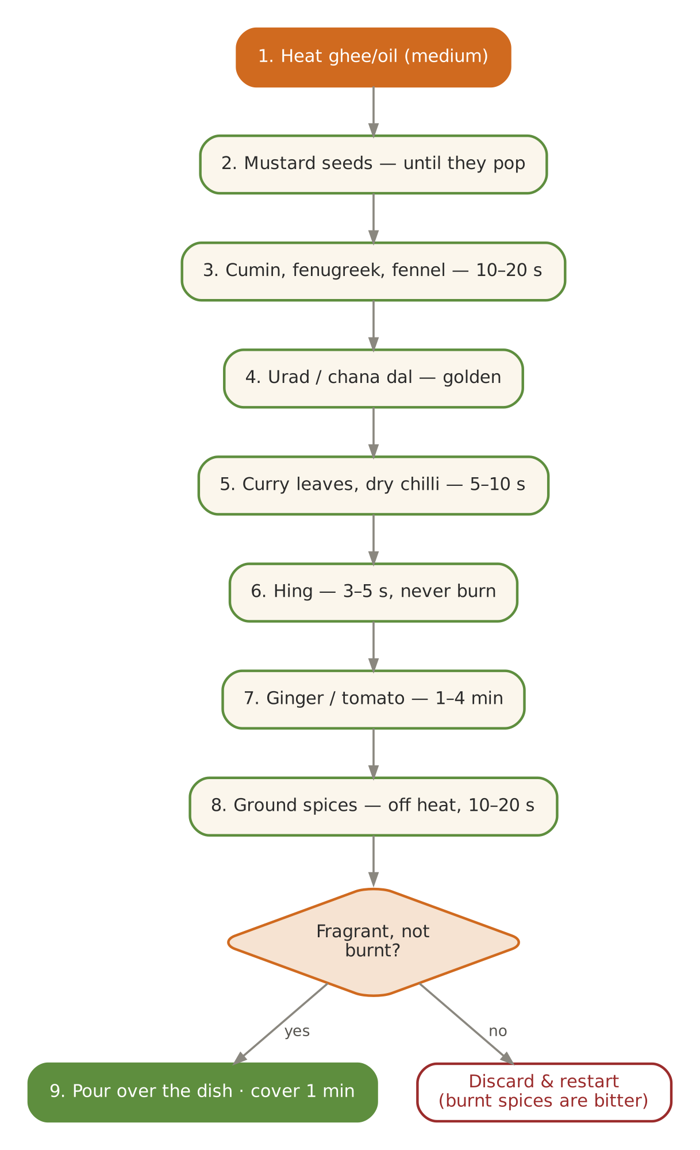
Figure. The tadka sequence — from heating the fat to pouring over the dish
Step | Ingredient | Heat | Time | Sign it is ready
1 | Ghee or oil (2–3 tsp for 4 servings) | Medium | 30–60 sec | Shimmers; a cumin seed sizzles at once
2 | Mustard seeds (if used) | Medium | 20–30 sec | Splutter and pop fully
3 | Cumin, fenugreek, fennel, ajwain | Medium-low | 10–20 sec | Darken one shade; fragrant
4 | Urad / chana dal (South style) | Medium-low | 20–30 sec | Golden
5 | Dry red chilli, curry leaves | Low | 5–10 sec | Leaves crisp (stand back — they spit)
6 | Hing | Low | 3–5 sec | Aroma rises — never let it burn
7 | Ginger, tomato (if used) | Low-medium | 1–4 min | Raw smell gone; tomato soft
8 | Ground spices (turmeric, coriander, chilli) | Off heat or lowest | 10–20 sec | Colour blooms; no scorching
9 | Pour over dal / add dish | — | — | Loud sizzle; cover for 1 minute to trap aroma

Common tadka mistakes
- Fat too cold: seeds soak up oil and taste raw. Fat smoking: spices burn and turn bitter.
- Mustard added with cumin: cumin burns before mustard pops. Always mustard first.
- Hing added first or for too long: it burns quickly and turns acrid.
- Ground spices on high heat: turmeric and chilli scorch in seconds. Lower the heat or turn it off.
- Too much fat: a tadka for four needs only 2–3 tsp; the elderly guest's total visible fat for the day is about 20–25 g.

Tadka profiles across India
Region / dish | Fat | Spices in order | Use it for
North Indian dal | Ghee | Cumin → hing → ginger → (tomato) → Kashmiri chilli | Moong, masoor, toor dals
South Indian | Coconut or sesame oil | Mustard → urad dal → chana dal → curry leaves → hing → dry chilli | Sambar, rasam, poriyal, upma
Gujarati | Ghee or groundnut oil | Mustard → cumin → fenugreek → clove → cinnamon → curry leaves → hing | Kadhi, dal, theplas
Bengali panch phoron | Mustard oil or ghee | Equal fennel, cumin, fenugreek, nigella, mustard (or radhuni) | Shukto, vegetables, dal
Kashmiri-style (sattvic) | Ghee or mustard oil | Fennel powder → dry ginger → cardamom → cinnamon | Yoghurt-free gravies, pumpkin
Rajasthani | Ghee | Cumin → hing → whole red chilli → coriander powder | Dal, kadhi, gatte-free curries

12. Grains — Choosing, Preparing, Cooking
Grains are the foundation of the thali and the main source of energy. Ayurveda prefers grains that are at least a year old (purana): newly harvested grain is considered heavy and Kapha-forming, while aged grain is lighter and easier to digest. All grains are washed, often soaked, sometimes dry-roasted — each step makes them lighter.
Grain | Sanskrit | Qualities | Dosha | Best for | Preparation tip
Basmati / aged rice | Shali | Sweet, cooling, light when aged | ↓V ↓P | Daily staple; khichdi, kanji | Wash 3 times; soak 20–30 min
Red rice (rosematta, njavara) | Rakta shali / shashtika | Sweet, nourishing | ↓V ↓P | Kanji, convalescence | Double-cook very soft for elders
Wheat | Godhuma | Sweet, cooling, heavy, nourishing | ↓V ↓P ↑K | Phulka, dalia, upma | Fresh-milled atta; rest dough 20 min
Barley | Yava | Sweet, astringent, drying | ↓K ↓P ↑V | Spring, diabetes, water retention | Soak overnight; add ghee for Vata
Oats | — | Sweet, warm when cooked | ↓V ↓P | Breakfast porridges | Cook with water first, then milk
Ragi (finger millet) | Nartaka / madhuli | Sweet, astringent, cooling | ↓P ↓K | Calcium-rich porridges, rotis | Whisk into cold water to avoid lumps
Jowar (sorghum) | Yavanala | Sweet, cooling, drying | ↓P ↓K | Summer rotis | Blend 50:50 with wheat for softness
Bajra (pearl millet) | Sajja | Sweet, heating, drying | ↓K ↓V (with ghee) | Winter only | Use fresh flour; plenty of ghee
Foxtail, kodo, little millet | Kanguni, kodrava | Light, drying | ↓K | Diabetic-friendly upma, khichdi | Soak 30 min; cook 1 : 4
Barnyard millet (samak) | Shyamaka | Light, cooling | ↓P ↓K | Fasting days | Quick-cooking; 1 : 4
Maize | Makka | Sweet, drying | ↓K | Winter makki roti | 25–35% with wheat for softness
Amaranth (rajgira) | Rajgira | Sweet, light | Tridoshic | Fasting; protein | Popped or as flour
Buckwheat (kuttu) | — | Heating | ↓K ↓V | Winter fasting | Small portions; bind with potato

Making any grain lighter
- Wash until the water runs clear — removes dust and surface starch.
- Soak: rice 20–30 min; millets 30 min; barley and whole grains overnight.
- Dry-roast before cooking (rice for kanji, suji for upma, dalia, millets) — roasting is one of Ayurveda's classic ways to make food laghu (light).
- Cook with a little ghee and whole spices (bay leaf, cumin, clove).
- Eat warm and freshly cooked; never refrigerate and reheat cooked rice more than once.

13. Pulses — Protein Without the Wind
Pulses (dals and beans) supply most of the protein in a vegetarian kitchen, but they are dry, rough and gas-forming — Vata qualities. Ayurveda ranks them by digestibility and prescribes techniques that turn them into gentle food. For guests over 55, this is essential: a well-cooked moong dal is medicine; an undercooked rajma is a night of discomfort.
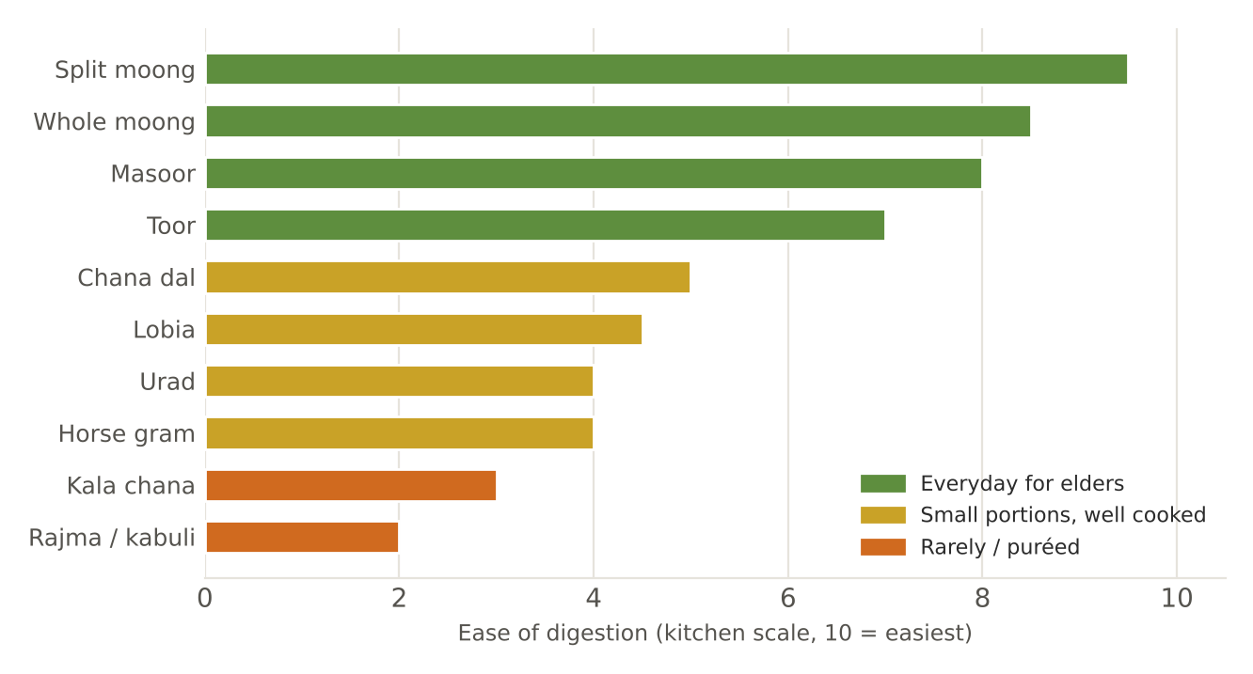
Figure. The digestibility ladder of pulses — from easiest (top) to heaviest (bottom)
Pulse | Soak time | Pressure-cook (whistles) | Water per cup | Dosha note | Best paired with
Split yellow moong | 15–30 min (optional) | 3 | 4 cups | Tridoshic — the house dal | Ghee, cumin, ginger
Whole green moong | 6–8 h | 5–6 | 4 cups | Light; cooling | Ginger, coconut
Masoor (red lentil) | 15 min | 2–3 | 4 cups | Slightly heating | Lauki, palak, lemon
Toor / arhar | 30 min | 4 | 4 cups | Balanced with hing | Drumstick, tamarind (small)
Chana dal | 2 h | 4 + 5 min low | 4 cups | Heavy, Vata-aggravating | Hing, ginger, lauki
Urad dal | 2–4 h | 4–5 | 4 cups | Heavy, nourishing; Kapha | Only in small amounts; ginger, hing
Lobia (cowpea) | 8 h | 5–6 | 4 cups | Heavy | Pumpkin, coconut
Kala chana | 8–10 h | 8–10 | 4 cups | Heavy, drying | Very soft, small portions
Kulthi (horse gram) | 8 h | 7–8 | 5 cups | Heating; Kapha–Vata | Winter and monsoon yusha
Rajma, kabuli chana | 10–12 h | 10+ | 4 cups | Very heavy | Rarely for elders — puréed if at all

Seven techniques that make pulses digestible
- Soak, then discard the soaking water; rinse well.
- Skim off the foam that rises during the first boil.
- Cook until completely soft — a grain should mash between thumb and finger.
- Add hing, ginger, cumin, ajwain or curry leaves during cooking or in the tadka.
- Add salt at the end (it can toughen pulses if added early in hard water).
- Pair with a grain (rice, wheat) for complete protein and gentler digestion.
- Serve as a soup (yusha) for weak digestion; as a thick dal for strong digestion.

14. Vegetables
Vegetables are mostly light and fibrous. Ayurveda favours cooked over raw for most people and nearly always for those over 55 — cooking breaks down roughness (a Vata quality), makes vegetables easier to chew and swallow, and lets ghee and spices balance them. Gourds (lauki, torai, tinda, parwal, ash gourd) are the sattvic vegetables par excellence: light, cooling, easy to digest.
Group | Examples | Dosha | Kitchen rule
Gourds | Lauki, torai, tinda, parwal, ash gourd, snake gourd | ↓P ↓V (cooked) | Everyday vegetables; cook covered until translucent
Sweet roots | Carrot, beet, sweet potato, pumpkin | ↓V ↓P | Grounding; ideal Vata food
Starchy tubers | Potato, arbi, yam | ↑V (gas) ↑K | Small portions; always with ajwain or hing
Cruciferous | Cauliflower, cabbage, radish, turnip | ↑V ↓K | Blanch first; cook with ginger, hing and ghee
Leafy greens | Palak, methi, sarson, bathua, chaulai | ↓P ↓K ↑V | Always cooked for elders; with ghee; lemon for iron
Pods and beans | French beans, flat beans, peas, drumstick | ↓K ↑V | Remove strings; cook soft; ajwain for peas
Okra | Bhindi | ↓V ↓P | Lubricating — good for Vata dryness
Bitter | Karela, neem flowers | ↓P ↓K ↑V | Small portions; salt and squeeze to reduce bitterness
Nightshades | Tomato, capsicum, (brinjal) | ↑P ↑V | Optional; tomato cooked, not raw; some sattvic guests avoid
Mushrooms | — | — | Not used in this sattvic kitchen

Raw salads for older guests?
- Classical Ayurveda and modern geriatric practice agree: raw, cold, rough vegetables are hard for weaker digestion and dentition.
- Offer steamed or lightly sautéed 'salads' instead — kosambari, warm beet thoran, steamed carrot with lemon and cumin.
- If a raw item is served (cucumber in summer), keep it small, finely cut, at room temperature, at lunch only.
- Wash all produce well in clean water, with a salted soak in the monsoon.

15. Fruits
Fruits are cleansing and light, but Ayurveda treats them with care: they digest quickly and ferment if trapped behind a heavy meal. The rule of thumb is to eat fruit alone, ripe, in season, at room temperature, and between meals rather than after them.
Rule | Reason | Practical form
Eat fruit alone | Fast digestion; ferments behind heavier food | Mid-morning or 4 pm; not as dessert after a full meal
Ripe, sweet, seasonal | Unripe and out-of-season fruit is sour, heavy, aggravating | Follow the produce calendar in Volume I
Not with milk | Sour fruit and banana with milk are classical incompatibles | No banana shakes; no fruit custard
Cooked for Vata | Raw fruit is cold and rough for Vata elders | Stewed apple, pear, guava with cinnamon and clove
Melons alone | Very cooling, quick to digest | Never mixed with other foods
Room temperature | Cold suppresses agni | Never straight from the refrigerator

Fruit | Dosha | Best season | Notes
Sweet apple, pear (stewed) | ↓V ↓P | Monsoon–winter | Stewed with cinnamon; gentle fibre
Banana (ripe) | ↓V ↑K | All year | Not with milk; not for congestion
Papaya (ripe) | ↓V ↓K ↑P (mild) | All year | Digestive; soft — good for elders
Pomegranate | Tridoshic | Autumn–winter | Juice for those who cannot chew seeds
Amla | Tridoshic | Winter | Rasayana; murabba, chutney, candy
Mango (ripe) | ↓V ↓P | Summer | Soak 1 h before cutting; at lunch with ghee and dry ginger
Guava (ripe) | ↓P ↓K | Winter | Deseed or cook for dentures
Oranges, kinnow | ↓V ↑P (mild) | Winter | Not with milk; at room temperature
Grapes, raisins (soaked) | ↓V ↓P | Summer; soaked all year | Soaked raisins on waking in Sharad
Dates, figs | ↓V ↓P | All year | Natural sweeteners; count as sugar for diabetics
Watermelon, muskmelon | ↓P ↑K | Summer | Alone, at midday
Jamun | ↓K ↓P ↑V | June–July | Small portions with rock salt

16. Milk, Curd, Buttermilk and Ghee
Dairy is central to a vegetarian Ayurvedic diet and especially valuable after 55: it provides complete protein, calcium and vitamin B12. But each dairy food has very different properties, and the rules for using them are among the most precise in Ayurveda.
Dairy food | Rasa / virya | Dosha | When and how | Avoid
Milk | Sweet / cooling | ↓V ↓P ↑K | Boiled with a pinch of turmeric, cardamom, dry ginger or nutmeg; warm; morning or bedtime; alone or with sweet grains | Cold milk; with sour fruit, banana, salt, fish; with a full salty meal
Curd (dahi) | Sour / heating | ↓V ↑P ↑K | At lunch only; fresh, not over-sour; with a little ghee, honey (unheated), sugar, amla or moong soup, as Charaka advises | At night; heated; daily in large amounts; in spring, summer and autumn in excess
Buttermilk (takra) | Astringent-sour / mildly heating | ↓V ↓K | Thin (1 part curd to 3–4 water), churned, butter removed, spiced with cumin, ginger, salt; after lunch | Very sour; for guests with burning acidity, choose sweet thin takra
Ghee | Sweet / cooling | ↓V ↓P | 2–3 tsp per day spread across meals; on rice and dal; in tadka; in golden milk | Excess in high LDL; in fever or heavy ama; equal parts with honey
Butter (fresh) | Sweet / cooling | ↓V ↓P | Small amounts; for making ghee | Old or salted butter
Paneer | Sweet / heavy | ↓V ↓P ↑K | Fresh, soft (soak in warm water); at lunch or breakfast | Stale; very large portions at dinner

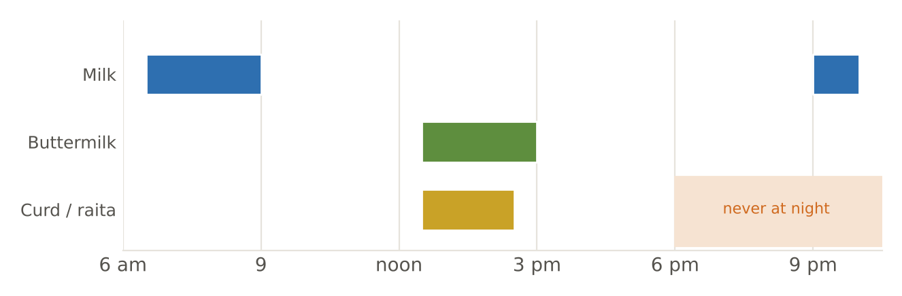
Figure. Curd, buttermilk and milk — when each belongs in the day

Charaka's rules for curd
The Charaka Samhita (Sutrasthana 7) gives unusually specific advice on curd, which the kitchen follows: curd should not be taken at night, should not be heated, should not be taken daily in excess, and is best taken with moong soup, honey, ghee, sugar or amla. Taking it otherwise is said to provoke fever, skin problems, bleeding disorders and other Pitta–Kapha disorders. In practice this means: curd and raita at lunch only, never in hot curries that are boiled after curd is added (kadhi is cooked from curd mixed with besan and water, and is classically treated more like buttermilk), and buttermilk rather than curd for most guests.

Making ghee and why it is special
Ghee is the only fat that Ayurveda calls agnivardhaka — it kindles digestion — while also cooling Pitta and lubricating Vata. It is yogavahi: it carries the properties of the herbs and spices cooked in it into the tissues. Old ghee (purana ghrita, a year or more) is considered medicinal in its own right. The kitchen makes ghee weekly from unsalted white butter (recipe in Volume I, Chapter 6). Modern guidance treats ghee as saturated fat; the kitchen reconciles both by using ghee as the main cooking fat in small, measured amounts and seed oils for the rest (Volume II, A3).

17. Oils and Fats
Fat | Virya | Dosha | Smoke point (approx.) | Best use | Note
Ghee | Cooling | ↓V ↓P | ~250 °C | Tadka, rice, sweets, golden milk | Measured: 2–3 tsp/day
Sesame oil (cold-pressed) | Heating | ↓V | ~210 °C | Winter cooking, abhyanga, oil pulling | The best oil for Vata
Mustard oil | Heating | ↓K ↓V | ~250 °C | North-Indian sabzis | Heat to smoking, cool slightly, then use
Coconut oil | Cooling | ↓P ↓V | ~175 °C (virgin) | Kerala dishes, raw drizzle | Saturated — moderate
Groundnut oil | Heating (mild) | ↓V | ~230 °C | General cooking | Neutral flavour
Sunflower / rice-bran | Neutral | — | ~230 °C | General cooking | Rotate oils for a balance of fatty acids

Fat for the 55+ guest — the house numbers
- Total visible fat (all oils and ghee) ≈ 20–25 g per day.
- Of which ghee 10–15 g (2–3 tsp), spread across meals as the Vata plan recommends.
- No deep-frying in daily menus; festival fried items in token portions or baked versions.
- Never reuse frying oil; never heat oil until it smokes repeatedly.
- Guests with high cholesterol, heart disease or gall-bladder problems follow their doctor's fat limit.

18. Sweeteners and Salts
Sweetener | Virya | Dosha | Use | Note
Mishri (rock sugar) | Cooling | ↓P ↓V | Summer sweets, thandai, fennel mukhwas | Considered the gentlest sugar
Jaggery (old, chemical-free) | Heating | ↓V | Winter sweets, kadha, panakam | Dark golden; bright yellow is sulphur-treated
Honey (raw) | Cooling (but Kapha-reducing) | ↓K | Warm (not hot) drinks; with ginger | Never heated; never in equal parts with ghee
Dates | Cooling | ↓V ↓P | Halwa, kheer, milk | Fibre and minerals with sweetness
Raisins (soaked) | Cooling | ↓V ↓P | Breakfast, kheer | Soak overnight
Refined white sugar | Cooling | ↑K | Avoided where possible | —

ICMR-NIN (2024) reminds us that jaggery, honey and sugar are all sugars; none is a health food. The Ayurvedic preference for mishri, old jaggery and honey is about their qualities — not permission for more. Added sugar for a guest should stay within about 20–25 g a day.
Salt | Ayurvedic view | Use | Note
Rock salt (saindhava) | The best salt: mildly cooling, tridoshic in small amounts | Fasting days; chaat; churnas | Low in iodine — not for every day
Iodised salt (samudra) | Heating; increases Pitta and Kapha | Everyday cooking | Iodine matters for thyroid health in older adults
Black salt (sauvarchala) | Digestive, light | Drinks, chaat, jaljeera | High sodium — small amounts
Total salt | — | ≤ 5 g per day (WHO); house recipes use ¾ tsp per 4 servings | No salt shakers on tables; lemon, herbs and roasted cumin give flavour

19. Water — The First Medicine
Ayurveda devotes whole chapters to water (jala varga). Water is the vehicle of every taste and the medium of digestion. For older adults, whose sense of thirst is weaker, how and when water is offered is as important as any recipe.
Practice | Classical guidance | Kitchen and lifestyle practice
Warm water (ushnodaka) | Boiled and cooled to warm, it kindles agni, clears Kapha and Vata, cleanses channels | Flasks of warm water on every table; boiled water cooled to room temperature in summer
Water before, during, after meals | Before: weakens digestion and the body; during: aids digestion (small sips); after: increases Kapha | Small sips of warm water during meals; avoid large glasses just before or after
Cold water | Suppresses agni; aggravates Vata and Kapha | No ice; earthen matka for gentle summer cooling
Copper vessel | Traditional for storing drinking water overnight | Optional; water only — never food, milk or acidic drinks
Herbal waters | Coriander, fennel, cumin, ginger infused | CCF tea, dhaniya water, saunf water by season
Quantity | Drink according to thirst, season and constitution | For older adults: offer 150 ml every hour 10 am–6 pm; 1.5–2 L/day unless restricted

Signs of dehydration in older guests
- Dark urine, dry mouth or lips, constipation, headache, dizziness on standing, confusion or unusual tiredness.
- Elders on diuretics or with diabetes are at higher risk; summer and fasting days are the riskiest times.
- Offer oral rehydration solution (ORS) in cases of loose motions or vomiting, and call a doctor if a guest cannot keep fluids down.

20. Food Combining — The Expanded Viruddha Guide
Volume II (A6) introduced the classical types of incompatible food. Here is the practical kitchen list, with what to serve instead.
Avoid combining | Why (Ayurvedic reasoning) | Serve instead
Milk + sour fruit (orange, pineapple, mango-sour) | Curdles; heavy, ama-forming | Fruit at 11 am; milk at bedtime
Milk + banana | Heavy, Kapha-forming, cold | Banana alone, or with almond milk
Milk + salt or salty meal | Opposite qualities; skin problems traditionally | Plain warm milk with cardamom, apart from meals
Milk + curd in one course | Two dairy foods of opposite nature | Kheer with dinner; raita with lunch
Curd at night | Kapha–Pitta aggravating | Thin buttermilk at lunch; golden milk at night
Heated curd | Turns it harmful in Ayurvedic view | Add curd off heat; or make kadhi with besan as a cooked takra
Honey + heat | Considered toxic (ama-forming) | Honey added below 40 °C
Ghee + honey in equal quantities | A classical incompatible dose | Use one or the other, or unequal amounts
Fruit + full meal | Fermentation and gas | Fruit between meals
Melon + anything | Digests too fast | Melon alone
Radish + milk | Classical incompatibility | Separate meals
Hot drink + cold food (or vice versa) at once | Shocks agni | Warm water with meals
Heavy food when digestion is weak | Agni viruddha | Krutanna ladder (Volume II, Section 1)
Fried food + cold drink | Very heavy | Warm herbal water
Leftover rice reheated repeatedly | Tamasic; food-safety risk | Cook fresh in smaller batches

21. Cooking Methods Compared
Ayurveda prefers cooking that makes food lighter and easier to digest while keeping it moist. Modern nutrition adds a concern for keeping vitamins and avoiding harmful compounds from very high heat. The table brings both together.
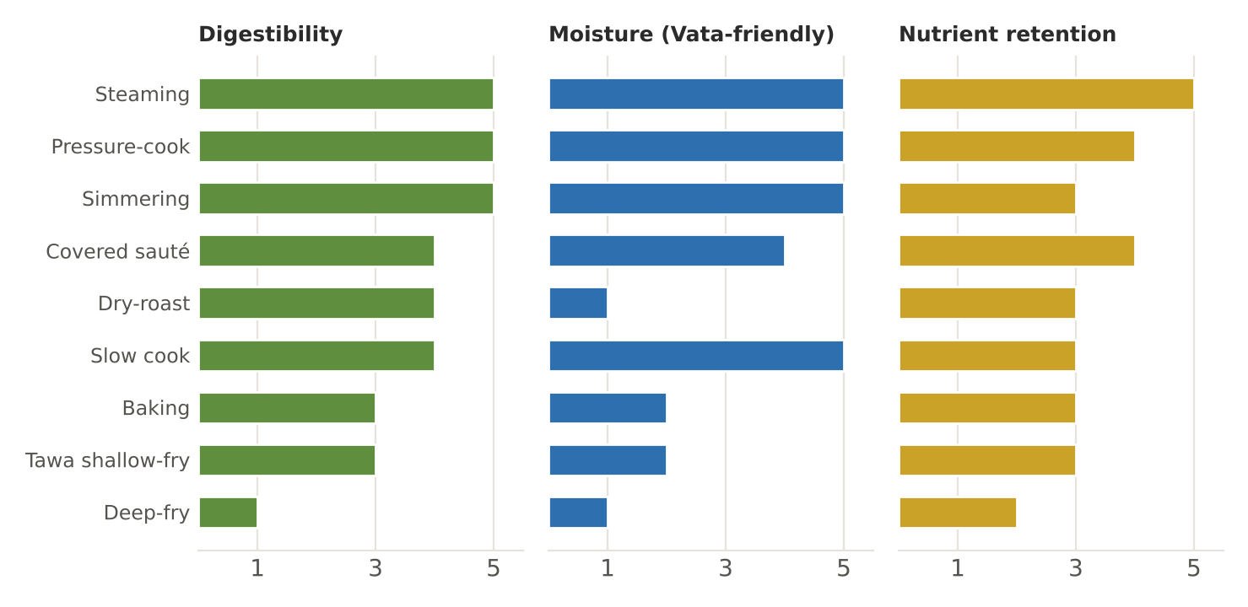
Figure. Cooking methods rated for digestibility, moisture and nutrient retention (kitchen guide, 1–5)
Method | Ayurvedic quality | Best for | Nutrient note | Elders
Steaming | Light, moist | Idli, dhokla, vegetables, koftas | Good retention of water-soluble vitamins | Excellent
Pressure-cooking | Soft, quick | Dal, khichdi, rice, tubers | Shorter time; good retention; deactivates anti-nutrients in pulses | Excellent
Simmering / boiling | Moist, light | Soups, kanji, kheer | Vitamins leach into water — serve the liquid | Excellent
Covered sautéing (sabzi) | Moderately light with ghee | Everyday vegetables | Moderate; short cooking keeps colour | Very good
Dry-roasting | Very light, drying | Grains, spices, makhana | — | Good (add ghee for Vata)
Slow cooking (handi, dum) | Soft, deep flavour | Dals, undhiyu, kheer | Long times reduce some vitamins | Good
Baking | Drying | Handvo, tikkis | Moderate | Good with moist sides
Shallow-frying on tawa | Heavier | Paratha, cheela | Uses more fat | Occasional
Deep-frying | Heavy, tamasic when repeated | Festival puri, pakora | Absorbs fat; reused oil forms harmful compounds | Rarely; token portions
Microwave reheating | Not addressed classically | Reheating single portions | Fast; uneven heating | Stir and check ≥ 75 °C

22. Cooking for Each Dosha
When a guest's dominant dosha or current imbalance is known, the kitchen can tilt the same menu towards them — usually with small swaps rather than separate meals. The tables below list foods to favour (✓) and to reduce (✗) for each dosha.
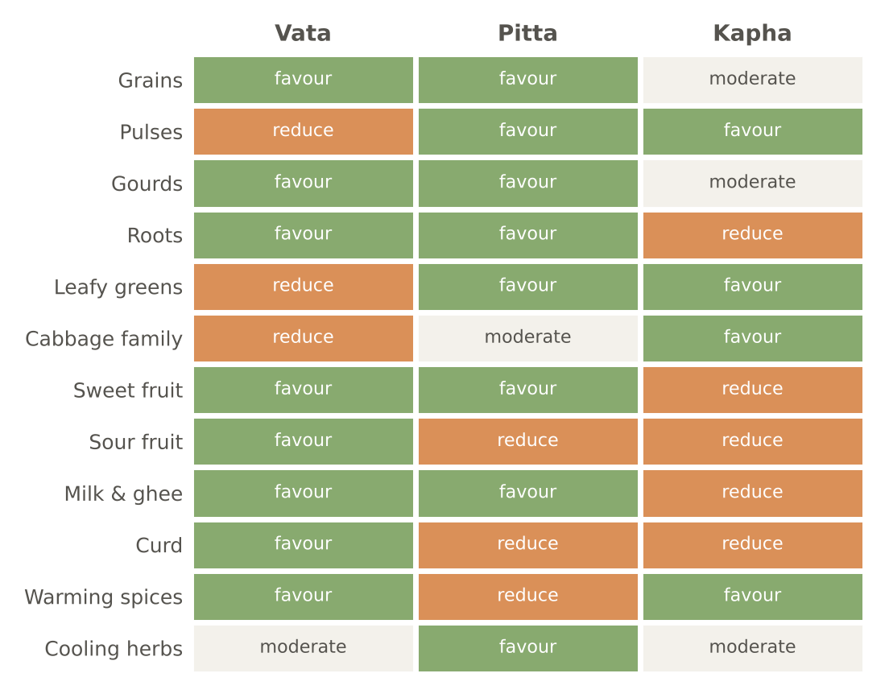
Figure. Food groups and the three doshas — a quick map for menu adjustments

Vata-balancing (the default for guests over 55)
Food group | Favour | Reduce
Grains | Rice, wheat, oats (cooked), khichdi, suji | Dry millets without ghee, crackers, puffed snacks, raw oats
Pulses | Moong, masoor, toor (well-cooked with hing) | Chana, rajma, kala chana, urad in excess, sprouts uncooked
Vegetables | Sweet potato, carrot, beet, pumpkin, gourds, okra, tender drumstick | Raw salads, cabbage family uncooked, potato in excess, dried vegetables
Fruits | Sweet ripe fruits, stewed apple and pear, papaya, soaked raisins, dates, figs | Dried fruit unsoaked, unripe fruit, cranberries, watermelon in winter
Dairy | Warm milk, ghee, buttermilk, fresh paneer | Cold milk, ice cream, powdered milk drinks
Oils | Sesame, ghee | Excessively dry diet
Sweeteners | Jaggery, dates, honey (unheated) | White sugar in excess
Spices | Ginger, cumin, hing, cinnamon, cardamom, fennel, ajwain | Chilli in excess, bitter herbs in excess
Drinks | Warm water, herbal teas, golden milk | Iced drinks, coffee, carbonated drinks

Pitta-balancing (acidity, inflammation, heat, irritability)
Food group | Favour | Reduce
Grains | Rice, wheat, barley, oats, ragi, jowar | Bajra, maize in excess, yeasted breads
Pulses | Moong, masoor (lightly), split peas | Urad, horse gram
Vegetables | Gourds, cucumber, leafy greens (cooked), cauliflower, broccoli, pumpkin | Tomato, chilli, raw radish, beetroot in excess
Fruits | Sweet grapes, pomegranate, amla, melons, sweet mango, coconut | Sour oranges, tamarind, unripe mango, sour berries
Dairy | Milk, ghee, fresh paneer, sweet thin buttermilk | Sour curd, aged cheese
Oils | Ghee, coconut, sunflower | Mustard, sesame in summer
Sweeteners | Mishri, dates | Jaggery and honey in excess
Spices | Coriander, fennel, cardamom, cumin, turmeric, mint | Chilli, mustard, fenugreek, cloves, garlic
Drinks | Room-temperature water, coconut water, rose and fennel coolers | Alcohol, coffee, very hot drinks, sour drinks

Kapha-balancing (heaviness, congestion, sluggish digestion, excess weight)
Food group | Favour | Reduce
Grains | Barley, millets, buckwheat, old rice in small portions | Wheat in excess, new rice, sweet breakfast cereals
Pulses | Most pulses: moong, masoor, toor, horse gram | Urad, heavy fried pulse snacks
Vegetables | Leafy greens, cabbage family, radish, drumstick, karela, beans | Sweet potato, potato, arbi in excess
Fruits | Apple, pomegranate, papaya, guava, jamun | Banana, melons, dates in excess
Dairy | Thin buttermilk, small amounts of warm milk with ginger | Curd, cheese, ice cream, excess paneer
Oils | Mustard, sesame in small amounts | Excess ghee and coconut
Sweeteners | Honey (unheated) in small amounts | Sugar, jaggery
Spices | All warming spices: ginger, pepper, mustard, turmeric, cinnamon, clove | Excess salt
Drinks | Warm water, ginger tea, tulsi kadha | Cold and sweet drinks

23. Freshness, Leftovers and Storage
Ayurveda regards food cooked more than about three hours earlier (paryushita) as having lost its vitality, and reheated, stale food as tamasic. Modern food safety agrees for different reasons: bacteria multiply quickly between 5 °C and 60 °C. For older guests, whose immunity is lower, both sets of reasoning point the same way.
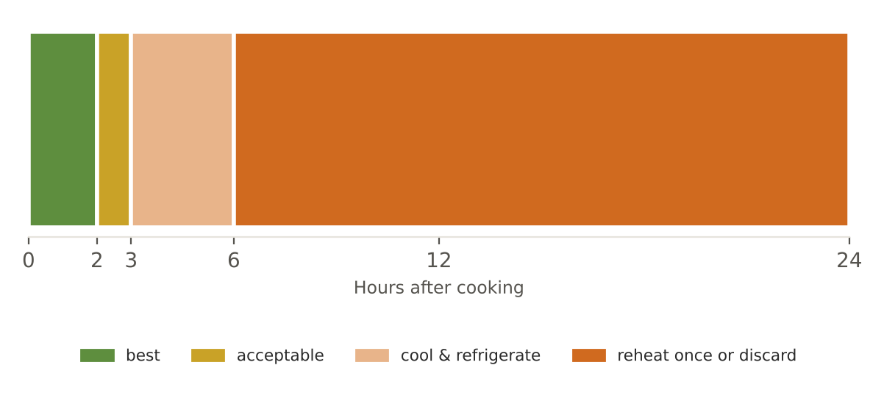
Figure. Freshness timeline — when cooked food is at its best and when it must be discarded
Food | Best served within | If stored | Never
Dal, sabzi, khichdi | 2 hours of cooking | Cool fast, refrigerate ≤ 5 °C, use within 24 h, reheat once to ≥ 75 °C | Reheat twice; leave out overnight
Cooked rice | 1–2 hours | Cool within 1 h, refrigerate, use within 24 h | Keep warm for hours (Bacillus cereus risk)
Phulka | Immediately | Wrapped in cloth in a casserole up to 2 h | Microwaved dry rotis for elders
Curd | Same day it sets | Refrigerate; use within 2 days | Over-sour curd for Pitta guests
Chutneys (coconut) | Same day | Refrigerate up to 1 day | Coconut chutney held at room temperature in summer
Milk desserts | 4 hours | Refrigerate; serve at room temperature within 24 h | Left out overnight (even the Sharad Purnima kheer tradition is limited to 2 hours)
Batters (idli, dosa) | After fermentation | Refrigerate up to 2 days | Over-fermented, sour batter

24. The Kitchen Pharmacy — Traditional Home Remedies
Indian households have long used kitchen ingredients for small everyday complaints. The table lists traditional culinary practices that are generally safe in food amounts. They are comfort measures, not treatments: each row lists when to stop and see a doctor.
Complaint | Traditional kitchen practice | How | See a doctor if
Low appetite, heaviness | Ginger–rock salt–lemon slice | A thin slice of fresh ginger with a pinch of rock salt and a few drops of lemon, 15 min before lunch | Weight loss, persistent nausea, pain
Gas, bloating | Ajwain or saunf water | ½ tsp ajwain or 1 tsp fennel boiled in 1 cup water 5 min; sip warm | Severe or persistent pain, vomiting, no stool or gas
Acidity, heartburn | Fennel–coriander water; cool (not cold) milk | Soak 1 tsp each overnight, strain, sip; or ½ cup cool boiled milk | Chest pain (emergency), black stools, difficulty swallowing
Constipation | Warm water on waking; 1 tsp ghee in warm milk at bedtime; soaked figs or raisins | Daily; plus fluids, fibre, walking | Blood in stool, sudden change in habit, pain, weight loss
Loose motions | Rice kanji, thin buttermilk with roasted cumin, ripe banana, bael | Small frequent servings; ORS for fluids | Blood, high fever, signs of dehydration, more than 2 days
Nausea | Laja peya; cardamom chewed; ginger tea | Small sips | Persistent vomiting, cannot keep fluids
Common cold, cough | Tulsi–ginger kadha; honey with ginger juice (unheated); steam inhalation | 2–3 times a day | Fever over 3 days, breathlessness, chest pain
Sore throat | Warm salt–turmeric gargle | ¼ tsp each in a cup of warm water | Difficulty swallowing or breathing, high fever
Poor sleep | Nutmeg-pinch golden milk; warm oil foot massage | At bedtime | Snoring with pauses in breathing, persistent insomnia
Joint stiffness in cold | Warm sesame oil massage; warm foods; dry ginger in milk | Daily in winter | Hot, swollen, red joint; fever
Dry skin | Abhyanga before bath; ghee in diet | Daily or 3 times a week | Itching with rash, non-healing sores
Mouth ulcer | Coconut oil or ghee applied; avoid spicy and sour | 2–3 times a day | Ulcer lasting over 2 weeks
Hiccups | Sip warm water slowly; a little honey (unheated) | — | Lasting more than 48 h
Mild headache from heat | Coriander water; rest in shade; rose water compress | — | Sudden severe headache, confusion, weakness (emergency)
Bad breath | Tongue scraping; chewing fennel; gargling | Daily | Persistent with dental pain or gum bleeding

25. Fifty Kitchen Tips from the Panel
1. Light the stove only when everything for the dish is cut and measured.
2. Wash rice until the water runs clear; soak it 20 minutes for softer, lighter grains.
3. For khichdi that never sticks, add 1 tsp ghee to the cooker before the grains.
4. A drop of oil in the dal water stops pressure-cooker froth from blocking the valve.
5. Skim the foam on boiling dal — Ayurveda considers it the heaviest part.
6. Salt dal at the end; it softens faster and you control salt better.
7. Roast suji until it smells of biscuits; underdone suji makes sticky upma.
8. For lump-free ragi or besan, always whisk into cold water first.
9. Fry hing in fat for no more than 5 seconds.
10. Bloom turmeric in fat for 10 seconds — it loses its raw taste and gains colour.
11. Use the back of a ladle to mash a third of a whole dal for body without blending.
12. Squeeze grated lauki and keep the water for kneading roti dough or for soups.
13. Soak paneer cubes in warm salted water for 10 minutes — it stays soft for elderly guests.
14. Blanch cauliflower and cabbage for 3 minutes in salted water before cooking — less wind.
15. Cook okra uncovered first (no slime), then cover at the end (soft for elders).
16. Rub bitter gourd with salt and rest 20 minutes; squeeze to reduce bitterness.
17. Boil yam and arbi with tamarind or kokum to remove the itch.
18. Add lemon juice off the heat — heat destroys vitamin C and makes it bitter.
19. Add delicate herbs (coriander, mint, tulsi) at the very end.
20. Make jaggery syrup separately and strain it — jaggery often carries grit.
21. Add jaggery to milk only off the heat, after it cools a little, or the milk may split.
22. For curd-based curries, whisk in a spoon of besan or rice flour to stabilise, and stir constantly until it boils.
23. Never let a kadhi or mor kuzhambu boil hard after the curd goes in.
24. Set curd from boiled milk cooled to lukewarm (≈ 40 °C); in winter, wrap the pot in a cloth.
25. Make ghee on the lowest heat; when the bubbling quietens and solids turn light brown, stop.
26. Keep a dedicated dry spoon in the ghee jar — water spoils ghee.
27. Store flours in the refrigerator in summer to prevent rancidity and insects.
28. Put a few dried neem or bay leaves in grain bins.
29. Knead phulka dough with lukewarm water and rest it 20 minutes — the secret of soft phulkas.
30. Roll phulkas evenly; uneven thickness stops them puffing.
31. Brush ghee on phulka immediately and stack in a cloth-lined casserole.
32. Steam idlis on high for the first 3 minutes, then medium — even rise.
33. Ferment batters in a warm spot in winter (inside a switched-off oven with the light on).
34. Add fruit salt to dhokla or rava idli batter only at the very last moment.
35. Purée soups while hot (carefully) for the silkiest texture; strain for Level 4 diets.
36. Add a spoon of milk powder or blended paneer to soups for invisible protein.
37. Grind coconut chutney with a little warm water to keep the oil from separating.
38. Temper curry leaves last in South-Indian dishes; stand back — they spit.
39. Cool cooked food you will store within 1 hour by spreading it in a wide steel tray.
40. Keep a probe thermometer at the hot counter; check 63 °C hourly.
41. Cut vegetables for elders to uniform 1–1.5 cm pieces — even cooking, easy eating.
42. Cook leafy greens in their own moisture with a lid; add salt only at the end.
43. Use iron kadhai for dry sabzis (adds iron) but never leave sour dishes standing in it.
44. Season iron pans with a thin oil film after drying them on the flame.
45. Re-tin (kalai) brass vessels when the yellow metal shows through.
46. Measure salt with a measuring spoon, not by hand — consistency protects BP-sensitive guests.
47. Taste with a clean spoon each time; never from the serving ladle.
48. Write the batch time on every container that leaves the stove.
49. Keep a small 'mild' pot aside before adding chilli for guests who need it plain.
50. End every shift by soaking tomorrow's pulses and setting tomorrow's curd.
PART III

The Art of Eating
How, when, how much and in what spirit — Ayurveda's rules of the meal

26. The Eight Factors of Wholesome Eating
Charaka (Vimanasthana 1) names eight factors that decide whether a meal nourishes or harms — the ashta ahara vidhi visheshayatana. They are a complete checklist for any kitchen, and they show that the same food can be medicine or poison depending on how it is prepared, combined, measured and eaten.

Figure. The eight factors that decide whether a meal nourishes
Factor | Sanskrit | Meaning | Annapurna Kitchen example
1. Nature of the food | Prakriti | Inherent qualities: moong is light, urad heavy | Moong as the house dal; urad only in small amounts
2. Preparation | Karana / samskara | Processing changes qualities: roasting lightens, soaking softens | Roast suji; soak pulses; cook greens; ferment batters
3. Combination | Samyoga | Foods change each other's effects | No milk with sour fruit; ghee with rice to lighten it
4. Quantity | Rashi | Total amount and amount of each item | 150 g rice, 180 ml dal, 2 phulkas; stomach rule (Ch. 28)
5. Place | Desha | Climate and region; also where the food grows | Haridwar's seasons; produce from the Annamaya garden
6. Time | Kala | Time of day, season, age, state of digestion | Lunch as main meal; ritucharya; Vata stage of life
7. Rules of eating | Upayoga samstha | How the meal is eaten | The twelve rules (Ch. 27)
8. The eater | Upayokta | The person's constitution, habits, digestion | Prakriti, current imbalance, health conditions, preferences

27. The Twelve Rules of Eating (Ahara Vidhi Vidhana)
Charaka also gives a short list of rules for the act of eating itself. They are remarkably modern — warm food, proper portions, not eating before the previous meal is digested, eating calmly and attentively.
Rule | Sanskrit | Meaning | Practice for older guests
Eat warm food | Ushnam ashniyat | Warm food tastes better, kindles agni, digests easily, moves Vata downward, reduces Kapha | Food served at 60–65 °C; insulated casseroles; warm plates in winter
Eat unctuous food | Snigdham ashniyat | A little fat makes food tasty, strengthens agni, nourishes and lubricates | ½ tsp ghee on rice and dal
Eat the right quantity | Matravat ashniyat | Neither too much nor too little; depends on agni | Standard portions with seconds offered, not pressed
Eat after the previous meal is digested | Jirne ashniyat | Eating on an undigested meal mixes raw and digested food | No snacking; 4–6 hours between meals; hunger as the cue
Eat compatible foods | Virya aviruddham ashniyat | Avoid opposite potencies and incompatible combinations | The viruddha guide (Ch. 20)
Eat in a pleasant place with proper utensils | Ishte deshe ishta sarvopakaranam | Calm, clean, pleasing surroundings | Quiet dining hall; clean thalis; flowers; no television
Do not eat too fast | Natidrutam ashniyat | Fast eating means poor chewing, choking risk, overeating | Seated meals; small spoonfuls; chew well
Do not eat too slowly | Nativilambitam ashniyat | Food turns cold; over-satiety; irregular digestion | Meals within about 20–30 minutes; keep food warm
Do not talk while eating | Ajalpan | Distraction, swallowing air, choking | Silence or soft conversation; the Centre may keep silent meals
Do not laugh while eating | Ahasan | Same as above — choking risk is real for elders | Calm atmosphere
Eat with attention | Tanmana bhunjita | Mind on the food | Pause before the meal; gratitude
Eat knowing yourself | Atmanam abhisamikshya | Knowing what suits one's body and state | Guests guided by intake card and prakriti

Choking safety for older diners
- Sit fully upright at 90°; stay upright for 30 minutes after eating.
- Small mouthfuls; finish each before the next; sip liquids between, not with food in the mouth.
- Avoid talking or laughing with food in the mouth (Charaka's rules are also safety rules).
- Watch for coughing, a wet or gurgly voice, or food left in the mouth — report to the duty manager and arrange a swallowing assessment.
- Staff trained in first aid for choking (back blows and abdominal thrusts) should be on duty at every meal.

28. How Much — Portion and Hunger
Classical texts describe dividing the stomach's capacity into parts: one part for solid food, one for liquid, and one left empty for the movement of the doshas (some texts divide it into four, with two parts solid). The modern equivalent is to stop at about three-quarters full — satisfied, not stuffed. For older guests, whose agni is often weaker, this is the single most useful rule.
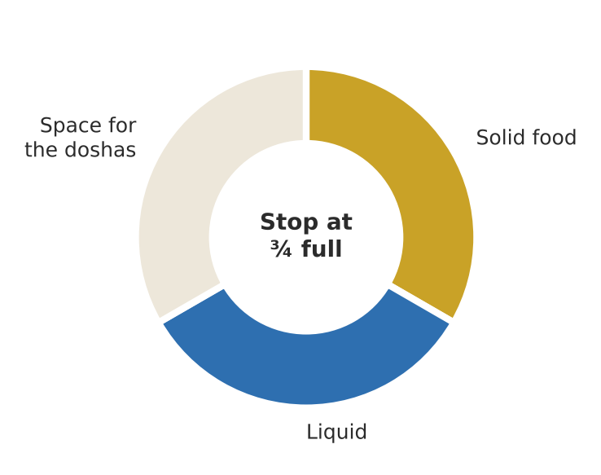
Figure. The classical division of the stomach — solid, liquid and space
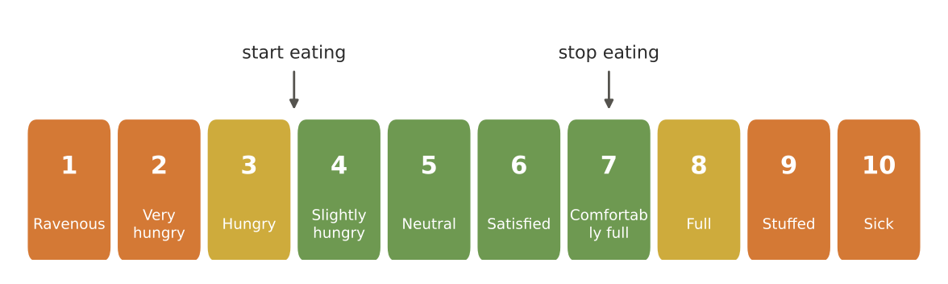
Figure. The hunger–fullness scale: begin eating at 3–4 and stop at 6–7
Measure | Classical idea | Kitchen translation
Anjali | The two cupped hands of the person | A portion of grain roughly the size of the eater's own two cupped hands
Agni bala | Quantity depends on digestive strength | Larger lunch; smaller breakfast and dinner; less when ill
Guru and laghu | Heavy foods to half satiety; light foods to near-satiety | Small sweets and paneer; generous soups and vegetables
Signs of the right amount | No heaviness, comfortable breathing, easy movement, satisfied senses | Ask guests how they feel an hour after the meal
Signs of too much | Heaviness, sleepiness, bloating, acidity, restlessness | Reduce portion; lighter dinner
Signs of too little | Weakness, early hunger, low mood, weight loss | Add ghee, milk, paneer, nuts; check appetite with a doctor if weight falls

29. When — Meal Timing and the Order of the Meal
Ayurveda times meals to agni, which follows the sun. The largest meal is at midday, breakfast is moderate and dinner light and early. Guests who are used to late, heavy dinners usually sleep better within a week of changing.
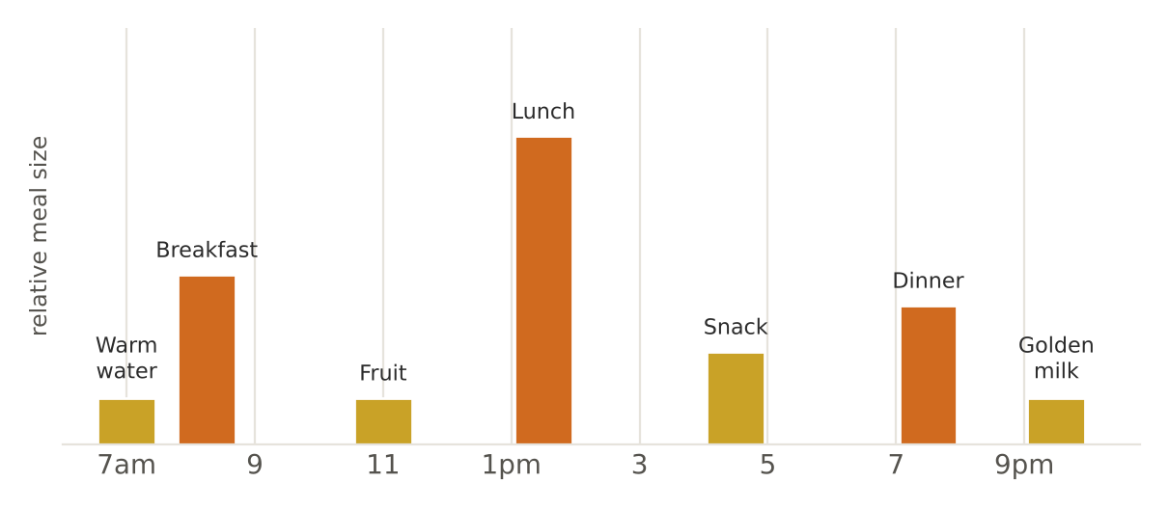
Figure. Meal size and timing through the day
Meal | Time | Size | Character | Volume I/II examples
Morning drink | 7:00 am | 150 ml | Warm water with cumin and ginger | Foundation recipe (Vol. I)
Breakfast | 7:30–9:00 am | Moderate | Warm porridge or steamed dish with protein | Upma, pongal, cheela, dalia, ragi porridge
Mid-morning | 11:00 am | Small | Fruit or herbal drink | Stewed fruit, takra, coconut water
Lunch | 12:30–2:30 pm | Largest | Full thali — all six tastes | Rice, dal, phulka, 2 sabzis, raita/takra
Evening | 4:00–5:00 pm | Small | Warm drink and light snack | Kadha, makhana, dhokla, stewed fruit
Dinner | 7:00–8:30 pm (ideally by 7:30) | Light | Soup, khichdi, kanji; small sweet | Yusha, khichdi, soups
Bedtime | 9:30 pm | 150 ml | Golden milk | Foundation recipe (Vol. I)

The order within the meal
Classical guidance suggests beginning a meal with sweet and heavier items (which need the strongest agni at the start), moving through sour and salty, and ending with lighter pungent, bitter and astringent items. Some traditions begin with a small bitter appetiser instead (the Bengali shukto, for example) — both open the appetite in different ways. Modern research on blood sugar suggests eating vegetables and protein before starch helps diabetic guests. The kitchen reconciles these:
Stage | Ayurvedic order | For diabetic guests
Before the meal | Ginger–rock salt slice; a sip of warm water | Same
Start | A spoon of rice with ghee and dal (sweet, unctuous) or a small bitter starter | Vegetables and dal first
Middle | Sabzis, sour and salty items, rotis | Then a smaller portion of rice or roti
End | Takra (buttermilk) with roasted cumin; a little fennel | Takra; no sweet, or only 1–2 tbsp
After | Mukhwas; mouth rinse; a short walk | Same

30. After the Meal
Do | Why | Avoid | Why
Rinse the mouth and clean teeth | Oral hygiene; removes food residue | Bathing within 1 hour | Draws blood and heat away from digestion
Sit in vajrasana for a few minutes (if knees allow) or sit upright | Traditionally aids digestion; upright posture helps reflux | Lying down at once | Reflux, choking risk, Kapha
Walk about a hundred slow steps (shatapavali) | Gentle movement aids digestion and blood sugar | Vigorous exercise | Competes with digestion
Rest quietly, left side if lying later | Traditionally favoured for digestion | Sleeping right after a heavy meal | Heaviness, Kapha (a short rest is fine for elders)
Chew a few fennel or coriander seeds | Freshens breath; digestive | Large drinks of cold water | Suppresses agni

Vajrasana — with care
- Many people over 55 have knee arthritis or have had knee replacements: kneeling may be painful or unsafe.
- Alternatives: sit upright on a chair with feet flat for 5 minutes, or take the gentle hundred-step walk.
- Never force a posture. Pain is a signal to stop.

31. Mindful and Sacred Eating
In the Indian tradition a meal is a yajna — an offering into the inner fire. That understanding changes how one eats: slowly, gratefully, without waste. At a centre devoted to the spiritual life, the meal is part of sadhana.

Before the meal
- Wash hands, feet and face; sit comfortably.
- Look at the food; notice its colours and aroma — Ayurveda says digestion begins with the senses.
- Offer a prayer of thanks. The Gita verse brahmarpanam (4.24) is commonly chanted; or a silent thank-you to the farmer, the cook and the earth.
- Some traditions set aside a small portion for birds, cows or those in need before eating.

Practice | How | Benefit
Silence for the first few minutes | Eat the first several mouthfuls without talking | Attention, slower pace, better chewing
Chew thoroughly | Until the food is soft; especially grains | Digestion begins in the mouth (bodhaka kapha)
Put the spoon down between mouthfuls | A natural pause | Prevents overeating; time for satiety signals
No screens or newspapers | Attention on the meal | Ayurveda's tanmana bhunjita; reduces overeating
Finish what you take | Take small portions; return for more | Reverence for food; less waste
Gratitude after | A moment of thanks; wash hands; rinse mouth | Closes the meal with contentment

32. Fasting Wisely After 55
Fasting (upavasa) is part of both Ayurveda and spiritual practice — Ekadashi, Navratri, Shravan Mondays. Ayurveda itself recommends langhana (lightening) when there is ama, and describes many grades from skipping one meal to fruit-only days. After 55, however, prolonged or dry fasts carry real risks: dehydration, dizziness, falls, low blood sugar in those on diabetes medicines, and loss of muscle. The kitchen supports guests who fast with a safe phalahari track.
Type of fast | Description | Suitable for most guests over 55? | Kitchen support
Light day (laghu ahara) | Simple meals: khichdi, soups, fruit | Yes | Pathya section (Vol. II, 1)
One-meal day | Two light meals instead of three | Usually, if not diabetic on medication | Make the one meal complete with protein
Phalahari | Fruit, milk, nuts, permitted grains (samak, kuttu, rajgira, singhara, sabudana), rock salt | Yes, with fluids | Vrat section (Vol. II, 12)
Fruit and milk only | Fruit, milk, curd | With care; not for diabetics | Ensure 1.5 L fluids
Water only | Warm water | Generally not advised after 55 without medical supervision | —
Nirjala (no water) | No food or water (e.g. Nirjala Ekadashi) | Not advised for older adults, especially in summer | Gently suggest a sip-water or phalahari alternative

Safety rules for fasting guests
- Guests on insulin or diabetes tablets must ask their doctor how to adjust medication before any fast.
- Keep fluids up: warm water, coconut water, thin buttermilk, milk.
- Break the fast gently: manda or peya, then soft khichdi — never a heavy feast.
- Watch for dizziness, sweating, confusion, palpitations — offer a sweet drink and seek medical help.

PART IV

Lifestyle — Vihara
Daily and seasonal routine, oil massage, movement, breath, sleep, conduct and sadhana after 55

33. Dinacharya — The Daily Routine
Ayurveda considers the daily routine the most powerful preventive medicine: it entrains the body's rhythms, steadies Vata and frees the mind. Charaka begins his description of healthy living with it. The routine below is the classical sequence adapted for people over 55 at the Centre — gentle, flexible, and safe. Nobody needs to adopt all of it at once; even three steps done every day (waking early, warm water, an early dinner) change how one feels within weeks.
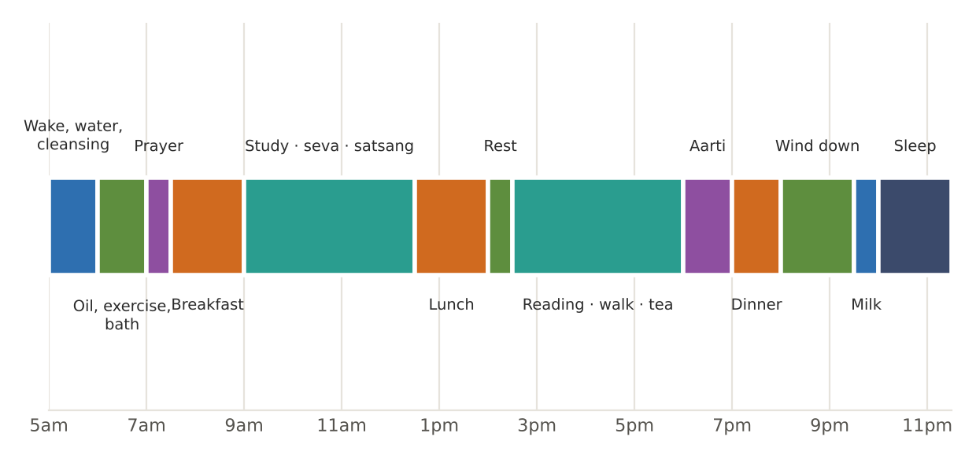
Figure. A day in rhythm — the dinacharya at a glance
Time | Practice | How | Why | Notes for 55+
5:00–6:00 am | Wake in brahma muhurta | Wake about 1½ hours before sunrise (two muhurtas of 48 min); sit up slowly | Vata time: lightness, clarity, ideal for prayer | Sit on the bed edge for a minute before standing (prevents dizziness)
On waking | Remember the divine; observe the body | A short prayer or intention; notice digestion of last night's meal | Begins the day in sattva | —
On waking | Warm water | 1 glass of warm water, plain or with cumin–ginger | Awakens agni; prompts bowel movement | Sip slowly
Morning | Elimination | Unhurried, without straining | Apana vata regularity | Footstool under the feet helps; no straining (BP)
Morning | Teeth and tongue | Soft brush or traditional twig (neem, babool); then tongue scraper, 7–10 gentle strokes back to front | Removes coating (ama) and odour-causing residue | A study found scraping reduced odour compounds more than a toothbrush [2]
Morning | Oil pulling (gandusha / kavala) | 1 tbsp sesame or coconut oil swished 5–10 min; spit into a bin (not the drain); rinse | Traditionally for teeth, gums, voice and jaw | Evidence is limited; never replaces brushing [3]; avoid if swallowing is unsafe
Morning | Eyes and face | Splash eyes with cool water; rinse face | Refreshes alochaka pitta | —
Morning | Nasya (optional) | 2 drops of warm sesame or medicated oil (anu taila) per nostril | Lubricates nasal passages; classical for head and senses | Only after learning from a vaidya; not with cold, fever or after meals
Morning | Abhyanga (oil massage) | Warm oil over the body 10–20 min before bath (Chapter 34) | Pacifies Vata; nourishes skin, joints, sleep | Non-slip mat; sit while oiling feet
Morning | Gentle exercise (vyayama) | 20–40 min: walking, chair yoga, balance work (Chapter 35) | Strength, circulation, digestion | To half capacity — light sweat on the forehead, breathing comfortable
Morning | Bath (snana) | Warm water on the body; lukewarm, not hot, on the head | Cleansing, refreshing, appetite | Grab bars; non-slip mat; avoid very hot water
Morning | Prayer, meditation, pranayama | 15–30 min (Chapter 36) | Calms mind; sets the day's tone | Seated on a chair is fine
7:30–9:00 am | Breakfast | Warm, moderate | — | —
Morning | Work, study, seva, satsang | Purposeful activity | Sattva; meaning | Rest when tired
12:30–2:30 pm | Lunch — main meal | All six tastes | Pitta time, strongest agni | —
After lunch | Hundred steps; rest | Short walk; then rest sitting or lying on the left side 15–20 min | Digestion | Charaka permits day sleep for the elderly and weak, and for all in summer — keep it short
Afternoon | Reading, satsang, light activity | — | Vata time: mental clarity | Warm drink at 4 pm
Sunset | Evening prayer, aarti, lamp | Ganga aarti at Har-ki-Pauri or the Centre's own | Transition into evening | —
7:00–7:30 pm | Light dinner | Soup, khichdi, kanji | Before Kapha slows digestion | At least 2–3 h before sleep
Evening | Gentle walk; family time; reading | No screens in the last hour | Wind down | —
9:30 pm | Golden milk; foot massage | Warm oil on soles | Sleep | —
By 10:00 pm | Sleep | Dark, quiet, cool room | Pitta time repair | 7–8 hours [4]

Three-step starter routine for new guests
- Wake by 6 am and drink a glass of warm water.
- Make lunch the main meal and finish dinner by 7:30 pm.
- Massage the feet with warm sesame oil at bedtime and sleep by 10 pm.
- Add one further practice each week: tongue scraping, a morning walk, abhyanga, ten minutes of breathing.

34. Abhyanga — The Art of Oil Massage
Charaka says that one who practises abhyanga daily is not easily affected by old age, fatigue or Vata disorders; that it gives good vision, nourishment, long life, good sleep and good skin, and makes the body strong and resilient. For people in the Vata stage of life it is perhaps the single most valuable lifestyle practice after a good diet and routine. The Centre offers a 60-minute Abhyangam by a trained female Panchakarma therapist for female guests (₹1,200 with medicated oil; ₹1,500 with Mahanarayan tailam from Kottakkal Arya Vaidya Sala); self-abhyanga can be learned for daily use.
Oil | Virya | Best for | Season | Note
Sesame (til), cured | Heating | Vata; dry skin, stiff joints, insomnia, cold | Autumn, winter, monsoon | The classical abhyanga oil; cure by warming to about 100 °C once and cooling
Coconut | Cooling | Pitta; heat, rashes, sensitive skin | Summer, early autumn | Solidifies in cold — warm the bottle in hot water
Mustard | Heating | Kapha; heaviness, cold | Winter | Strong; patch-test first
Almond | Mildly warming | Vata–Pitta; delicate or dry skin | All year | Costly; good for the face
Sunflower | Neutral | Pitta–Kapha | Summer | Light
Medicated oils (Mahanarayan, Dhanvantaram, Ksheerabala, Bala) | Varies | Joint stiffness, Vata disorders | As advised | On an Ayurvedic physician's advice

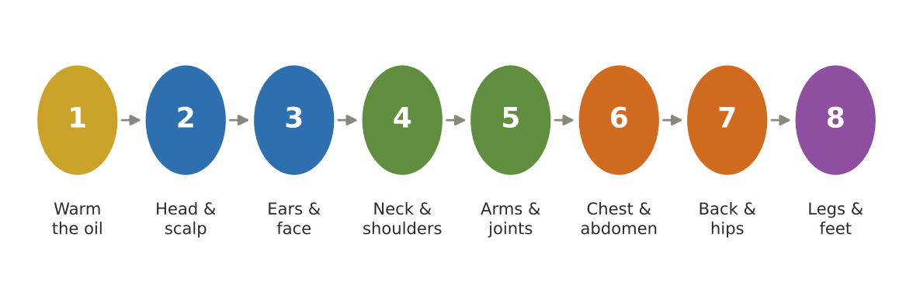
Figure. Self-abhyanga in eight steps
Step | Area | Movement | Time
1 | Warm the oil | Place the bottle in hot water to body temperature or slightly above | —
2 | Head and scalp | Small circles with fingertips; a little oil on the crown | 2 min
3 | Ears and face | Massage the outer ear; gentle upward strokes on the face | 1 min
4 | Neck and shoulders | Long strokes down the back of the neck; circles on the shoulders | 2 min
5 | Arms | Long strokes on the long bones; circles on elbows and wrists | 2 min
6 | Chest and abdomen | Circles on the chest; clockwise circles on the abdomen (following the colon) | 2 min
7 | Back and hips | Reach what you can; up-and-down strokes | 2 min
8 | Legs and feet | Long strokes on thighs and shins; circles on knees and ankles; thorough sole massage | 4–5 min

After massage, rest 10–15 minutes to let the oil soak in, then bathe in warm water using a mild soap or traditional gram-flour paste (besan ubtan) to remove excess oil. Wipe the bathroom floor dry — oiled feet on wet tiles are a serious fall risk.

When not to do abhyanga
- During fever, acute cold or flu, indigestion or immediately after meals.
- With ama signs (coated tongue, heaviness) — dry powder massage (udvartana) is classical instead, under guidance.
- On broken, infected or inflamed skin; over varicose veins with pressure; on recent fractures or surgical wounds.
- During menstruation some traditions avoid full abhyanga; a light foot massage is fine.
- Guests with heart, kidney or skin conditions should check with their doctor first.

Padabhyanga — the bedtime foot massage
Charaka mentions oiling the feet for steadiness, sound sleep and good vision. It is the easiest abhyanga for older adults to do every night: warm 1 tsp of sesame oil or ghee, massage each sole for 2–3 minutes with the thumb, from heel to toes, then the ankles; wipe off the excess and wear cotton socks to protect sheets and floors.

35. Movement After 55
Ayurveda recommends exercise (vyayama) to half one's capacity (ardha shakti) — until light sweat appears on the forehead, nose and armpits and breathing quickens but stays comfortable. Charaka cautions that the elderly and those with Vata disorders should exercise gently. Modern guidance agrees in spirit and adds specifics: the World Health Organization recommends 150–300 minutes of moderate activity a week for adults, with muscle-strengthening on two or more days, and for those over 65 multicomponent activities — balance, coordination and strength — on three or more days a week to prevent falls [1].
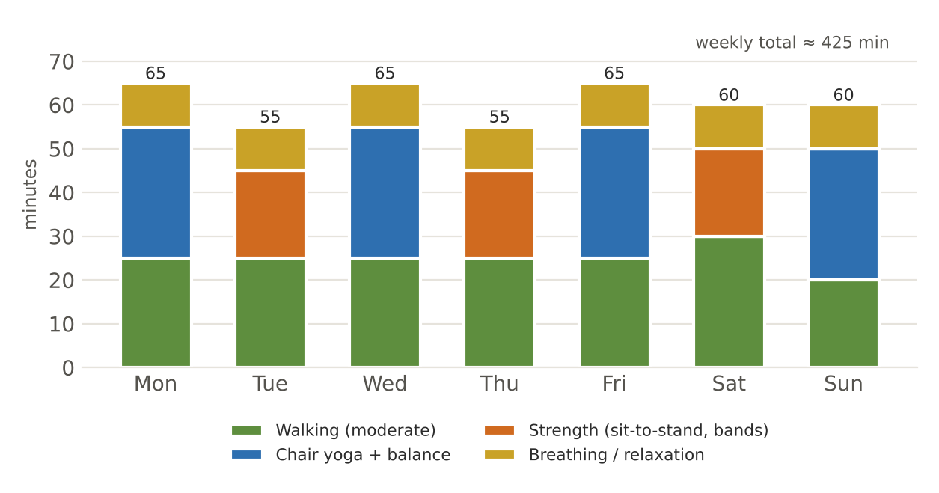
Figure. A balanced week of movement for guests over 55 (minutes per day)

Gentle chair-and-standing yoga sequence (30 minutes)
Chair-based yoga programmes have been studied in older adults with improvements in mobility, function and confidence, including in knee osteoarthritis [5]. The sequence below is led daily at the Centre by an English-speaking yoga trainer (40-minute session, ₹300) and can be practised alone once learned.
No. | Practice | Position | How | Breaths / reps | Benefit | Caution
1 | Settling breath | Seated on chair | Feet flat, spine tall; slow belly breaths | 10 breaths | Calms, focuses | —
2 | Neck rolls (half circles) | Seated | Chin to chest, ear to shoulder side to side — never full backward circles | 5 each way | Neck mobility | Stop if dizzy
3 | Shoulder rolls | Seated | Lift, back, down | 10 | Upper back, posture | —
4 | Seated cat–cow | Seated, hands on knees | Arch with inhale, round with exhale | 8 | Spine mobility | Gentle range in osteoporosis
5 | Seated twist | Seated | Hand to opposite knee, turn gently from the waist | 3 breaths each side | Digestion, spine | Small range after spinal surgery
6 | Seated side bend | Seated | One arm overhead, lean gently | 3 breaths each side | Rib cage, breathing | —
7 | Ankle and wrist circles | Seated | Slow circles | 10 each | Joint lubrication | —
8 | Seated marching | Seated | Lift knees alternately | 20 | Hip strength, circulation | —
9 | Sit-to-stand | Chair | Stand up and sit down without hands if possible | 5–10 | Leg strength — key for independence | Use hands if needed
10 | Chair-supported mountain pose (tadasana) | Standing behind chair | Hands on chair back; stand tall; weight even | 5 breaths | Posture, balance | —
11 | Heel raises | Standing, holding chair | Rise onto toes, lower slowly | 10 | Calf strength, balance | —
12 | Chair-supported tree pose (vrikshasana) | Standing, holding chair | Sole of one foot on the other ankle or calf | 3–5 breaths each side | Balance | Keep a hand on the chair
13 | Supported warrior (virabhadrasana) | Standing, chair at side | Small step forward, bend front knee slightly | 3 breaths each side | Leg strength | Short stance
14 | Walking practice | Hall or garden | Heel–toe walking along a line | 2 lengths | Gait, balance | Near a wall or rail
15 | Relaxation (shavasana or seated) | Lying or seated | Body scan, slow breath | 3–5 min | Rest, calm | Use a chair if lying down is difficult

Stop and seek help if
- Chest pain or pressure, unusual breathlessness, palpitations.
- Dizziness, light-headedness, sudden headache, blurred vision.
- New or sharp joint pain; numbness or tingling.
- Avoid inversions (head below heart), deep forward bends and heavy breath-holding if you have high blood pressure, glaucoma, osteoporosis or a recent surgery — and check with your doctor before starting any new routine.

36. Breath and Meditation
Prana — the life-breath — is the first of the five sub-doshas of Vata. Calm, slow breathing steadies Vata, settles the mind and is one of the safest practices at any age. Strong, forceful techniques, however, are not for everyone after 55.
Practice | How | Duration | Benefit | Caution
Diaphragmatic (belly) breathing | Hand on belly; breathe in through the nose so the belly rises; out slowly | 3–5 min | Calming; reduces stress | Safe for nearly all
Nadi shodhana (alternate-nostril) | Right thumb closes right nostril, ring finger the left; inhale left, exhale right, inhale right, exhale left — no breath-holding | 5–10 rounds | Balances, calms Vata | Gentle; no retention for BP or heart conditions
Bhramari (humming bee) | Inhale; exhale with a soft humming sound, ears gently closed | 5–7 rounds | Calming; aids sleep | Stop if dizzy
Ujjayi (gentle) | Slight constriction at the throat; slow, audible breath | 3–5 min | Steadying | Keep it soft
Sheetali / sheetkari | Inhale through a rolled tongue or teeth; exhale through the nose | 5–10 rounds | Cooling — summer, Pitta | Not in cold weather or with sensitive teeth
Kapalabhati, bhastrika | Forceful exhalations / bellows breathing | — | Energising | Not advised with high BP, heart disease, hernia, glaucoma, recent surgery, pregnancy — learn only from a teacher
Japa (repetition of a mantra or name) | With or without a mala | 10–20 min | Concentration, devotion | Suits all
Silent sitting / dhyana | Seated comfortably, eyes closed, attention on breath or a sacred word | 10–30 min | Calm, clarity | A chair is fine

37. Nidra — Sleep
Ayurveda names sleep one of the three pillars of life alongside food and regulated living. Good sleep nourishes the tissues, steadies the mind and supports ojas; poor sleep aggravates Vata and dulls agni. Many older adults sleep more lightly and wake more often; that is common, but adults over 65 still benefit from about 7–8 hours of sleep a night [4].
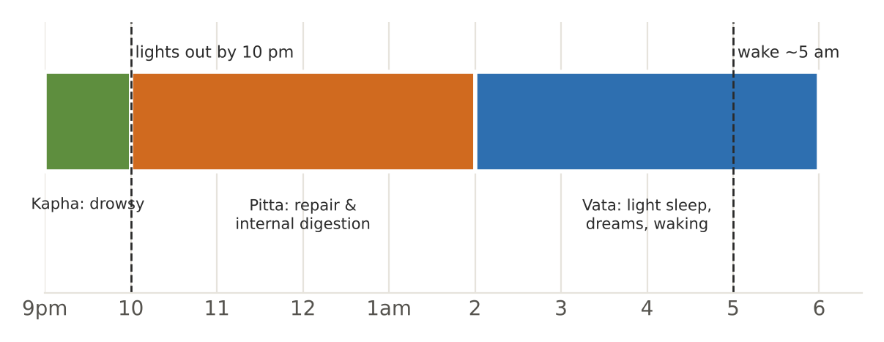
Figure. An Ayurvedic night — sleeping with the doshas
Practice | Ayurvedic reason | How
Sleep by 10 pm | Before the Pitta hours of night; deeper sleep in Kapha time | Lights dim from 9 pm
Light, early dinner | Heavy late meals disturb sleep and cause ama | Dinner by 7:30 pm
Golden milk | Milk, nutmeg and ghee calm Vata | 150 ml at 9:30 pm
Foot massage | Grounds Vata; traditionally for sleep and eyes | Warm sesame oil or ghee, 3 min each foot
Screens off an hour before bed | Rajasic stimulation; light delays sleep | Read, pray, chant instead
Same time every day | Routine steadies Vata | Including weekends
Day sleep sparingly | Charaka allows it in summer, and for the elderly and weak | 20–30 min after lunch, not late afternoon
Comfortable room | Calm, dark, ventilated | Light quilt in winter; cotton in summer
Night-time safety | Elders get up at night | Night-light in bathroom path; bed at knee height; grab bars

When to see a doctor about sleep
- Loud snoring with pauses in breathing, or gasping at night.
- Regularly sleeping less than 6 or more than 9 hours, or feeling unrefreshed with daytime sleepiness.
- Restless legs, frequent night urination, pain that wakes you, or low mood.

38. Ritucharya — Living with the Seasons
Volume I set the menu for each month. This chapter summarises the lifestyle for each of the six seasons (Part IV-B, Chapters 43–48, gives each season in depth) — what to wear, how to exercise, which oil to use, how to bathe and sleep. The underlying logic is the same: favour the qualities opposite to the season's.
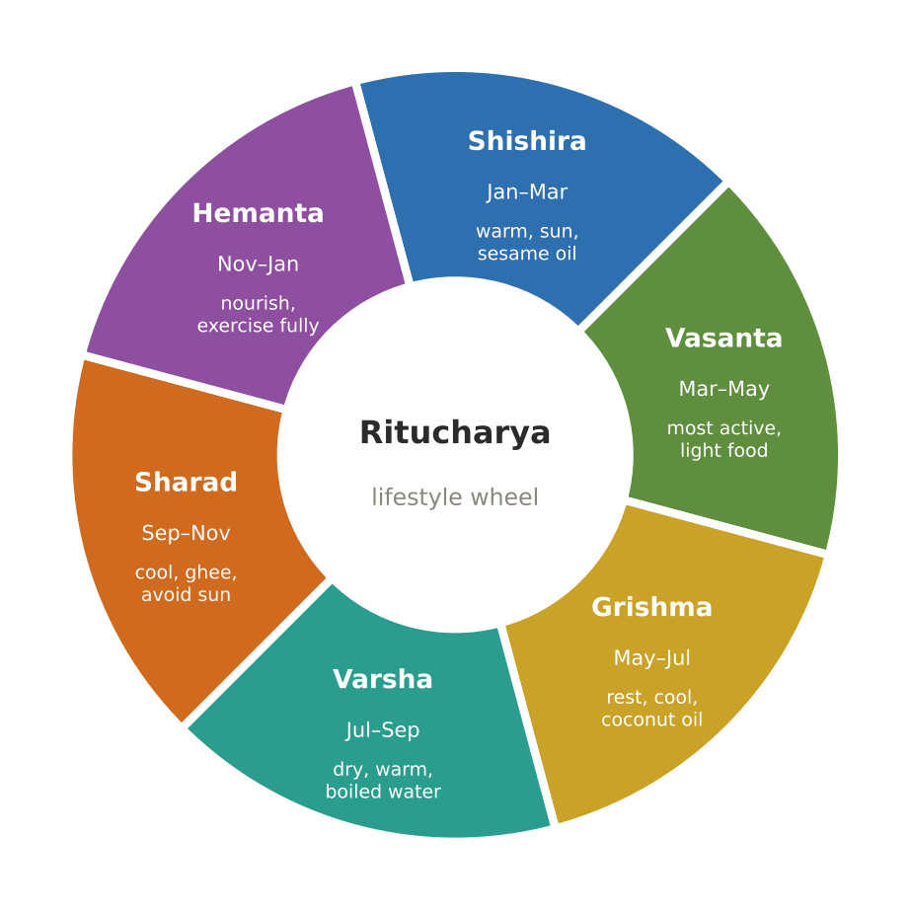
Figure. The six seasons and their lifestyle themes
Season (Haridwar) | Ritu | Dosha | Exercise | Oil and bath | Clothing and home | Sleep and other
Mid-Jan to mid-Mar | Shishira (late winter) | Kapha accumulating; Vata | Moderate; brisk walks in sun | Sesame or mustard abhyanga; warm baths | Wool, warm socks; sunlight indoors | Avoid day sleep; sun exposure mid-morning
Mid-Mar to mid-May | Vasanta (spring) | Kapha aggravated | Most active season; brisk walking, yoga | Dry rubbing or light oil; warm baths | Light layers | No day sleep; early rising; gargles
Mid-May to mid-Jul | Grishma (summer) | Vata accumulating; Pitta rising | Light only, early morning | Coconut oil; cool (not cold) baths | Light cotton; shade; khus curtains | Short day nap permitted; moonlit evenings; avoid midday sun
Mid-Jul to mid-Sep | Varsha (monsoon) | Vata aggravated; Pitta accumulating | Light; indoor yoga | Sesame abhyanga; warm baths; keep skin dry | Dry clothes; dry floors; mosquito protection | Boiled water; avoid getting wet; no day sleep
Mid-Sep to mid-Nov | Sharad (autumn) | Pitta aggravated | Moderate | Coconut or sunflower oil; lukewarm baths | Light clothing; evening moonlight | Avoid midday sun; sandalwood; early sleep
Mid-Nov to mid-Jan | Hemanta (early winter) | Strong agni; Vata | Most strength-building; exercise fully (within limits) | Sesame abhyanga daily; warm baths | Warm clothes; sun in the morning | Nourishing food; warm rooms; oil the feet

Ritu sandhi — the junction between seasons
The last seven days of one season and the first seven days of the next form a fortnight of transition (ritu sandhi). Ayurveda advises changing diet and routine gradually during this time — dropping the outgoing season's habits by quarters and adopting the incoming ones — rather than abruptly. Season changes in Haridwar (mid-March, mid-July, mid-September, mid-November) are when colds, digestive upsets and joint pain rise among guests. The kitchen responds by lightening menus for a week and serving warm water and kadha generously.

39. The Natural Urges — Not to Suppress, and to Restrain
Charaka lists thirteen natural urges (adharaniya vega) that should not be suppressed, because suppressing them disturbs Vata and causes disease. He also lists mental urges that a wise person restrains (dharaniya vega). For older adults, the first list has practical implications: easy access to toilets, unhurried mornings, not holding urine on outings.
Urge not to suppress | Possible effect of suppression (classical) | Practical support
Flatus | Bloating, pain, Vata disorders | Unhurried toilet breaks; ajwain water
Stool | Cramps, headache, constipation | Regular morning time; footstool
Urine | Bladder pain, difficulty passing urine | Toilets near rooms and dining hall; outings with stops
Sneezing | Headache, facial pain | Cover with elbow; do not hold
Thirst | Dryness, fatigue | Water always available
Hunger | Weakness, body ache | Meals on time
Sleep | Heaviness, yawning, fatigue | Allow rest; short nap
Cough | Breathlessness, hiccups | Warm water; medical advice if persistent
Breathlessness on exertion | Heart and lung strain | Stop and rest
Yawning | Stiffness of neck | Yawn freely
Tears | Eye and head discomfort | Allow grief and emotion
Vomiting | Skin problems, nausea | Seek medical help if repeated
Semen | Discomfort | —

Urge to restrain | Sanskrit
Greed | Lobha
Grief (excessive) | Shoka
Fear | Bhaya
Anger | Krodha
Pride, ego | Mana / ahankara
Shamelessness | Nirlajjata
Envy | Irshya
Excessive attachment | Atiraga
Malice, desire to harm | Abhidhya

40. Sadvritta — The Code of Good Conduct
Ayurveda holds that mental and social conduct are as much a part of health as food. Charaka's sadvritta (good conduct) describes ways of living that keep the mind sattvic. A few that are especially relevant to life at an ashram-guesthouse:
- Speak truthfully, kindly and in measure; avoid harsh speech.
- Respect elders, teachers and the learned; serve others (seva).
- Keep the senses neither starved nor indulged — moderation in all things.
- Rise early, keep clean, wear clean clothes, keep the living space tidy.
- Be calm in success and failure; forgive easily; avoid holding grudges.
- Give in charity according to capacity; share food.
- Avoid excessive exertion, late nights, and the company of those who disturb the mind.
- Begin each day with remembrance and end it with gratitude.

41. Common Concerns After 55 — Food and Lifestyle Pointers
These pointers bring together the diet and lifestyle advice in this book for complaints that older guests often mention. They complement medical care and never replace it.
Concern | Food pointers | Lifestyle pointers | See a doctor if
Weak digestion, bloating | Moong, khichdi, yusha; ginger–rock salt before lunch; hing and ajwain; no snacking | Regular times; walk after meals; warm water | Weight loss, pain, vomiting, blood in stool
Constipation | Warm water on waking; ghee; stewed fruit; soaked figs; dalia, bhindi, bathua; fluids | Morning routine; walking; abhyanga of abdomen (clockwise) | Sudden change, blood, pain
Acidity, reflux | Rice, milk, ghee, coconut, gourds, fennel; less chilli, sour, fried, tea | Small meals; dinner early; no lying down after meals; raise head of bed | Chest pain, difficulty swallowing, black stools
Joint stiffness | Warm, moist food; ghee and sesame; turmeric and ginger in cooking; avoid cold and dry food | Abhyanga; warm baths; chair yoga daily; keep joints warm | Red, hot, swollen joint; fever
Poor sleep | Light early dinner; golden milk with nutmeg | Routine; foot massage; no screens; bhramari | Snoring with pauses, depression
Low appetite, weight loss | Small frequent meals; ghee, milk, paneer, nuts, date milk; fortified milk | Gentle activity; company at meals | Unexplained weight loss — always
Memory and concentration | Ghee, milk, almonds, walnuts; regular meals | Routine, reading, satsang, japa, social connection | Rapid decline, confusion
Low mood, loneliness | Warm, sweet, nourishing food; no skipping meals | Satsang, seva, walks with others, sunlight | Persistent sadness, hopelessness — seek help early
Blood sugar | Millets, barley, moong; vegetables first; methi, karela; no sweets alone | Walk after meals; regular times | Follow medical plan
Blood pressure | ≤ 5 g salt; lauki, gourds, fruit; less pickle, papad | Walking; pranayama (gentle); sleep | Follow medical plan; sudden headache or weakness — emergency
Dry skin, itching | Ghee, sesame; fluids | Abhyanga; lukewarm (not hot) baths | Rash, wounds that do not heal
Frequent colds | Warm food; ginger, tulsi, turmeric, black pepper; amla daily in winter | Dry after bath; cover head in cold wind | Fever over 3 days, breathlessness

42. Sadhana in Haridwar
Haridwar — the gateway to the Himalaya where the Ganga leaves the hills — has drawn seekers for millennia. Kankhal, at its southern edge, is home to the Daksha Mahadev temple and to the samadhi shrine of Sri Anandamayi Ma (1896–1982), the Bengali saint whose body was laid to rest on the banks of the Ganga near the Kankhal ashram [8]. Shree Shree Ma Anandamayee International Centre welcomes guests in this atmosphere of prayer, study and service.
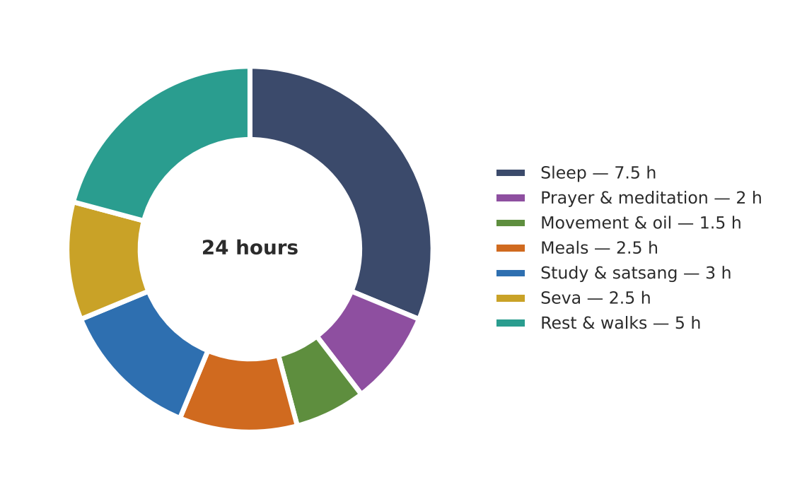
Figure. A day of sadhana at the Centre — practice, study, service and rest
Element of sadhana | At the Centre and in Haridwar | How the kitchen supports it
Prayer and meditation | Morning and evening practice; temple visits; Ganga aarti at dusk | Early light breakfast; dinner early enough to attend aarti
Study (svadhyaya) | The Centre's library and the books archive of Ma's teachings (books.ssmaic.org) | Quiet dining for reflection
Satsang | Gatherings, kirtan, talks | Tea and light prasad
Seva | Service in the garden, kitchen, library | Garden-to-table work in the Annamaya garden
Silence (mauna) | Silent meals or silent days by choice | Written meal orders; quiet service
Fasting and festivals | Ekadashi, Navratri, Shivratri, Guru Purnima | Phalahari track; festival thalis (Vol. II, C2)
Rest | Time for walks by the Ganga, sleep, recovery | Regular, nourishing meals

PART IV-B

The Six Seasons in Depth
Season-by-season kitchen and lifestyle guides for Haridwar

43. Shishira — Late Winter (mid-January to mid-March)
Shishira is the coldest, driest part of the year in Haridwar: foggy mornings give way to bright, chilly days and cold winds. The sun is in its northward course (uttarayana), which Ayurveda says gradually draws strength from the body; yet digestive fire remains strong from Hemanta. Kapha accumulates quietly in the cold, ready to melt in spring; Vata is provoked by dryness and wind. For older guests this is the season of stiff joints, dry skin, chest colds and low mood on grey days.
Aspect | State in Shishira | What it means for guests over 55
Weather | 7–23 °C; fog, cold dry wind | Joints stiffen; skin cracks; risk of chills
Agni | Strong | Can digest nourishing food — do not under-feed
Doshas | Kapha accumulating; Vata provoked by cold and dryness | Warm, unctuous, mildly pungent food; protect from wind
Common complaints | Joint pain, dry cough, colds, constipation, low mood | Abhyanga, warm baths, ginger, sunshine, routine

Daily routine adjustments
Practice | Shishira guidance
Waking | 5:30–6:00 am; do not rush into the cold — warm the room first
Abhyanga | Daily with warm sesame or mustard oil; head and feet especially
Exercise | Moderate; brisk walks in mid-morning sun; indoor chair yoga on foggy days
Bath | Warm water; dry thoroughly; cover the head afterwards
Clothing | Wool layers, cap, warm socks; protect ears and chest from wind
Sunlight | 15–20 minutes of morning sun on arms and face — warmth and vitamin D
Sleep | Warm room, quilt; foot massage; avoid day sleep (increases Kapha)
Mind | Satsang, music, company — winter gloom is real for many elders

Kitchen guide
Group | Favour | Reduce
Grains | Wheat, aged rice, bajra (small), makki with wheat | Cold or dry cereals
Pulses | Moong, masoor, urad (small), horse gram yusha | Undercooked beans
Vegetables | Sarson, bathua, methi, carrots, peas, radish (cooked), turnip, sweet potato | Raw salads, cold vegetables
Fruit | Amla, guava (cooked), oranges at room temperature, stewed apple | Cold fruit, melons
Dairy and fats | Milk with spices, ghee, sesame, butter in small amounts | Cold milk, cold curd
Sweets | Til–gud, gajar halwa, gur rice in small portions | Cold desserts
Spices | Ginger, dry ginger, black pepper, ajwain, cinnamon, clove | —
Drinks | Kadha, golden milk, ginger tea, warm water | Iced drinks

Signature dishes | Volume
Sarson–palak–bathua saag; methi–moong chilla; Sankranti khichdi; til–gud–saunth ladoo; haldi–adrak kadha | Volume I, January
Bajra raab; bajra–moong khichdi; makki–wheat roti; gur wale chawal; kulattha yusha | Volume II

44. Vasanta — Spring (mid-March to mid-May)
Spring is beautiful in Haridwar — mustard fields, flowering trees, Holi colours — and it is also the season when the Kapha that accumulated in winter melts under the warming sun. The result, classically, is congestion, allergies, heaviness, sluggish digestion and drowsiness. Agni weakens. The remedy is lightness: lighter, drier, warmer food; more activity; less sleep in the day.
Aspect | State in Vasanta | What it means for guests over 55
Weather | 13–34 °C; warm days, cool nights | Layers; sudden changes bring colds
Agni | Weakening | Smaller, lighter meals
Doshas | Kapha aggravated | Bitter, pungent, astringent tastes; honey, barley
Common complaints | Colds, cough, allergies, heaviness, indigestion, drowsiness | Activity, light food, warm water, gargles

Daily routine adjustments
Practice | Vasanta guidance
Waking | 5:00–5:30 am — the most important season for early rising
Abhyanga | Light oil or dry rubbing (udvartana) with gram-flour paste; warm bath after
Exercise | The most active season: brisk walks, longer yoga sessions (within limits)
Bath | Warm
Gargles | Warm salt–turmeric water or plain warm water
Sleep | No day sleep; early bedtime
Outdoors | Morning walks in gardens; avoid dust and pollen if allergic

Kitchen guide
Group | Favour | Reduce
Grains | Barley, old rice, millets, roasted grains | New grains, heavy breads, excess wheat
Pulses | Moong, masoor, horse gram | Urad, heavy pulses
Vegetables | Karela, methi, neem flowers (sparingly), drumstick, gourds, leafy greens (cooked) | Potato, sweet potato in excess
Fruit | Pomegranate, papaya, early mulberries | Banana, sour fruit, melons early in season
Dairy and fats | Thin buttermilk; ghee in small amounts | Curd, cheese, sweets, fried foods
Sweeteners | Honey (unheated) | Sugar, jaggery in excess
Spices | Ginger, pepper, turmeric, mustard, fenugreek | —
Drinks | Warm water with honey; ginger tea; barley water | Cold drinks

Signature dishes | Volume
Jau–moong porridge; lauki–chana dal; karela with jaggery and fennel; vegetable dalia khichdi; Holi thandai (warm) | Volume I, March
Yava yavagu; barley–vegetable soup; foxtail-millet upma; shukto; lemon rasam | Volume II

45. Grishma — Summer (mid-May to mid-July)
Summer in Haridwar is hot and dry until the monsoon breaks: loo winds, temperatures near 40 °C, harsh afternoon sun. The body loses strength and fluid; Vata accumulates from dryness and Pitta rises with heat. Agni is low — the body conserves energy. Older adults are especially vulnerable to dehydration and heat exhaustion. The classical prescription is cool, sweet, liquid, unctuous food and plenty of rest.
Aspect | State in Grishma | What it means for guests over 55
Weather | 25–40 °C; hot winds; humid by month-end | Heat exhaustion and dehydration risk
Agni | Low | Light, liquid, cooling meals
Doshas | Vata accumulating; Pitta rising | Sweet, cool, liquid, a little ghee
Common complaints | Dehydration, fatigue, burning, acidity, heat rash, sleeplessness | Fluids hourly, shade, rest, coolers

Daily routine adjustments
Practice | Grishma guidance
Waking | 5:00 am — do outdoor tasks before 8 am
Abhyanga | Coconut oil; short; or foot massage only
Exercise | Light only, early morning; swimming or gentle walking
Bath | Cool (not cold) baths, even twice a day
Clothing | Loose, light cotton; head covered outdoors
Rest | A short afternoon rest is classically allowed for all in summer
Evening | Sit in moonlight or on a cool terrace; sandalwood paste traditionally
Fluids | 150 ml every hour from 10 am to 6 pm; earthen matka water

Kitchen guide
Group | Favour | Reduce
Grains | Rice, wheat, barley, ragi, jowar | Bajra, maize, buckwheat
Pulses | Moong, masoor (lightly) | Horse gram, urad
Vegetables | Lauki, torai, tinda, parwal, ash gourd, cucumber (cooked or in raita), pumpkin | Chilli, raw radish, excess tomato
Fruit | Mango (soaked, at lunch), melons (alone), bael, jamun, litchi, pomegranate | Sour and unripe fruit
Dairy and fats | Milk, ghee, sweet thin buttermilk, rose phirni | Sour curd, cheese, fried foods
Sweeteners | Mishri, gulkand | Jaggery in excess, honey in excess
Spices | Coriander, fennel, cardamom, mint, cumin | Mustard, chilli, fenugreek, dry ginger in excess
Drinks | Aam panna, bael sharbat, sattu, panakam, kokum, khus, rose–fennel, coconut water | Iced drinks, alcohol, coffee, very sour drinks

Signature dishes | Volume
Lauki–moong dal; tinda masala; vegetable rava idli; aam panna; gulkand–rose phirni; bael sharbat; vegetable stew with idiyappam | Volume I, April–June
Laja peya; majjige huli; ash-gourd soup; curd rice (lunch); neer mor; khus sharbat; lauki kheer | Volume II

Heat exhaustion — act quickly
- Signs: heavy sweating or hot dry skin, dizziness, headache, nausea, weakness, confusion, fast pulse.
- Move the guest to shade or a cool room; loosen clothing; sponge with cool water; give sips of ORS or salted buttermilk if conscious.
- Confusion, fainting, very high temperature or no sweating with hot skin can be heat stroke — call emergency services immediately.

46. Varsha — Monsoon (mid-July to mid-September)
The monsoon brings relief from heat but weakens digestion further: humidity, acidic rainwater and polluted water make the season the most dangerous for food-borne illness. Vata is aggravated by the cool, damp winds and the body's weakness; Pitta accumulates, to flare in autumn. Agni is at its weakest of the year. This is the Shravan season of the Kanwar Yatra in Haridwar — the town fills with pilgrims, and the kitchen's hygiene must be at its most careful.
Aspect | State in Varsha | What it means for guests over 55
Weather | 25–33 °C; heavy rain; very humid | Slips and falls on wet floors; damp clothes
Agni | Weakest | Fresh, warm, light, well-spiced food
Doshas | Vata aggravated; Pitta accumulating | Sour and salty in moderation; ginger, pepper, hing
Common complaints | Indigestion, loose motions, infections, joint pain, colds, fungal skin | Boiled water; cooked food only; dry skin and clothes

Daily routine adjustments
Practice | Varsha guidance
Waking | 5:30 am
Abhyanga | Sesame oil; warm baths; dry the body and hair thoroughly
Exercise | Light; indoors on wet days
Clothing | Dry clothes always; change if damp; anti-slip footwear
Home | Dry floors, ventilation, mosquito nets, no stagnant water
Water | Boiled water only; ginger water or dry ginger–coriander water
Sleep | No day sleep; sleep in a dry room

Kitchen guide
Group | Favour | Reduce
Grains | Old rice, wheat, barley, ragi | New grains
Pulses | Moong, masoor, horse gram (yusha) | Heavy pulses, sprouts (raw — never)
Vegetables | Gourds, pumpkin, okra, corn (cooked), arbi with ajwain, fresh turmeric and ginger | Raw salads, leafy greens unless cooked thoroughly
Fruit | Pear, plum, jamun, early guava — cooked or very fresh | Cut fruit from outside; watermelon
Dairy and fats | Ghee; thin spiced buttermilk at lunch | Curd at any time other than lunch; milk sweets held long
Spices | Ginger, dry ginger, pepper, cumin, hing, ajwain, turmeric | —
Drinks | Boiled water, tulsi–ginger kadha, ajwain water, sukku malli | Cold drinks, street juices

Signature dishes | Volume
Ven pongal; adraki moong dal; Haridwar khatta-meetha kaddu; pepper–jeera rasam; moong dal dhokla; dhaniya panjiri; monsoon clear soup | Volume I, July–September
Marunnu kanji; kulattha yusha; ajwain–saunf water; steamed corn chaat; tulsi–vegetable broth; arbi patra (steamed) | Volume II

47. Sharad — Autumn (mid-September to mid-November)
After the rains, the sun returns hot and bright — the 'October heat'. Pitta accumulated during the monsoon now flares: skin rashes, acidity, irritability, eye strain, bleeding gums and headaches are classical Sharad complaints. The season is also one of festivals: Navratri, Dussehra, Sharad Purnima, Diwali. Ayurveda prescribes sweet, bitter and astringent tastes; ghee; and cool, light food — the season of rice, milk, amla and pomegranate.
Aspect | State in Sharad | What it means for guests over 55
Weather | 18–32 °C; clear, sunny days; cool nights | Midday sun is harsh; evenings pleasant
Agni | Recovering, moderate | Normal meals; avoid heavy fried festival food
Doshas | Pitta aggravated | Cooling, sweet, bitter; ghee
Common complaints | Acidity, rashes, eye strain, irritability, fever after rains | Ghee, milk, moonlight, cool environment

Daily routine adjustments
Practice | Sharad guidance
Waking | 5:30 am
Abhyanga | Coconut or sunflower oil
Exercise | Moderate; avoid exercising in midday sun
Sun | Avoid midday sun; hats and umbrellas outdoors
Evening | Moonlight (Sharad Purnima kheer tradition); cool, airy rooms
Mind | Calm; festival schedules can be tiring — protect rest

Kitchen guide
Group | Favour | Reduce
Grains | Rice, wheat, barley, samak (for fasts) | Bajra, maize
Pulses | Moong, masoor | Horse gram, urad
Vegetables | Gourds, ash gourd, pumpkin, leafy greens (cooked), sweet potato, karela | Chilli, excess tomato
Fruit | Pomegranate, amla, sweet grapes, custard apple, guava | Sour fruit
Dairy and fats | Milk, ghee, kheer, fresh paneer | Sour curd
Sweeteners | Mishri, dates | Excess jaggery
Spices | Coriander, fennel, cardamom, turmeric, cumin | Mustard, chilli, fenugreek
Drinks | Coriander water, coconut water, rose and fennel coolers, amla drinks | Alcohol, coffee in excess

Signature dishes | Volume
Rajgira–milk porridge; whole moong dal; sattvic palak paneer; samak khichdi; Sharad Purnima rice kheer; Kerala parippu; olan | Volume I, September–October
Thayir sadam (lunch); coconut rice; ash-gourd soup; lauki kheer; rose–fennel cooler; samak pulao; makhana raita | Volume II

48. Hemanta — Early Winter (mid-November to mid-January)
Hemanta is the season of greatest strength. Cold air drives the body's heat inward, and agni becomes powerful — able to digest the heavy, nourishing foods that would burden it in spring or monsoon. Ayurveda warns that if this fire is not given enough fuel it consumes the tissues themselves, aggravating Vata. For older guests this is the time to build strength: nourishing meals, regular abhyanga, the most exercise of the year within their capacity, and good sleep.
Aspect | State in Hemanta | What it means for guests over 55
Weather | 8–26 °C; crisp, dry, cold nights | Warm clothing; morning sunlight
Agni | Strongest of the year | Nourishing meals; do not skip breakfast
Doshas | Vata may rise with cold and dryness; Pitta settling | Sweet, sour, salty; ghee, sesame, milk
Common complaints | Dry skin, joint stiffness, constipation, colds | Abhyanga, warm food, fluids, sunlight

Daily routine adjustments
Practice | Hemanta guidance
Waking | 5:30 am
Abhyanga | Daily with warm sesame oil; head oiling
Exercise | The most strength-building season — walks, chair yoga, sit-to-stand, light bands
Bath | Warm water; dry and dress warmly at once
Clothing | Warm layers; cover head, ears and feet
Sleep | Warm room; foot massage; 7–8 hours

Kitchen guide
Group | Favour | Reduce
Grains | Wheat, aged rice, new rice in moderation, bajra and makki with ghee | Dry, light-only meals
Pulses | Moong, masoor, urad (small), panchmel dal | —
Vegetables | Carrot, peas, cauliflower, sweet potato, methi, palak, radish (cooked), sarson | Raw salads
Fruit | Amla, guava, oranges, apple | Cold fruit
Dairy and fats | Milk, ghee, paneer, sesame | Cold dairy
Sweets | Gajar halwa, til–gud, moong dal halwa, date–nut sweets (small portions) | Excess sugar
Spices | Ginger, dry ginger, pepper, cinnamon, cardamom, nutmeg | —
Drinks | Badam–kesar milk, golden milk, kadha, warm water | Cold drinks

Signature dishes | Volume
Paneer–methi paratha; panchmel dal; Annakut sabzi; badam–kesar milk; amla murabba; shakarkandi–gajar–ginger soup; gajar halwa with dates | Volume I, November–December
Sakkarai pongal; light undhiyu; nimona; methi–malai paneer; gobhi–shalgam; soft atta ladoo; date–walnut barfi; date milk | Volume II

Moving between seasons — the ritu sandhi fortnight
- In the last week of each season, begin reducing the foods and habits of that season by about a quarter every few days.
- In the first week of the new season, introduce its foods and routines gradually.
- Lighten meals and serve kadha or warm herbal water generously around mid-March, mid-July, mid-September and mid-November, when guests most often fall ill.

49. Questions Guests Ask
These are the questions most often asked at the dining hall and reception, with the answers the team gives.
Question | Answer
Why no onion and garlic? | The Centre follows a sattvic diet. In yogic and Ayurvedic tradition onion and garlic are rajasic and tamasic — stimulating or dulling the mind — and are avoided by many sadhakas. Hing and ginger give the same depth of flavour.
Is the food spicy? | No. Spices are used for digestion and aroma, not heat. Chilli is mild and optional; plain portions are always available.
Why is lunch the biggest meal? | Digestive fire is strongest around midday (the Pitta hours). A light early dinner helps sleep and morning appetite.
Can I have curd at dinner? | Ayurveda advises against curd at night. Thin buttermilk at lunch, and warm golden milk at bedtime, are offered instead.
Why is my water warm? | Warm water supports digestion and is gentler for older adults. Room-temperature water is available; ice is not served.
Why so much ghee — isn't it unhealthy? | We use about 2–3 teaspoons per person per day, within an overall fat limit. Ayurveda values ghee for digestion and dryness; guests with high cholesterol can ask for less.
I am diabetic — what should I eat? | Tell reception at check-in. The kitchen serves vegetables and dal first, smaller rice portions, millets, and no sugary drinks, and every recipe has a diabetic note. Follow your doctor's advice on medication and fasting.
I have dentures / difficulty chewing. | Ask for soft or minced texture. Every dish can be adapted (Volume II, Section 13); phulka can be served torn small or replaced with soft rice.
Can I get food at other times? | Meals are prepared fresh to order. Please inform by 6 pm the previous day. On-demand meals cost ₹200 extra, subject to availability.
Do you cater for fasts? | Yes — a full phalahari menu for Ekadashi, Navratri and other fasts, with rock salt and permitted grains. Older guests are encouraged to keep drinking fluids.
Are the recipes available? | Yes. All three volumes of the Annapurna Kitchen books, and the website, list every recipe with exact measures.
Who can have the Abhyangam? | It is offered to female guests by a trained female Panchakarma therapist, by appointment. Male guests can be directed to advanced therapies about 15 minutes away.
Is yoga suitable for me at 75? | The 40-minute class is gentle and chair-based where needed. Tell the trainer about any health conditions; stop if anything hurts.
Can I bring my own food or snacks? | Guests may keep personal snacks in their rooms; the dining hall serves only the sattvic menu.
Do you use garden produce? | Wherever possible. The Annamaya garden supplies herbs, greens, fruit and seasonal vegetables.

50. Myths and Facts in the Ayurvedic Kitchen
Common belief | What the panel says
"Jaggery and honey are healthy, so you can eat as much as you like." | Ayurveda prefers them for their qualities, but nutritionally they are sugars. ICMR-NIN (2024) treats all added sugars alike; keep portions small.
"Ghee is always bad for the heart." | Ghee is a saturated fat and should be measured; in small amounts within a balanced diet it is a traditional and valued food. Guests with heart disease follow their doctor's advice.
"Raw food is always healthier." | For older adults with weaker digestion and teeth, cooked food is usually easier to digest and safer. Cooking also makes some nutrients more available.
"Ayurveda forbids all cold water." | Ayurveda advises against iced water, especially with meals. Water cooled naturally in an earthen pot is fine in summer.
"Fasting is always good for health." | Gentle lightening (langhana) helps when digestion is heavy; prolonged or dry fasts can harm older adults. Fast safely (Chapter 32).
"Turmeric cures everything." | Turmeric is a valuable culinary spice. High-dose supplements can interact with blood thinners and other medicines and are taken only on medical advice.
"Copper vessels make all water medicinal." | Storing drinking water in clean copper is traditional; copper is never used for cooking, milk or sour drinks.
"If it is natural, it is safe." | Herbs are active substances. Medicinal herbs, kadha kits and nasya oils should be used on the advice of a qualified practitioner.
"Ayurveda and modern medicine conflict." | They often agree — warm, fresh, home-cooked food; regular routine; sleep; moderate exercise; less salt and sugar. Where they differ, the guest's doctor decides on medical matters.
"Spicy food is Ayurvedic." | Traditional Ayurvedic food is lightly and thoughtfully spiced for digestion, not fiery. Excess chilli aggravates Pitta and Vata.

PART V

The Annapurna Lifestyle Programme
Turning the three volumes into a guest experience at the Centre

51. The Guest Journey
Every guest, whether staying three nights or three months, moves through the same journey. The kitchen, reception and wellness team each have a role at every stage.
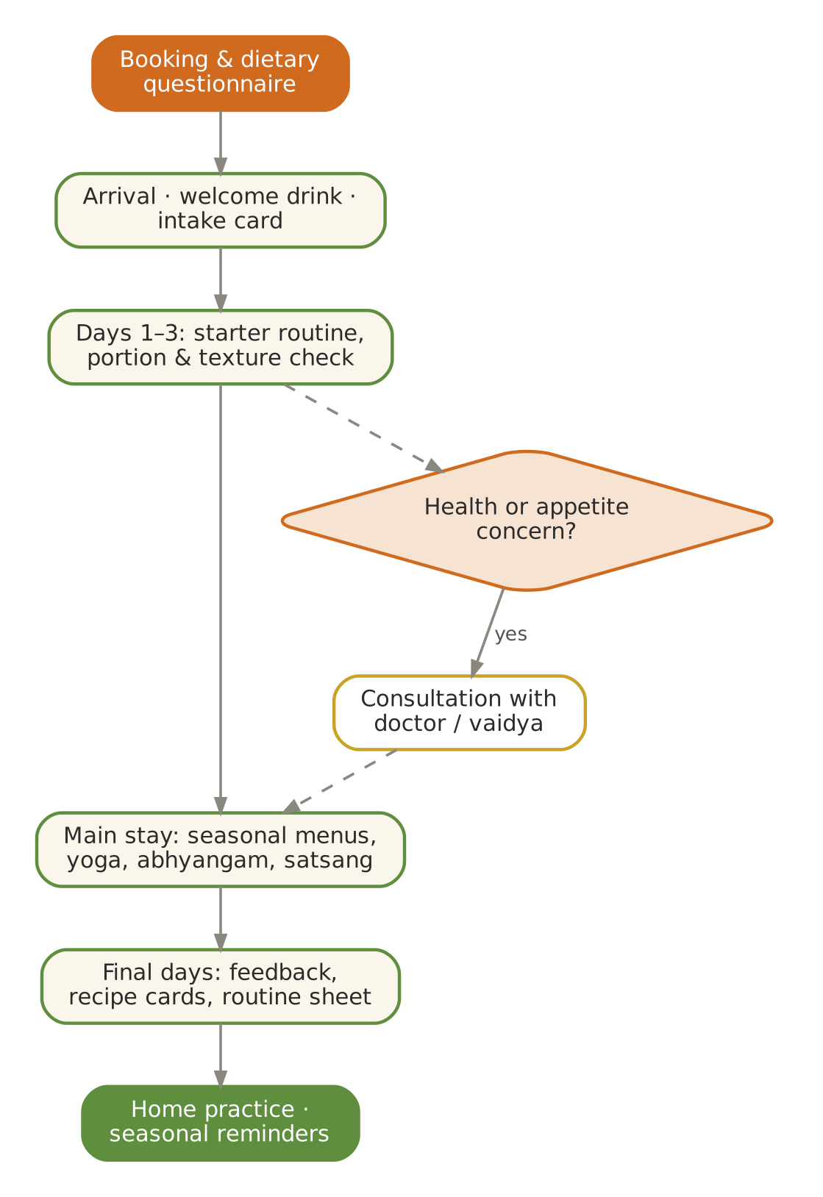
Figure. The guest journey — from booking to the return home
Stage | Guest experience | Reception | Kitchen | Wellness
Before arrival | Booking; dietary questionnaire | Sends meal policy and intake card | Notes allergies, conditions, texture needs | Notes therapy requests
Arrival day | Welcome drink; orientation | Explains timings, meal-order deadline (6 pm the day before) | Light welcome dinner | Offers consultation booking
First 3 days | Settling into routine | Checks room safety, night lights | Observes appetite; adjusts portions and texture | Starter routine (Ch. 33); first yoga class
Main stay | Daily rhythm, sadhana, therapies | Supports outings, satsang | Seasonal menus from Volumes I–II; festival thalis | Yoga, abhyangam, breath practice
Final days | Preparing to leave | Feedback form | Shares recipes guests liked | Home routine sheet
After departure | Home practice | Follow-up email | Printed recipe cards | Seasonal reminder messages

52. A Seven-Day Wellness Stay
The template below combines the daily routine, meals and services into a gentle week. It is a suggestion, not a schedule to be imposed: guests choose what suits them.
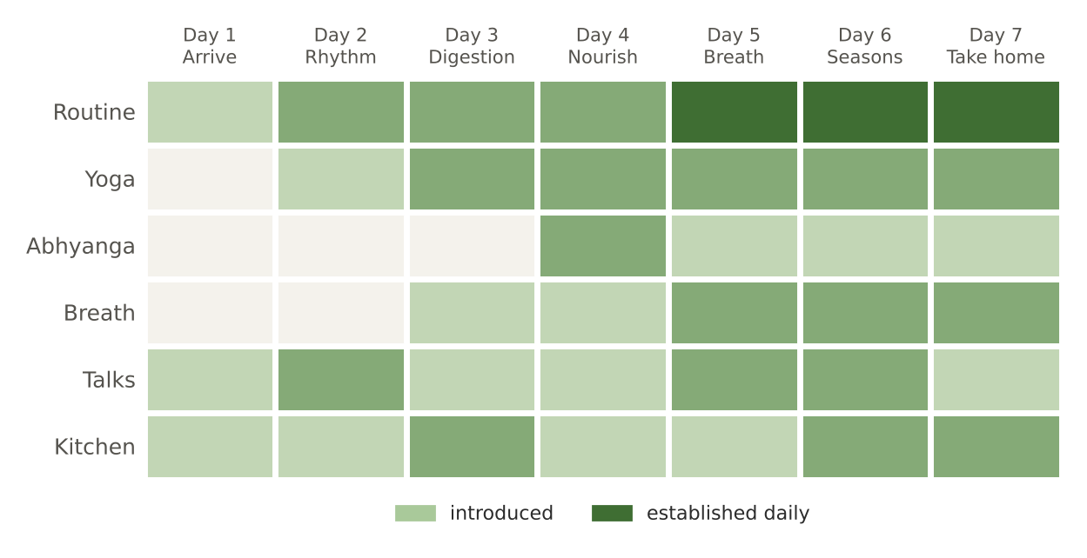
Figure. Seven-day stay — how practices build through the week
Day | Theme | Morning | Midday | Afternoon | Evening
1 — Arrive | Settle | Arrival, welcome drink (CCF tea) | Light lunch: khichdi, lauki sabzi, takra | Rest; garden walk | Light dinner; golden milk; early sleep
2 — Rhythm | Wake with the sun | Warm water, tongue scraping, yoga introduction | Full thali | Talk: the dosha clock | Foot massage demonstration
3 — Digestion | Kindle agni | Yoga; ginger–rock salt slice before lunch | Thali with digestive tadka | Kitchen visit: tadka and spices | Moong yusha dinner
4 — Nourish | Oil and warmth | Abhyangam (by appointment) or self-abhyanga | Full thali; ghee and sesame | Rest; reading | Ganga aarti; light dinner
5 — Breath | Calm the mind | Yoga with pranayama; nadi shodhana | Thali | Satsang or library | Bhramari before sleep
6 — Seasons | Living with the year | Garden walk: what is in season | Festival-style thali | Talk: ritucharya | Light dinner
7 — Take home | Plan the home routine | Yoga; personal routine sheet | Farewell lunch | Recipe cards; feedback | Departure or extended stay

53. Services at the Centre
The Centre's published guest services, reproduced here so that the kitchen, reception and website describe them consistently.

Sattvic Meal Experience — Annapurna Kitchen
Meal | Time | Price | Menu
Breakfast | 7:30–9:00 am | ₹300 | Dalia / oats / muesli, bread, butter and jam, fresh fruits, tea / coffee / milk — seasonal dishes from Volumes I–II rotate in
Lunch | 12:30–2:30 pm | ₹300 | Rice, dal, roti, two seasonal vegetables, yogurt
Dinner | 7:00–8:30 pm | ₹300 | Rice, dal, roti, two seasonal vegetables, sweet
À la carte | — | ₹100 each | Fresh juices (seasonal fruits / cucumber, slow juicer), fruit salad bowl, vegetable salad, light snacks (khichdi or poha)

Meal policy
- All meals are freshly prepared in advance. Kindly inform at least one day prior — by 6:00 pm on the previous day for breakfast and all meals the next day.
- On-demand meals: ₹200 extra, subject to availability.
- Our intention: simple, sattvic food to support healing, clarity and sadhana.

Ayurvedic Wellness & Yoga
Service | Details | Price
Abhyangam (full-body oil massage) | 60 minutes; by a trained female Panchakarma therapist; for female guests only; indoor therapy on a professional massage table; fresh towels provided | ₹1,200 with medicated SCA oil · ₹1,500 with Mahanarayan tailam (Kottakkal Arya Vaidya Sala)
Yoga session | 40 minutes; gentle, guided, suitable for all levels; English-speaking trainer | ₹300 per session
Ayurveda consultation | External Ayurvedic doctor available on prior request | On request
Advanced therapies | Advanced Ayurvedic treatments available about 15 minutes away | On request
Post-therapy care | Rest after therapy and take a warm bath for best results | —

All services are by prior appointment only; please contact reception. Intention: to create a space for healing, clarity and sadhana through authentic Ayurveda and yoga.

54. Garden to Table — the Annamaya Connection
The Annamaya Living Food Forest and Ayurveda Garden is planned as a working model of India's edible, medicinal and sacred plant heritage — themed zones such as the Nakshatra and Navagraha vatikas, an Ayurveda dravya garden, a saag garden, fruit forest, spice and herb beds, millets and roots. For the kitchen it means one simple principle: let the garden, not the supplier, set the menu.
Garden zone | What the kitchen receives | Typical dishes
Saag garden | Methi, palak, bathua, chaulai, moringa, curry leaf | Saags, dals, chillas, soups
Spice and herb beds | Tulsi, mint, lemongrass, coriander, fresh turmeric and ginger | Kadhas, chutneys, teas, tadka
Fruit forest | Amla, guava, papaya, banana, mango, bael, jamun, pomegranate | Murabba, chutneys, stewed fruit, sharbats
Vegetable beds | Gourds, pumpkin, okra, beans, roots by season | Everyday sabzis
Millets and grains | Ragi, jowar, foxtail, samak (trial plots) | Porridges, rotis, khichdi
Medicinal plants | Ashwagandha, brahmi, giloy (display and education) | Not used in cooking without a vaidya's advice

The zero-waste kitchen cycle
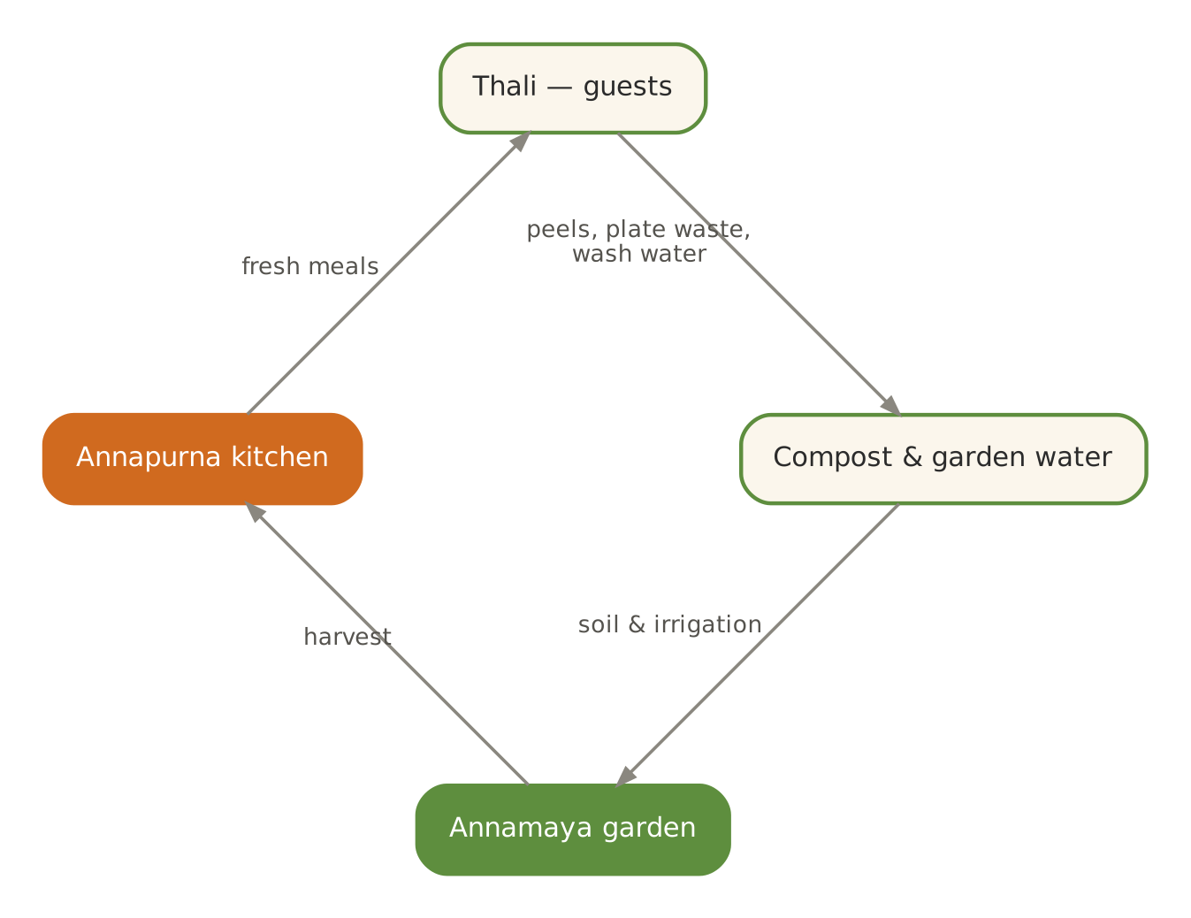
Figure. The zero-waste cycle — garden, kitchen, compost, garden
Stream | What | Where it goes
Vegetable trimmings and peels | Clean scraps | Compost for the Annamaya garden; some to the Centre's cows if any
Cooked leftovers (unserved) | Within safe time | Staff meals the same day
Plate waste | Uneaten food | Compost (cooked food composted separately)
Dry waste | Packaging | Segregated for recycling
Used oil | Never reused for frying | Collected for authorised biodiesel recycling where available
Water | Rice and dal washing water | Garden irrigation

55. Training the Kitchen Team
Module | Content | Duration | Source in the three volumes
1. Ayurveda basics | Elements, doshas, tastes, agni | 2 sessions | Vol. III, Part I
2. Cooking for 55+ | Portions, textures, salt, fat, protein | 2 sessions | Vol. I Ch. 2, 5; Vol. II Part A
3. Spices and tadka | The spice pharmacy; tadka sequence | 1 session + practice | Vol. III Ch. 10–11
4. Pulses and grains | Soaking, cooking ratios, digestibility | 1 session + practice | Vol. III Ch. 12–13
5. Food combining and freshness | Viruddha; leftovers | 1 session | Vol. III Ch. 20, 23
6. Texture modification | IDDSI levels; testing | 1 session + practice | Vol. II Section 13
7. Food safety | FSSAI Schedule 4; temperatures; logs | 1 session; FoSTaC course | Vol. II Part D
8. Service and mindful dining | Quiet service; choking first aid; respect | 1 session | Vol. III Ch. 27
9. Seasonal menu planning | Using Volumes I and II | Monthly | Vol. I Part II; Vol. II Part C
10. The cook's mind | Calm, cleanliness, prayer, seva | Ongoing | Vol. III Ch. 9

PART VI

Appendices
Checklists, planners, glossary and sources

A. Daily Routine Checklist
Print one per guest per week; tick each practice done.
Practice | Mon | Tue | Wed | Thu | Fri | Sat | Sun
Woke by 6 am
Warm water on waking
Tongue scraping
Oil pulling (optional)
Abhyanga or foot massage
Gentle exercise (20–40 min)
Breathing or meditation
Lunch as main meal
Walk after meals
1.5 L fluids
Dinner by 7:30 pm
Screens off by 9 pm
Asleep by 10 pm

B. Prakriti Score Sheet
Guest name | Date | Vata ticks | Pitta ticks | Kapha ticks | Dominant | Current imbalance noticed | Kitchen notes

C. Guest Intake Card (Kitchen Copy)
Item | Guest response
Name, room, length of stay
Food allergies or intolerances
Medical conditions affecting diet (diabetes, BP, kidney, heart, reflux)
Medicines needing food at fixed times
Chewing or swallowing difficulty; dentures
Texture level (if set by a clinician)
Fasting days observed
Tomato, chilli or other preferences
Prakriti (if known)
Emergency contact

D. Seasonal Lifestyle Quick Card
Season | Wake | Exercise | Oil | Favour | Reduce
Late winter (Jan–Mar) | 5:30 | Moderate | Sesame / mustard | Warm, light-to-moderate, pungent-bitter | Cold, heavy, sweet excess
Spring (Mar–May) | 5:00 | Most active | Light / dry rub | Light, warm, bitter, barley, honey | Curd, sweets, day sleep
Summer (May–Jul) | 5:00 | Light, early | Coconut | Sweet, cool, liquid, ghee | Pungent, sour, salty, sun
Monsoon (Jul–Sep) | 5:30 | Light, indoors | Sesame | Warm, fresh, light, sour-salty, ginger | Raw, cold, curd at night, river water
Autumn (Sep–Nov) | 5:30 | Moderate | Coconut / sunflower | Sweet, bitter, astringent, ghee, amla | Sour, salty, pungent, midday sun
Early winter (Nov–Jan) | 5:30 | Strongest | Sesame | Nourishing, unctuous, sweet-sour-salty | Fasting, cold, dry food

E. Glossary of Sanskrit Terms
Term | Meaning
Abhyanga | Oil massage
Adharaniya vega | Natural urges that should not be suppressed
Agni | Digestive and metabolic fire
Ahara | Food, diet
Akasha | Space, ether
Ama | Undigested residue; toxin of poor digestion
Amla (rasa) | Sour taste (also the name of the fruit amalaki)
Anjali | The measure of two cupped hands
Ardha shakti | Half of one's capacity (for exercise)
Asthi | Bone tissue
Bhramari | Humming-bee breath
Brahma muhurta | The period about 1½ hours before sunrise
Brimhana | Nourishing, building
Dhatu | Tissue (seven in number)
Dinacharya | Daily routine
Dosha | Functional principle: Vata, Pitta, Kapha
Gandusha / kavala | Holding / swishing oil or liquid in the mouth
Ghrita | Ghee
Guna | Quality (twenty physical; three mental)
Guru / laghu | Heavy / light
Jala | Water
Kapha | Dosha of water and earth
Kashaya | Astringent taste
Katu | Pungent taste
Krutanna | Cooked rice preparations of the pathya kitchen
Langhana | Lightening therapy; fasting in its gentle forms
Lavana | Salty taste
Madhura | Sweet taste
Mahabhuta | Great element (five)
Majja | Marrow and nerve tissue
Mala | Waste product
Mamsa | Muscle tissue
Manda | Clear rice water
Meda | Fat tissue
Nadi shodhana | Alternate-nostril breathing
Nasya | Nasal administration of oil
Nidra | Sleep
Ojas | The essence of all tissues; immunity and vitality
Padabhyanga | Foot massage
Pathya / apathya | Wholesome / unwholesome
Peya | Thin rice gruel
Pitta | Dosha of fire and water
Prabhava | Special action of a substance
Prakriti | Constitution
Prana | Life-breath; a sub-dosha of Vata
Prithvi | Earth
Rajas | Quality of activity and passion
Rakta | Blood tissue
Rasa | Taste; also plasma tissue
Rasayana | Rejuvenation
Ritu / ritucharya | Season / seasonal routine
Ritu sandhi | Junction between seasons
Ruksha / snigdha | Dry / unctuous
Sadvritta | Code of good conduct
Sattva | Quality of clarity and balance
Shad rasa | The six tastes
Shatapavali | The hundred steps after a meal
Shita / ushna | Cooling / heating
Shukra | Reproductive tissue
Tamas | Quality of inertia
Takra | Thin churned buttermilk
Tejas | Fire principle
Tikta | Bitter taste
Upavasa | Fasting
Vata | Dosha of space and air
Vayu | Air
Vihara | Lifestyle, activities
Vikriti | Current state, imbalance
Vilepi | Thick rice porridge
Vipaka | Post-digestive effect
Virya | Potency (heating or cooling)
Viruddha ahara | Incompatible food
Vyayama | Exercise
Yavagu | Gruel (of barley or rice)
Yogavahi | Carrier of the properties of other substances (ghee, honey)
Yusha | Thin pulse soup

E2. Weekly Meal & Lifestyle Planner
Day | Breakfast | Lunch | Evening | Dinner | Movement | Practice of the day
Monday
Tuesday
Wednesday
Thursday
Friday
Saturday
Sunday

Notes for the week | Response
Appetite and digestion
Sleep (hours, quality)
Energy and mood
Bowel regularity
Joint comfort
One thing to change next week

F. Take-Home Routine Sheets by Constitution
Guests leave with a one-page routine suited to their dominant dosha. These are the three standard sheets; the wellness team personalises them.

Vata-dominant guest
Time / area | Practice
Waking | 6:00 am at the same time daily; warm water with cumin and ginger
Self-care | Daily sesame-oil abhyanga; warm bath; oil in the ears and on the feet at night
Movement | Gentle and regular: walking, chair yoga, balance; avoid exhaustion
Breakfast | Warm porridge (oats, dalia, ragi) with ghee and dates
Lunch | Rice, moong dal with ghee, two cooked vegetables (roots, gourds), takra
Afternoon | Warm herbal tea and soaked almonds or dates
Dinner | By 7:00 pm: khichdi or soup with ghee
Night | Golden milk with nutmeg; foot massage; bed by 9:30–10 pm
Avoid | Cold, dry, raw food; skipping meals; late nights; travel fatigue; worry

Pitta-dominant guest
Time / area | Practice
Waking | 5:30 am; room-temperature water or coriander water
Self-care | Coconut or sunflower oil abhyanga; lukewarm baths; avoid midday sun
Movement | Moderate; early morning or evening; swimming or walking; no competitive strain
Breakfast | Do not skip: rice flakes, ragi porridge, idli with coconut chutney
Lunch | Rice, moong or masoor dal, gourds, leafy greens, sweet buttermilk; on time
Afternoon | Coconut water, pomegranate, fennel tea
Dinner | By 7:30 pm: moong yusha, lauki soup, rice with ghee
Night | Warm (not hot) milk with cardamom; sheetali in summer; bed by 10 pm
Avoid | Chilli, sour, fried and fermented food; anger; overwork; heat

Kapha-dominant guest
Time / area | Practice
Waking | 5:00–5:30 am — never late; warm water with honey (added warm) and lemon
Self-care | Dry rubbing or light mustard-oil massage; warm baths; gargles
Movement | The most vigorous of the three (within capacity): brisk walks, longer yoga
Breakfast | Light or small: barley porridge, poha, besan cheela, ginger tea
Lunch | Millet or old rice, moong or horse-gram dal, greens, karela, drumstick; takra
Afternoon | Ginger–tulsi tea; no snacking
Dinner | Small and early (by 7:00 pm): soup or yusha
Night | Bhramari; bed by 10 pm; no day sleep
Avoid | Sweets, curd, cheese, fried food, cold drinks, overeating, day sleep

G. Where to Find It — Cross-Reference to Volumes I and II
Topic in this volume | Recipes and menus in Volume I | Recipes and resources in Volume II
Agni and ama (Ch. 7) | Moong yusha; Sankranti khichdi; pepper–jeera rasam; CCF tea | Section 1 pathya kitchen (manda to yusha); ajwain–saunf water
Six tastes (Ch. 5) | The thali plate model; seven-day menus | Shukto (bitter); inji puli (pungent-sour); amla chutney
Spice pharmacy (Ch. 10) | Sattvic garam masala; digestive churna | Til and flax podi; mukhwas; spices catalogue (D2.8)
Grains (Ch. 12) | Ratios table; soft phulka | Millets section; breads section; staples scaling (C5)
Pulses (Ch. 13) | Dals in every month | Dals, kadhis, sambars & rasams (Section 3)
Dairy (Ch. 16) | Ghee; spiced takra; golden milk | Neer mor; curd rice; date milk; fortified milk
Water (Ch. 19) | Jeera–ginger water | Coolers and kadhas (Section 9)
Food combining (Ch. 20) | House rules | Research A6 (viruddha)
Cooking for each dosha (Ch. 22) | Season cards per month | Ingredient profiles (C3)
Freshness and storage (Ch. 23) | Food-safety flowchart | Receiving and storage flowchart (D1)
Eating rules (Ch. 26–31) | Daily rhythm; portion table | Recipe finder; IDDSI textures
Fasting (Ch. 32) | Vrat recipes (Appendix B) | Vrat & phalahari (Section 12)
Seasons (Ch. 38, 43–48) | Twelve month chapters | Season tags on every recipe; monthly plans (C1)
Guest programme (Part V) | Meal policy, timings | Festival thalis (C2); tools and service ware (D3)

H. Sources
Web sources were consulted in October 2026. Classical references (Charaka Samhita, Sushruta Samhita, Ashtanga Hridaya, Bhagavad Gita) are paraphrased from standard editions and translations; consult a qualified teacher for detailed study.
[1] WHO 2020 guidelines on physical activity and sedentary behaviour — University of Sydney news summary. https://www.sydney.edu.au/news-opinion/news/2020/11/26/new-global-guidelines-on-physical-activity-and-sedentary-behavio.html
[2] Tongue-cleaning methods: a comparative clinical trial employing a toothbrush and a tongue scraper (PubMed 15341360). https://pubmed.ncbi.nlm.nih.gov/15341360/
[3] Effect of oil pulling in promoting oro-dental hygiene: a systematic review of randomized clinical trials (PubMed 27261981). https://pubmed.ncbi.nlm.nih.gov/27261981/
[4] Health in Aging (American Geriatrics Society Foundation). How much sleep do older adults need? https://www.healthinaging.org/blog/?p=503
[5] LiveUp. The benefits of chair yoga for older people (summarising Kemeny 2023, Yao 2023, Ward 2025). https://www.liveup.org.au/articles/the-benefits-of-chair-yoga-for-older-people
[6] Charaka Samhita Online — Dinacharya. https://www.carakasamhitaonline.com/index.php/Dinacharya
[7] Charaka Samhita Online — Viruddha Ahara. https://www.carakasamhitaonline.com/index.php/Viruddha_Ahara
[8] New World Encyclopedia — Sri Anandamoyi Ma. https://www.newworldencyclopedia.org/entry/Sri_Anandamoyi_Ma
[9] ICMR-NIN Dietary Guidelines for Indians 2024 — summary of recommendations. https://thesouthfirst.com/news/icmr-releases-dietary-guidelines-for-indians-after-13-years-says-no-to-protein-supplements
[10] IDDSI Framework. https://iddsi.org/framework
[11] Annapurna Kitchen Volume I (Twelve-Month Sattvic Menu Book) and Volume II (Recipe Treasury & Kitchen Resource Book), with their source lists. https://www.ssmaic.org

Disclaimer
- This volume offers general Ayurvedic dietary and lifestyle guidance and kitchen practice. It is not medical advice and does not replace consultation with a qualified doctor or Ayurvedic physician.
- Breathing, yoga and massage practices should be learned from a qualified teacher and adapted to individual health; stop any practice that causes pain or discomfort.

॥ सर्वे भवन्तु सुखिनः सर्वे सन्तु निरामयाः ॥
May all be happy; may all be free from illness.
Annapurna Kitchen · Shree Shree Ma Anandamayee International Centre
Daksh Mandir Road, Kankhal, Dist. Haridwar – 249408 (U.K.), India · www.ssmaic.org

